**CAS**n=10  
(20.4, 80)

n=20  
(67.70930232558139, 227)

n=30  
(189.6721991701245, 724)

n=40  
(315.2649572649573, 1264)

n=50  
(459.81907090464546, 1905)  
  
**BOUNDED CAS**  
n=10  
(22.78125, 61)

n=20  
(83.62176165803109, 147)

n=30  
(464.48936170212767, 609)

n=40  
(672.679347826087, 849)

n=50  
(1036.19, 1201)

**TAS**n=10  
(24.207792207792206, 84)

n=20  
(21.693181818181817, 73)

n=30  
(292.468, 1125)

n=40  
(343.846394984326, 1369)

n=50  
(380.7919799498747, 1503)

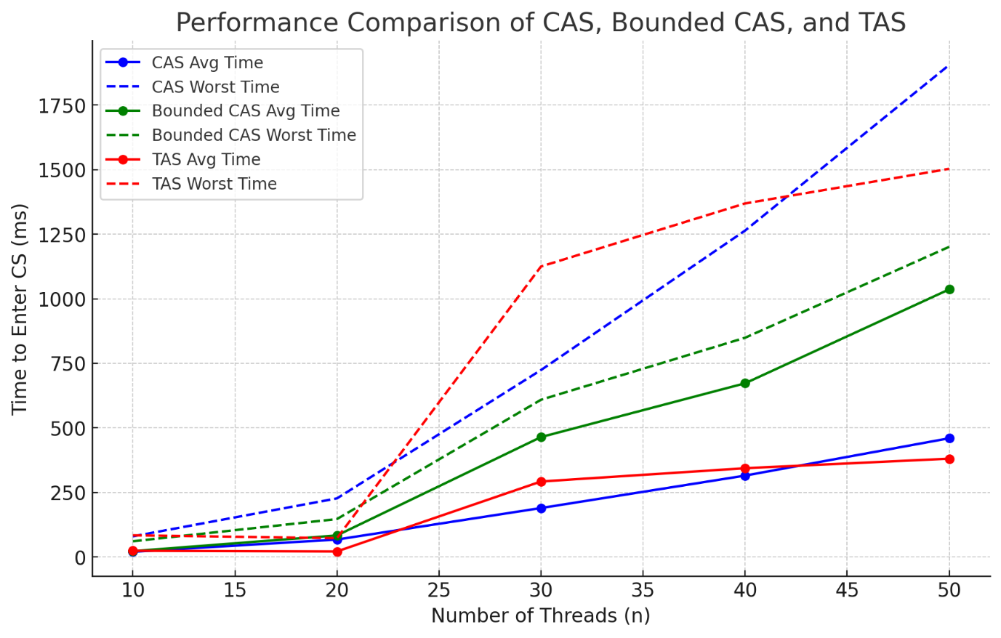

We observe that for simply performance, upto somewhere between 40 and 45 threads, CaS is the best performing algorithm. After that, TaS slightly outperforms CaS.  
  
In terms of starvation, upto around 23 threads, CaS is most prone to starvation, and TaS is least prone. Between 23 and around 42 threads, however, TaS is most prone to starvation, and bounded CaS is least prone to starvation. After that, CaS is most prone to starvation.  
  
Overall the best performing algorithm is most definitely CaS, and the least prone algorithm to starvation is bounded CaS.