DNS CACHE
EROS MUÑOZ ZANÓN
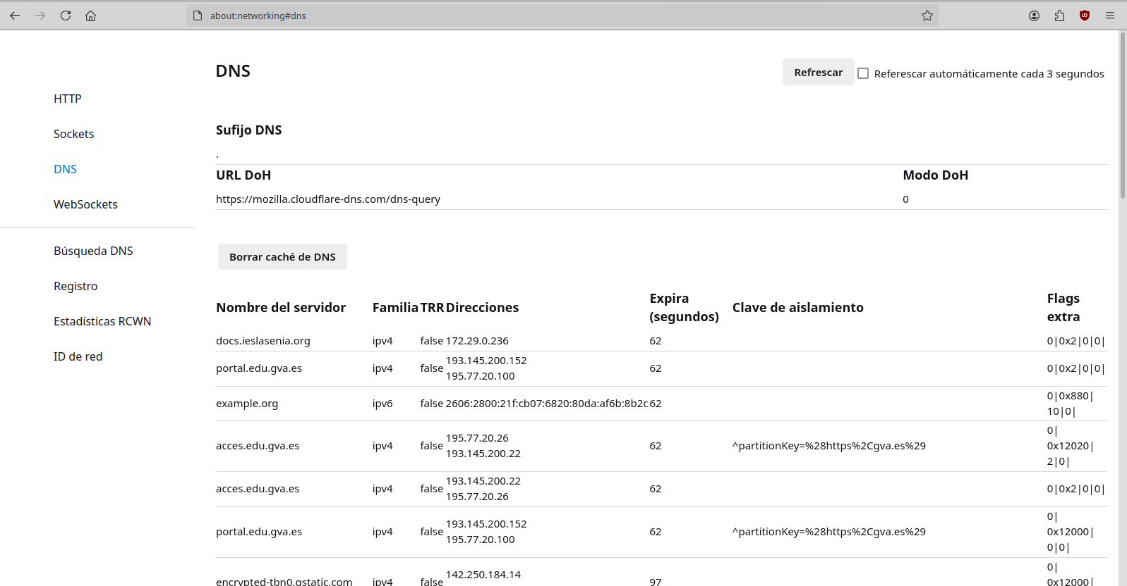

I found on Google that when I put this about:networking#dns in Firefox, since in Chrome it didn't work The dns appear along with the IPs of the pages you are running

