HOUR WASH LAUNDRY SHOP SYSTEM
System Process & Workflow Flowchart Documentation

1. Executive Overview & Flowchart Specification
This document presents the official system flowcharts for the Hour Wash Laundry Shop Management System. The flowcharts define the precise operational logic, decision points, user interaction paths, and automated system processes across the three primary user roles: Customer, Staff, and Administrator/Owner.
📌 FLOWCHART SYMBOL LEGEND & STANDARDS
All flowcharts adhere to standard UML flowchart modeling standards:
• Oval (Terminator): Marks the starting point or completion of a workflow.
• Parallelogram (Input/Output): Represents user interactions, screen displays, and user data entries.
• Diamond (Decision): Denotes conditional branching (Yes/No validation checks).
• Rectangle (Process): Indicates backend system computations, API dispatches, and database mutations.
• Circle (Connector): Serves as off-page / role transition connectors (e.g., T, A, B, C).

2. Figure 1: Login Page Flowchart
Defines the authentication and role-based routing flow. Users enter credentials, which are validated against the database. Valid users are dynamically routed to their specific role dashboard (Customer A, Staff B, or Admin C), while invalid attempts trigger error messages and re-entry loops.
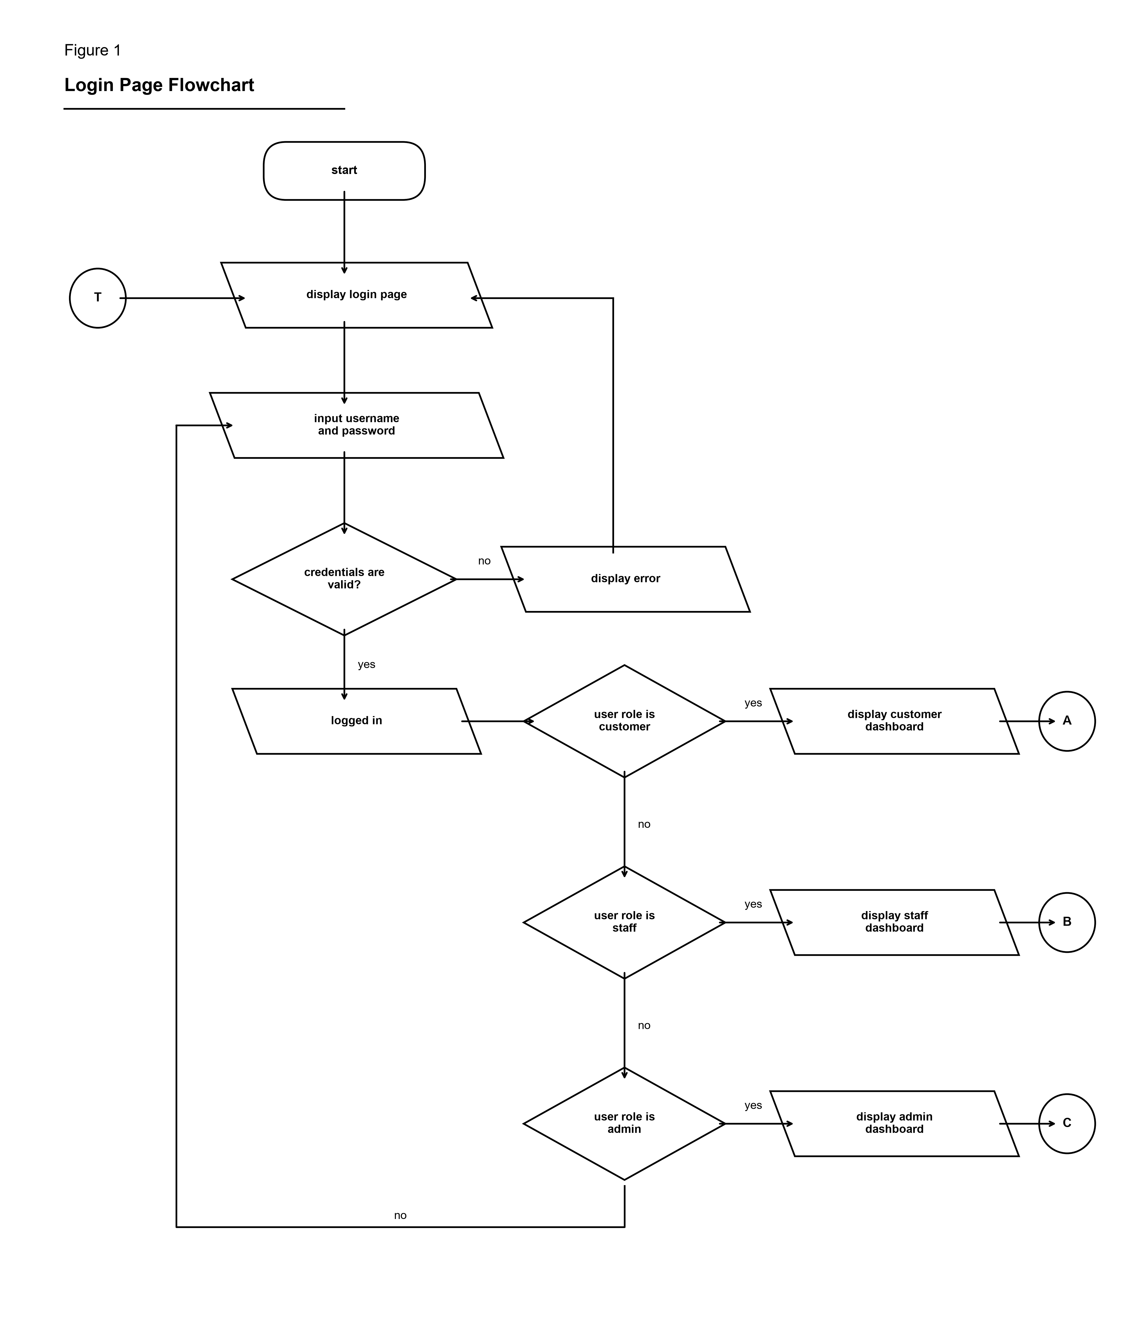
Figure 1 — Login Page Flowchart (Hour Wash System)

3. Figure 2: Customer Order Placement Flowchart
Illustrates the customer order placement workflow. Customers select laundry service options (wash, dry, fold), input load weights (kg), review pricing calculations, and confirm orders. The system automatically generates a unique Order ID and QR code, sending instant confirmation via SMS (TextBee API) and Email (Brevo API).
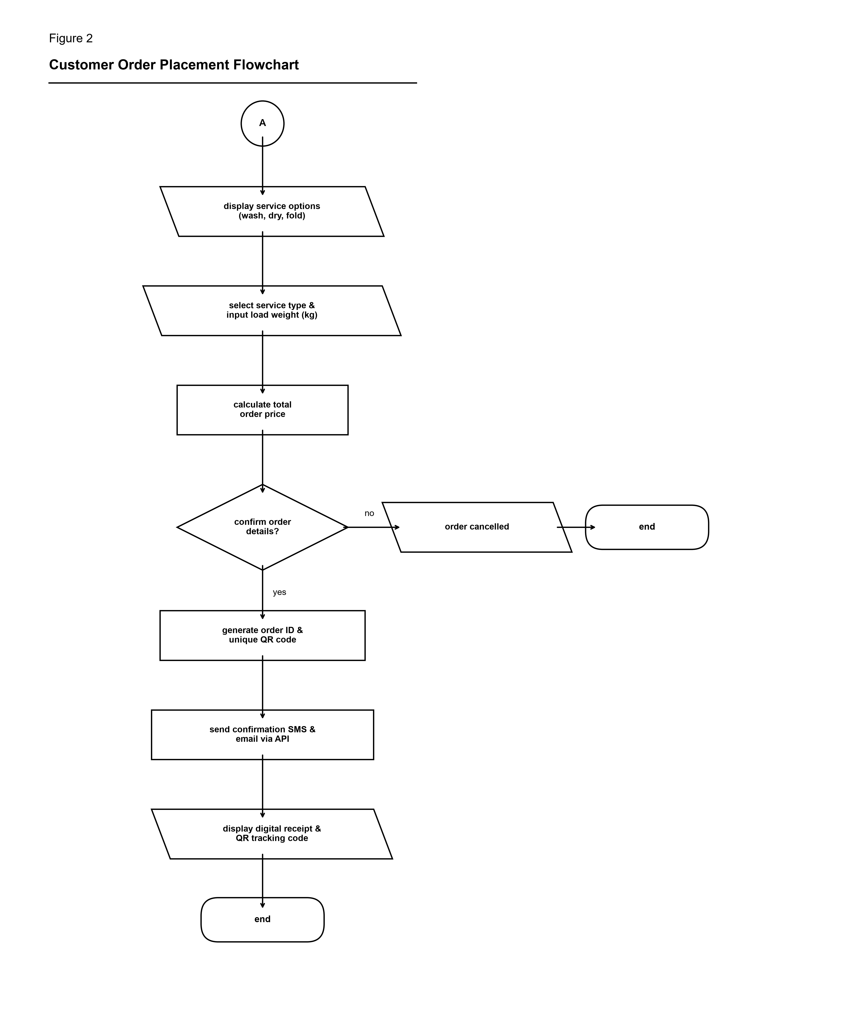
Figure 2 — Customer Order Placement Flowchart (Hour Wash System)

4. Figure 3: Staff Laundry Service Processing Flowchart
Details the staff operational workflow for laundry processing. Staff members scan the customer QR code to fetch order details, verify and weigh laundry items, and update status through the service lifecycle (Washing → Drying → Folding → Ready for Pickup). Completion triggers automated SMS/Email alerts to the customer.
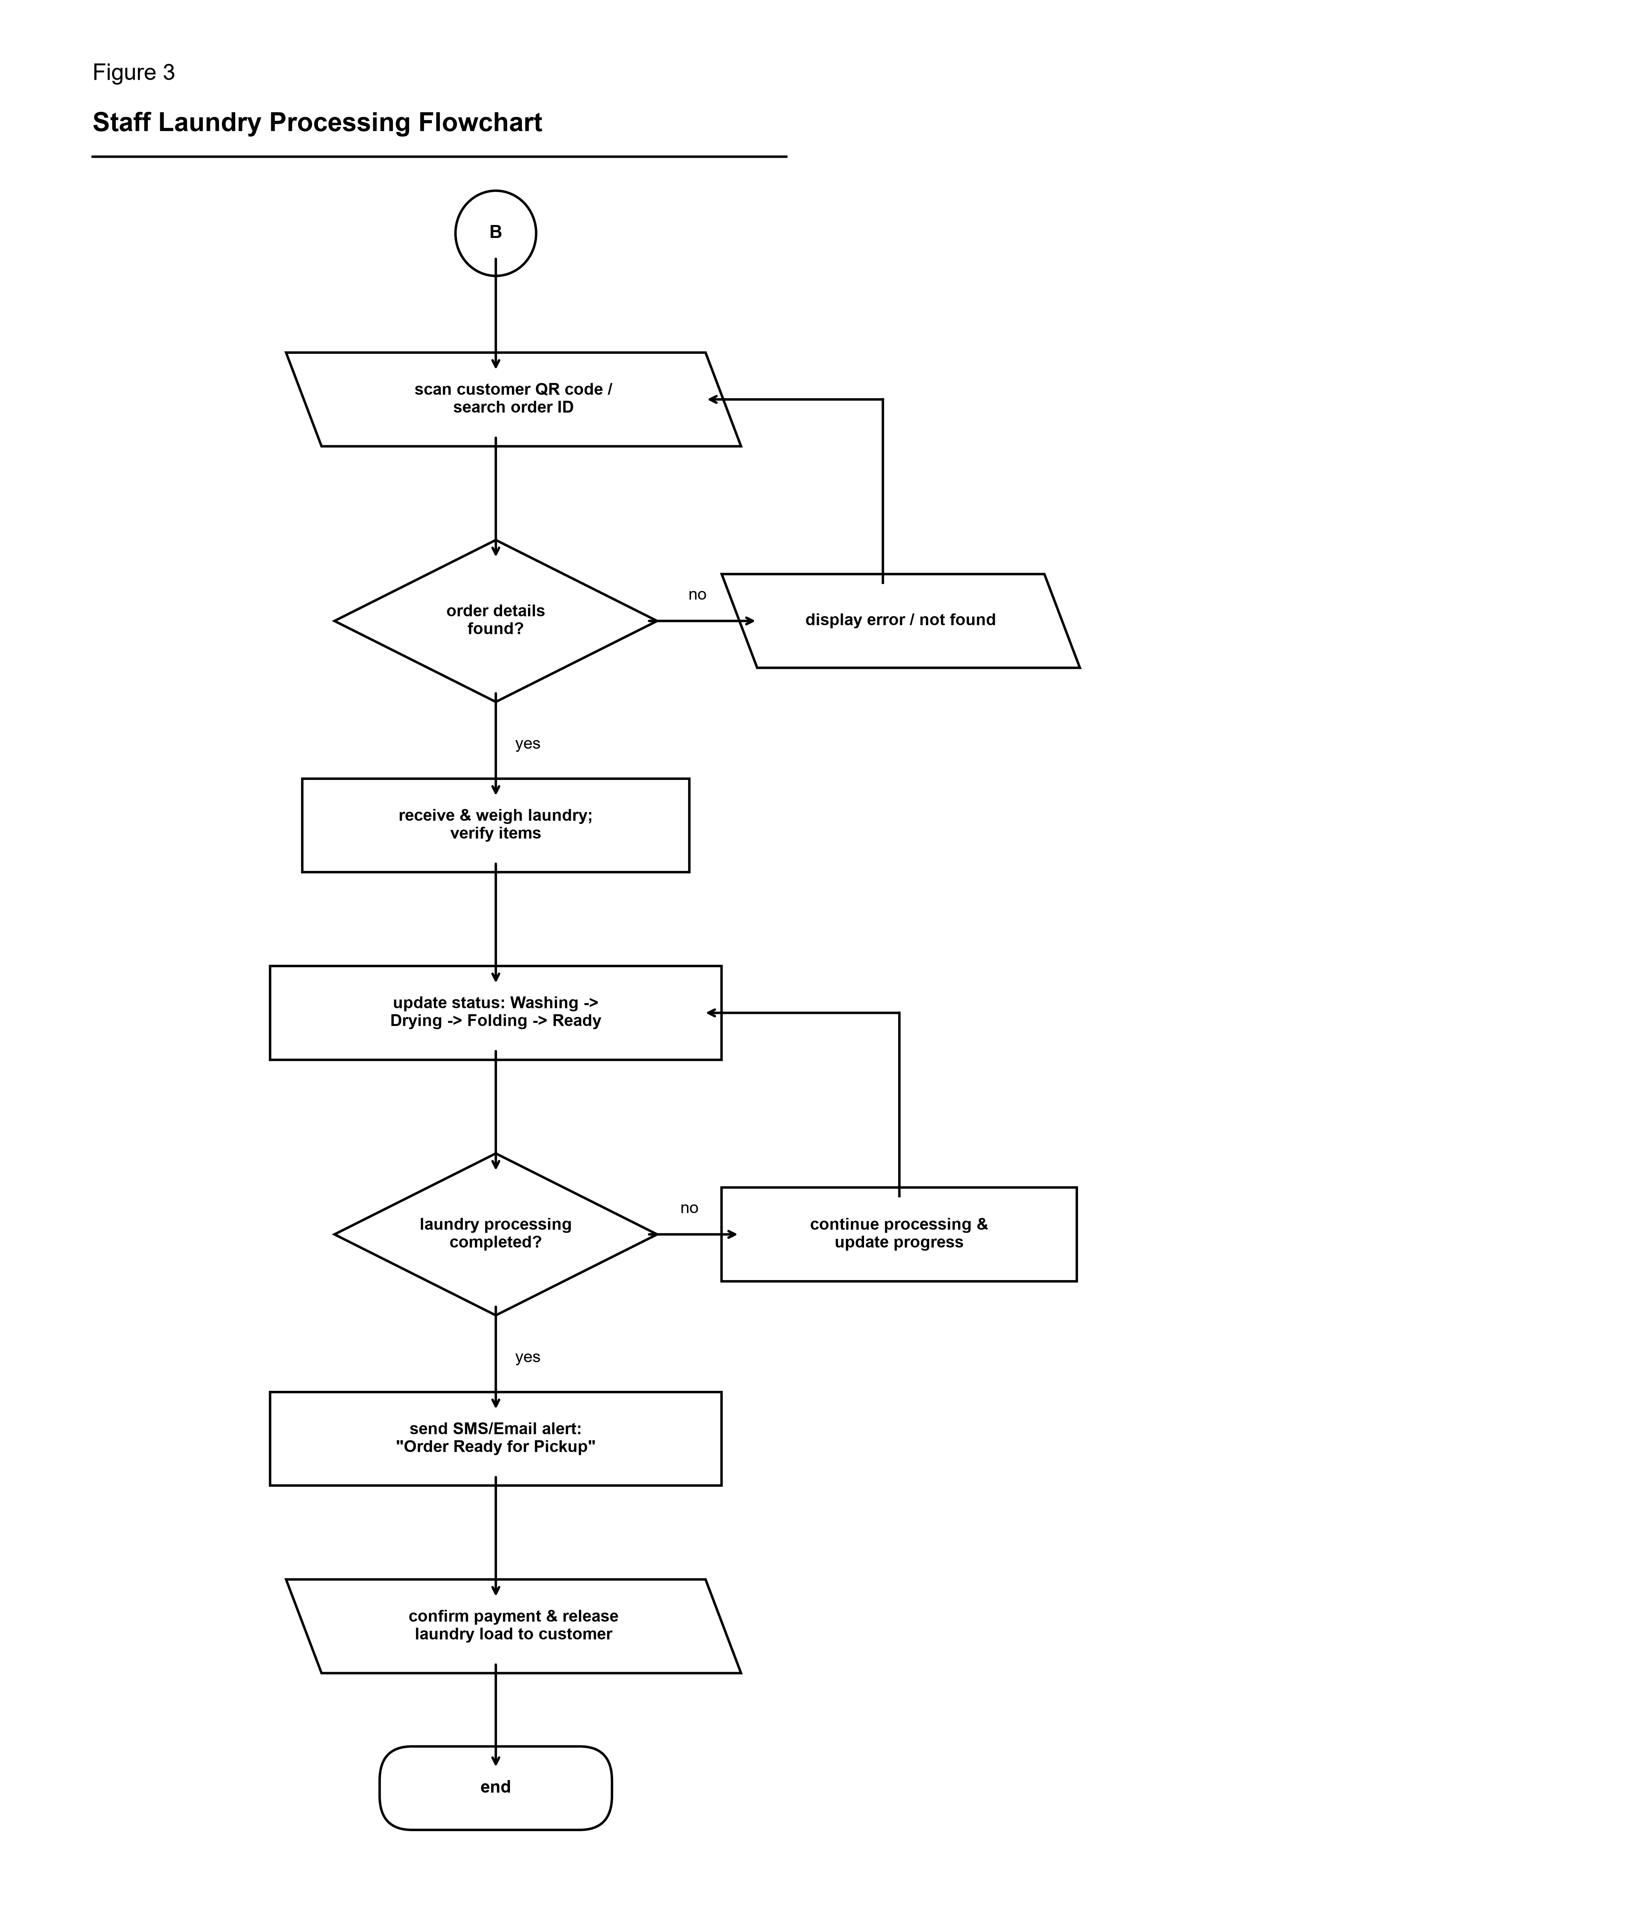
Figure 3 — Staff Laundry Service Processing Flowchart (Hour Wash System)

5. Figure 4: QR Code Tracking & Notification Flowchart
Outlines the real-time QR tracking and notification mechanism. Customers or staff scan the QR token, which queries the backend database for live status updates. When laundry status changes, automated webhooks dispatch TextBee SMS and Brevo Email notifications to the customer.
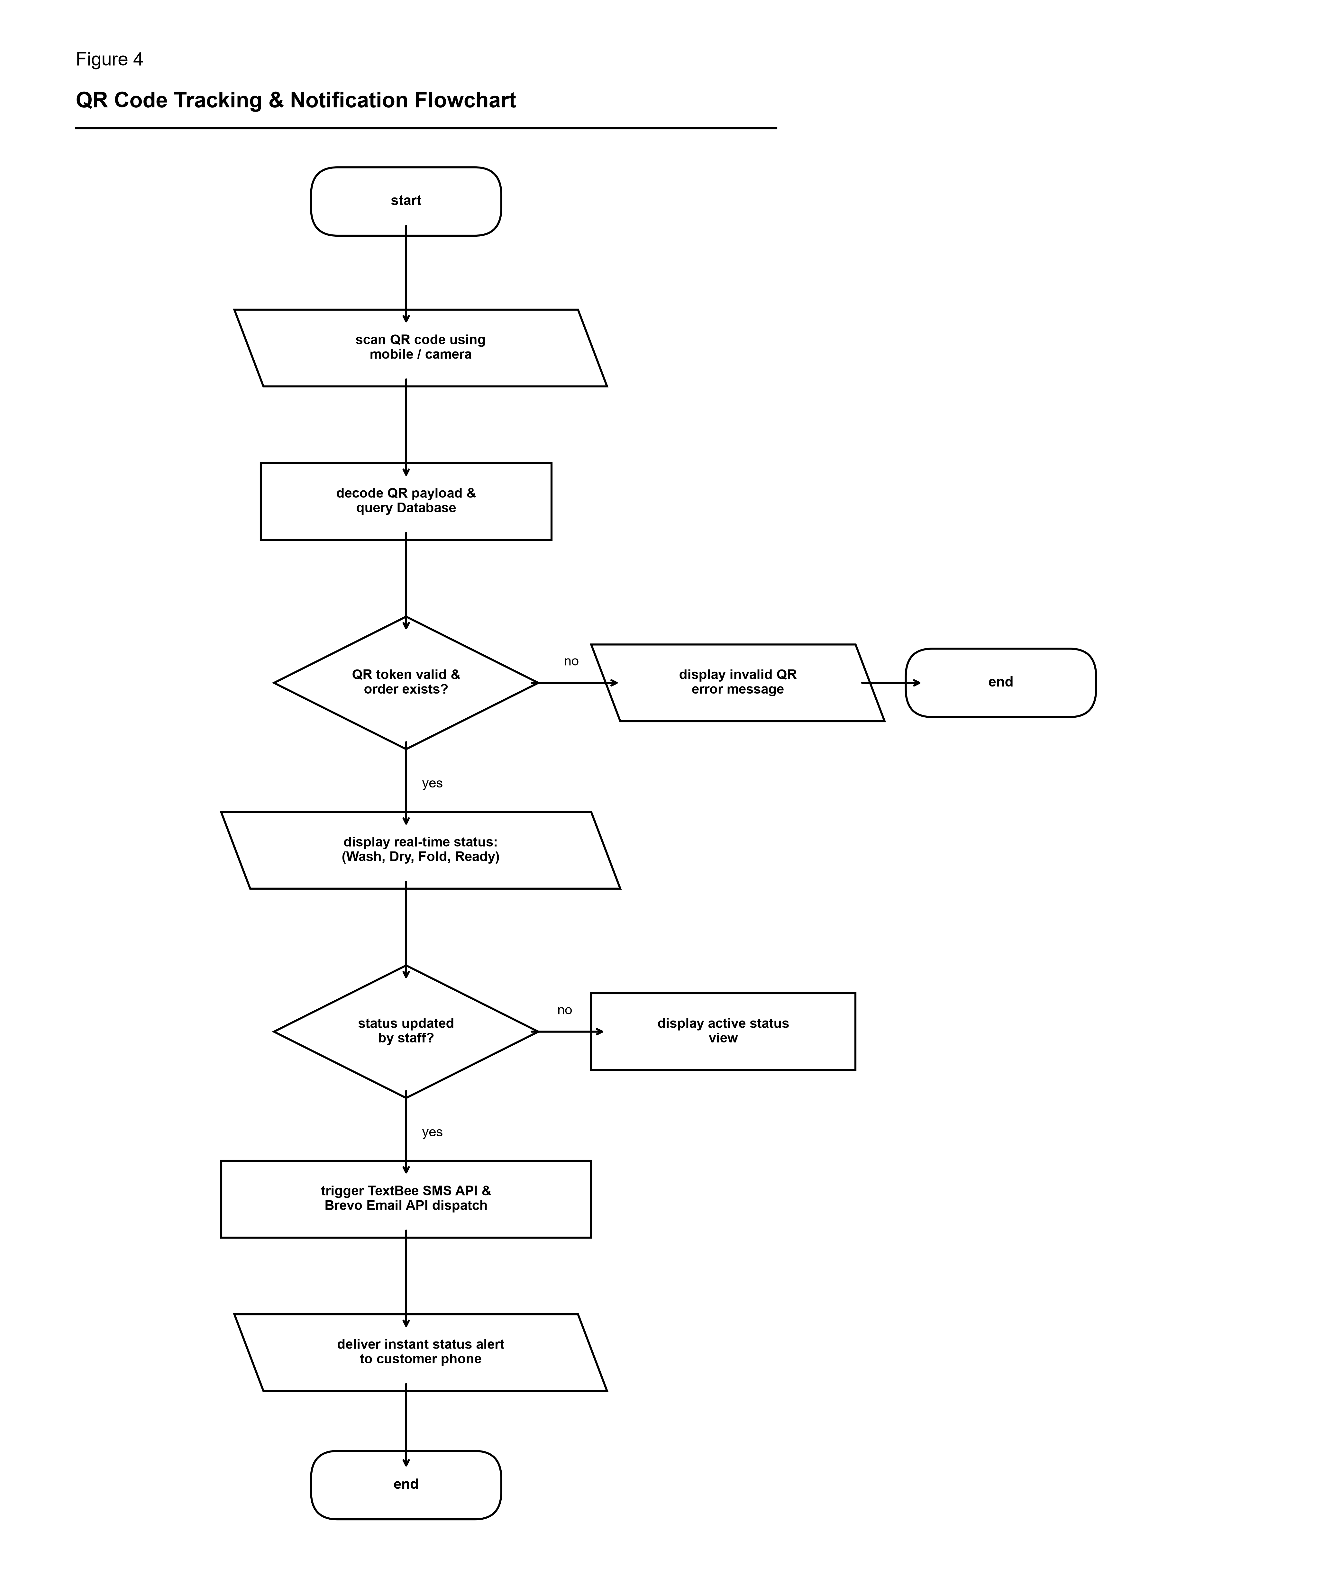
Figure 4 — QR Code Tracking & Notification Flowchart (Hour Wash System)

6. Figure 5: System Administration & Management Flowchart
Represents the administrative control workflow. Administrators manage customer and staff user accounts, configure laundry service pricing and detergent inventories, inspect revenue analytics reports, and audit system operational logs.
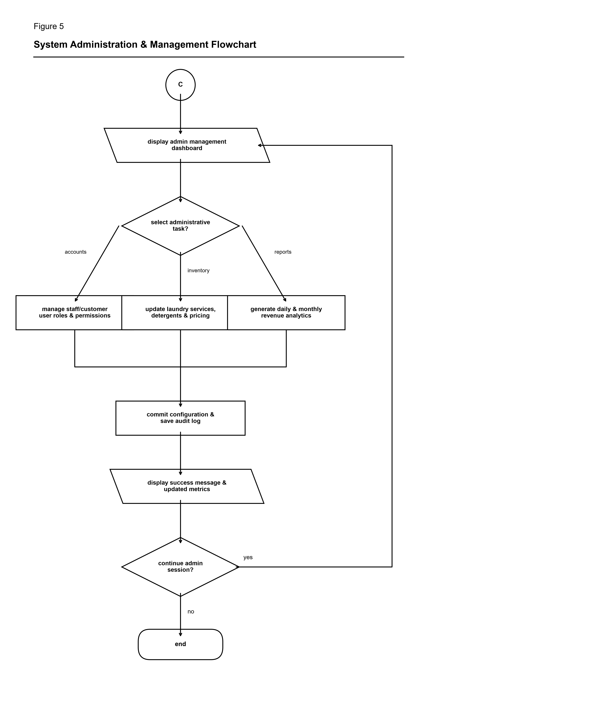
Figure 5 — System Administration & Management Flowchart (Hour Wash System)

