**Database Course Design Report**

1. **Introduction**

**In this course design, we use Django to build a campus e-commerce website for SCUT. The website is focus on the back-end design. You can visit** [**http://xinshi.cool:8000/**](http://xinshi.cool:8000/) **to try the website. We mainly achieve the login function, the search function, the commodity edits function and the transaction process. We use MySQL as our database and ORM to manage the database in the program.**

1. **User Guide**
2. **To visit our website, you can visit** [**http://xinshi.cool:8000/**](http://xinshi.cool:8000/)**. We have deployed the resources on our server with domain name. Since the domain name is not register for an e-commerce website, this might cannot reach. You can run this Django project on your own computer. The database resources are stable running at the server.**
3. **The start page of the website provide a login interface and the search interface.**

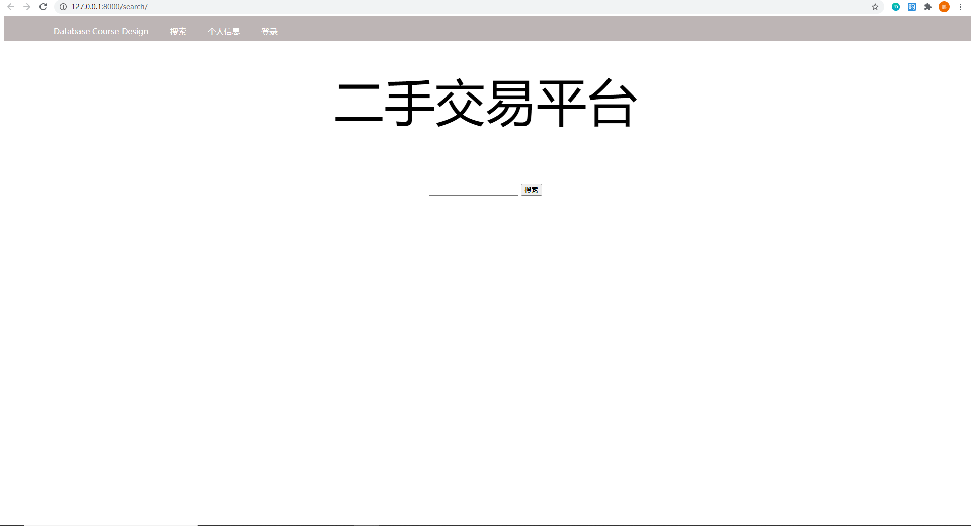

**Users can input search key to searching for items, and can press the “登录” button to login or register.**

1. **At the login page, the user need provide their user account and the password to login. We also achieve the verification code function to limit the unsafe login action. At the register page, the new user needs to provide some detail messages like user account and the password. The following messages like name and college is optional.**



1. **The searching result page shows all the search result from the searching keywords. We also support “space” to split the keywords, means that using “A ‘space’ B” can get items which name includes both A and B.**

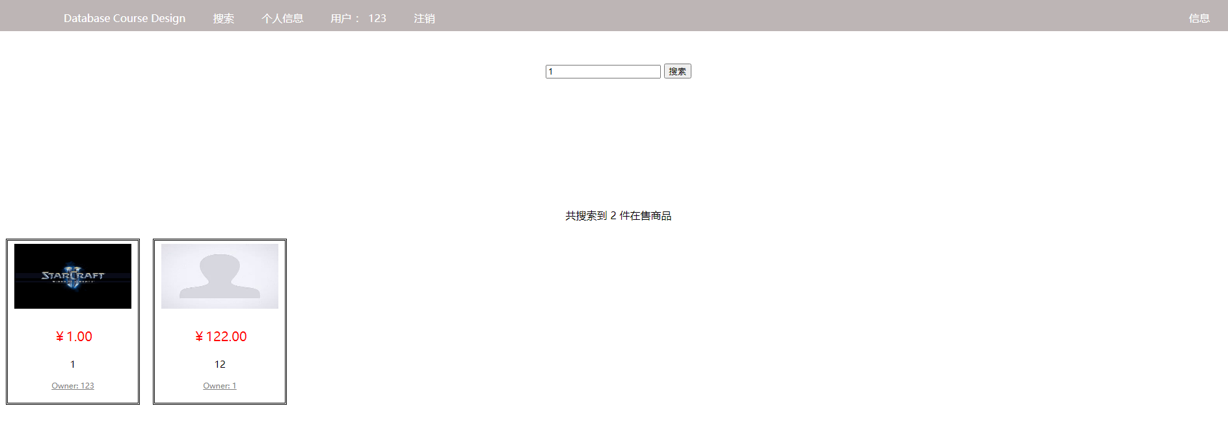

1. **At the items detail page, the user can see larger picture about the item. The name, price, descriptions and owner are listed on the right side. After press the “确认购买” button, the server will handle the request. The seller will receive a message about the purchase request. The buyer needs to wait for seller’s confirmation. Also, the buyer can visit the seller’s personal information page to get the contact methods.**



1. **Flow Chart**

**Webpage flow chart:**

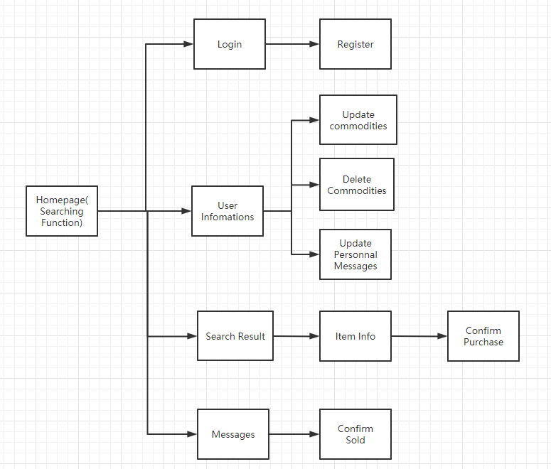

**User flow chart:**

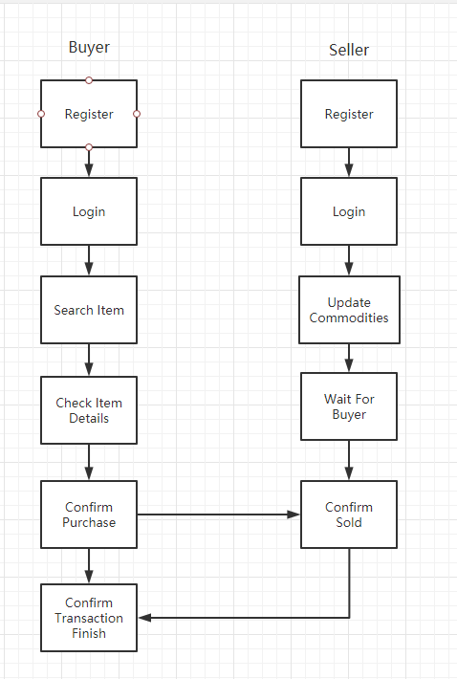

1. **Database Settings**

**With the ORM functions, we can create the database tables as a class and use migration function built-in Django. Also, add, delete, modify and search can be easier to achieve via ORM functions and process the database as a normal class of object.**

**Commodity**

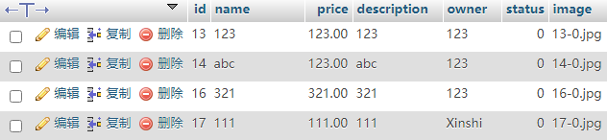

**Teacher(Manager)**



**Transaction**

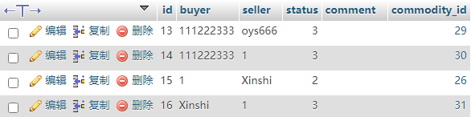

**User**

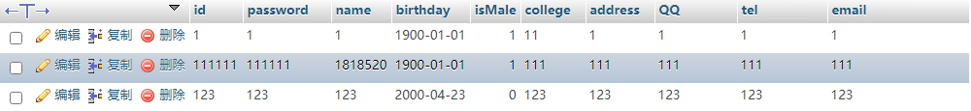

**Program of ORM**

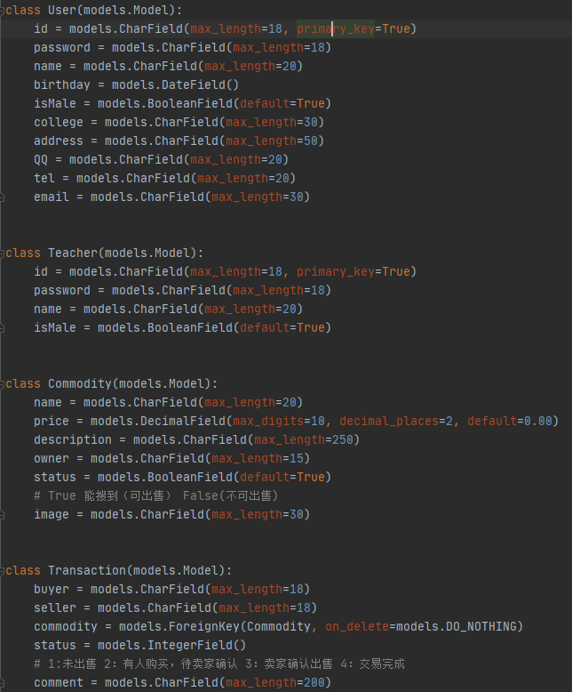

**Example of add, delete, modify and search**

**Add: Create a commodity from the input settings.**



**Delete: Delete one commodity**



**Modify: Use update function to modify the data.**



**Search: Search from user table where “id=input account” and “password = input password”**



1. **Achievement Details**
2. **Summary**