SECURE-PARKING
- Planning and Conceptualization:
- Define your Goals:
- Project Requirements from the business
  - What does application do?
  - Which users does the application need?
  - Does it need authentication?
  - Which data should it load from the other api or backend?
  - Which data should it send to the backend, using which method, and which data does it need to be returned from backend server?
  - How many pages does the application need? What are they?
  - In each page, which information should it show?
  - Which feature categories does the application need?
  - What can user do which the site? Which action they can do?
- State Management + Technology Decisions
  - How many slice of state do you need in your application?
  - With each state, where do you need to store them? (Global Remote state - backend, Global UI state - State management library like Redux, Local State)
- Create a sitemap:
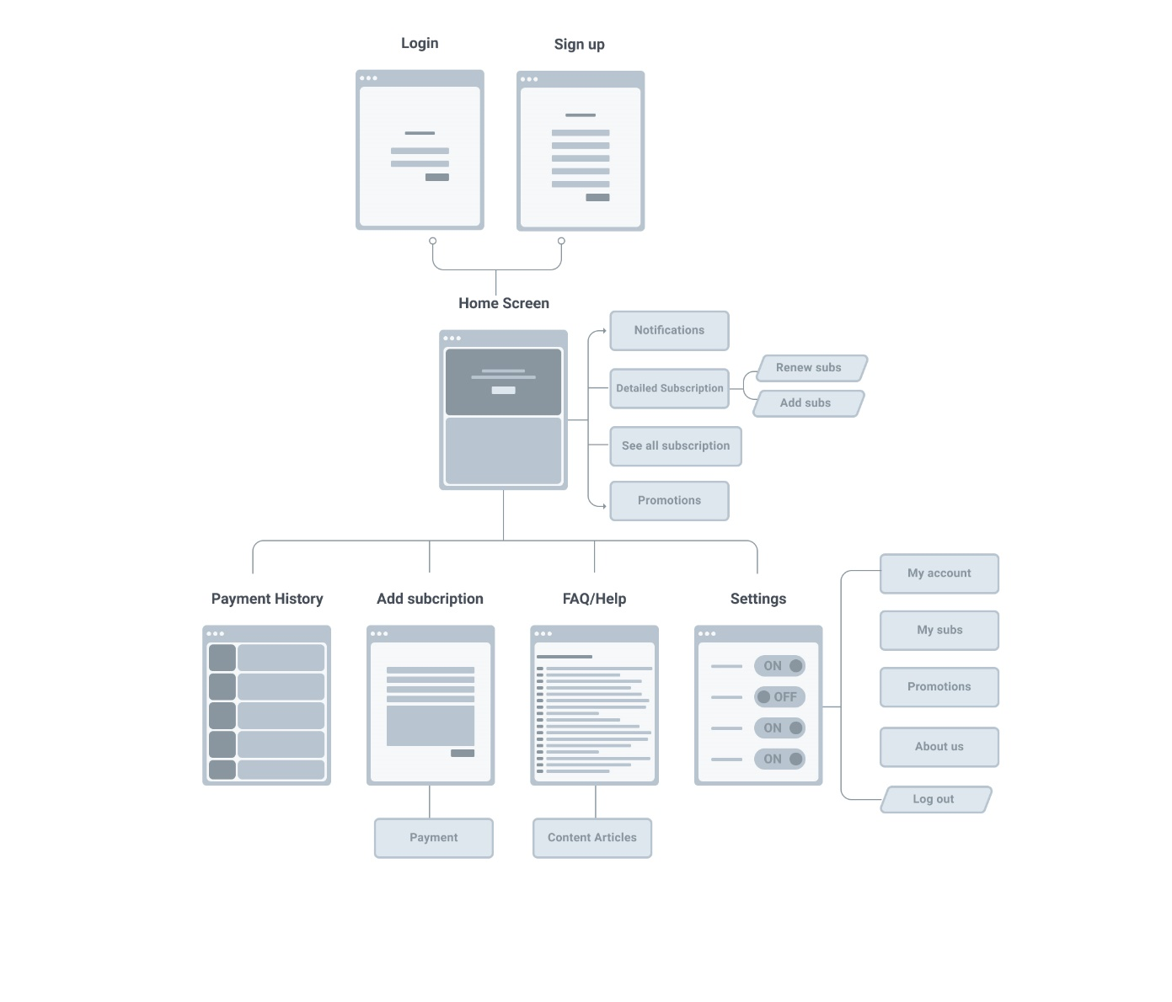
- Desktop Website screen:
- Width: 1440px
- Font: Poppins
- Common Components:
- Header:
- Site’s Logo
- Date
- Notification Button
- User Dropdown
- Main part (Pages’s differences)
- Pages:
- My Subscriptions
- Sidebar
  - Enable Pages Tab
  - Buy Now:
    - Button:
      - Color: White
      - Background Color: #0093D0
      - Text: Buy Now
      - Width: 180
      - Height: 44
    - Buy Now Illustration
- Hero section
  - Heading (Text, no need to create an component)
  - Button:
    - Color: White
    - Background Color: #0093D0
    - Text: Add New Subscription
    - Width: 210
    - Height: 50
  - Hero’s Image
- Monthly Parking Subscriptions part:
  - Heading
  - Subscription’s cards:
    - Quantity: 4
    - Card’s Heading
    - Card’s Body:
      - Expiration Date
      - License Date
      - Parking Zone
      - Parking Location
      - Button:
        - Color: White
        - Background Color: #56CCF2
        - Text: Charge
        - Width: 452
        - Height: 56
- Payment History
    - Sidebar
      - Enable Pages Tab
      - Buy Now:
        - Button:
          - Color: White
          - Background Color: #0093D0
          - Text: Buy Now
          - Width: 180
          - Height: 44
        - Buy Now Illustration
    - Payment History part:
      - Heading
      - Button:
        - Color: White
        - Background Color: #0093D0
        - Text: Add New Subscription
        - Width: 210
        - Height: 50
      - Pagination buttons:
      - Payment History’s cards:
        - Quantity: Based on number (Use Pagination)
        - Card’s Heading
        - Card’s Body:
          - Duration
          - License Plate
          - Parking Location
          - Price
- Add New
    - Sidebar
      - Enable Pages Tab
      - Buy Now:
        - Button:
          - Color: White
          - Background Color: #0093D0
          - Text: Buy Now
          - Width: 180
          - Height: 44
        - Buy Now Illustration
    - Add New Subscription part:
      - Heading
      - Form:
        - Text Input:
          - Quantity: 1
          - Label
          - Input element
        - Text and find input:
          - Quantity: 2
          - Label
          - Input element
        - Generated Parking Info:
        - Date Picking Input:
          - Quantity: 2
          - Label
          - Date Picking Box
        - Other Charge Fields:
          - Checkbox:
            - Quantity: 2
            - Label
            - Checkbox
        - Fee Card(Body only):
        - Button:
          - Color: White
          - Background Color: #0093D0
          - Text: Pay Now
          - Width: 210
          - Height: 50
- Help
- Sidebar
  - Enable Pages Tab
  - Buy Now:
    - Button:
      - Color: White
      - Background Color: #0093D0
      - Text: Buy Now
      - Width: 180
      - Height: 44
    - Buy Now Illustration
- Help part:
  - Heading
  - Tabs:
    - Quantity: 2
    - Issues Question:
      - Heading: Question (Start with a question icon)
      - Body: Answer (hidden by default)
    - Tabs Button:
      - How it look: 1 icon above + 1 description text
      - Enable:
        - Icon color: #0093D0
        - Icon Width: 64px
        - Icon Height: 64px
        - Color: #0093D0
        - Circle background: #0093D0
      - Disable:
        - Icon color: #32336C
        - Circle background: #EAEFF5
        - Color: #32336C
- Profile
- Sidebar
  - Enable Pages Tab
  - Buy Now:
    - Button:
      - Color: White
      - Background Color: #0093D0
      - Text: Buy Now
      - Width: 180
      - Height: 44
    - Buy Now Illustration
- Profile part:
  - Forms:
    - User’s image
    - User’s username
    - User’s email
    - Tabs:
      - Quantity: 3
      - Tab’s Heading
      - Tab’s Body
        - Text Input:
          - Quantity: 1
          - Label
          - Input element
        - Date Picking Input:
          - Quantity: 2
          - Label
          - Date Picking Box
        - Password Input:
          - Quantity: 2
          - Label
          - Password input
        - Button:
          - Quantity: 2
          - Color: White
          - Background Color: #0093D0
          - Text: Save Changes / Update Password
          - Width: 180
          - Height: 44
- Login
- Forms:
  - Heading
  - Text Input:
    - Quantity: 1
    - Label
    - Input element
  - Password Input:
    - Quantity: 1
    - Label
    - Password input
  - Forgot password link
  - Button:
    - Quantity: 1
    - Color: White
    - Background Color: #0093D0
    - Text: Login
    - Width: 300
    - Height: 50
  - Sign up link
  - Illustration Image
- Sign Up
- Forms:
  - Heading
  - Radio Button:
    - Quantity: 2
    - Label
    - Radio Button
  - Text Input:
    - Quantity: 4
    - Label
    - Input element
  - Password Input:
    - Quantity: 2
    - Label
    - Password input
  - Button:
    - Quantity: 1
    - Color: White
    - Background Color: #0093D0
    - Text: Sign Up
    - Width: 300
    - Height: 50
  - Sign in link
- Sign In OTP:
- Background Color: #F2F7FD
- Heading
- Text
- OTP Input:
  - Max Length: 6
  - Color: #32336C
  - Dot color: #EAEFF5
  - Background Color: #FFF
- Mobile Website screen:
- App screen:
- Develop a content strategy
- Design and User Experience
- Choose a Theme or Template:
- Design the Layout
- Create Wireframes:
- Figma Layout: Figma
- Development:
- Frontend: Mostly React, HTML, CSS and Bootstrap 5 (For mobile responsiveness)
- Backend: .NET
- Test and Debug:
- Content Creation and Optimization
- Create High quality contents
- Optimize for Search Engines (SEO)
- Reduce Image and Video size to reduce website’s size
- Optimize Website speed
- Launch and Maintenance:
- Launch your website
- Monitor and maintain
- Gather Feedback
- Improve website overtime

