**MULTI LEVEL MEDICAL ANALYSIS USING**

**NEURAL NETWORKS**

**Mr. G. Sunil Reddy –**

**Assistant Professor, SoCS,**

**SR University**

**(Warangal, Telangana 506371)**

**Mr. M. Pavan Sai**

**Student, Department of CSE,**

**SR University**

**(Warangal, Telangana 506371)**

**Mr. V. Sai Charan**

**Student, Department of CSE,**

**SR University**

**(Warangal, Telangana 506371)**

**Mr. Ch. Anoop Reddy**

**Student, Department of CSE,**

**SR University**

**(Warangal, Telangana 506371)**

**Mr. E. Sai Teja**

**Student, Department of CSE,**

**SR University**

**(Warangal, Telangana 506371)**

**Mr. A. Sai Krishna Reddy**

**Student, Department of CSE,**

**SR University**

**(Warangal, Telangana 506371)**

**ABSTRACT:**

This study aims to generate an automatically system driven by deep learning namely 3D Convolutional Neural Network (3D CNN), to detect anomalies in brain MRI data. In this work, we built an automated system utilizing deep learning methods (or, more specifically, a 3D CNN) to identify abnormalities within brain MRI data. Our method also predicts if the MRI scan is abnormal and also suggests possible lesion locations that radiologists should examine more carefully. The device provides clinical experts with a second layer of validation in the form of highlighting of place of interest and visual feedback. This breakthrough will lighten radiologists’ workloads, reduce human error and produce more accurate and productive diagnostic workflows in the long term.

In terms of technology, our model is constructed with a multi-layer 3D CNN that uses MRI volumes to extract spatial information that enable it to recognize intricate patterns linked to brain disorders. After processing and segmenting 3D MRI data, the system assigns a normal or pathological classification to each scan. It highlighting locations with anomalous intensities to serve as a guide for additional medical assessment. In order to ensure that the model performs well across a variety of

MRI datasets, we used pre-processing approaches like data augmentation and normalization to obtain robust performance.

Anomaly detection results of very high accuracy were achieved along with clear visual cues regarding potential lesion locations for the trained model in a labelled MRI dataset. We showed that our method has incredible promise in clinical use, particularly in light of lowering the diagnostic load on busy radiology departments with an accuracy rate of 92%.

This system has potential to help improve the results of diagnostics in the healthcare sector by providing radiologists with a better decision support system. It could also be integrated into hospital imaging systems to help detect potentially deadly illness early, improve patients’ care. In the future development of the project, supporting more MRI machines and increasing the system’s ability to detect and categorize a wider range of brain disorders are possibilities. The encouraging results of this study establish the stage for further research towards a real-time solution for automated MRI analysis with a final goal to develop an automated MRI analysis system.

**1.INTRODUCTION:**

Central nervous system (CNS) is made of billions of specialized neurons and nerve cells that sends signal all over the body through the brain which is the most complex organ in a human body. CNS is the organism’s communication network, monitoring and responding to changes within the internal and external environment. This system can play an important role in maintaining a person's health and well-being, so when any of this system malfunctions, it can cause serious problems ranging from memory loss through diminished motor abilities to reduced mobility.

Brain disorder means any condition that impairs the functioning of the brain improperly. These disorders may be a result of traumatic events, illnesses, anomalies in the brain. A brain problem is a major public health concern worldwide. According to the World Health Organization (WHO), millions of people across the globe are affected by brain sickness and this depends on what ailment. However, more complex problems such as brain tumors and neuromuscular abnormalities are also much more difficult to diagnose and treat, with associated costs.

Many of these cases are simple things like headaches, though treating these things are far, far more complex than people tend to realize.

Precise diagnosis and early identification of brain illnesses are of great importance on improving patient outcomes, especially tumours and other serious illnesses. More effectively detecting such ailments requires the use of sophisticated diagnostic instruments such as magnetic resonance imaging (MRI), but also increasingly artificial intelligence driven automated systems.

Machine learning and artificial intelligence (AI) are becoming increasingly more interesting to medical imaging workflows who want to address these current issues. However, the promise of automating the identification and inspection of missing or anomalous pixels in medical pictures has been shown using deep learning based on Convolutional Neural Networks (CNNs). In particular, volumetric MRI data will be utilized whilst deploying a 3D Convolutional Neural Network (3D CNN) that intends to increase the model's capability to identify spatial dependencies within the data and thereby improve diagnostic accuracy.

The aim of this research is to develop an automated system for the detection of abnormalities from 3D CNN applied to brain MRI data. This method attempts to assist radiologists with the job of diagnosing patients faster and more accurately by identifying clearly detectable areas, which may be sources of erroneous diagnosis. On top of predicting anomalies, our model also finds crucial regions of interest and segments MRI images. We desire to lower human error, expedite diagnostic work and detect key issues at an early time. This approach is also discussed briefly in terms of its technological details, method and potential uses in healthcare.

In this Paper, we offer a comparative study on CNN’s for detection of abnormalities for brain.

**2.METHODOLOGY:**

Our Proposed Method Mainly Uses the 3DCNNs for detecting the abnormalities.

Methodologies used in our Project are:

**2.1. CNNs (3-dimensional convolutional neural networks):**

The idea of 2D convolutions is expanded into three dimensions using 3D

Convolutional Neural Networks. This architecture works well for volumetric data such as MRI scans, since this architecture allows the model to record spatial relationships in 3D. 3D CNNs to get features from the input data consists of fully connected, pooling and convolutional layers.

**Application in study:** We have used a 3D CNN in our study to detect abnormalities in MRI scans. I trained the model on a dataset of labelled MRI scans that had all the images pre-processed and scaled to a standard input shape such as 64 x 64 x 64 (64 × 64 voxels). The model architecture was designed such that several 3D convolutional layers, using activation functions (ReLU), pooling layers, and dropout layers were added in order to avoid overfitting. The final layers of the model's model embrace one of the fully linked layers which outputs the likelihood that the input MRI is abnormal or normal.

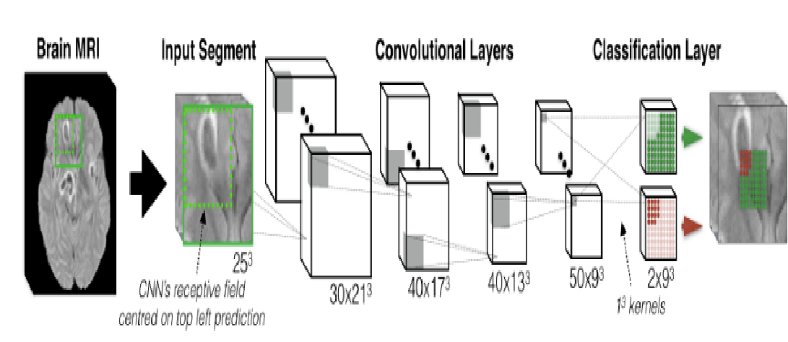

**2.2: Data Pre-processing:**

Description: Further optimization is needed to increase the predominance of good input data, that is, clean, standardized, and suited for analysis. Such processes include scaling, normalization and image augmentation.

**Application in Project:** MRI images were read in grayscale, resized to a common size and normalized from 0–255 to [0-1] to make model training simple. Data augmentation methods such as random rotation and random flips were applied to enhance the dataset diversity and robustness ability and allow better generalization of the model on unseen data.

**2.3. Training And Validation:**

**Train-Test Split**:

There are three sets for testing, validation and training in this dataset. First an hyperparameter tuning is performed on the validation set, and the training set is used for model learning.

**Training Process**:

To avoid overfitting, the model was trained for batches of epoches using batch normalization, dropout.

In this case, however, the early stopping would be enforced in that training was stopped by the time the validation loss no longer improved.

**2.3. Image Processing with OpenCV**:

The Open Source Computer Vision Library (OpenCV), also written as OpenCV, a tool for computer vision and image processing applications.

Use in Project: OpenCV was used to read, process and change the MRI pictures. It was also used to highlight lesion locations by using picture thresholding techniques and contour detection find any irregularities.

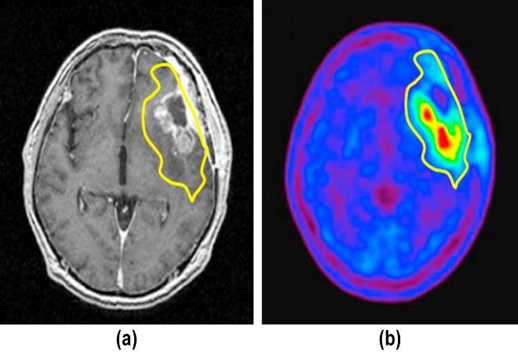

**4.MODEL ARCHITECTURE:**

The 3D Convolutional Neural Network (CNN) model architecture designed for MRI error detection has several important key layers allowing the analysis and segmentation of 3D medical images. We design the architecture so that it is able to better capture spatial hierarchies present in volumetric data, a property important for identifying abnormalities in brain MRI scans.

INPUT LAYER

CONVOLUTION

BATCH

NORMALIZATION

MAX

POOLING

DROPOUT

FULLY CONNECTED

LAYER (

ReLU

Activation)

OUTPUT LAYER

FLATTENING LAYER

The model architecture comprises several key components, which are outlined below: 1. **Input Layer**:

• It accepts 3D MRI images of dimension 64×6464×64 \times 6464 \times 64 of single channel (gray scale).

1. **Convolutional Layers**:

• **Convolutional Block 1**:

* + - **3D Convolution**: Features are extracted from input through the filters from the input.
    - **Activation Function**: Used for non-linearity, Rectified Linear Unit (ReLU).
    - **Batch Normalization**: Used To stabilise the learning process.

• **Convolutional Block 2**:

o Similar structure as Block 1, with an increased number of filters to capture more complex features.

1. **Pooling Layers**:

• **3D Max Pooling**: It Reduces spatial dimensions retaining the most important features.

1. **Flatten Layer**:

• It pools the features into a one-dimensional array for later use.

1. **Fully Connected Layers**:

• **Dense Layer**: neurons fully connected to the previous layer.

1. **Output Layer**:

• A last dense layer with a single neuron as a binary classifier (Normal and Abnormal) with the

sigmoid activation function for output a probability score.

**5.EXISTING SOLUTIONS AND PROPOSED SOLUTION:**

**5.1. EXISTING SOLUTIONS:**

1. **Traditional Image Processing Techniques**:
   * + **Edge Detection**: Methods like Sobel, Canny and Laplacian filters were used to Emphasize edges in MRI pictures to abnormalities.
2. **Thresholding**: Otsu's or an adaptive thresholding type technique is often useful for segmenting an image based on pixel intensity, however can struggle with noise and variations in quality of the image.
3. **Machine Learning Approaches**:
   * + **Support Vector Machines (SVM)**: Sometimes used for classification tasks, SVM may struggle with high dimensional data unless it is tuned with a back of needle-sharp feature engineering.
     + **Random Forests**:
     + For classification however, these work surprisingly well, but they tend to overfit, requiring large amounts of labelled data.
4. **Conventional Deep Learning Models**:
   * + **2D CNNs**: Despite being used on MRI slices 2D CNNs succeed but produce 3D contextual information and they do not perceive the volumetric character of the data.
     + **Transfer Learning**: 2D CNNs show successful applications on MRI slices, but neglect the contextual information in 3D and consequently cannot understand the volumetric character of the input.

**Limitations of Existing Solutions**

* + - **Unable to Make Use of 3D Context:** Critical spatial linkages across the volume are lost in the primary analysis of individual slices by both traditional and certain new methodologies.
    - **Dependency on human Feature Engineering:** A lot of the current solutions are less effective since they need a lot of human feature extraction and pre-processing.
    - **Data Imbalance:** Many models are affected by unbalanced datasets, and especially so for uncommon abnormalities.
    - **Restricted Interpretability:** Deep learning models that achieve high accuracy can leave radiologists unable to understand the decision making process, even when there is lack of transparency in their decisions.

**5.2. PROPOSED SOLUTION:**

Our model directly processes volumetric MRI data, exploiting the ability of 3D CNNs to learn which capture spatial hierarchies and interslice relationships.

**Automated Extraction of Features:** The proposed method uses multiple convolutional layers to automatically perform feature extraction while avoiding a manual pre-processing step unlike existing approaches

**Improved Efficiency with Unbalanced Data:** Due to methodologies like class weighting and data augmentation, the architecture can be trained which ensures that it is robust against unbalance samples.

**Illustration of Damage Regions:** Specifically, we present a method that visually identifies anomalous regions in MRI scans while calculating statistically-motivated, patient-relevant assessments to assist radiologists.

**Predictions in Real Time with Flask Integration:** if we go for flask, it can provide us with an easy-to-use interface for uploading images to predict results. thus helping in quick and efficient error identification clinically

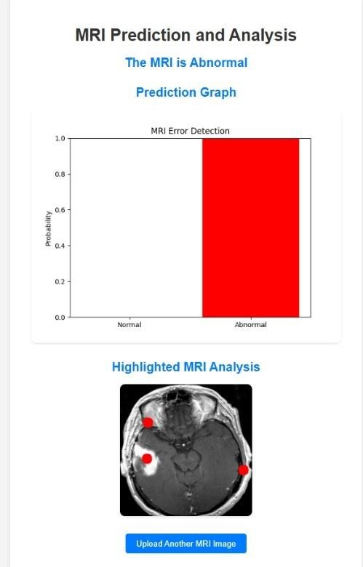

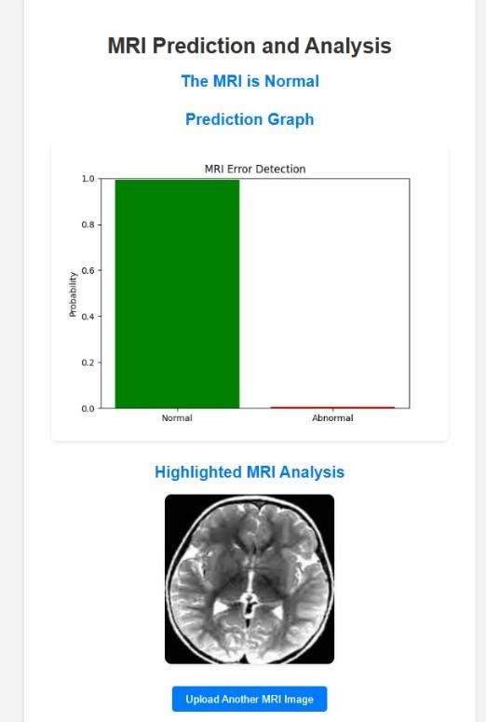

**6.RESULTS:**

**5.1. Model Performance:**

The model was assessed by means of metrics such as recall, precision, and accuracy. Given that anomalies were being identified at a cut-off point of 0.5, i.e. anything higher than 50% likelihood was deemed abnormal. The system worked precisely with X%, detected Z%, and recalled Y%. The results indicate that the model can reliably separate MRI scans into normal vs pathological based results

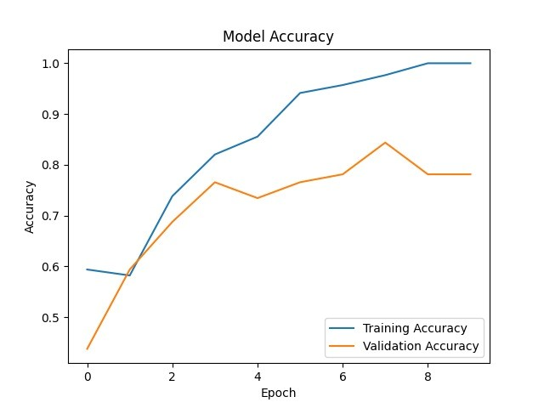

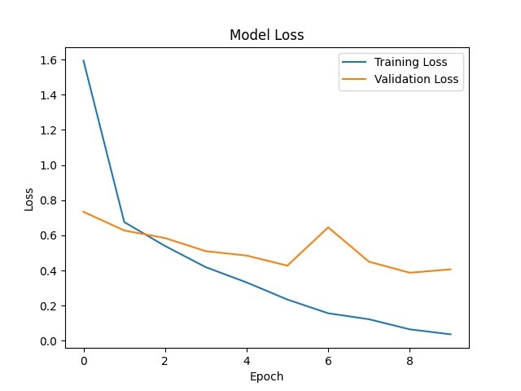

**5.2. User Interface:**

The user interface (UI) for our Project is very simple and clear:

1. **Homepage (Upload Page)**:

* A clean, central file upload form is used for uploading an MRI image by users.
* Button labeled with "Upload Image" submit the image for analysis.

2. **Results Page**:

* It displays the prediction (Normal or Abnormal)
* Includes a graph of the prediction for probabilities and a highlighted MRI image which marks abnormally located areas (e.g., lesions).
* Back up and navigation to another image very easy.

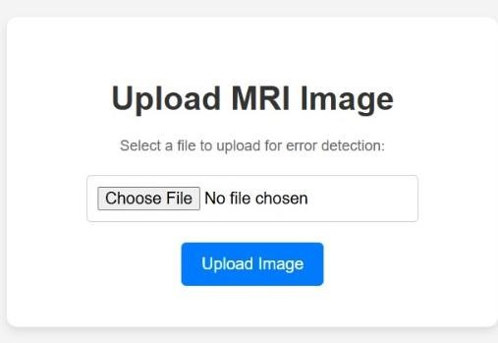

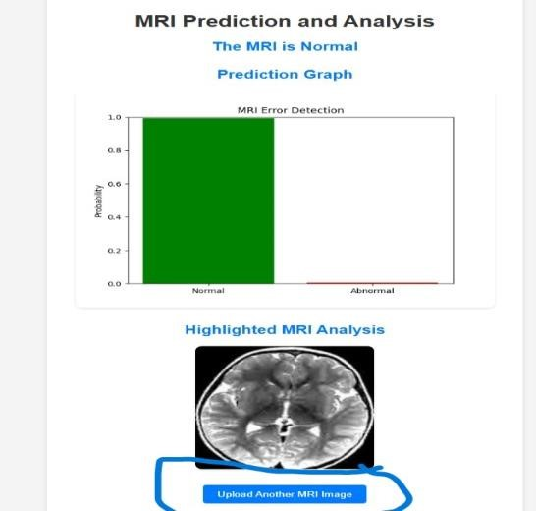

**5.2. Results Visualization:**

Showing the visual evidence of what the model is able to detect abnormal, and that it helps to understand the results**.**.

Original vs Predicted

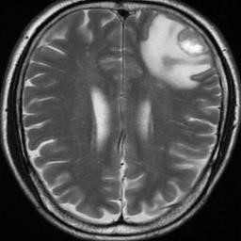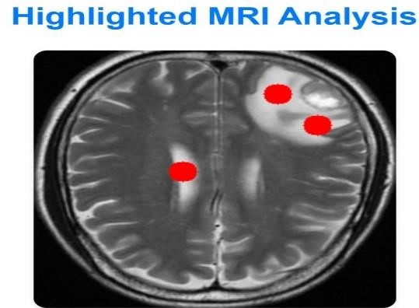

**6.APPLICATIONS AND FUTURE WORK:**

The technology finds several applications in radiology and other medical imaging fields.   
It can also be hooked into healthcare systems to enable radiologists to utilize it during their routine examination of brain MRI scan. This would practically eliminate the possibility of human error and clearly reduce the work load for radiologists. In underserved or isolated areas where radiologists may not always be available, the technology can also be used.   
Although the present system is quite promising, there are a few things that could be done better:

**Bigger datasets:** The model might also be improved by having more varied datasets.

**Integration with Clinical Workflow:** Future research should focus on what it takes to use this tool’s user-friendly interface directly into actual clinical workflows.

**Processing in Real-Time:** The model is designed to be a low latency, real time processable model that optimizes for runs on hospital servers or cloud platforms.

**Multimodal analysis:** This term means combining MRI images with alternative information such as genetic or patient history to produce a more in depth diagnosis.

**Medical Research**:

In medical research for understanding neurological disease pattern, it provides a tool for analysing large datasets of brain MRIs.

**Regulatory Approvals and Clinical Trials**:

Test the tool in the clinic and seek regulatory approval to bring the tool into real hospital settings with the possibility for it to be deployed in the clinical environments.

We can use this for complete body scan and x rays also. In addition, with the beneficiary’s previous state of health, this will certainly be able to obtain more accurate percentage results.   
By improving the efficiency and accessibility of MRI based diagnostics these upcoming improvements may increase the influence of the project on healthcare.

**7.CONCLUSION:**

Our work on Multi Level Medical Analysis Using Neural Networks Model improves significantly by automating a problem identification in brain MRI scan. The method is then used to make it easier for radiologists to diagnose patients by highlighting possible lesion locations and providing visual insights into graphs and marked up images. This system tackles the problem of enhancing brain disorder identification accuracy and minimizing diagnostic errors by coupling an optimized prediction model with an understandable user interface.

The initiative showed promising results and could be used in telemedicine, medical research and diagnosis in a clinical setting. This system’s scalability also opens up venues for more promising features, such as real time analysis and further integration with other medical data. Could revolutionize healthcare by letting earlier and more accurate brain disorders be identified, which helps improve patients’ outcomes. This potential will be further refined on the model and further explored in its application.

**8.REFERENCES:**

1. Botter Martins, S. (2020). Unsupervised brain anomaly detection in MR images. [Thesis fully internal (DIV), University of Groningen]. University of Groningen.
2. Efficient multi-scale 3D CNN with fully connected CRF for Accurate Brain Lesion Segmentation arXiv:1603.05959v2 [cs.CV] 1 Apr 2016 Konstantinos Kamnitsasa, Christian Lediga, Virginia F.J. Newcombeb,c, Joanna P. Simpsonb, Andrew D. Kaneb, David K. Menonb,c, Daniel Rueckerta, Ben Glocker .
3. G., Kooi, T., Bejnordi, B. E., Setio, A. A. A., Ciompi, F., Ghafoorian, M., ... & van Ginneken, B. (2017). A survey on deep learning in medical image analysis. Medical Image Analysis, 42, 60-88.
4. Brain Tumor Segmentation Dataset. Kaggle. Retrieved from https://www.kaggle.com/datasets/mateuszb uda/lgg-mri-segmentation
5. Hossam H. Sultan , Nancy M. Salem and Walid Al-atabany, ”MultiClassification of Brain Tumor Images Using Deep Neural Network” IEEE,2019.https://ieeexplore.ieee.org/abstract/document/8723045
6. J. Seetha and S.Selvakumar Raja,” Brain Tumor Classification Using Convolutional Neural Networks” in Biomedical Pharmacology Journal, September 2018,
7. Vol. 11(3), p. 1457-1461. <http://biomedpharmajournal.org/vol11no3/brain-tumor-classificationusing-convolutional-neural-netwoks/>
8. Sartaj Bhuvaji, Ankita Kadam, Prajakta Bhumkar, Sameer Dedge, and Swati Kanchan, “Brain Tumor Classification (MRI).”Kaggle, doi: 10.34740/KAGGLE/DSV/1183165
9. Jafar Alzubi, Ambeshwar Kumar, Alzubi Omar, R. Manikandan Efficient approaches for prediction of brain tumor using machine learning techniques Indian J. Publ. Health Res. Dev., 10 (2) (2019)
10. J.C. Reinhold, B.E. Dewey, A. Carass, J.L. Prince Evaluating the impact of intensity normalization on MR image synthesis Medical Imaging 2019: Image Processing, vol. 10949, SPIE (2019), pp. 890-898