ADVANCE MOBILE APPLICATION DEVELOPMENT
FINAL PROJECT DOCUMENTATION

PROJECT TITLE

Kaibigan An AI Assisted Localized Mental Wellness Companion for Filipinos

Prepared by:
Tolentino, Errol Kelvin A.
ITE231

Subject:
Mobile Application Development
Submitted to:
Prof. Paul John D. Cabance
Date Submitted:
September 2026

TABLE OF CONTENTS
CHAPTER 1 PROJECT OVERVIEW 3
Introduction 3
Project Objectives 3
Scope of the Project 4
Limitations 4
CHAPTER 2 SYSTEM ANALYSIS AND DESIGN 5
System Description 5
System Flow 5
Use Case Diagram 9
Database Design 9
User Interface Design 12
CHAPTER 3 SYSTEM DEVELOPMENT 13
Tools and Technologies Used 13
Development Process 13
CHAPTER 4 RESULTS AND TESTING 14
System Features 14
Functional Testing 15
Evaluation 16
CHAPTER 5 CONCLUSION AND RECOMMENDATIONS 17
Conclusion 17
Recommendations 17

CHAPTER 1
PROJECT OVERVIEW

Introduction
Kaibigan is a mobile mental wellness application for Filipino users who want a private space to write, reflect and practice everyday self-care. It combines personal journaling with mood tracking, gratitude, calming exercises and educational lessons. The application supports English, Filipino and selected Taglish copy, with configurable appearance and companion preferences.
Its central feature is an optional AI journal conversation. Users can write and save an entry without requiring a successful AI reply. When a response is requested, Kaibigan provides a supportive reflection and keeps the conversation with the saved entry. A separate Insights carousel presents a recap, notable moments and optional reflection prompts. These features support personal reflection and do not provide diagnosis or treatment.

Project Objectives

General Objective
To develop an AI-assisted and localized mobile wellness companion that helps Filipino users manage private reflections and engage in accessible daily self-care activities.

Specific Objectives
- Provide private journal creation, reading, editing, searching, favorites and confirmed deletion, with writing available independently of AI.
- Offer optional AI responses and saved reflection insights while keeping journal content available during service failures.
- Bring mood tracking, gratitude, guided reflection, future letters, affirmations, grounding and breathing into one application.
- Support a localized experience through language and appearance preferences, reusable routines and educational lessons.
- Separate account records from device-only use and apply authenticated access controls to cloud records.

Scope of the Project
The project focuses on individual reflection and everyday wellness. Its main functions are organized as follows:
- Access and navigation. Users can register or sign in for account-based use, or deliberately continue in offline mode. The main destinations are Home, Activities, Records and Lessons.
- AI Journal. Users can write and manage entries, request an optional companion response, continue a conversation and revisit saved Insights. The title is optional when the entry contains writing.
- Activities. The activity grid contains Gratitude Garden, Mood Tracker, AI Journal, Reflection, Future letters, Affirmations, Grounding and Breathe.
- Routines and weekly reflection. These are available separately from the eight-item Activities grid. Routines support predefined or customized steps and saved progress. Weekly reflection reviews recent records and can be saved to the journal.
- Records and lessons. Users can review supported journal, reflection, mood, gratitude and routine-related history. Lessons provide educational ideas, reading progress and selected quiz or conversation-practice activities.
- Preferences and storage. Supported settings include language, theme, journal appearance, companion and privacy choices. Account records use Supabase; offline records and selected progress use device storage.

Limitations
- Kaibigan does not diagnose conditions, provide psychotherapy, prescribe medication, monitor users continuously or contact emergency responders on their behalf.
- AI responses may be inaccurate or unavailable. Online AI, authentication, cloud access and external learning resources depend on connectivity and configured services.
- Offline records remain on the device. They do not have automatic cloud backup, guaranteed recovery after device loss or an implemented automatic migration to an account.
- The implemented interface and source do not establish clinical effectiveness, user acceptance, live backend correctness or real-device performance. These require separate evaluation.
- Notification timing depends on permission and operating-system behavior. Therapist dashboards, social communities, clinical integrations and organizational administration are outside the project scope.

CHAPTER 2
SYSTEM ANALYSIS AND DESIGN

System Description
The Flutter client presents the interface and feature flows. Supabase provides authentication and a PostgreSQL database for account records. SharedPreferences stores supported local records, preferences and resumable routine state. At startup, Kaibigan restores the selected access mode, offers the first-use introduction where applicable, and completes setup before opening the main navigation.

System Flow
Figure 1 connects startup to the main features. Connectors A to D lead to the detailed flows; N returns to the main navigation. P, used in later figures, denotes the storage path in Figure 3. Signing out returns account use to authentication; closing the app ends the current interaction.
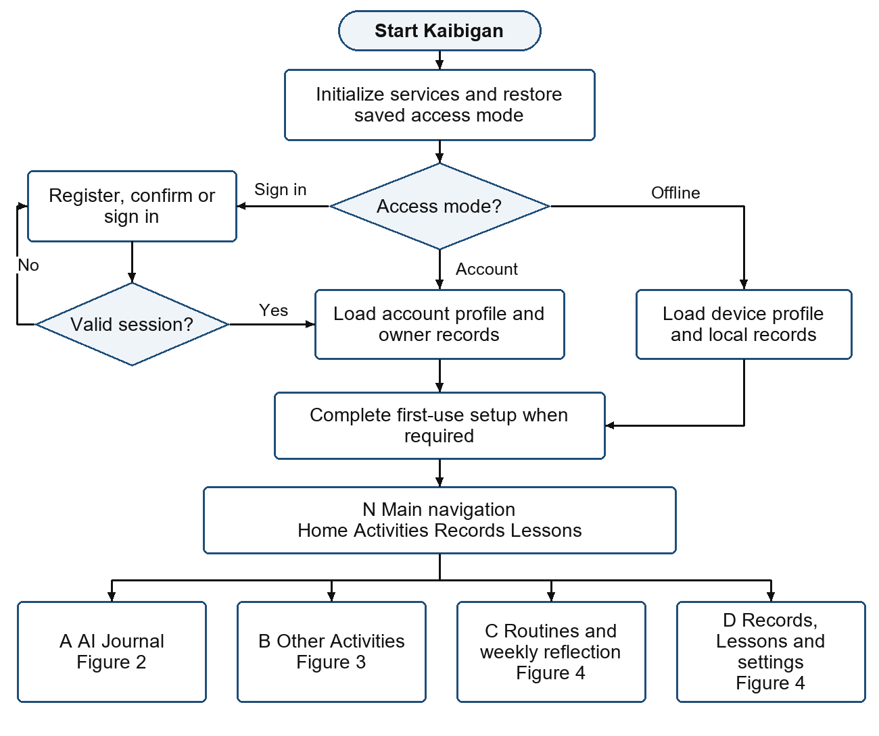
Figure 1 Startup and main navigation

AI Journal and Saving
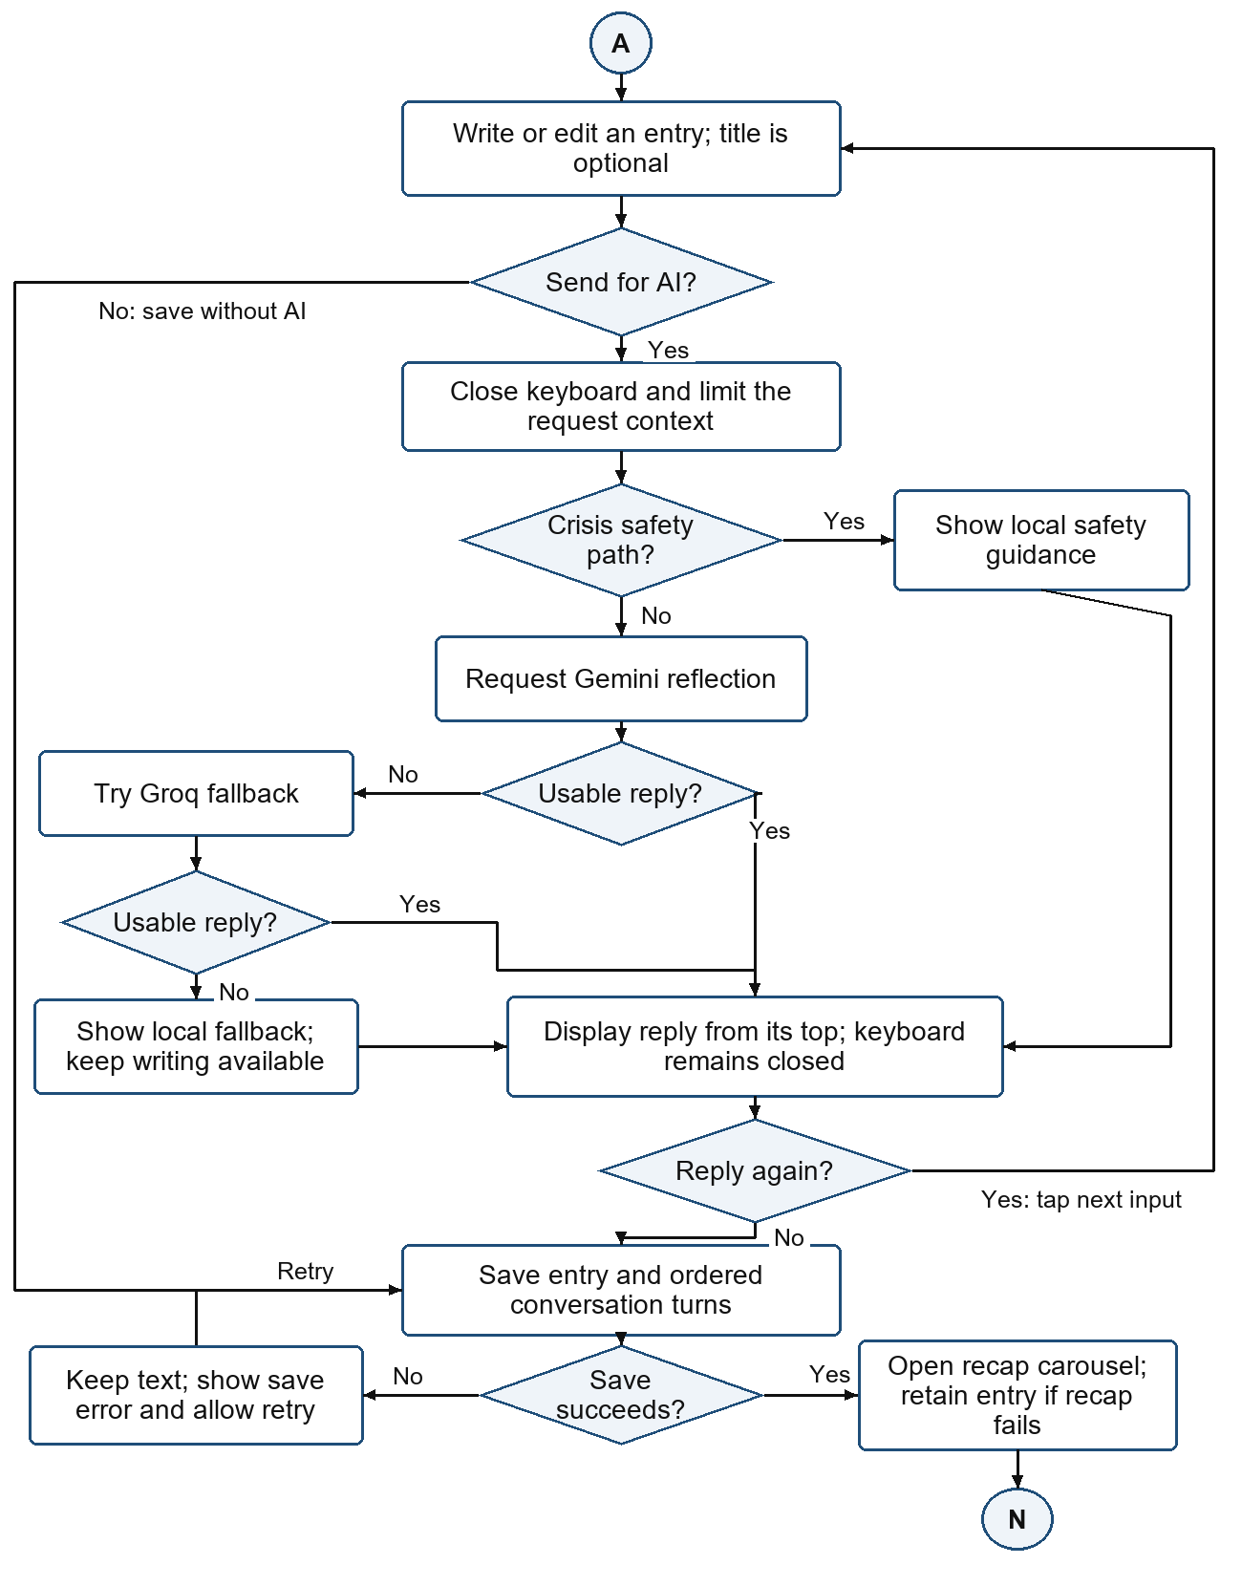
Figure 2 Optional AI conversation and journal persistence

Main Activities
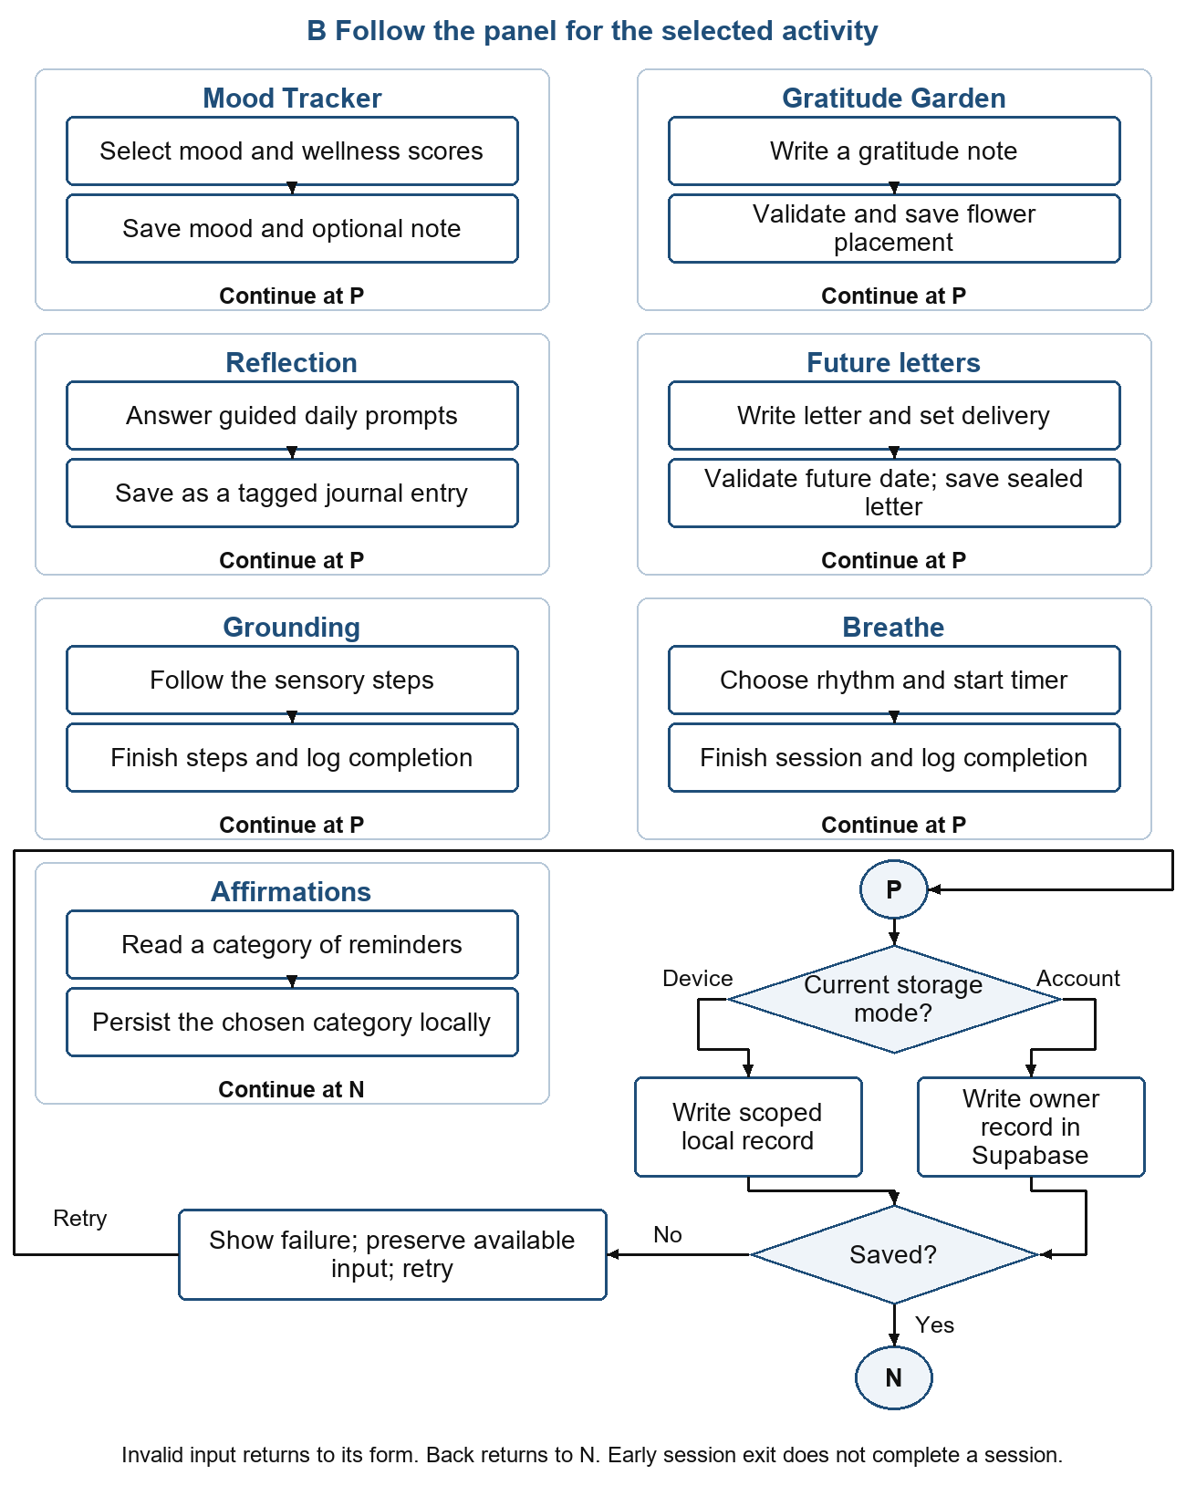
Figure 3 Activity flows and the shared storage path

Routines Records Lessons and Settings
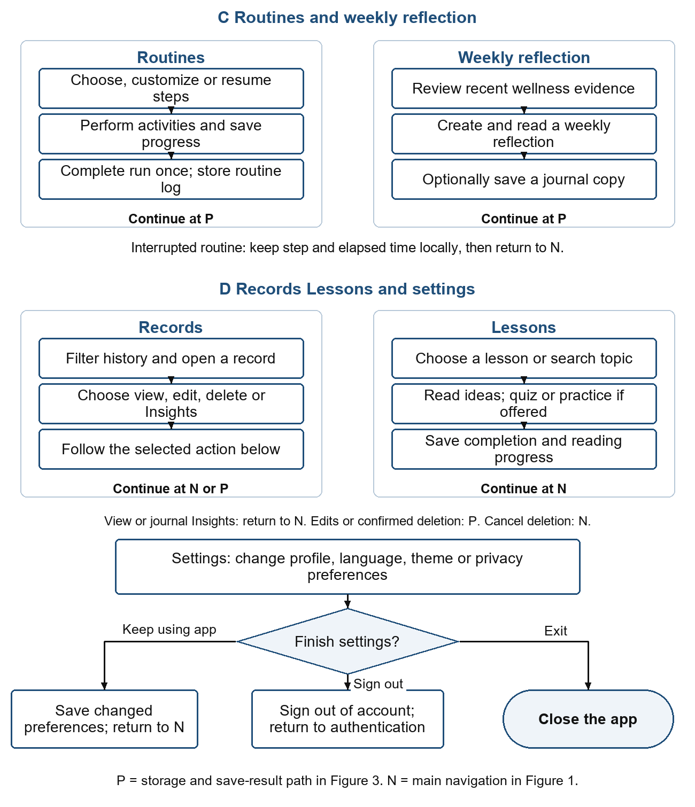
Figure 4 Routines weekly reflection Records Lessons and settings

Use Case Diagram
The primary actor is the individual user. Account users can access their own cloud records; offline users work with device records. The use cases describe the same main feature set without introducing administrator or therapist roles. AI providers and Supabase are supporting implementation services.
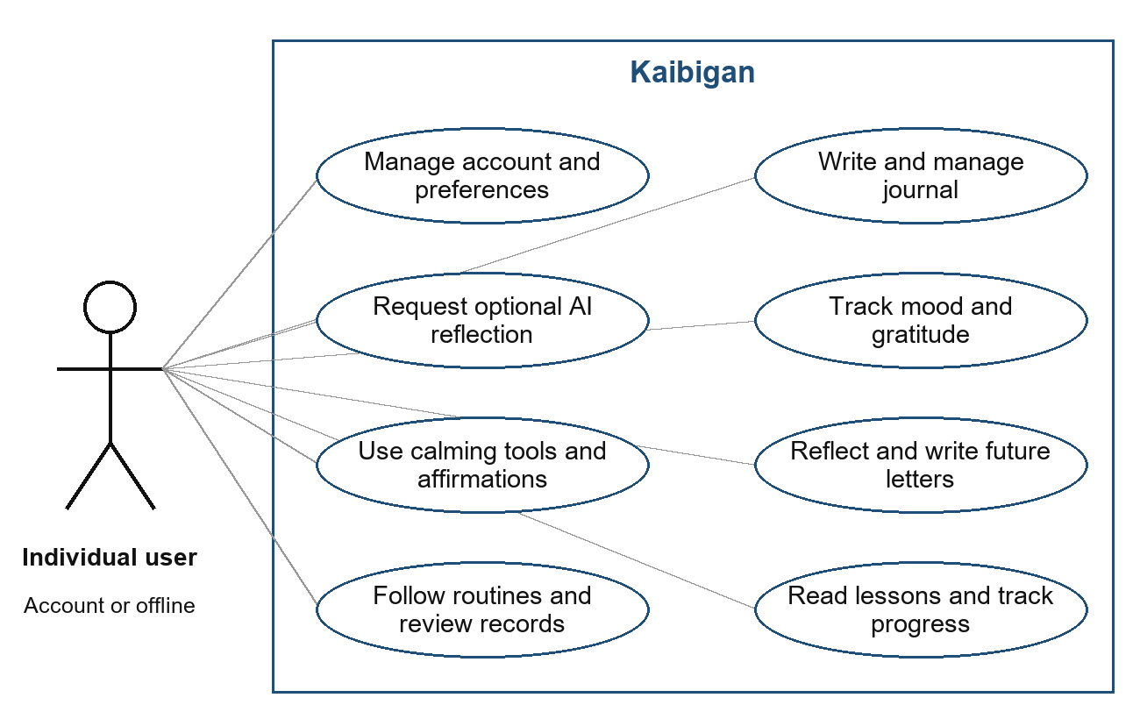
Figure 5 Main user use cases

Database Design
The database design follows the current SQL schema. The primary key of profiles is also a foreign key to auth.users.id. Each account-owned child record references profiles.id through user_id. Row Level Security policies restrict access to the authenticated owner. The cloud schema and its policies must be deployed and tested together.
Companion choices are defined in the application and selected through profile fields; the current schema has no separate mascot table. Offline collections are scoped device records, rather than extra Supabase entities. Routine definitions and an unfinished routine session are also kept locally.

ERD Overview
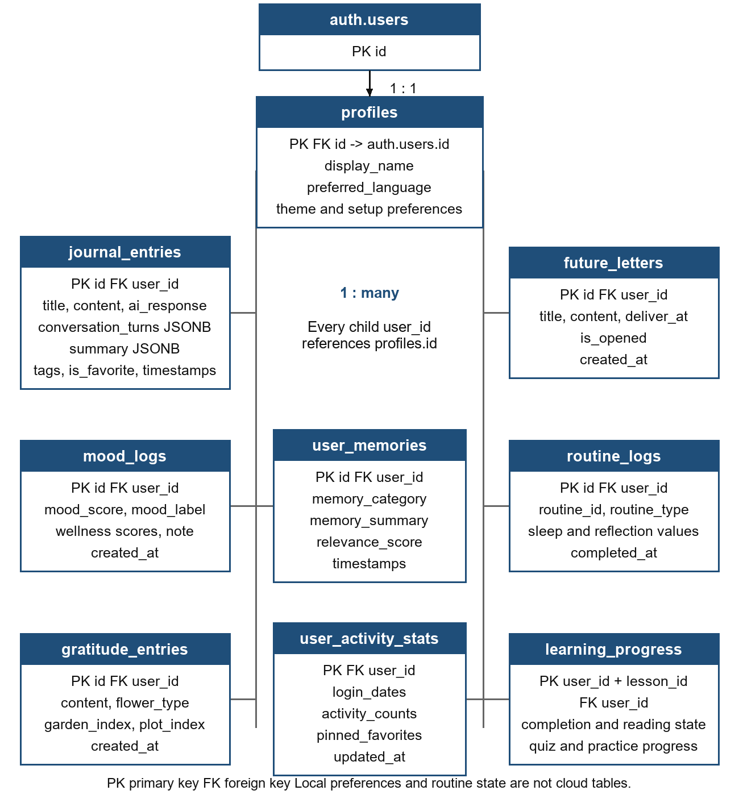
Figure 6 Current cloud entities and ownership relationships
The diagram shows the main record attributes and supporting tables. A profile has many journals, moods, gratitude notes, letters, routine logs, learning records and memory facts. user_activity_stats has at most one row per profile. The composite key of learning_progress is user_id and lesson_id.

Database Tables
The following dictionary summarizes the fields needed to understand the main features. Types and key relationships follow the current schema rather than the earlier logical draft.
Entity | Key and main fields | Purpose
profiles | id UUID PK/FK; display_name; preferred_language; preferred_mascot_id; theme and setup fields | Account identity and preferences.
journal_entries | id UUID PK; user_id FK; title; content; ai_response; conversation_turns JSONB; summary JSONB; tags; is_favorite | Journal writing, ordered conversation and saved Insights.
mood_logs | id UUID PK; user_id FK; mood_score; mood_label; stress, energy, sleep and anxiety scores; note | Mood and wellness observations.
gratitude_entries | id UUID PK; user_id FK; content; flower_type; garden_index; plot_index | Gratitude writing and stable garden placement.
future_letters | id UUID PK; user_id FK; title; content; deliver_at TIMESTAMPTZ; is_opened BOOLEAN | Sealed personal letters and their availability.
routine_logs | id UUID PK; user_id FK; routine_id; routine_type; reflection values; completed_at | Completed routines and supported individual activity logs.
learning_progress | user_id + lesson_id composite PK; completed; viewed_ideas; helpful_ideas; reading position; quiz and practice fields | Personal learning progress.
user_memories | id UUID PK; user_id FK; memory_category; memory_summary; relevance_score | Optional companion personalization facts.
user_activity_stats | user_id UUID PK/FK; login_dates; activity_counts; pinned_favorites | Activity usage and favorite shortcuts.
The profile key is the authenticated user identifier. The is_opened Boolean records whether a future letter has been opened. Journal summaries use JSONB, and learning progress includes supported quiz and practice fields.

User Interface Design
The interface uses a warm visual theme, scalable text and consistent navigation. The main navigation retains the position of each visited destination. Activities open in their own feature screens, and the bottom navigation can hide while scrolling down or while the keyboard is open.

Main Destinations
- Home presents greetings, daily activity information and shortcuts. Routines and weekly reflection are separate home sections. Focus, highlights and sleep-related records may remain available in their relevant home or routine flows, but they are not tiles in the eight-item Activities grid.
- Activities presents Gratitude Garden, Mood Tracker, AI Journal, Reflection, Future letters, Affirmations, Grounding and Breathe.
- Records combines supported personal record categories. Opening a journal shows the conversation. The Insights button opens the original recap carousel instead of placing a second stack of recap cards in the record scroll.
- Lessons provides educational topics, saved reading position, helpful ideas and selected practice activities. External resources require connectivity when they are requested.

Journal Interaction
The journal separates the user writing area from companion replies. Sending a message closes the keyboard and positions the view at the beginning of the reply. The next writing area does not receive automatic focus; the user taps it to continue. The journal no longer displays mascot artwork. Reply entrance animations and repeated conversation rebuilds during typing have been reduced.
Saving an entry is separate from requesting a reply. After a successful save, a recap can be generated and kept as Insights. If recap generation or persistence fails, the journal entry remains saved and the interface can offer a retry. Reopening unchanged content reuses its stored recap. Editing the content can invalidate an older recap so it is not presented as a summary of the new text.

Record Actions
Users can search journals, mark favorites, edit the selected entry and confirm deletion. Cancelling a destructive action retains the record. Mood notes, gratitude content and other record types expose the actions supported by their own screens; the interface does not assume that every tracker supports the same edits. Future letters remain sealed until their configured delivery time.

CHAPTER 3
SYSTEM DEVELOPMENT

Tools and Technologies Used

Software
- Flutter and Dart implement the mobile interface. Provider manages state; supporting packages provide charts, audio, notifications and PDF export.
- Supabase provides authentication, PostgreSQL storage and backend functions. SharedPreferences stores local records and progress; secure-storage services support sessions.
- Gemini is the primary AI provider and Groq is the fallback. The kaibigan-ai function is the authenticated server route. Direct calls support local demonstrations; production keys belong on the server.

Hardware
A Flutter-capable workstation supports development. Android devices or emulators are needed for installation, keyboard, audio, lifecycle and permission checks.

Development Process

Requirements Gathering
Requirements cover independent writing, optional AI, main activities, localization and private records. The scope and test scenarios were compared with the implementation on 18 October 2026.

Design
The design separates interface state, cloud records, local progress and AI requests. Flowcharts include recovery paths, and the ERD identifies account ownership.

Development
Feature providers manage records. AI processing limits context, applies local safety handling and attempts configured providers. Writing remains available if AI fails; local storage is distinguished from synchronization.

Testing
Flutter regression tests supplement the 70-case plan. Device and controlled-backend checks must confirm interruptions, access policies, provider failures and permissions before an end-to-end result is recorded.

CHAPTER 4
RESULTS AND TESTING

System Features

Account Access and Offline Use
Users can register, confirm an account, sign in and restore a session. Offline mode allows supported writing and records to remain on the device. Home, Activities, Records and Lessons provide the main navigation.

AI Journal and Insights
Users write and manage entries independently of AI. Optional replies are stored in conversation order. Saved Insights reopen in a carousel through a button in the journal record, and sending keeps the keyboard closed until the user taps the next input.

Mood Tracker and Gratitude Garden
Mood Tracker accepts a mood and optional wellness observations. Gratitude Garden saves a written note with a flower and garden position. Records and feature history provide access to saved information.

Reflection and Future Letters
Guided daily reflection saves a tagged journal entry. Future letters use a chosen delivery date and remain sealed until available. Weekly reflection is separate from the activity grid and can produce a journal copy.

Affirmations Grounding and Breathe
Affirmations offer reminders by category. Grounding guides sensory steps. Breathe provides guided rhythms, timing and supported audio. Session completion and early exit are handled separately.

Routines Records and Lessons
Routines combine available activities and restore unfinished progress. Records combines supported history categories. Lessons track reading, helpful ideas and selected practice or quiz progress.

Localization and Preferences
Language, theme, journal appearance and companion preferences personalize the interface. Cloud record access is associated with the account; device records remain scoped to their local identity.

Functional Testing
The condensed test plan contains 70 cases across 21 scenarios: 36 P0, 32 P1 and 2 P2 cases. Original case identifiers were retained during compression. All 70 statuses are Not Run, with no recorded actual results. The following selection summarizes main-feature checks; it does not reproduce the entire workbook or assign new pass results.
Test Case | Expected Result | Status
TC-AUTH-001  Register and confirm | One confirmed account reaches Home with the correct identity. | Not Run
TC-AUTH-005  Sign out | The session ends and private routes cannot expose account content. | Not Run
TC-JRN-001  Save without AI | One journal entry reopens with the same writing and no required AI reply. | Not Run
TC-JRN-003  Edit a journal | The same record is updated without a duplicate. | Not Run
TC-JRN-005  Delete a journal | Cancel retains both records; confirmation removes only the selected entry. | Not Run
TC-AI-001  AI conversation | One supportive reply is kept in the correct conversation order. | Not Run
TC-NET-002  AI failure recovery | Provider or network failure keeps journal writing and saving available. | Not Run
TC-OFF-002  Offline records | Supported local records survive relaunch within the correct scope. | Not Run
TC-MOOD-001  Mood validation | Valid boundary scores are accepted; out-of-range values are rejected. | Not Run
TC-GRAT-001  Gratitude Garden | A valid note and its flower placement reopen correctly. | Not Run
TC-HOME-002  Daily reflection | Guided reflection and relevant home or routine writing persist. | Not Run
TC-RTN-004  Resume routine | The same routine resumes after backgrounding or process termination. | Not Run

Functional Testing Continued
Test Case | Expected Result | Status
TC-RTN-005  Routine completion | Completion writes one validated log without duplication. | Not Run
TC-LTR-003  Future letter | The letter persists and becomes readable at the delivery boundary. | Not Run
TC-CALM-003  Breathe | Timing, audio and exit rules stay correct through rotation. | Not Run
TC-INT-002  Grounding | Answers survive an app switch and the session can be completed. | Not Run
TC-AFF-002  Affirmations | Category choice persists and the daily reminder remains stable. | Not Run
TC-LRN-002  Lessons | Reading progress and a helpful idea are saved. | Not Run
TC-HOME-004  Records | Supported history categories open and empty states remain truthful. | Not Run
TC-PERS-002  Language | The chosen language persists and supported Filipino copy is rendered. | Not Run

Evaluation
A recorded local regression run passed 159 automated checks covering selected journal, navigation, recap and layout behavior. This development result is separate from the 70-case workbook, whose formal execution fields remain unfilled. Live services, access policies and physical-device behavior still require recorded verification.

Strengths
- Independent journal writing and a reusable Insights carousel support continued reflection without duplicate recap displays.
- The activity grid and separate routine and weekly-reflection sections provide clear entry points.
- Local records, resumable routines and language preferences support specific continuity and personalization needs.

Weaknesses
- Formal workbook execution, physical-device frame timing, live backend isolation and user acceptance remain unverified in the supplied evidence.
- AI and cloud features depend on external services. Offline device records lack automatic cloud backup or migration, and notifications remain subject to device restrictions.

CHAPTER 5
CONCLUSION AND RECOMMENDATIONS

Conclusion
Kaibigan brings private journaling, optional AI reflection and accessible wellness activities into a localized mobile application. Its main interface connects Home, Activities, Records and Lessons. The Activities grid contains eight focused tools, while routines and weekly reflection remain separate. Journal records preserve the conversation and provide an Insights button for the saved recap carousel.
The current architecture combines Flutter, Supabase and scoped device storage. The revised system flows include account and offline access, optional AI, provider fallback, save failure, activity completion, routine recovery and navigation returns. The updated database model includes saved journal summaries and current learning progress, and removes entities that are absent from the schema.
The implementation and local regression evidence support continued development of the main workflows. The condensed 70-case plan still requires formal execution. Conclusions about user satisfaction, clinical benefit, production security or real-device performance cannot be drawn from the supplied material.

Recommendations
- Execute the condensed test plan against a named build and record actual results, status and evidence. Prioritize account access, private record ownership, journal preservation and AI failure recovery.
- Measure journal scrolling, keyboard transitions and animation frame timing on representative Android devices, including a narrow screen and enlarged text. Check audio and routine recovery during real interruptions.
- Verify the deployed schema, Row Level Security and authenticated backend functions in a controlled environment. Keep production AI provider secrets on the server rather than in client configuration.
- Review English and Filipino copy, accessibility labels, touch targets and lesson content with intended users. Evaluate usefulness and readability without claiming clinical outcomes.
- Develop explicit backup or account-import options for offline records before promising cross-device recovery. Test notification denial, revocation and rescheduling behavior and explain their limits.

