ADVANCE MOBILE APPLICATION DEVELOPMENT
FINAL PROJECT DOCUMENTATION

PROJECT TITLE
Kaibigan: An AI-Assisted Localized Mental Wellness Companion for Filipinos

Prepared by:
Tolentino, Errol Kelvin A.
ITE231

Subject:
Mobile Application Development
Submitted to:
Prof. Paul John D. Cabance
Date Submitted:
September 2026

TABLE OF CONTENTS
CHAPTER 1 – PROJECT OVERVIEW 3
Introduction
Project Objectives
Scope of the Project
Limitations
CHAPTER 2 – SYSTEM ANALYSIS AND DESIGN 5
System Description
System Flow
Use Case Diagram
Database Design
User Interface Design
CHAPTER 3 – SYSTEM DEVELOPMENT 12
Tools and Technologies Used
Development Process
CHAPTER 4 – RESULTS AND TESTING 13
System Features
Functional Testing
Evaluation
CHAPTER 5 – CONCLUSION AND RECOMMENDATIONS 16
Conclusion
Recommendations

CHAPTER 1
PROJECT OVERVIEW

Introduction
Kaibigan is a mobile mental wellness companion designed to give Filipino users a private and approachable space for journaling, emotional reflection, and everyday self-care. It brings personal writing and simple wellness activities into one application so users can express their thoughts, record their experiences, and reflect over time.
The application includes mood tracking, gratitude activities, guided breathing and grounding, affirmations, personal reflections, routines, future letters, and mental wellness learning resources. Filipino and English language support, customizable themes, and a friendly interface support a localized experience.
An optional AI-assisted reflection feature uses Google Gemini, with Groq as a fallback provider, to offer supportive responses and prompts based on journal entries. Users can write, save, and manage entries without requesting AI. Flutter provides the mobile interface, while Supabase handles authentication, storage, and access control. AI communication passes through backend services.

Project Objectives

General Objective
To design and develop Kaibigan, an AI-assisted and localized mental wellness companion that provides Filipino users with an accessible and private space for journaling, emotional reflection, and everyday self-care.

Specific Objectives
- To develop a private digital journaling feature that allows users to create, manage, and reflect on their personal journal entries.
- To integrate an optional AI-assisted reflection feature that provides supportive responses and prompts based on journal entries while maintaining appropriate limitations for mental wellness use.
- To provide accessible wellness activities such as mood tracking, gratitude journaling, breathing and grounding exercises, affirmations, focus activities, and personal reflections.
- To incorporate a localized and personalized experience through Filipino and English language support, customizable themes, routines, and a friendly interface suited to Filipino users.
- To implement secure management of accounts and personal wellness records through authentication, controlled database access, and appropriate handling of user data and AI requests.

Scope of the Project
Kaibigan focuses on individual reflection and everyday mental wellness. Its scope covers the following features and services:
- Accounts and profiles: register, sign in, and manage selected preferences.
- Journaling: create, view, edit, delete, organize, and save personal entries independently of AI.
- AI reflection: request optional supportive journal responses, with fallback and basic safeguards.
- Wellness tracking: record daily mood and wellness for later reflection.
- Self-care: gratitude, Today's Focus and Highlight, daily and weekly reflection, breathing, 5-4-3-2-1 grounding, affirmations, and future letters.
- Routines: use predefined or custom routines, resume unfinished progress, and log completion.
- Learning: access educational and psychoeducational mental wellness and self-care resources.
- Personalization: choose Filipino or English, light or dark themes, and visual or companion preferences.
- Data security: restrict personal records through Supabase authentication and access controls.
- AI safety: guide sensitive or crisis-related content toward appropriate human or emergency assistance.

Limitations
- Professional care: no diagnosis, psychotherapy, medication prescription, treatment planning, or replacement of licensed professionals.
- AI reliability: responses may be inaccurate, incomplete, or inappropriate and depend on external providers.
- Monitoring: no continuous mental or physical monitoring or independent determination of immediate danger.
- Emergency intervention: no contacting responders, professionals, family, or other people on the user’s behalf.
- Connectivity: authentication, cloud synchronization, AI, and online resources require internet access.
- User scope: no therapist dashboards, provider access, communities, caregiver accounts, or organizational administration.
- Integrations: no wearable, hospital, electronic medical record, or other clinical-system connections.
- Reminders: device permissions and operating-system scheduling prevent guaranteed delivery at an exact time.

CHAPTER 2
SYSTEM ANALYSIS AND DESIGN

System Description
Kaibigan is organized around the individual user and the privacy of personal wellness records. After authentication, the application loads the user’s profile and accessible records, restores local routine configuration and any resumable session, and opens Home. Home provides greetings, daily streak information, and action cards that lead to journaling, tracking, routines, and settings.
The Flutter client communicates with Supabase for authenticated records and access control. Device storage holds selected preferences and resumable activity state. Optional AI requests use an authenticated backend function, with Gemini attempted before the Groq fallback. The journal remains usable when an AI response is unavailable.

System Flow
Launch → Initialize services → Restore or establish a session → Load personal records and local progress → Open Home → Select an activity → Save or update applicable data → Return Home or sign out.
At startup, the application initializes its environment, Supabase client, notification service, and system overlay. If no authenticated session exists, the authentication page accepts sign-in, registration, or an available provider flow. A valid session permits owner-scoped records to load through Row Level Security (RLS). Signing out clears the authentication session and local user cache.

Journal Entries and Optional AI Reflection
The journal list reads the current user’s entries. A new entry accepts a title, body, and emotional reflection. Requesting AI is optional. When requested, the flow applies input bounds and local crisis checks before an authenticated backend request. Sensitive crisis content follows the guidance path; ordinary reflection proceeds through Gemini and, on failure, Groq. If both providers fail, the entry remains savable without an AI response.
Saving inserts the journal entry together with its conversation turns and any AI response. The persistence flow also supports extracting durable personalization memory. If the user does not save, the documented path permits a device draft or discard without a cloud write. Existing entries can be edited and saved, deleted after confirmation, marked as favorites, or viewed without a database write.
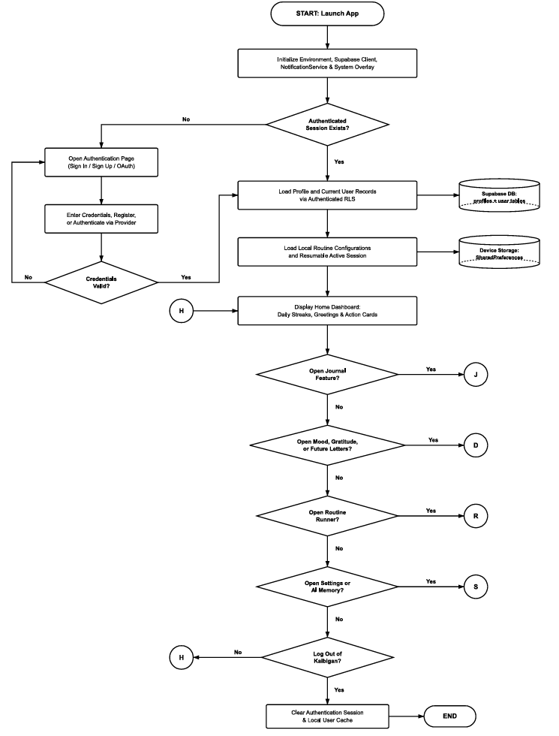
Figure 1 Kaibigan overall system flow

Data Trackers and Wellness Routines
For mood, gratitude, and future letters, the selected tracker reads owner-scoped records. A new record is inserted with the user identifier when saved. Applicable records are updated or deleted only through the corresponding confirmation flow. Viewing a record alone does not require a write.
The progressive routine runner loads steps and an active session from device storage. It executes the selected activities and timers. Completion writes a routine log and clears the active session; an unfinished run stores the resumable step and elapsed time locally.
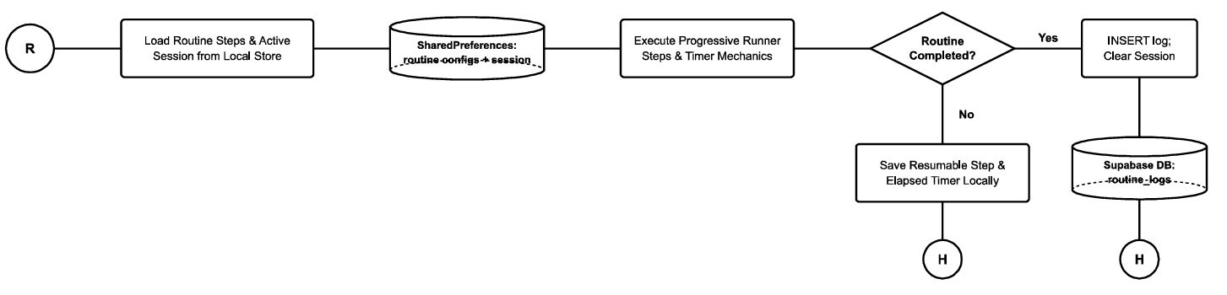
Figure 2 Routine execution and resumable progress

Settings and Personalization Memory
Saving profile or companion-tone changes updates the profile record. Local theme and language changes are written to SharedPreferences. A personalization memory fact is deleted only after confirmation. Leaving settings without a change produces no write.

Use Case Diagram
The primary actor is the individual Kaibigan user. The user manages an account, private entries, wellness activities, routines, learning, and preferences. Supabase and the AI providers support these actions as services. The project does not include an administrator, therapist, caregiver, or community role.
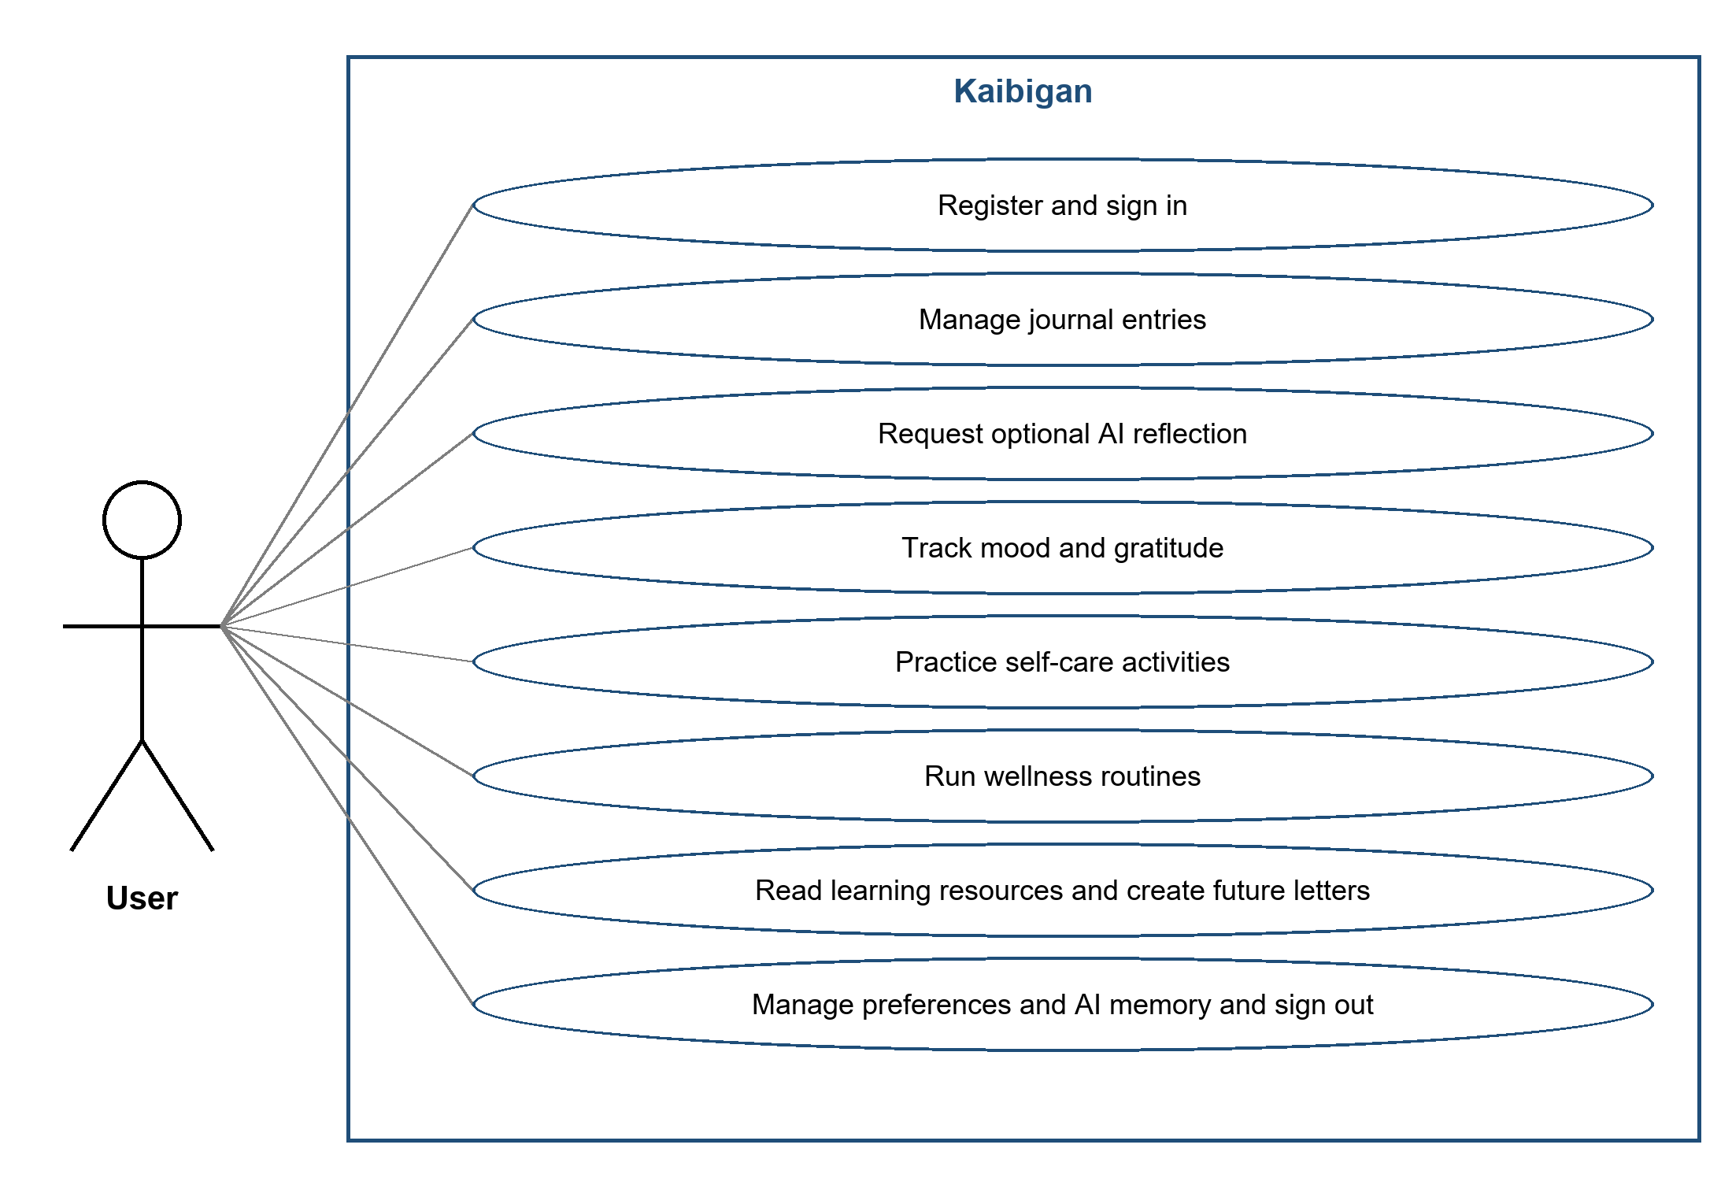
Figure 3 Kaibigan user use cases
AI reflection is an optional part of journal use. Core writing and record management do not depend on requesting it. Each private-record action is associated with the current user, and access control applies to database reads and writes.

Database Design
Supabase provides user authentication, persistent records, and access control. The entity relationship diagram links profile information to personal journals, mood logs, gratitude entries, future letters, routine logs, learning progress, activity statistics, and personalization memories. Companion or mascot information supports selected visual preferences.

ERD Overview
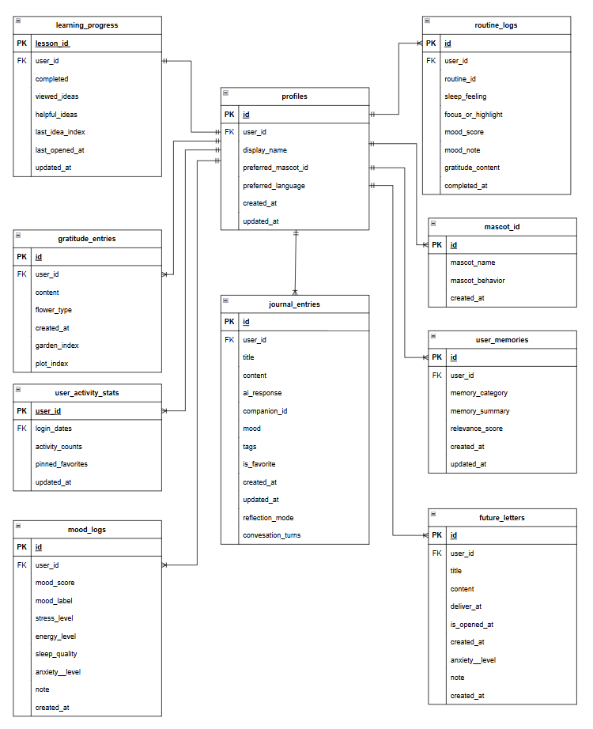
Figure 4 Kaibigan entity relationship diagram

Database Tables
The following data dictionary describes the logical roles of the fields. The ERD provides the entity and attribute names; logical types below express their meaning rather than prescribing physical SQL declarations.
Table: profiles
Field | Logical Type | Description
id | Identifier | Profile record key shown in the ERD.
user_id | Identifier | User ownership reference.
display_name | Text | Name displayed in the application.
preferred_mascot_id | Identifier | Selected companion or mascot reference.
preferred_language | Text | Selected application language.
created_at | Date and time | Profile creation time.
updated_at | Date and time | Most recent profile update.

Table: journal_entries
Field | Logical Type | Description
id | Identifier | Journal entry key.
user_id | Identifier | Owner of the entry.
title | Text | Journal title.
content | Text | Personal journal body.
ai_response | Text | Optional AI reflection associated with the entry.
companion_id | Identifier | Companion associated with the reflection.
mood | Recorded value | Mood information attached to the entry.
tags | Collection | Entry organization labels.
is_favorite | Boolean | Favorite state.
created_at | Date and time | Creation time.
updated_at | Date and time | Most recent edit.
reflection_mode | Text | Selected reflection mode.
conversation_turns | Structured data | Ordered journal and assistant conversation turns.

Table: Additional documented entities
Entity | Key Attributes | Purpose
mood_logs | id, user_id, mood_score, mood_label, stress_level, energy_level, sleep_quality, anxiety_level, note, created_at | Stores recorded mood and wellness observations.
gratitude_entries | id, user_id, content, flower_type, created_at, garden_index, plot_index | Stores gratitude text and garden placement.
future_letters | id, user_id, title, content, deliver_at, is_opened_at, created_at | Stores personal letters and their delivery/opening state.
routine_logs | id, user_id, routine_id, sleep_feeling, focus_or_highlight, mood_score, mood_note, gratitude_content, completed_at | Records completed routine activity and related reflection values.
learning_progress | lesson_id, user_id, completed, viewed_ideas, helpful_ideas, last_idea_index, last_opened_at, updated_at | Tracks lesson completion, reading position, and selected ideas.
user_activity_stats | user_id, login_dates, activity_counts, pinned_favorites, updated_at | Supports activity history, daily use, and favorites.
user_memories | id, user_id, memory_category, memory_summary, relevance_score, created_at, updated_at | Stores durable personalization facts used by the companion flow.
mascot_id | id, mascot_name, mascot_behavior, created_at | Describes the available companion or mascot choices.

RLS restricts access to the current user’s applicable records. The application supplies the user identifier when creating tracker records, and destructive operations require confirmation. Device-only preferences and resumable routine state are kept separately in SharedPreferences.

User Interface Design
Kaibigan uses a warm, friendly interface with Filipino and English support and clear access to personal reflection activities.
- Authentication and Home: sign-in, registration, greetings, streaks, action cards, and ongoing activities.
- Journal: entry list, editor, optional AI reflection, and saved-entry management.
- Trackers: mood, gratitude garden, and future letters with personal record views.
- Activities and learning: breathing, grounding, affirmations, reflections, routines, and educational content.
- Profile and settings: display name, language, theme, companion choices, and personalization memory.

CHAPTER 3
SYSTEM DEVELOPMENT

Tools and Technologies Used

Software
- Flutter: mobile interface and application feature flows.
- Supabase: authentication, storage, RLS, and protected backend AI requests.
- Google Gemini and Groq: primary and fallback reflection providers.
- SharedPreferences: local preferences, routine configuration, and resumable session state.

Hardware
Use a Flutter-capable workstation and compatible mobile device or emulator, with specifications recorded for the tested build.

Development Process

Requirements Gathering
Requirements cover private journaling, optional AI reflection, wellness activities, localization, and secure records. Scope remains individual self-care, subject to the clinical and service limitations in Chapter 1.

Design
The design separates the Flutter interface, authenticated records, local preferences and progress, and backend AI. Flowcharts define navigation and persistence; the ERD organizes records and companion information.

Development
Authenticated, owner-scoped records support the feature modules. Optional AI uses input bounds, sensitive-content checks, and provider fallback without blocking journaling. Local storage retains preferences and routine progress. Database changes require save or confirmation actions.

Testing
Verify feature flows, AI safeguards, ownership, recovery, preferences, and device reminders using controlled identities and synthetic content. Record execution evidence against the Chapter 4 matrix.

CHAPTER 4
RESULTS AND TESTING

System Features

Feature 1 User Accounts and Home
Description: Users register or sign in, load their profile and accessible records, and reach a Home view with greetings, daily streaks, and feature action cards. Signing out clears the authenticated session and local user cache.

Feature 2 Private Digital Journaling
Description: Users create, read, edit, delete, organize, and save personal entries. Existing records support favorite state. The journal can be used without AI, and the persistence flow distinguishes saving from retaining a local draft or discarding changes.

Feature 3 Optional AI Assisted Reflection
Description: Users can request a supportive response to journal text. The flow applies input bounds and local crisis checks, uses an authenticated backend service, attempts Gemini first, and falls back to Groq. If AI is unavailable, the entry remains savable. The feature does not provide diagnosis or professional treatment.

Feature 4 Mood Gratitude and Reflection
Description: Users record aspects of daily wellness, gratitude, focus, highlights, and daily or weekly reflection. Gratitude records can be represented as flowers with garden and plot placement.

Feature 5 Self Care and Wellness Routines
Description: Guided breathing, 5-4-3-2-1 grounding, affirmations, and predefined or custom routines offer simple self-care activities. The progressive runner saves unfinished progress locally and logs a completed routine.

Feature 6 Future Letters and Learning
Description: Future letters support personal messages intended for later delivery. Learning resources provide mental wellness and self-care material, with progress and helpful ideas represented in the data model.

Feature 7 Localization Privacy and Personalization
Description: Filipino and English support, light and dark themes, profile and companion preferences, and memory management personalize the experience. Supabase authentication and access policies are intended to protect private records.

Functional Testing
The following matrix defines acceptance checks for the documented features and limitations. Each status is recorded after executing the check and reviewing its evidence.
Test Case | Expected Result | Status
Register and sign in | A valid account reaches its own profile and Home; invalid credentials do not open personal records. | Not Run
Restore and end a session | An existing session restores correctly; sign-out clears the session and local user cache. | Not Run
Save a journal without AI | The entry saves and reopens with unchanged title and content without requiring an AI response. | Not Run
Edit and favorite a journal | Saving updates the intended entry; its favorite state persists without creating a duplicate. | Not Run
Confirm journal deletion | Cancel retains the record; confirmation removes only the selected entry. | Not Run
Request an AI reflection | The optional request passes through the authenticated backend and produces a supportive user-facing response. | Not Run
Exercise AI provider fallback | Failure of Gemini invokes the Groq fallback; total AI failure leaves the entry savable. | Not Run
Handle sensitive AI content | The documented safety path supplies appropriate guidance without claiming diagnosis or direct intervention. | Not Run
Enforce private record ownership | One user cannot read or change another user’s protected personal records. | Not Run
Save tracker records | Mood, gratitude, and future-letter records reopen under the correct user; confirmed changes affect the intended record. | Not Run
Resume and finish a routine | An unfinished run restores its saved step/time; completion records a routine log and clears the active session. | Not Run
Persist personalization | Language and theme choices remain after reopening; saved profile changes affect the intended profile. | Not Run
Manage personalization memory | A confirmed deletion removes the selected memory fact; cancellation leaves it unchanged. | Not Run
Use learning and self-care | Documented activities and educational resources open correctly; learning progress matches the user’s actions. | Not Run
Check reminder permissions | Permission and scheduling limits are reported honestly; the interface does not guarantee an exact delivery time. | Not Run

Evaluation
The evaluation below concerns the design’s alignment with the project objectives. Execution status, measured performance, and user acceptance should be assessed through recorded testing before they are reported as achieved results.

Strengths
- Journaling remains available as a core activity without requiring an AI interaction.
- Filipino and English support and configurable appearance address localization and individual preferences.
- Several everyday self-care activities and routines are available within one personal reflection workflow.
- Authenticated storage, owner-scoped access control, and backend AI communication provide a defined privacy architecture.
- Provider fallback and resumable routine state address specific service and interruption scenarios in the design.

Weaknesses
- Authentication, cloud synchronization, AI processing, and online resources depend on connectivity and external service availability.
- AI responses can still be incomplete, inaccurate, or inappropriate despite safeguards.
- The application cannot monitor users continuously or perform emergency intervention.
- Reminder timing depends on device permission and operating-system scheduling.
- Individual-use scope excludes professional care workflows, social communities, and clinical system integrations.

CHAPTER 5
CONCLUSION AND RECOMMENDATIONS

Conclusion
Kaibigan combines private journaling, emotional reflection, and accessible self-care activities in a localized mobile experience for Filipino users. Its design supports mood and gratitude tracking, breathing and grounding, affirmations, routines, learning, and future letters alongside optional AI-assisted reflection.
The architecture uses Flutter for the mobile interface, Supabase for authentication and personal records, device storage for selected preferences and progress, and backend services for Gemini and Groq communication. The separation between journal management and AI processing allows users to continue reflecting without depending on an AI response.
The project’s value lies in supporting everyday reflection within its stated limits. It does not provide diagnosis, treatment, continuous monitoring, or direct emergency intervention. Acceptance of the final implementation depends on verified functional, privacy, reliability, and usability results.

Recommendations
- Complete and document functional, access-control, recovery, and device testing, with evidence for each acceptance result.
- Review Filipino and English content for clarity, consistency, accessibility, and suitability for everyday self-care.
- Continue reviewing AI output safeguards, failure handling, and provider behavior while preserving the ability to journal without AI.
- Strengthen connectivity-recovery feedback and clarify which records or activities depend on online services.
- Regularly review personal-data access policies, backend AI request handling, and user controls over personalization memory.
- Test reminder permission changes and operating-system scheduling behavior across intended devices; communicate delivery limitations clearly.
- Collect user feedback on navigation, routine continuity, readability, and the usefulness of reflection activities before expanding beyond individual self-care.

