
PROJECT DOCUMENTATION
KAIBIGAN
An AI-Assisted Localized Mental Wellness Companion for Filipinos
A private, culturally responsive space for reflection, everyday self-care, and gentle support - built with Flutter, Supabase, and an optional AI reflection companion.
Technology: Flutter • Provider • Supabase/PostgreSQL • Supabase Edge Functions
AI Providers: Google Gemini (primary) • Groq (fallback)
Version: 1.0.0+1 • Repository snapshot: 31 August 2026
Prepared from the current Kaibigan codebase

1. Project Title and Description
Project Title
Kaibigan: An AI-Assisted Localized Mental Wellness Companion for Filipinos
Project Description
Kaibigan is a cross-platform mental wellness application designed as a cozy, private journaling and self-care companion for Filipino users. It responds to a common gap in digital wellness tools: many products feel clinical, culturally distant, or focused on streaks and performance rather than reflection. Kaibigan instead combines English and Filipino language support, a warm visual system, and low-pressure activities that help users notice emotions, record meaningful moments, and build sustainable routines.
The application is built in Flutter with Provider-based state management. Supabase supplies authentication, PostgreSQL persistence, Row Level Security, and an authenticated Edge Function for production AI requests. Core experiences include an AI-assisted journal, mood and sleep tracking, a gratitude garden, future letters, daily and weekly reflections, guided breathing and grounding, affirmations, customizable routines, mental-health learning content, unified entries, profile preferences, and PDF export.
The AI companion is optional and does not control whether a journal entry can be written or saved. Before an AI request is sent, the application applies input limits and crisis-oriented guardrails. In production, the authenticated Edge Function attempts Google Gemini first and uses Groq as a fallback, returns a structured reflection response, and avoids logging journal content or model output. Long-term AI memories can be viewed and removed by the user.
Positioning: Kaibigan is a reflection and self-care companion, not a therapist, diagnostic system, emergency service, or substitute for professional mental-health care.

2. Project Objectives Defined
General Objective
To design, develop, and evaluate Kaibigan as a secure, culturally responsive, and engaging mobile wellness companion that helps Filipino users practice emotional reflection, daily self-care, and healthy routine-building through localized content, private cloud-synced records, and optional AI-assisted guidance.
Specific Objectives
- To provide a private journal with full create, read, update, delete, favorite, tag, and PDF-export capabilities, while keeping writing and saving independent from AI generation.
- To integrate an optional AI reflection companion that offers structured, empathetic responses, supports user-controlled memory, detects crisis-related language, and routes urgent cases toward immediate human help.
- To implement mood, stress, energy, anxiety, sleep, gratitude, focus, highlight, and reflection activities that help users notice patterns without presenting clinical diagnoses.
- To support morning, midday, night, and custom routines with progressive steps, reminders, completion logs, and resumable sessions.
- To offer bilingual English/Filipino presentation, light and dark themes, adjustable journal and garden appearance, accessible mobile layouts, and a warm Filipino-inspired interface.
- To secure per-user records through Supabase authentication, PostgreSQL foreign keys, and Row Level Security policies, while providing sensible local storage for selected preferences and progress.
- To provide trusted mental-health learning content, grounding and breathing exercises, affirmations, future letters, weekly reflection, and adaptive recommendations in one coherent home experience.

3. Scope and Limitations Identified
System Scope (In-Scope)
- Target Audience: Filipino adolescents and adults seeking a gentle personal tool for journaling, mood awareness, self-care routines, and psychoeducational support.
- Platforms: Flutter targets Android, iOS, web, and compatible desktop development environments, with responsive layouts and touch, mouse, trackpad, and stylus input.
- Authentication and Profile: Email/password registration and sign-in, password recovery, optional Google OAuth, profile settings, mascot preference, theme mode, and English/Filipino language selection.
- Home and Adaptive Support: A single home surface loads recent records, presents routine progress and activity cards, and recommends check-in, grounding, breathing, reflection, gratitude, or focus activities from current user context.
- AI Journal and Reflection: Journal CRUD, drafts, conversation-style AI responses, reflection modes, mood and tags, favorites, save summaries, user feedback, user-controlled AI memories, and PDF export.
- Tracking and Memory Activities: Mood logs, sleep logs, gratitude entries visualized as flowers across 15-plot gardens, daily goals, today’s focus, today’s highlight, daily reflection, weekly reflection, and a unified entries timeline.
- Self-Care and Learning: 5-4-3-2-1 grounding, paced breathing and mindfulness sessions, affirmations, future letters, a comfort corner, localized learning paths, and trusted MedlinePlus article discovery.
- Routines and Reminders: Default morning, midday, and night routines; custom routine configuration; progressive activity execution; resumable sessions; completion logs; and local notification support.
- Cloud Data and Security: Supabase Auth, PostgreSQL tables, per-user Row Level Security, authenticated Edge Function access, bounded AI input, provider fallback, and non-logging of journal/model content.
System Limitations (Out-of-Scope)
- Clinical Care: Kaibigan does not diagnose conditions, provide psychotherapy, create treatment plans, monitor medication, or replace a licensed professional or emergency service.
- Emergency Response: Crisis language can trigger supportive messaging and Philippine emergency resources, but the system cannot contact responders, verify a user’s safety, or continuously monitor risk.
- Internet Dependency: Authentication, cloud synchronization, AI responses, password recovery, OAuth, and online article discovery require network access. Selected preferences and learning progress may remain local, but the application is not a complete offline-first system.
- AI Uncertainty: Gemini and Groq outputs may be incomplete or inaccurate. Availability, latency, and response quality depend on third-party services and configured API quotas.
- Privacy Boundary: Row Level Security protects server-side records, but client builds still require responsible configuration. Direct demo AI keys embedded through compile-time defines are recoverable and must not be used for production publishing.
- User Model: The current release focuses on one private end user per account. Clinician dashboards, caregiver access, peer communities, classroom management, and organization-level administration are excluded.
- Devices and Integrations: The current scope does not include wearable sensor ingestion, clinical-record integration, telehealth sessions, location tracking, camera/OCR analysis, or automated health scoring.
- Notification Constraints: Reminder behavior depends on platform permissions and operating-system scheduling; delivery at an exact time is not guaranteed on every device.

4. Updated System Flowchart
The linked flowcharts separate authentication and navigation from journal CRUD, AI assistance, cloud persistence, and device-only persistence. Every decision has exactly two exits: Yes and No.
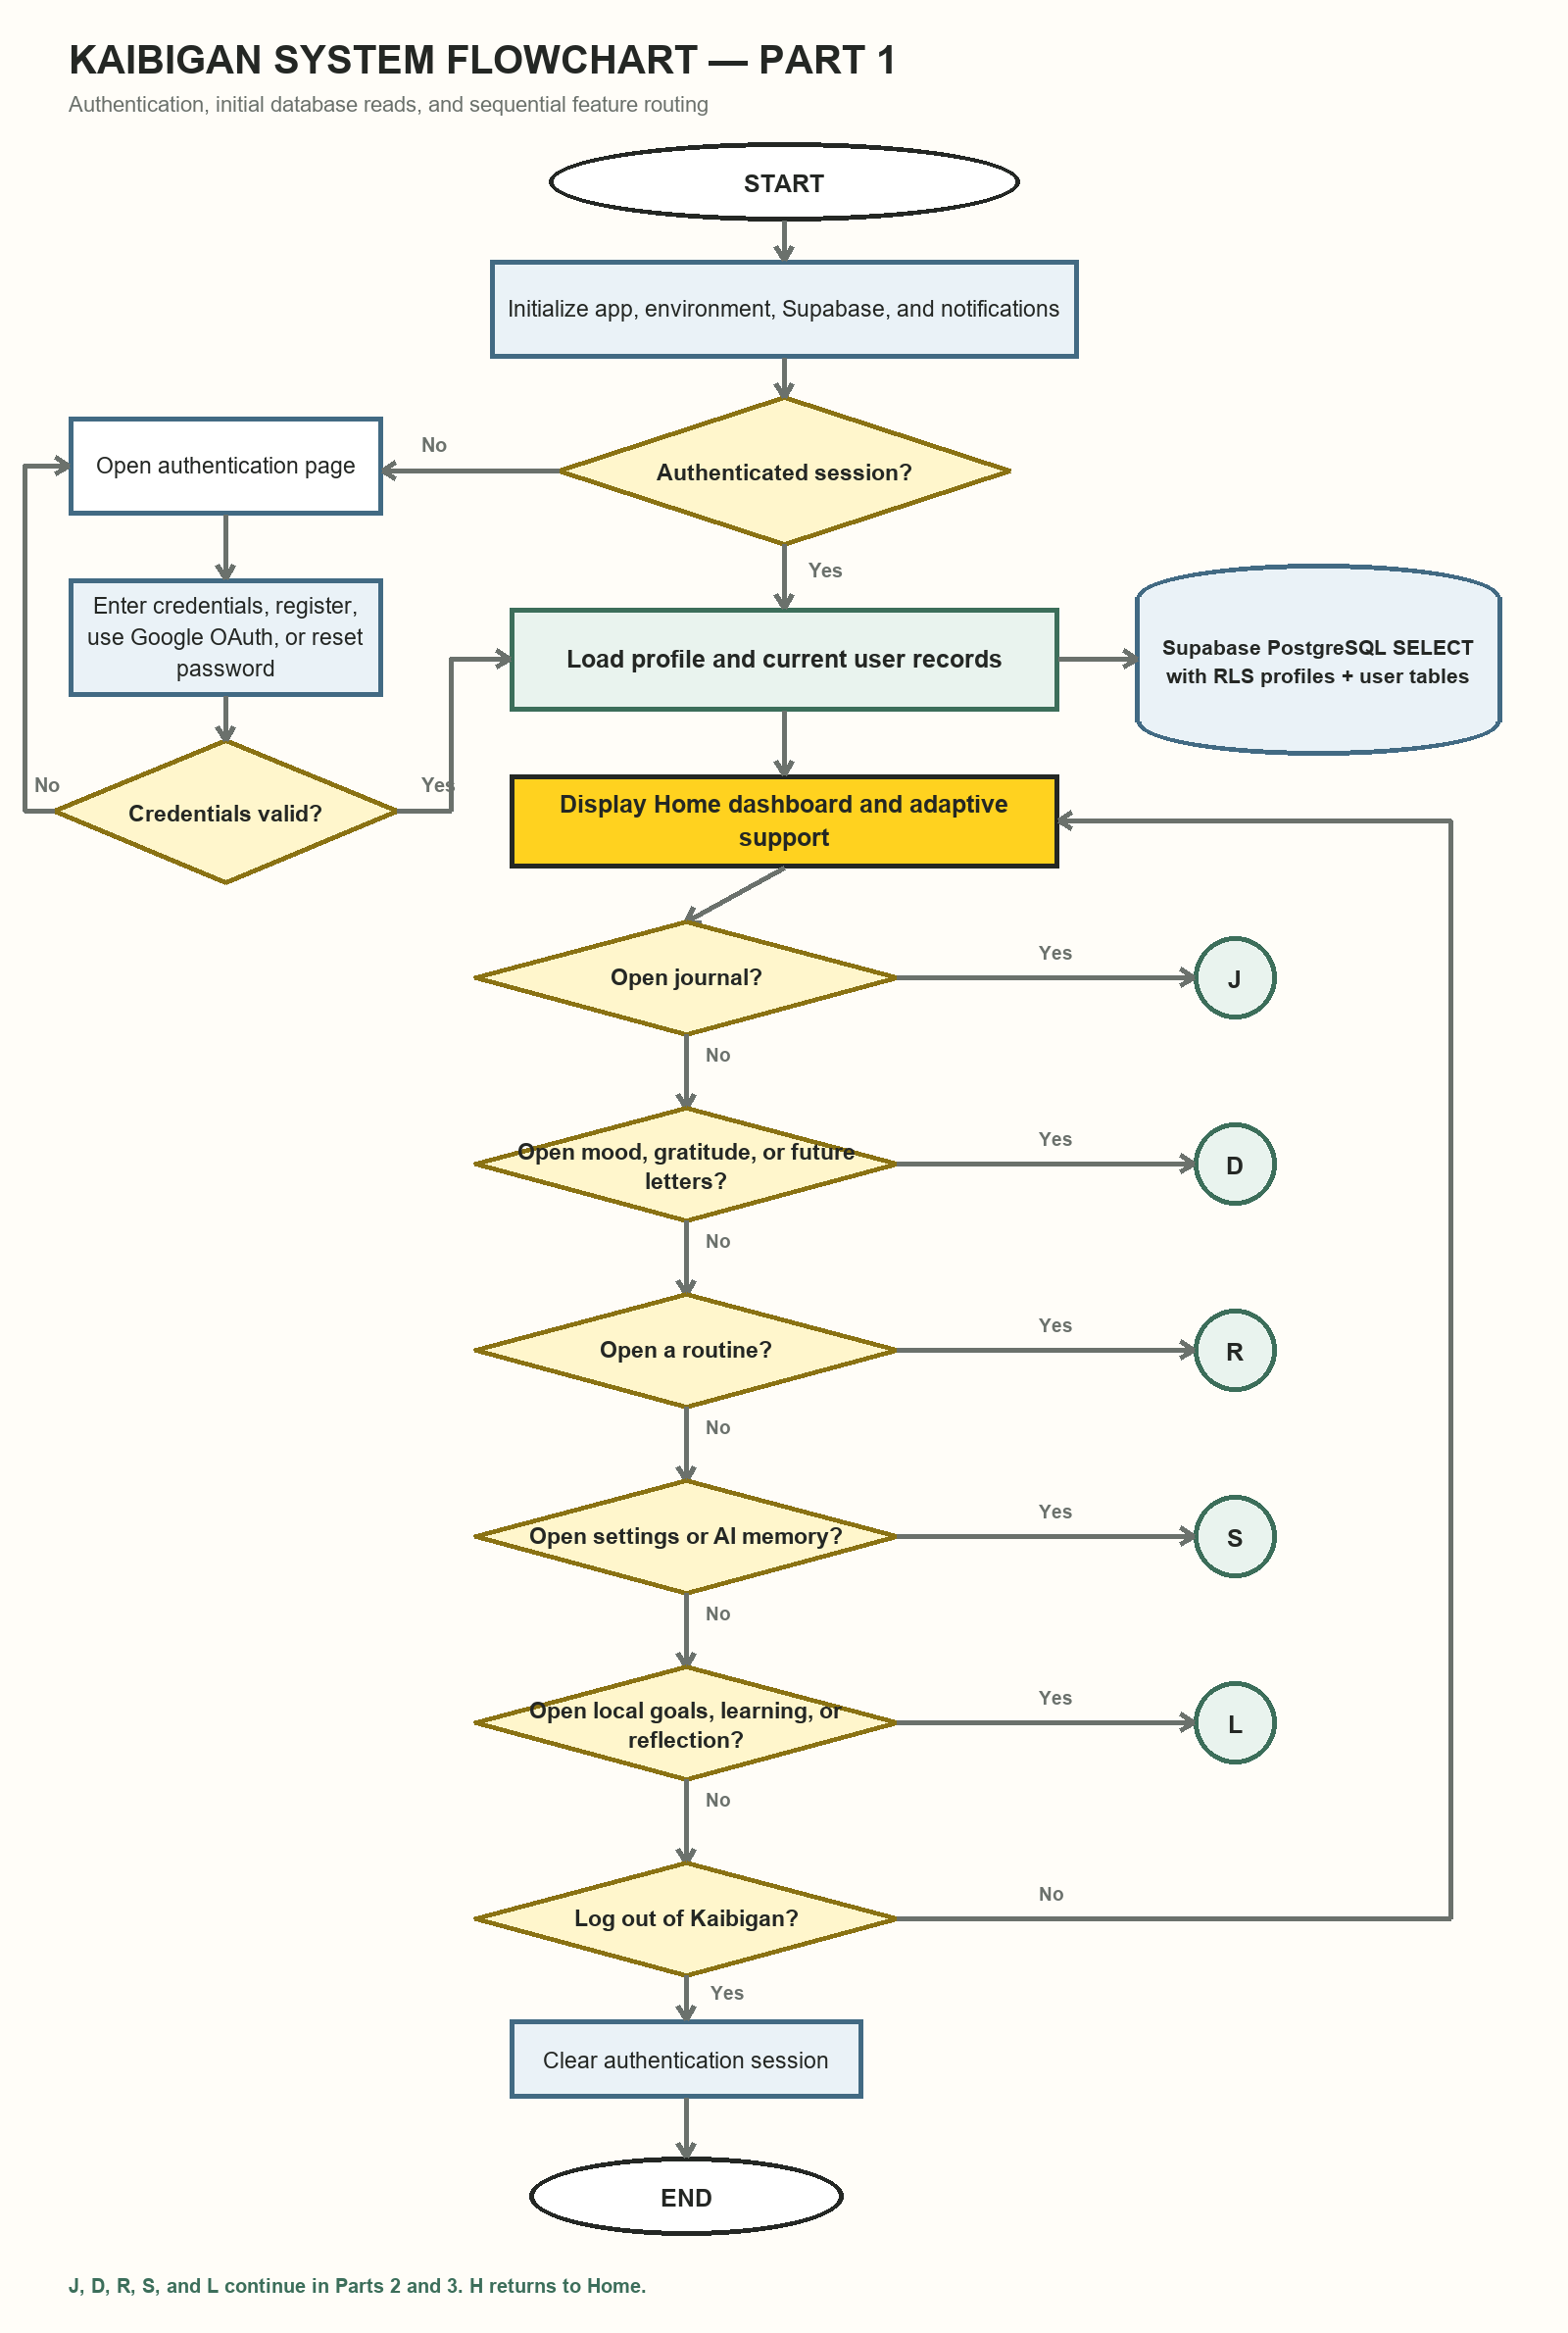
Figure 1. Part 1 — authentication, initial database reads, and feature routing.

4.2 Journal CRUD and AI Assistance
This continuation shows every journal create, read, update, delete, and favorite operation; the optional authenticated AI path; Gemini-to-Groq fallback; and the exact journal and memory writes.
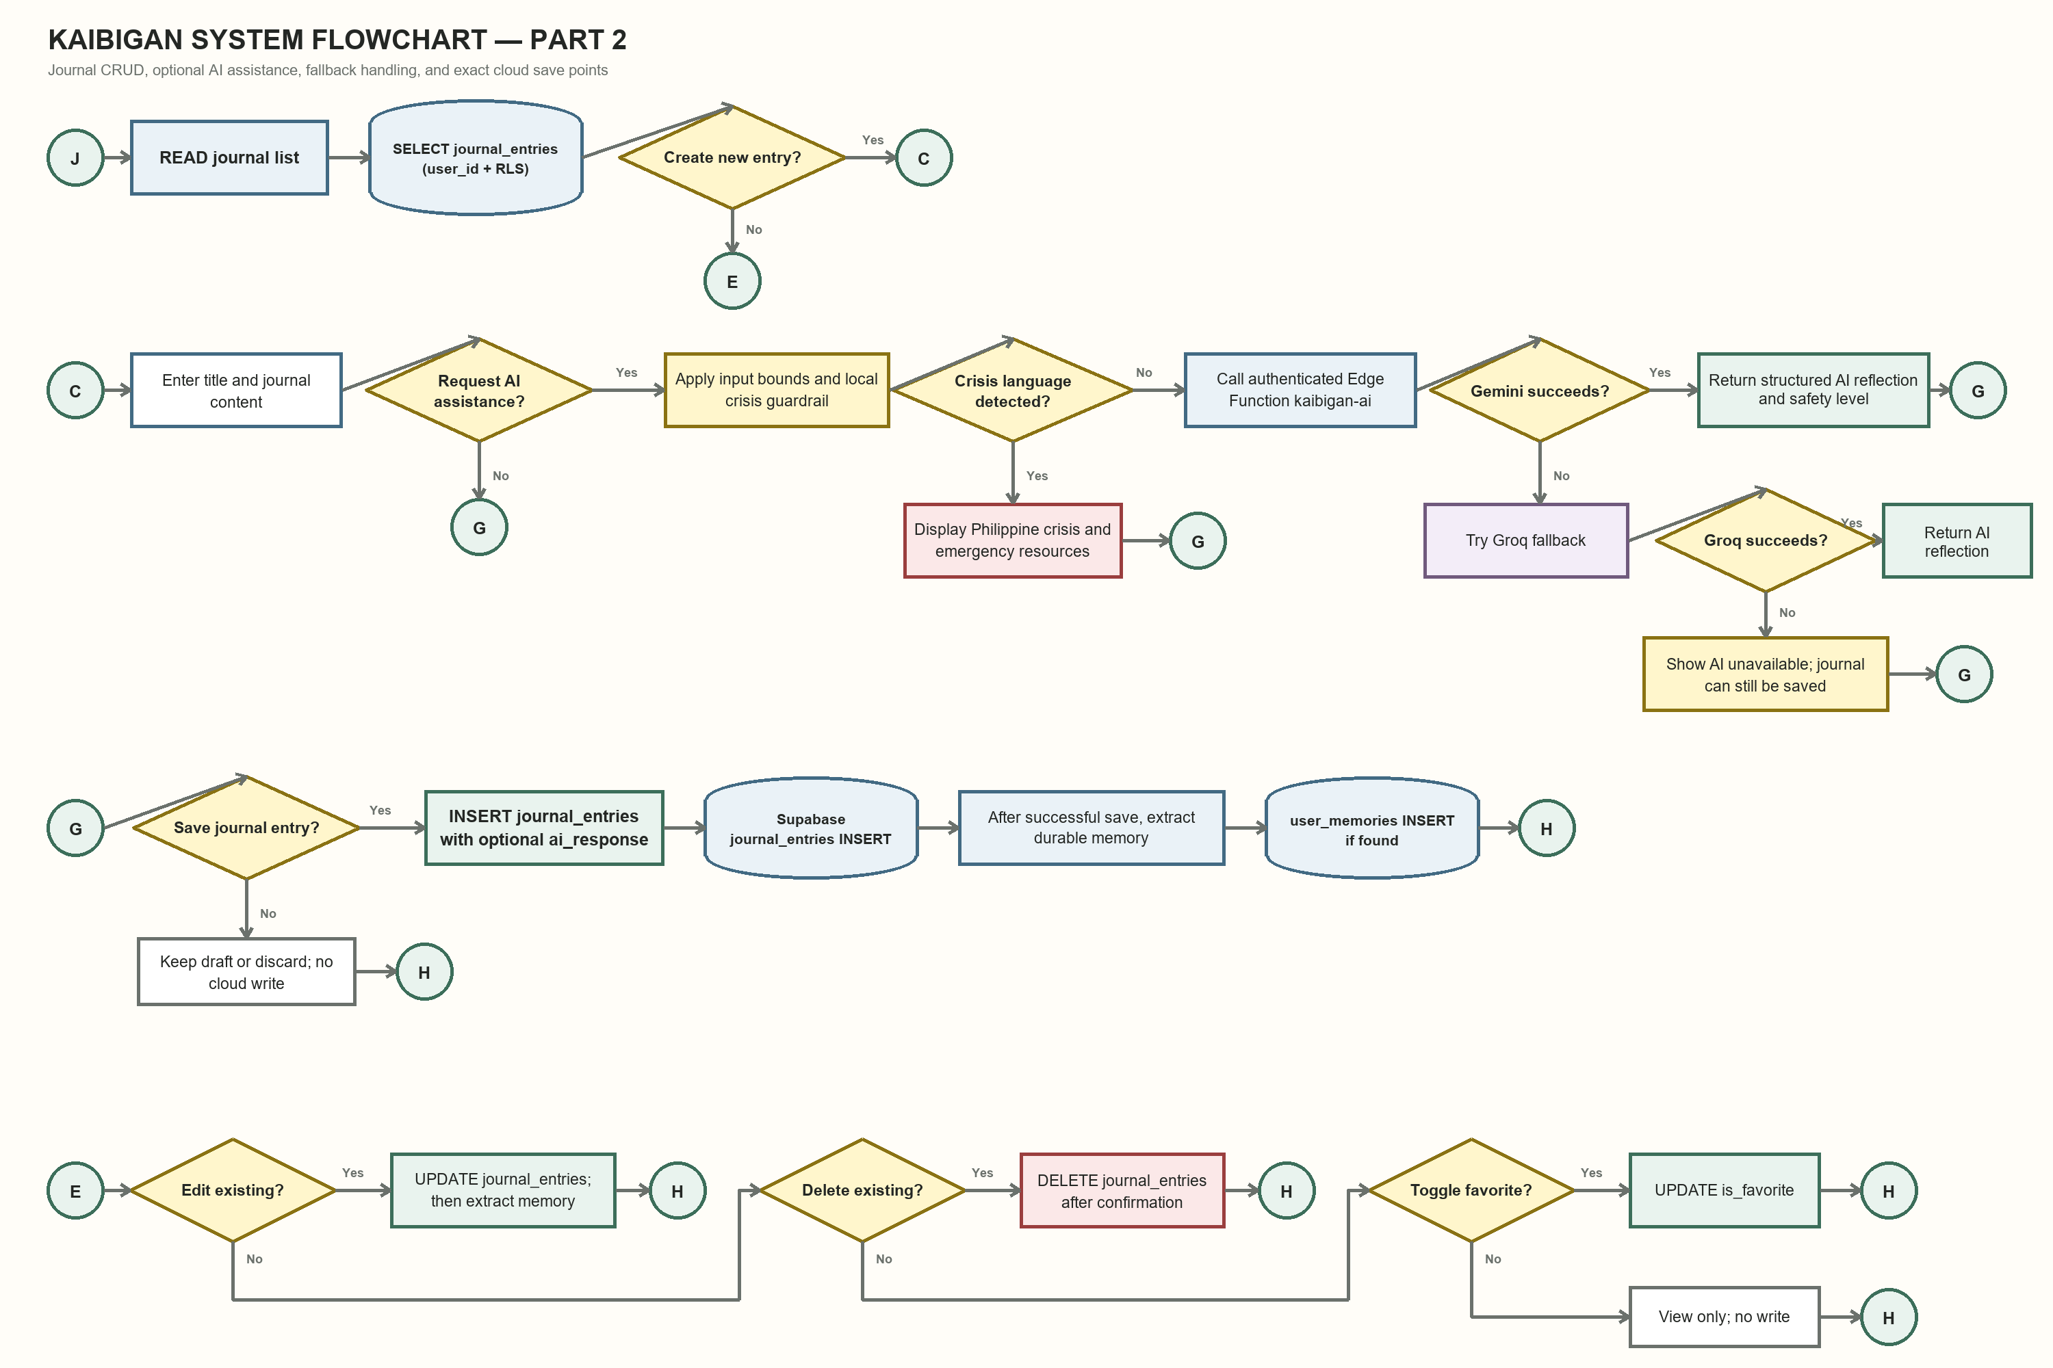
Figure 2. Part 2 — journal CRUD, AI assistance, fallback behavior, and cloud save points.

4.3 Other CRUD and Persistence
This continuation identifies CRUD for mood, gratitude, future letters, routine logs, profiles, and AI memories, while distinguishing Supabase writes from SharedPreferences device writes.
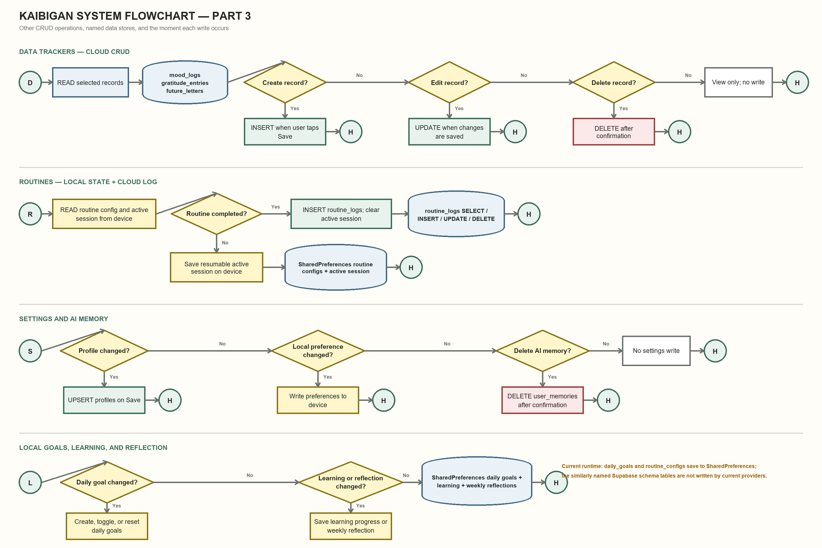
Figure 3. Part 3 — other CRUD operations and cloud versus device persistence.

5. Entity Relationship Diagram
Crow's-foot connectors show the logical one-to-zero/one identity link and the database-enforced one-to-many ownership relationships. Solid lines represent declared foreign keys; dashed lines represent logical links that are not enforced by the current SQL. No many-to-many junction table exists in the present schema.
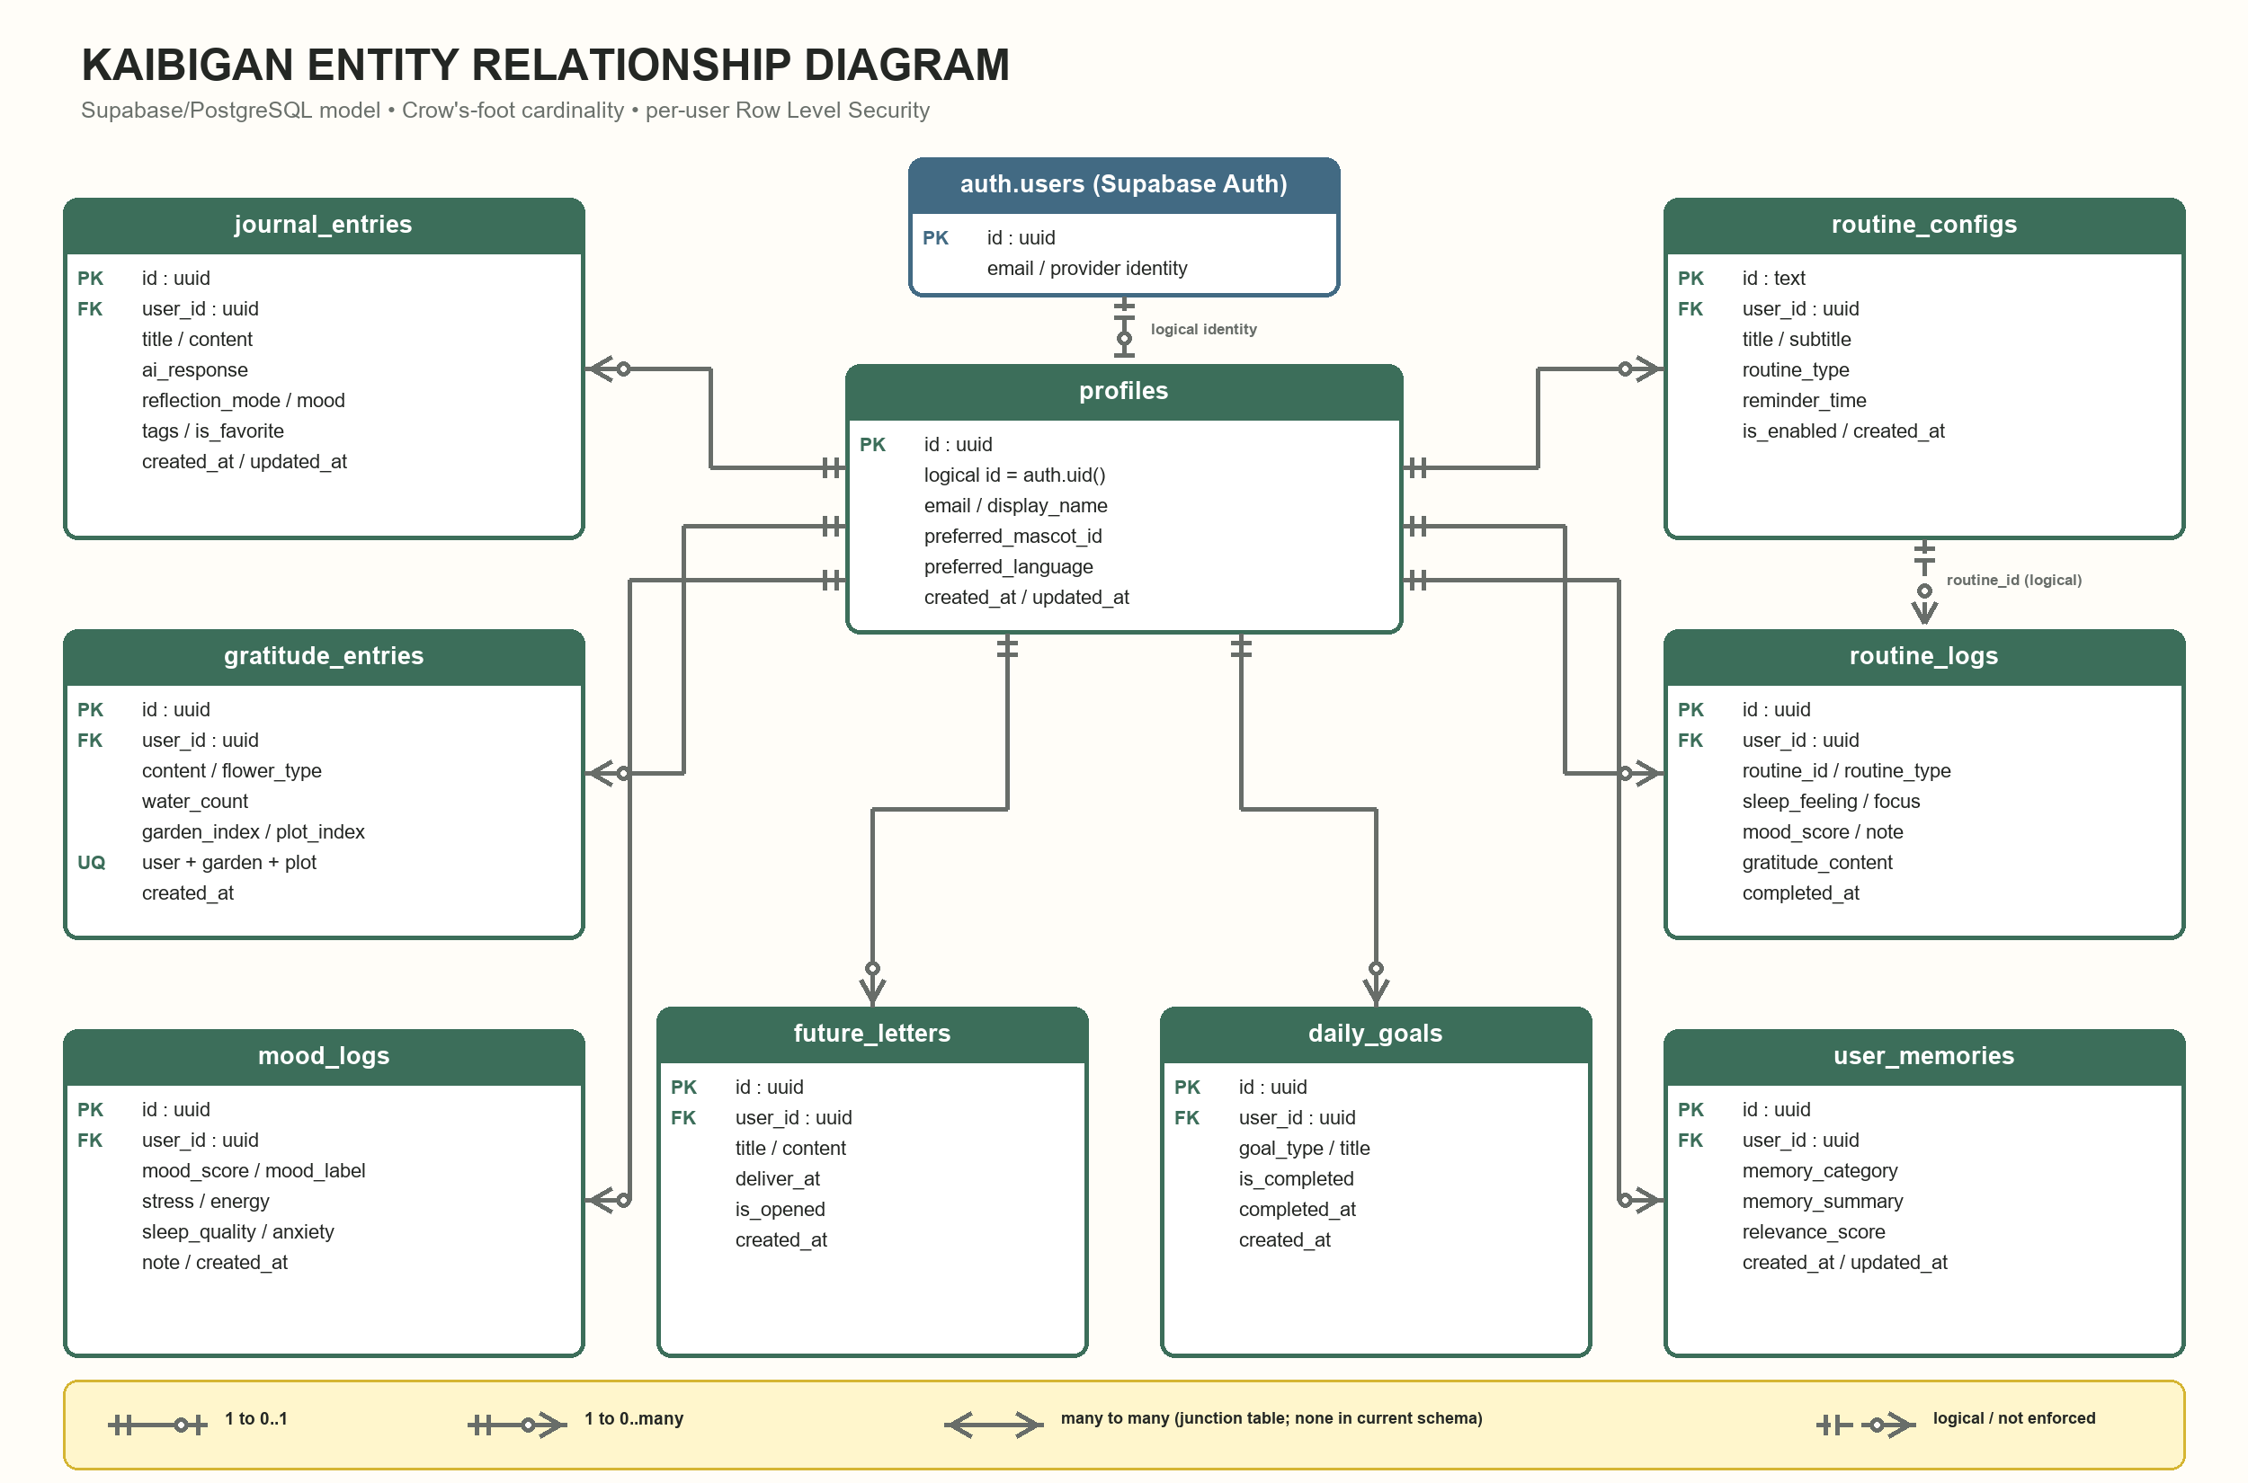
Figure 4. Kaibigan ERD using Crow's-foot cardinality. Many-to-many notation appears in the legend only because the current schema has no junction table.

