Ashplats Conservation

Group

Ashplats Conservation Group was formed in 1997 to restore this ancient wood to a good condition. The group works with Mid Sussex District Council (MSDC) and site owners East Grinstead Memorial Estate Ltd (EGMEL).

Ashplats Wood

At the end of WWII, Alfred Wagg dedicated the East Court Estate, which includes the woods, to the people of East Grinstead in memory of those who lost their lives in the War.

Ashplats wood is part ancient woodland containing a mixture of Sweet Chestnut, Oak, Ash, and Hazel

The site is designated as a Site of Nature Conservation Importance (SNCI), and is within the High Weald Area of Outstanding Natural Beauty (AONB).

The high part of the wood is underlain by Tunbridge Wells sands and the lower slopes and adjoining fields are on Wadhurst clay.

Water permeates through the sandstone, and seeps out where it meets the clay. These wet areas are often indicated by Pendulous Sedge, a large grass-like plant

Ghyll springs and steams are a feature of the Sussex High Weald, they support rare and unique flora and fauna.

The woodland slopes support woodland species, including the ubiquitous bluebells.
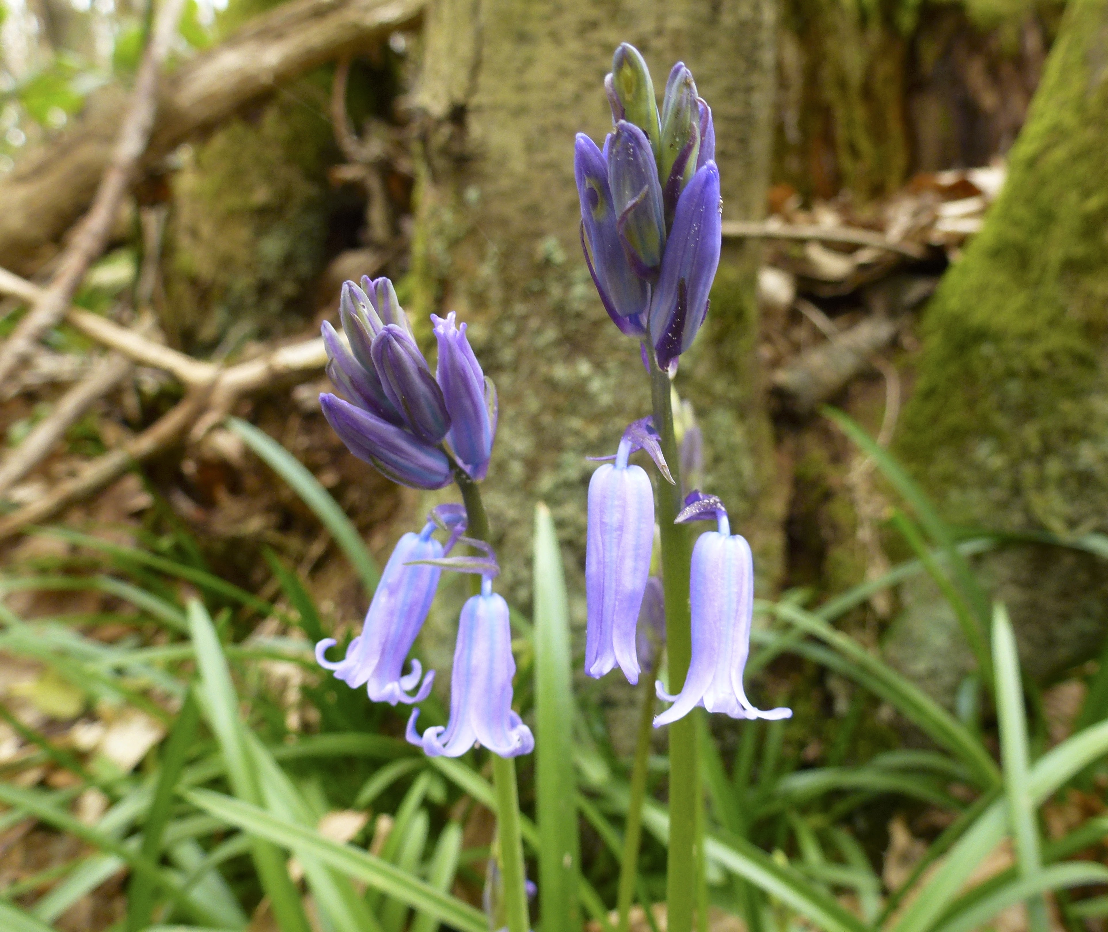

The Work of The

Conservation Group

Promote practical conservation through volunteers for the benefit of the countryside and wildlife.

Organise task days on the second Sunday of each month September to April.

Remove invasive and non-native species from the woods. .

Maintain some of the smaller paths with corduroy pathing.

Create and maintain natural habitats within the woods.

Practice the ancient art of hazel coppicing to encourage good habitat for dormice.

Maintain the ponds, home of many newts, frogs, and other threatened species.

Survey the woods, recording the species we find.

The park and woodlands are managed by MSDC and are subject to Local Authority Bylaws which are displayed around the site. This site is regularly patrolled by the MSDC Park Rangers.

Please help us protect Ashplats Wood and the wildlife by keeping the area free of litter.

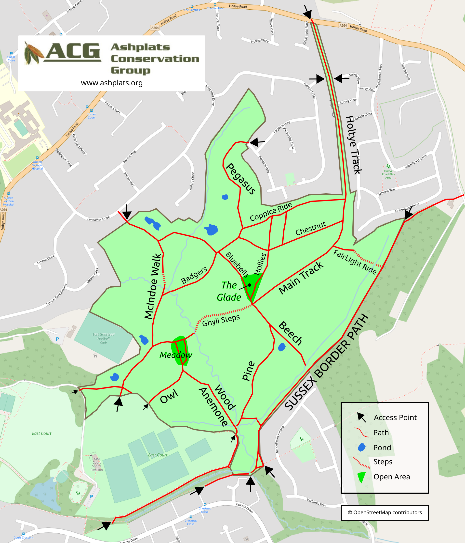

How You Can Help

Join a friendly team of volunteers to help keep this ancient wood in the condition it should be.
We meet at 10am on the 2nd Sunday of each month, September to April. Dates and meeting places are on the website and posted around the site.
Children welcome, under 16’s must be accompanied by an adult.
No experience is needed, just enthusiasm.
Tools, gloves and training provided. Wear old clothes and stout boots.
Learn new skills and make a difference. Even if you can only give a few hours, it all makes a difference.

Contact
Group Secretary: ACGSecretary@gmail.com


www.ashplats.org

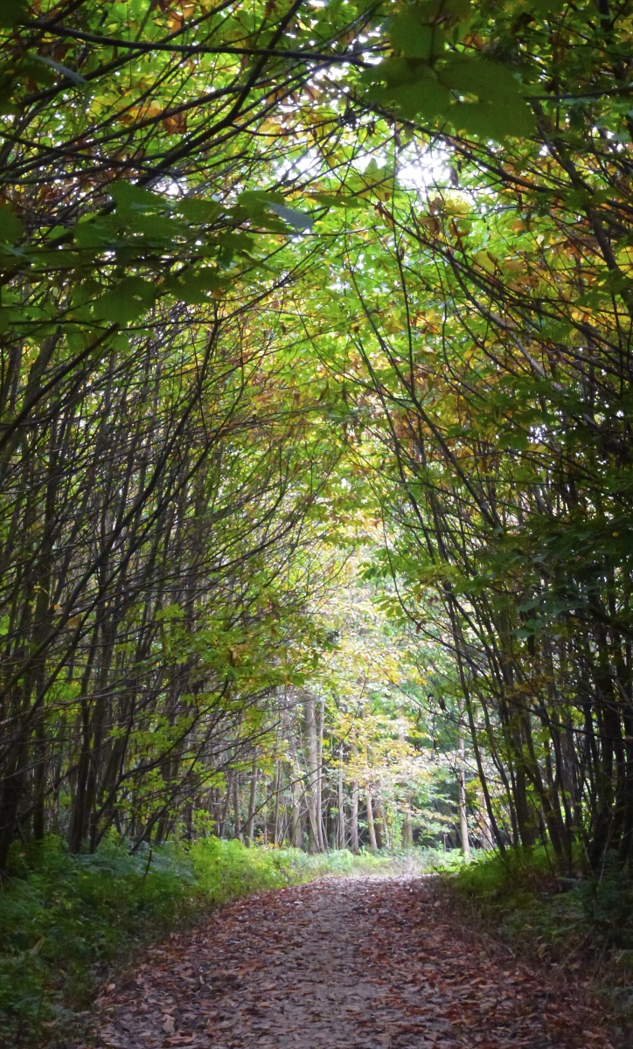

Volunteering in

Ashplats Woods

