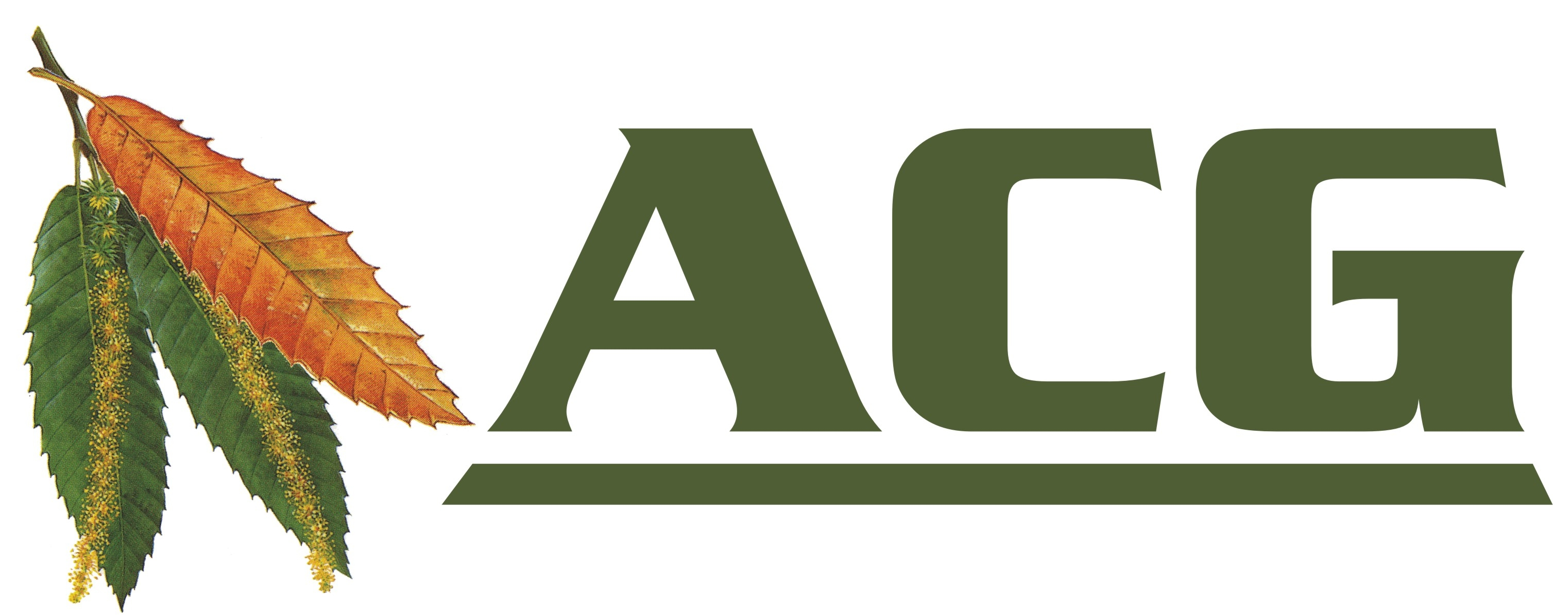

Ashplats Conservation Group
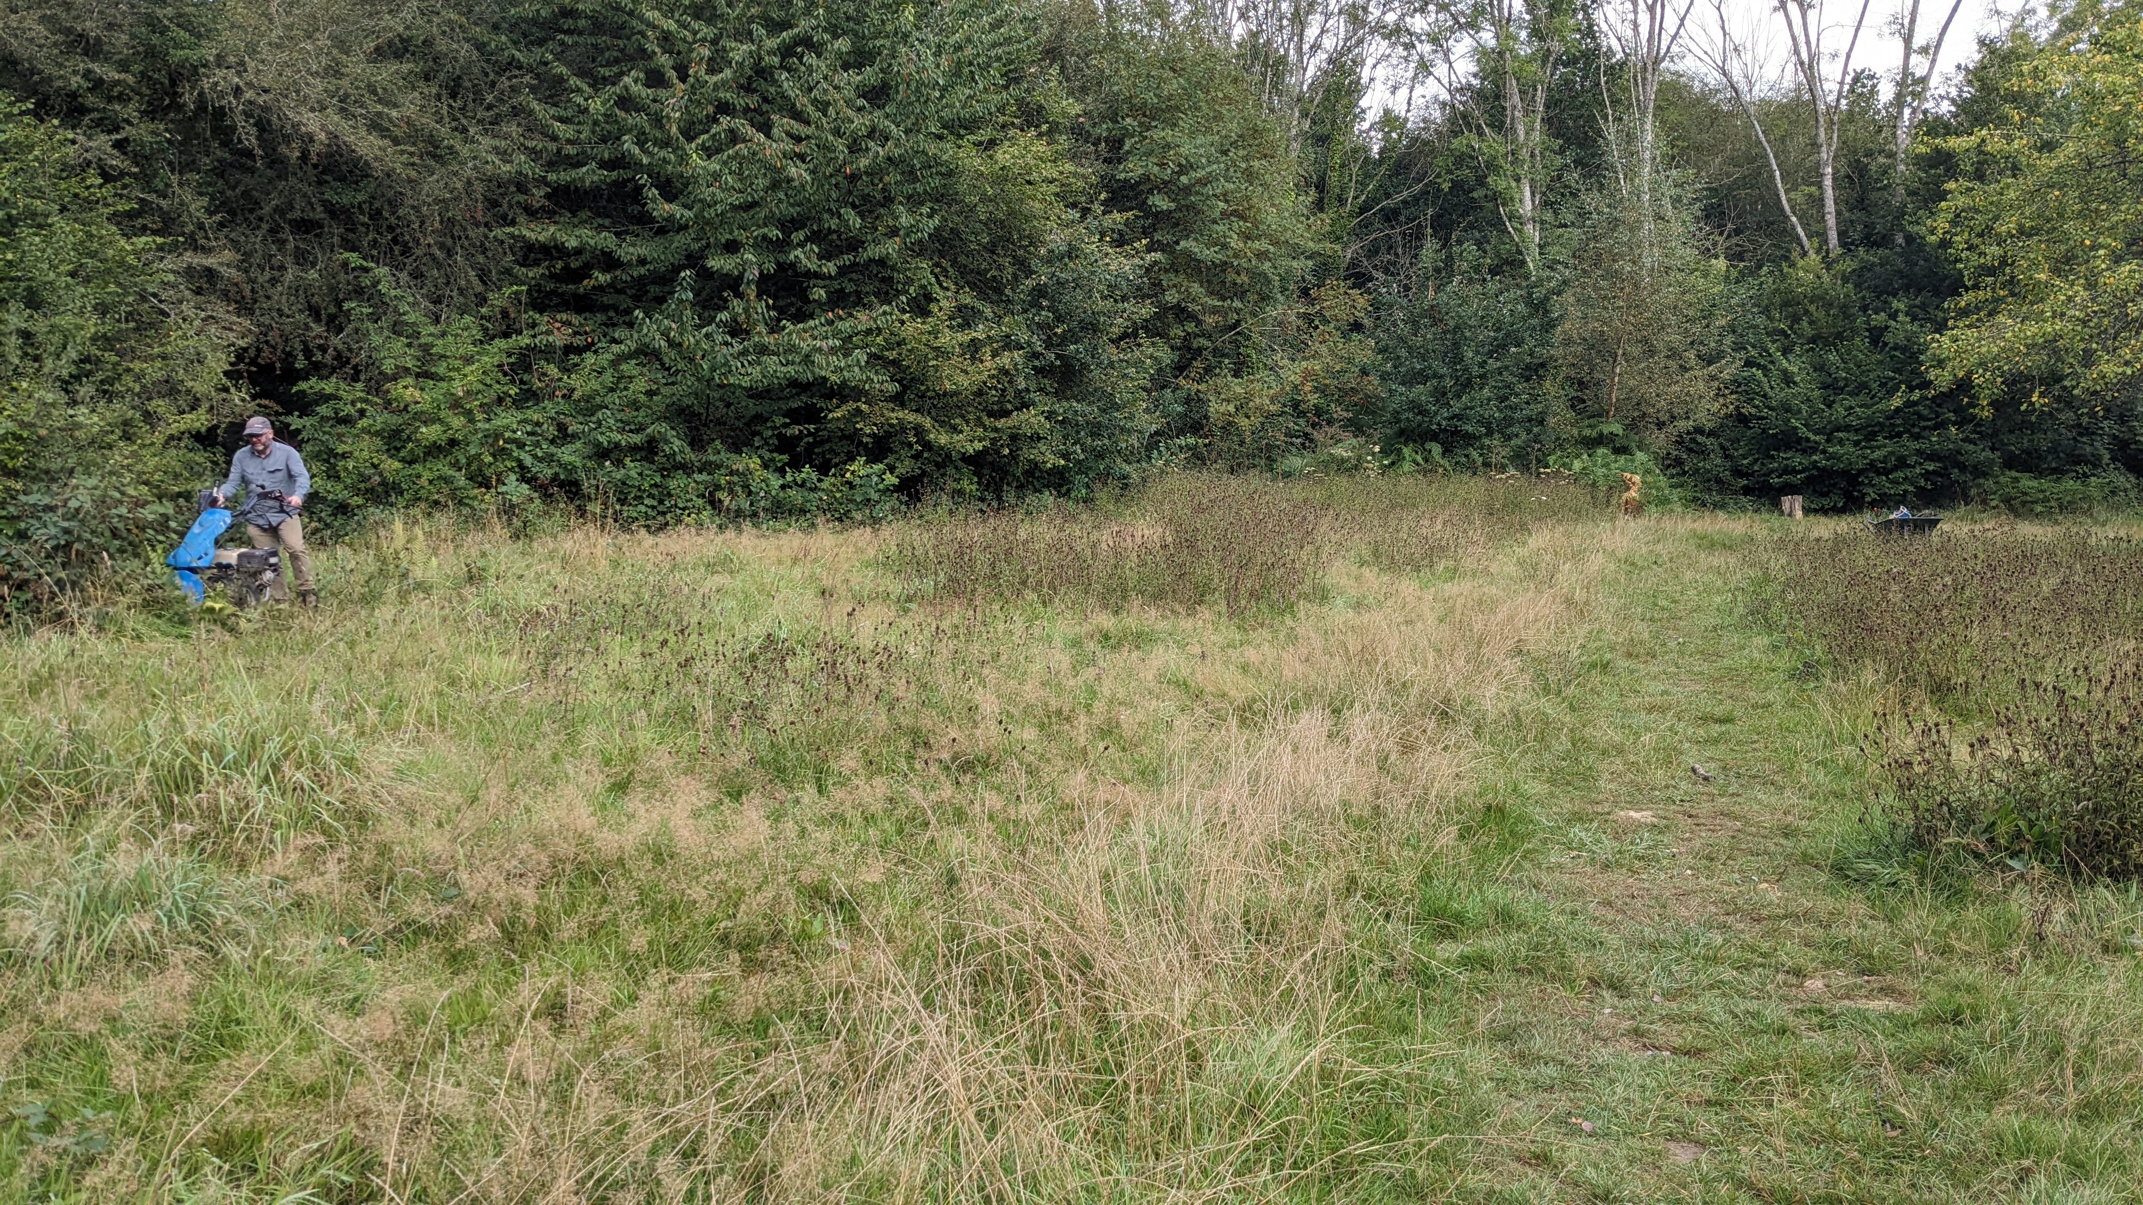

Task Days 2025/6

September 14th Clearing the Lake
October 12th Clearing the Lake
November 2nd Coppicing along Pines Path
December 14th Rhododendron removal
January 11th Coppicing along Pines Path
February 8th Scout Land. Fixing the path, removing sycamore

For information on joining the Conservation Volunteers,
visit our website or email us at:

https://ashplats.org Email: acgsecretary@gmail.com


https://fb.com/AshplatsConservationGroup/

