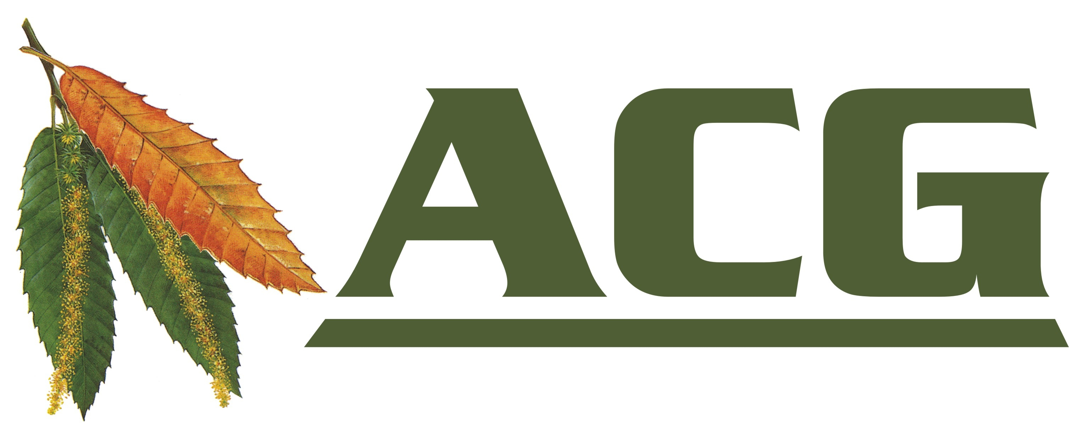

Ashplats Conservation Group

Upcoming 2023 Task Days

We are on summer hiatus, restarting in September with
our annual meadow mow and rake.
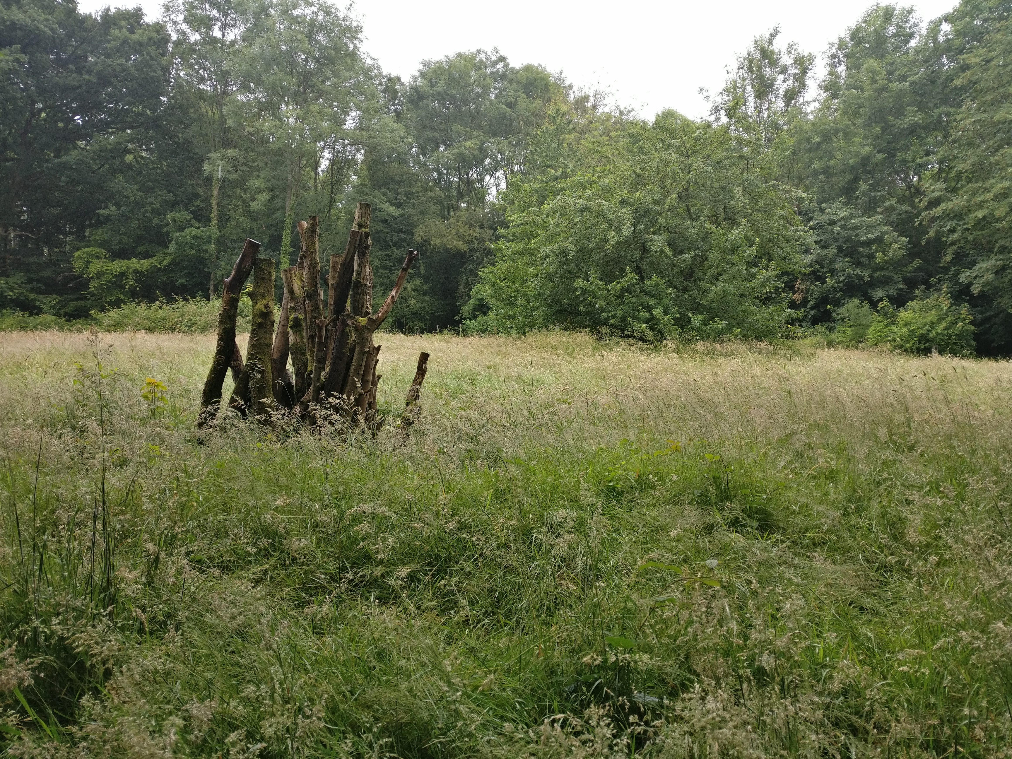
For information on joining the Conservation Volunteers,
visit our website or email us at:

https://ashplats.org Email: acgsecretary@gmail.com


https://fb.com/AshplatsConservationGroup/

