**Name:** …Zhou Changhui Eric………..…………… **Class:..**……………………………

**ENTHALPY CHANGE**

Experiment # 2

**Investigation to find the enthalpy change of reaction**

1. **INTRODUCTION**

In this skills task, we will look at the method used to calculate the enthalpy change for the exothermic metal displacement reaction between aluminium and copper(II) sulfate:

**Al(s) + CuSO4(aq) → Cu(s) + Al2SO4(aq)**

This practical will assess for **Data Analysis** *[6 marks]***, and Evaluation** *[6 marks]*.

1. **METHODOLOGY**
2. **Materials**

* Analytical scale/electronic balance
* coffee-cup calorimeter /styrofoam cup
* measuring cylinder
* thermometer or temperature probe
* 1.0 mol dm3 copper(II) sulfate solution
* zinc powder
* Weighing boat
* spatula
* Retort stand and clamp
* Stirring rod

1. **PROCEDURE**
2. Using an electronic balance, accurately measure the mass of 25 cm3 of 1.0 mol dm-3 CuSO4 solution. Transfer the solution to the coffee-cup calorimeter.
3. Using a thermometer or a temperature probe, record the temperature of the solution every 30 seconds for up to three minutes, or until a constant temperature is achieved.
4. At three minutes, add between 1.3 g to 1.4g of aluminium powder, record the exact mass of aluminium and commence stirring.
5. Continue to take temperature readings for up to five minutes after the maximum temperature has been reached.
6. Repeat steps 1-4 two more times. To complete three trials.
7. Produce a temperature versus time graph to determine the change in temperature.
8. Use your value of ∆T to calculate the heat released, Q, and the enthalpy change for the reaction, ∆H.

**III. DATA AND RESULTS**

1. **RAW DATA** *(Include uncertainties)*

***Table 1:Qualitative Data (All observation)***

|  |  |
| --- | --- |
|  | **OBSERVATION** |
| **Before the reaction** | **Grey powder and blue solution.** |
| **During the reaction** | **Some gray powder floats on the solution while some sinks to the bottom.** |
| **After the reaction** | **All gray powder sank. The solution becomes dirty.** |

***Table 2: Temperature Change per min***

| **TIME (MIN)** | **0.75** | **1.5** | **2.25** | **3** | **3.75** | **4.5** | **5.25** | **6** | **6.75** | **7.5** |
| --- | --- | --- | --- | --- | --- | --- | --- | --- | --- | --- |
| **TEMPERATURE 0C** | **18.5** | **18.5** | **18.4** |  | **18.6** | **18.8** | **19.1** | **19.2** | **18.9** | **18.6** |

| **TIME (MIN)** | **0.75** | **1.5** | **2.25** | **3** | **3.75** | **4.5** | **5.25** | **6** | **6.75** | **7.5** |
| --- | --- | --- | --- | --- | --- | --- | --- | --- | --- | --- |
| **TEMPERATURE 0C** | **18.5** | **18.5** | **18.4** |  | **18.5** | **18.9** | **19.2** | **19.1** | **18.8** | **18.5** |

| **TIME (MIN)** | **0.75** | **1.5** | **2.25** | **3** | **3.75** | **4.5** | **5.25** | **6** | **6.75** | **7.5** |
| --- | --- | --- | --- | --- | --- | --- | --- | --- | --- | --- |
| **TEMPERATURE 0C** | **18.5** | **18.5** | **18.4** |  | **18.6** | **18.8** | **19.2** | **19.0** | **18.8** | **18.6** |

1. **PROCESSED DATA** *(Include uncertainties)*

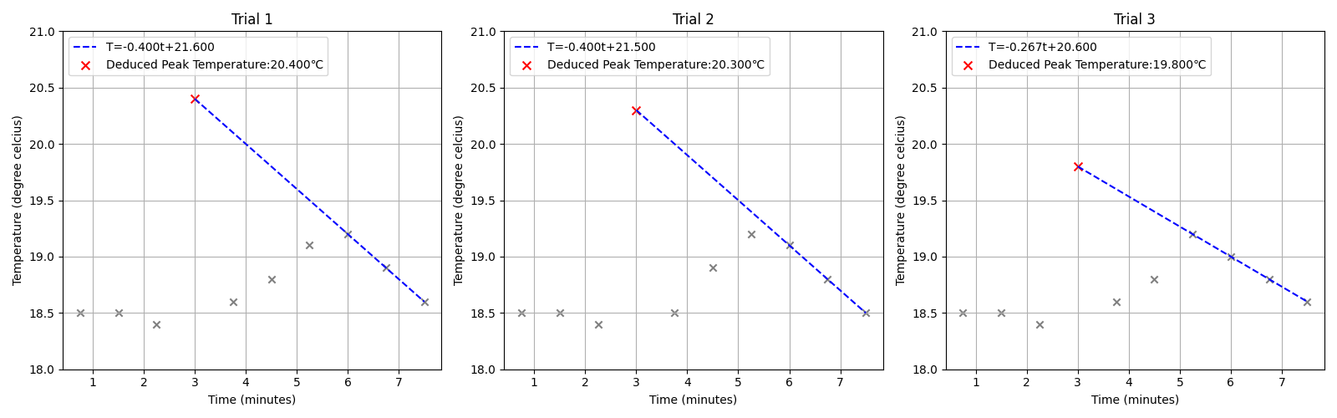

|  |  |
| --- | --- |
| **Mass of the solution (g)** | 29.73g (±0.01g) |
| **Initial Temperature (0C)** | 18.5 (±0.1℃) |
| **Maximum Temperature (0C)** | 20.2 (±0.1℃) |
| **Change in Temperature 𝝙T (0C)** | 1.7 (±0.2℃) |
| **Heat change, q (J)** | 2.1×10²(±11.8% = ±24.92J) |
| **Enthalpy change, 𝝙T (kJ mol-)** | -8.5(±11.8% = ±100J/mol)* |

*The uncertainty of the solution’s concentration is not known, because it was neither on the bottle nor prepared myself. Therefore, the actual uncertainty should be larger.

1. **SAMPLE CALCULATION** *(show the calculations done in the experiment.)*

**Q=cmΔT=4.18J/(g℃)×29.73g×1.7℃≈**2.1×10²J

**Enthalpy change = $\frac{-Q}{mol}$**  = $\frac{-2.1×10²J}{25 cm3× 1.0 mol /dm-3}$**≈-**8.5 kJ mol-1

1. **EVALUATION AND IMPROVEMENT)** *(Evaluation should include the methods strengths and weakness, the percentage value error of the experiment (Accepted Value: -217 kJ mol-), the apparatus errors of the experiment and check if it accounts to the difference of the accepted and experimental value, other errors that does not include the apparatus errors. Include what you can do to improve the experiment*

The experiment has been completed but the outcome is not ideal due to various reasons. It was simple to repeat and the cost was cheap. However, the percentage error was 96%, showing significant error in the experiment. Here are several aspects that can be improved.

**Insulation** The calorimeter provided in the experiment has neither a cover nor a vacuum insulation layer. This make it hard to insulate since conduction and convection are only have limited prevention. A better calorimeter like a thermo-flask may provide better result.

**Reaction rate** The reaction is a very quick one, giving the solution sufficient time to cool down during the reaction. Catalyst, if available, can speed up the reaction without changing the overall enthalpy change, making the result more accurate and precise.

**Thermometer** The thermometer provided is not very sensitive to minor changes in the temperature. The overall change is very big, making error caused by the thermometer significant. Using a more accurate one, preferably a mercury one, might provide more ideal result.

**Mixing of reagents** When putting aluminum powder into the container, some got stuck on the inner surface of the container, making reaction incomplete. A better way to mix the reagents will be folding the paper carrying the powder in half before pouring the powder.

**Change of environmental temperature** The experiment was conducted in the morning, where the environmental temperature itself was rising. Using air conditioner during the experiment, or do it at noon, when the temperature change is not that significant can rule out this factor.

1. **CONCLUSION***(List your take away from the activity and necessary information that highlights the experiment)*

As is shown in the graph, the temperature remained still at first. After the reagents were mixed, the temperature first increased quickly, and then kept decreasing until it reached the room temperature again. It shows that the reaction is exothermic and took about two minutes to complete. We can extrapolate the decreasing dots to get the highest temperature, which is about 20.2℃.

*(do we actually need to draw a graph in this task?)*

1. **REFERENCES**