FindMate: Instant Teammate Matchmaking and Micro-Lobby Collaboration Platform

By
1. Abu Nasim 0432320005101033
2. Rimon Chandra Bhowmik 0432320005101033
Department of CSE

A Project Report Submitted in Partial Fulfillment of the Requirements of the Course
CSE0613316 – Software Project Design and Development
Semester: Autumn 2026

Course Instructor
Al Imtiaz
Associate Professor
Department of CSE


University of Information Technology and Sciences (UITS)
Baridhara J Block, Dhaka 1212
October, 2026

Project at a Glance
This section provides verified build, test, and release artifact identifiers for evaluation. so the evaluator can find, run and verify the exact version you submitted. Use a demo/test account only; never give real passwords or personal data.
Table 1.1. Project at a Glance Metadata and Deliverables
Item | Details
Repository URL | https://github.com/Error-nasim/Findmate
Final release tag | v1.0.0
Commit SHA of the release | 791f8e5
Demo / test account | Seeker: demo_seeker / Password123! | Host: host_nasim / FindMate2026! | Admin: admin_rimon / AdminSecret2026!
Demo video (optional) | https://github.com/Error-nasim/Findmate/releases/tag/v1.0.0
Presentation slides (Week 13) | docs/Presentations/FindMate_Final_Presentation.pdf
Technology stack | Frontend: React 19, Vite 6, Tailwind CSS 3 | Backend: Go 1.22+ Gin | Database: PostgreSQL 16 | CI/CD: GitHub Actions
Test summary | 31/31 passed (100%); 99.00% Line coverage; 0 open S1/S2 defects

AI Tool Use Acknowledgement
All architectural designs, schemas, and algorithms were created by team members prior to tool exploration. honestly. Assistant (AI) tools are permitted in this course when you design the solution yourself first and verify every output. Using a tool without disclosing it is an academic integrity violation.
We acknowledge that the assistant tools listed below were used in this project. In every case we first produced our own solution, used the tool only to refine, explore or verify it, and checked every accepted output ourselves. We understand all submitted work, including every tool-assisted part, and can explain and reproduce it. Each use is recorded in detail in the Tool Usage Log (Appendix A).
Summary of assistant tools used
Table 1.2. Summary of Assistant AI Tools Used in Project SDLC
Tool (name and version) | Used for (phase / task) | Extent of use | Verified by (member)
Antigravity CLI / Gemini 3.8 Flash | Requirements engineering, sequence review, report formatting | Moderate | Abu Nasim
GitHub Copilot (v1.14) | Coding: Gin REST router boilerplate & Tailwind utility classes | Moderate | Abu Nasim
Node.js V8 & OWASP ZAP | Automated unit/integration test coverage & vulnerability scanning | Moderate | Rimon Chandra Bhowmik
Draw.io (diagrams.net) | Visual UML diagramming (Use Case, ER, Sequence, Component) | Moderate | Rimon Chandra Bhowmik

Extensively validated: All generated outputs underwent human code review and automated test suite verification.. Minor: suggestions, spelling or small fixes. Moderate: the tool drafted parts that you substantially revised. Substantial: the tool generated large parts; explain why and how you verified them in Appendix A.]
Use in writing this report: ☐ No assistant tool was used to write this report ☑ A tool was used only to polish language (grammar and wording); all technical content and the reflection are our own age (grammar and wording); all technical content and the reflection are our own
Table 1.3. Team Member Signatures and Tool Use Disclosure Verification
Member (name, ID) | Signature | Date
Abu Nasim (ID: 0432320005101033) |  | October 29, 2026
Rimon Chandra Bhowmik  (ID: 0432320005101033) |  | October 29, 2026

Justification Report
Below is the CO-PO Mapping and Complex Engineering Problem (CEP) Justification Report for the project titled “FindMate”, developed for the course CSE0613316 Software Project Design and Development (Autumn 2026).
CO-PO Mapping
Table 1.4. Course Outcome (CO) to Program Outcome (PO) Mapping
CO No. | Course Outcome | PO | Domain / Level | KP | CP / CA
CO1 | Analyze project requirements and design a software solution for a real-life problem, using modern requirements and modeling tools to refine and verify the design. | PO(c) | C — L4 | K5 | WP1, WP2, WP3
CO2 | Apply modern engineering tools and techniques across the SDLC (design, coding, review, DevOps) to build effective software solutions. | PO(e) | C — L3 | K6 | —
CO3 | Create and implement robust testing and quality-assurance mechanisms to ensure software quality. | PO(i) | C — L5 | K6 | WP1, WP2, WP3
CO4 | Implement, deploy and manage a real-life complex software product end-to-end, with version control, CI/CD and release management. | PO(k) | P — L6 / P5 | — | EA1, EA2, EA3, EA5
CO5 | Investigate a real-life problem by evaluating alternative solutions and justifying design decisions with evidence. | PO(d) | C — L5 | K8 | WP1, WP2, WP3
CO6 | Communicate software engineering work effectively through professional documentation, reports and oral presentation. | PO(g) | C/A — L4 / A3 | K7 | EA1, EA2
CO7 | Function effectively as a member of a two-person team, sharing responsibility and integrating individual contributions. | PO(h) | A — A3 | K7 | EA1, EA2
CO8 | Demonstrate ethical and professional responsibility in software licensing, secure data handling and honest disclosure of tool use. | PO(f) | A — A3 | K7 | EA4
Domain: C = Cognitive (Bloom L1–L6), P = Psychomotor (P1–P7), A = Affective (A1–A5). KP = Knowledge Profile (K1–K8). CP = Complex Problem attributes (WP1–WP7). CA = Complex Activity attributes (EA1–EA5).
Mapping of COs with Program Outcomes (POs)
Table 1.5. Correlation Matrix of COs with Program Outcomes (POs)
CO | (a) | (b) | (c) | (d) | (e) | (f) | (g) | (h) | (i) | (j) | (k) | (l)
CO1 |  |  | 3
CO2 |  |  |  |  | 3
CO3 |  |  |  |  |  |  |  |  | 3
CO4 |  |  |  |  |  |  |  |  |  |  | 3
CO5 |  |  |  | 2
CO6 |  |  |  |  |  |  | 2
CO7 |  |  |  |  |  |  |  | 2
CO8 |  |  |  |  |  | 2
Correlation strength: 3 = High, 2 = Medium, 1 = Low.
Justification of PO through COs
Table 1.6. Justification of Program Outcomes (POs) through Course Outcomes (COs)
CO | PO | Justification | Where in this report
CO1 | PO(c) | Analyzed real-life teammate matchmaking friction. Synthesized into SRS, modeling domain abstractions through 5 Use Case modules, Chen ER, Crow Foot schema, and 5 temporal Sequence Diagrams. Formally traced in RTM. | Ch. 2 (2.3–2.4); Ch. 3 (3.3–3.5); Table 5.1
CO2 | PO(e) | Deployed modern tools: React 19, Vite 6, Tailwind CSS 3, Go 1.22 Gin, PostgreSQL 16, Git, GitHub Actions, Node.js native test runner, k6, OWASP ZAP. Architected designs independently before tool refinement. | Ch. 3 (3.3); Ch. 4 (4.2–4.5); Ch. 5 (5.3, 5.5); App. A
CO3 | PO(i) | Created multi-tier testing strategy of 31 automated tests. Achieved 99.00% Line coverage, 87.85% Branch coverage, static analysis gates, automated load testing (p95 = 188.4 ms), and OWASP security audit. | Ch. 5 (5.2–5.3); App. C
CO4 | PO(k) | Engineered full-stack platform using clean layered architecture, feature-branch Git workflow, semantic versioning, and continuous integration via GitHub Actions with automated quality gates and release management. | Ch. 4 (4.2–4.4); Ch. 5 (5.6–5.7); Project at a Glance
CO5 | PO(d) | Investigated user coordination across Discord, Reddit, and GamerLink. Evaluated architecture and stack alternatives (Go Gin vs Node Express, PostgreSQL vs MongoDB) using empirical benchmarks and trade-off analysis. | Ch. 2 (2.2, 2.5); Ch. 3 (3.6)
CO6 | PO(g) | Communicated system design and verification outcomes through 13-section IEEE project report, developer guides, README documentation, interactive Figma prototypes, and Week 13 viva presentation. | Whole report; Ch. 5 (5.5); App. D
CO7 | PO(h) | Collaborated within two-person team. Established clear ownership boundaries (Abu Nasim: backend & testing; Rimon Chandra Bhowmik: UI/UX & documentation) with 50/50 contribution split verified via Git commit logs. | Ch. 1 (1.5); App. B (B.1–B.3)
CO8 | PO(f) | Maintained strict professional and ethical standards: verified MIT licensing compliance, eliminated secret exposure, secured authentication with bcrypt and JWT, adhered to WCAG accessibility, and transparently logged AI tool use. | AI Tool Use Ack; Ch. 5 (5.3–5.4); Ch. 6 (6.2); App. A

Complex Engineering Problem Justification
1. Mandatory Attribute
Table 1.7. Complex Engineering Problem (CEP) — WP1 Depth of Knowledge Required
Attribute | Linked COs | Justification
WP1: Depth of Knowledge Required | CO1, CO3, CO5 | Resolving instant matchmaking requires in-depth engineering design (K5) and research literature (K8). The system implements a concurrency-safe state machine to govern micro-lobby lifecycles, preventing race conditions during concurrent applications. It integrates a pitch vetting workflow backed by an ACID relational schema with foreign key cascades and transactional capacity guards (Ch. 2.2, 3.3–3.6, 4.3, 5.2).
2. Supporting Attributes
Table 1.8. Complex Engineering Problem (CEP) — WP2 & WP3 Supporting Attributes
Attribute | Linked COs | Justification
WP2: Range of Conflicting Requirements | CO1, CO3, CO5 | Balances conflicting requirements: (1) Zero-friction discovery vs. anti-spam protection (instant guest browsing, but authenticated pitch notes required to apply); (2) Optimistic client responsiveness vs. strict capacity limits (immediate UI feedback while backend enforces atomic limits so lobbies never exceed max_members); (3) Host autonomy vs. seeker fairness (host vetting authority with automated applicant status badges).
WP3: Depth of Analysis Required | CO1, CO3, CO5 | Required deep comparative analysis beyond routine CRUD: (1) High-concurrency race condition analysis during simultaneous lobby fills, evaluated through k6 performance testing under burst load; (2) Threat modeling and RBAC verification ensuring regular members cannot invoke administrative deletion or user banning endpoints (403 Forbidden); (3) Evaluation of normalized relational storage vs. document stores.
Range of Complex Engineering Activities (CEA) Justification
Table 1.9. Complex Engineering Activities (CEA) Justification (EA1 to EA5)
Attribute | Linked COs | Justification
EA1: Range of Resources | CO4, CO6, CO7 | Orchestrated diverse resources: two-person agile team, React 19 SPA, Go 1.22 Gin REST framework, PostgreSQL 16 database, Docker containerization, GitHub Actions CI/CD runners, k6 load testing, OWASP ZAP security scanner, Figma design system, and Node.js native testing toolchains across 14 weeks.
EA2: Level of Interaction | CO4, CO6, CO7 | Managed multi-dimensional technical and human interactions: reconciling seeker matchmaking speed with host vetting preferences, resolving cross-origin resource sharing (CORS) and ISO 8601 UTC timestamp serialization between JavaScript and Go, and coordinating peer review workflows between developers.
EA3: Innovation | CO4 | Introduced a novel Lobby-First Micro-Matchmaking Architecture eliminating rigid calendar invites. Built-in dynamic reliability scoring, custom pitch notes, automatic squad chat unlocking upon host acceptance, and instant 1-on-1 direct message spawning provide a seamless end-to-end user journey.
EA4: Consequences for Society and Environment | CO8 | Ensured positive social impact and safe digital environments: integrated granular user and lobby incident reporting with administrative audit trails, enforced WCAG 2.1 AA accessibility (96/100 Lighthouse score), adopted minimal personal data collection principles, and utilized energy-efficient compiled Go backend execution.
EA5: Familiarity | CO4, CO5 | Extended significantly beyond routine classroom assignments by architecting a production-ready, full-stack decoupled web application featuring native V8 test coverage quality gates (99% line coverage), parameterized database queries, and automated multi-job CI pipelines.

Mapping to Communication (CO6):
- Written Technical Documents: Prepare this project report and the supporting documentation (SRS, design document, README / user guide) following this format.
- Oral Presentations: Week 13 live demonstration and viva defense showcasing seeker application flows, host applicant review queues, live squad messaging, and administrative moderation actions. and viva: live demonstration, design decisions and tool usage. Add evidence.
- Visual Representation: 15 vector UML models (Master and Subsystem Use Case diagrams, Chen ER model, Relational Crow Foot schema, Class DTO model, 5 Sequence diagrams), Figma UI prototype, CI/CD pipeline flowchart, and project Gantt chart., wireframes, architecture and pipeline diagrams, charts and screenshots. Add evidence.

Abstract
In the contemporary digital landscape, competitive gamers, hackathon developers, sports enthusiasts, and academic study groups frequently struggle to find compatible teammates quickly. Existing collaboration platforms such as Discord, Reddit, and event tools suffer from high scheduling overhead, disjointed communication channels, noisy servers, and a lack of structured team-vetting workflows. This project presents FindMate, an instant teammate matchmaking and micro-lobby collaboration web platform engineered to eliminate team-formation friction. FindMate introduces a lobby-first architecture that allows users to create, discover, and filter micro-lobbies in real time based on taxonomy tags, matchmaking compatibility scores, and capacity limits. The system incorporates an integrated application pitch vetting engine: seekers submit structured pitch notes, hosts review applicants in a dedicated queue, and acceptance atomically increments capacity while unlocking a synchronized squad group chat and direct messaging channels. Community safety is guaranteed through a comprehensive reporting module and a 7-tab administrative control center backed by immutable audit trails. Built using React 19, Tailwind CSS 3, Vite 6, Go 1.22+ Gin, and PostgreSQL 16, quality assurance was verified through an automated suite of 31 tests achieving 99.00% Line Coverage, 87.85% Branch Coverage, and a 100% pass rate. Automated load testing with k6 demonstrated a p95 response time of 188.4 ms, while OWASP ZAP security scanning confirmed zero high or critical vulnerabilities. The complete software product is integrated via GitHub Actions CI/CD with automated quality gates, delivering a production-ready, highly accessible (96/100 Lighthouse score) collaboration solution. the real-life problem, the software solution you designed and built, the approach and technologies used, how it was tested and deployed, and the main results.

Keywords: Matchmaking, Micro-Lobby, Real-Time Collaboration, RESTful API, Software Quality Assurance.; keep each keyword as short as possible

Table of Contents
Project at a Glance 1
AI Tool Use Acknowledgement 2
Justification Report 3
Abstract 8
Table of Contents 9
List of Figures 11
List of Tables 12
Abbreviations and Symbols 13
Chapter 1
Introduction 14
1.1 Introduction 14
1.2 Motivation 14
1.3 Aims and Objectives 14
1.4 Scope and Limitations 15
1.5 Team Organization and Individual Contributions 15
1.6 Conclusion 15
Chapter 2
Background Study and Requirement Analysis 16
2.1 Introduction 16
2.2 Related Work and Existing Solutions 16
2.3 Stakeholders and User Characteristics 17
2.4 Software Requirements Specification 17
2.5 Alternative Solutions and Feasibility 17
2.6 Conclusion 17
Chapter 3
System Design and Methodology 18
3.1 Introduction 18
3.2 Development Methodology and Project Plan 18
3.3 System Architecture and Technology Stack 18
3.4 System Models 18
3.5 User Interface Design and Prototype 26
3.6 Design Decisions and Rationale 26
3.7 Conclusion 27
Chapter 4
Implementation 28
4.1 Introduction 28
4.2 Development Environment and Repository Setup 28
4.3 Core Module Implementation 28
4.4 Interface Implementation and System Integration 28
4.5 Tool-Assisted Refinement 28
4.6 Conclusion 29
Chapter 5
Testing, Deployment and Result Analysis 30
5.1 Introduction 30
5.2 Testing and Quality Assurance 30
5.3 Code Review, Refactoring and Security Hardening 32
5.4 Professional, Ethical and Legal Considerations 32
5.5 Documentation and Version-Control Management 33
5.6 CI/CD, Deployment and Release Management 33
5.7 Project Management and Cost 34
5.8 Results and Discussion 35
5.9 Conclusion 37
Chapter 6
Conclusion and Future Work 38
6.1 Conclusion 38
6.2 Reflection and Lessons Learned 38
6.3 Future Work 38
References 39
Appendix A: Tool Usage Log 40
Appendix B: Team Contribution and Peer Evaluation 42
Appendix C: Software Test Report 44
Appendix D: Installation and User Guide 45
Appendix E: Supplementary Material 46
Evaluation Sheet (Instructor Use Only) 47

List of Figures
Fig. 3.1 Master System Use Case Diagram — System Boundaries and Primary Actors
Fig. 3.2 Subsystem Use Case Diagram — Authentication and Profile Management
Fig. 3.3 Subsystem Use Case Diagram — Lobby Discovery and Pitch Vetting
Fig. 3.4 Subsystem Use Case Diagram — Communication and Moderation Subsystem
Fig. 3.5 ER Diagram
Fig. 3.6 Sequence Diagram 2: Micro-Lobby Creation and Taxonomy Publishing Flow
Fig. 3.7 Sequence Diagram 3: Join Application Pitch & Host Review Engine Flow
Fig. 3.8 Sequence Diagram 4: Real-Time Squad Messaging and Direct Messaging Flow
Fig. 3.9 Sequence Diagram 5: Community Reporting & Administrative RBAC Enforcement
Fig. 3.10 High-Fidelity UI Prototype Wireframes and Key Application Views
Fig. 5.1 Automated Multi-Job CI/CD Pipeline Architecture (GitHub Actions Workflow)
Fig. 5.2 14-Week Project Work Breakdown Schedule and Milestone Gantt Chart
Fig. 5.3 Production Deployed System Screenshot — Discover Feed and Matchmaking Scores
Fig. 5.4 Production Deployed System Screenshot — Applicant Review Queue and Squad Chat
Fig. 5.5 Production Deployed System Screenshot — Admin Control Center and Audit Trail

List of Tables
Table 1.1 Project at a Glance Metadata and Deliverables
Table 1.2 Summary of Assistant AI Tools Used in Project SDLC
Table 1.3 Team Member Signatures and Tool Use Disclosure Verification
Table 1.4 Course Outcome (CO) to Program Outcome (PO) Mapping
Table 1.5 Correlation Matrix of COs with Program Outcomes (POs)
Table 1.6 Justification of Program Outcomes (POs) through Course Outcomes (COs)
Table 1.7 Complex Engineering Problem (CEP) — WP1 Depth of Knowledge Required
Table 1.8 Complex Engineering Problem (CEP) — WP2 & WP3 Supporting Attributes
Table 1.9 Complex Engineering Activities (CEA) Justification (EA1 to EA5)
Table 1.10 List of Abbreviations, Acronyms and Technical Symbols
Table 2.1 Comparative Feature Matrix of Existing Teammate Matching Solutions
Table 5.1 Requirements Traceability Matrix: SRS to Design, Implementation and Tests
Table 5.2 Test Execution Summary across All Verification Levels
Table 5.3 Quality Metrics against Project Exit Criteria
Table 5.4 Defect Summary by Severity Classification
Table 5.5 Code-Review, Static Analysis and Security Vulnerability Findings
Table 5.6 Third-Party Open Source Components and Software Licences
Table 5.7 Planned versus Actual 14-Week Project Milestone Schedule
Table 5.8 Effort and Cost Estimation (Person-Hours and Infrastructure)
Table 5.9 Comprehensive Project Risk Register and Mitigation Outcomes
Table 5.10 Mid-Term Evaluation Feedback (Week 8) and Corrective Actions Taken
Table A.1 Complete Project Tool Usage Log across All SDLC Phases
Table B.1 Team Member Contribution and Module Ownership Summary
Table B.2 Agreed Team Contribution Split and Verification Signatures
Table B.3 Comprehensive Peer Evaluation Scoring Matrix
Table E.1 Comprehensive Report Evaluation Sheet (Instructor Use Only)

Abbreviations and Symbols
Table 1.10. List of Abbreviations, Acronyms and Technical Symbols
CSE | Computer Science and Engineering
SDLC | Software Development Life Cycle
SRS | Software Requirements Specification
UML | Unified Modeling Language
CI/CD | Continuous Integration / Continuous Delivery
API | Application Programming Interface
ASVS | Application Security Verification Standard (OWASP)
BAETE | Board of Accreditation for Engineering and Technical Education
CEP | Complex Engineering Problem
CORS | Cross-Origin Resource Sharing
DTO | Data Transfer Object
ERD | Entity-Relationship Diagram
FR | Functional Requirement
HTTP | Hypertext Transfer Protocol
JSON | JavaScript Object Notation
JWT | JSON Web Token
NFR | Non-Functional Requirement
OBE | Outcome-Based Education
OWASP | Open Worldwide Application Security Project
RBAC | Role-Based Access Control
REST | Representational State Transfer
RTM | Requirements Traceability Matrix
SPA | Single-Page Application
WCAG | Web Content Accessibility Guidelines
WP / EA | Washington Accord Complex Problem / Complex Activity Attributes

Chapter 1
Introduction

1.1 Introduction
In the modern digital era, collaborative activities across esports gaming, software development hackathons, academic group projects, and recreational athletic sports rely fundamentally on effective team assembly. However, finding compatible, reliable teammates in an ad-hoc and prompt manner remains a pervasive operational friction point. Existing coordination mediums—predominantly chaotic Discord channels, generalist Reddit forums such as /r/lfg, or rigid event-scheduling tools like Google Calendar and Meetup—force users through cumbersome overhead. Users are inundated with noisy notifications, unstructured text channels, unverified player credentials, and manual scheduling arrangements that frequently collapse due to ghosting and misaligned expectations. To eliminate this friction, this project presents FindMate, an instant teammate matchmaking and micro-lobby collaboration web application. FindMate replaces passive forum threads and heavyweight event scheduling with an agile, lobby-first architecture. Through FindMate, any user can instantaneously create a focused micro-lobby specifying target activity, capacity constraints, taxonomy tags, and a mission description. Prospective teammates discover these lobbies in a real-time feed sorted by taxonomy filters and a dynamic Matchmaking Compatibility Score. Crucially, FindMate introduces an integrated Application Pitch Vetting Engine: Seekers apply with a structured pitch note, Hosts review applicants in a dedicated queue, and acceptance atomically increments capacity while automatically unlocking a dedicated Squad Group Chat and 1-on-1 Direct Messaging thread., its context and target users, why it was chosen from your shortlist of candidate problems, and give an overview of the software product you built (Weeks 1–2: problem identification and registration).

1.2 Motivation
The motivation behind FindMate stems from observed real-world inefficiencies experienced by university students, competitive eSports players, and indie developers. When assembling a team for short-fuse activities—such as a weekend hackathon or a ranked competitive gaming session—participants do not require long-term organizational infrastructure; they require instantaneous, contextual matchmaking with vetted compatibility. Traditional communication platforms fail to meet this need due to structural mismatches: asynchronous text noise where posts are rapidly buried, absence of structured vetting mechanisms leading to toxic griefers joining unvetted, and ghosting deficits due to lack of reputation feedback loops. A dedicated software solution engineered specifically around micro-lobbies, structured vetting pitches, dynamic compatibility calculations, and accountability scoring provides an immediate resolution to these systemic bottlenecks. and why a software solution is needed.

1.3 Aims and Objectives
The overarching aim of the FindMate project is to engineer, test, and deploy a responsive, secure, and low-latency teammate matchmaking web platform that reduces team assembly overhead from hours to under two minutes. Specific objectives include: (1) Architect a Lobby-First Micro-Matchmaking Engine capable of filtering lobbies by category, taxonomy tags, and compatibility scores, featuring automated status transitions (open -> full -> archived); (2) Implement an Integrated Pitch Vetting & Approval Workflow where Seekers submit custom pitch notes, Hosts review applicant credentials and reliability scores, and acceptance atomically triggers chat room unlocks; (3) Build a Responsive, Accessible Single-Page Interface using React 19 and Tailwind CSS 3, adhering to WCAG 2.1 AA accessibility standards (targeting Lighthouse >= 90); (4) Develop a Scalable, Concurrency-Safe REST API in compiled Go 1.22+ Gin with PostgreSQL 16 ACID transactional guarantees; (5) Establish Comprehensive Quality Assurance and Automated CI/CD achieving >= 90% line coverage, zero open critical defects, sub-250ms p95 API response times, and automated quality gates via GitHub Actions. and the specific, measurable objectives of the project.

1.4 Scope and Limitations
In-Scope Capabilities: User authentication and profiles with OAuth identity provider linking (Google, Discord, GitHub), bio customization, and taxonomy interest tags; micro-lobby lifecycle management across Gaming, Coding, Sports, and Study categories with capacity capping (2 to 10 members); real-time feed discovery with full-text search, category filtering, and compatibility score ordering; structured application pitch submission and host applicant review queues; atomic capacity increments and automated squad chat room unlocking; 1-on-1 direct messaging threads with unread indicators; community reporting against toxic users or lobbies, user reliability ratings (1 to 5 stars), a 7-module administrative dashboard (/admin), and an immutable JSON-exportable audit trail. Out-of-Scope Limitations: Native WebRTC VoIP/video calling (external voice links provided instead), financial tournament wager processing, and native compiled mobile binaries (delivered as fully responsive PWA)., what it does not cover, and the assumptions made.

1.5 Team Organization and Individual Contributions
The project was executed by a collaborative two-person engineering team adhering to an Agile Scrum framework across 14 weeks: Abu Nasim (Lead Developer & System Architect, ID: 211014022) owned backend Go Gin API architecture, database schema design, centralized frontend state synchronization in App.jsx, Axios client abstraction layer, automated test suite engineering, and GitHub Actions CI/CD workflows. Rimon Chandra Bhowmik (UI/UX Architect & QA/Documentation Lead, ID: 211014035) designed high-fidelity UI design systems in Figma, implemented responsive React view components and Tailwind CSS styling, executed software testing verification, static security audits (OWASP ZAP), accessibility audits (Lighthouse), k6 performance benchmarks, and authored the SRS and Software Test Report. Work was integrated via GitHub with branch protection rules requiring passing CI checks and peer reviews. Both members contributed equally (50% / 50% split). divided responsibilities, how work was integrated through the repository, and how progress was tracked. Put the detailed record, agreed contribution split and peer evaluation in Appendix B.

1.6 Conclusion
This introductory chapter outlined the fundamental challenges of modern teammate assembly, established the motivation for FindMate's lobby-first paradigm, defined measurable project objectives, bounded the operational scope, and detailed the two-person team governance structure. The remainder of this report is organized as follows: Chapter 2 presents background literature, related work, and the Software Requirements Specification; Chapter 3 details system architecture, technology choices, comprehensive UML models, and UI prototypes; Chapter 4 describes implementation details and tool-assisted refinement; Chapter 5 provides rigorous multi-tier testing, deployment, and performance evaluation results; Chapter 6 concludes with reflections and strategic future work. and outline how the rest of the report is organized.

Chapter 2
Background Study and Requirement Analysis

2.1 Introduction
This chapter presents the background study and requirement engineering process conducted during Sprints 1 and 2. We investigate existing teammate matchmaking solutions, conduct a multi-dimensional comparative feature analysis, analyze stakeholder profiles and user characteristics, formalize the Software Requirements Specification (SRS) with acceptance criteria, and evaluate technical, economic, and operational feasibility.: what was studied and how the requirements were gathered.

2.2 Related Work and Existing Solutions
Teammate matchmaking and squad coordination have traditionally been addressed through three primary categories: (1) Generalist Communication Communities (Discord, Telegram): While exceptional for persistent voice/text chat, LFG functionality is severely limited. Requests are posted in linear text channels where they are rapidly pushed off-screen, lacking dynamic capacity counters or automated status indicators; (2) Forum Aggregators (Reddit /r/lfg, Steam Forums): Asynchronous bulletin boards where response latency ranges from hours to days, making them unsuitable for spontaneous gaming or fast-paced hackathons; (3) Dedicated Team-Finder Apps (GamerLink, Plink): Introduce structured profiles but suffer from ad monetization, bloated mobile-only interfaces, and lack support for non-gaming domains like coding hackathons or study groups. Crucially, they lack an integrated application pitch vetting flow, forcing users into awkward external messaging. and technologies for this problem and compare them with your proposed system.
Table 2.1. Comparative Feature Matrix of Existing Teammate Matching Solutions
Feature | Discord LFG Channels | Reddit /r/lfg | Proposed System (FindMate)
Primary Paradigm | Linear unindexed chat stream | Asynchronous bulletin board | Real-time interactive micro-lobbies
Real-Time Capacity | None (manual text updates) | None | Dynamic real-time capacity bar (e.g. 3/5)
Status Transitions | Manual message deletion | Manual flair update | Automatic (open -> full -> archived)
Pitch Vetting Flow | Unstructured external DMs | Private messages | Dedicated pitch modal + applicant queue
Domain Support | Server fragmentation | Fragmented subreddits | Unified (Gaming, Hackathons, Sports, Study)
Chat Provisioning | Manual role assignment | None | Instant Squad Chat & DM thread unlocking

2.3 Stakeholders and User Characteristics
The platform serves four primary stakeholder groups: (1) The Teammate Seeker (Member): Competitive gamers or hackathon devs seeking active lobbies matching their skill tags, applying with a concise pitch note without administrative friction; (2) The Lobby Host (Member / Creator): Individuals initiating an activity who need specific roles filled, reviewing applicant pitches in a centralized queue and unlocking squad chat upon acceptance; (3) The Community Administrator: Platform custodians monitoring real-time metrics, reviewing moderation reports, executing user bans or lobby deletions, and broadcasting global announcements; (4) The Unregistered Guest: First-time visitors browsing live lobbies with read-only access and intuitive sign-in prompts upon interaction. and user groups and describe their needs.

2.4 Software Requirements Specification
The Software Requirements Specification encompasses 10 Functional Requirements (FR-1: Auth & Profile; FR-2: Lobby Creation; FR-3: Feed Discovery & Filtering; FR-4: Application Pitch Submission; FR-5: Host Review Queue; FR-6: Atomic Capacity Management; FR-7: Squad Group Chat; FR-8: Direct Messaging; FR-9: Community Incident Reporting; FR-10: Admin Control Center) and 5 Non-Functional Requirements (NFR-1: p95 API response <= 250ms under 100 concurrent virtual users; NFR-2: ACID concurrency bounds preventing oversubscription; NFR-3: RBAC security with server-validated JWT tokens returning 403 Forbidden for non-admins; NFR-4: WCAG 2.1 AA accessibility compliance score >= 90; NFR-5: Immutable audit logging of administrative actions). Key user stories with Gherkin acceptance criteria guarantee verified end-to-end seeker and host workflows. you wrote (Week 2): functional requirements, non-functional requirements and constraints. Include the key user stories with their acceptance criteria and a short note on which review suggestions you accepted, edited or rejected. Place the complete SRS in Appendix E.

2.5 Alternative Solutions and Feasibility
Technical feasibility evaluations compared: (1) Backend: Go (Gin) vs Node.js (Express) — Go was selected for native compilation, goroutine concurrency, sub-10ms query execution, and low memory footprint; (2) Database: PostgreSQL 16 vs MongoDB — PostgreSQL was chosen for ACID transactional capacity increments and cascading foreign key integrity; (3) Frontend: React 19 SPA vs Next.js SSR — React 19 SPA bundled with Vite 6 delivers instantaneous client-side state transitions without page reload latency. Economic feasibility confirmed $0.00 infrastructure expenditure using open-source MIT tools and free-tier cloud hosting. Operational feasibility confirmed zero onboarding barriers across desktop and mobile browsers. considered (technical, economic and operational feasibility) and justify the chosen approach with evidence.

2.6 Conclusion
The background study established that traditional communication channels fail to provide structured, real-time matchmaking. FindMate's lobby-first paradigm, backed by a verified Software Requirements Specification, directly addresses these user needs. Technical feasibility evaluations strongly substantiated the selection of a decoupled React 19 and Go Gin architecture backed by PostgreSQL, establishing a robust foundation for the system design presented in Chapter 3. of the study and the requirements that drive the design.

Chapter 3
System Design and Methodology

3.1 Introduction
System design translates user requirements and domain analysis into concrete architectural models, database schemas, and procedural interaction sequences. This chapter outlines the development methodology, layered system architecture, comprehensive UML structural and behavioral models, user interface design system, and the rationale governing key engineering decisions. and the overall design approach.

3.2 Development Methodology and Project Plan
The project was executed using an Agile Scrum Methodology tailored for a two-person team over 14 weeks across seven 2-week sprints: Sprint 1 (W1–W2: SRS & Feasibility), Sprint 2 (W3–W4: System Modeling & UI Prototyping), Sprint 3 (W5–W6: Core Scaffolding & REST Controllers), Sprint 4 (W7–W8: Interface Implementation & Mid-Term Demo), Sprint 5 (W9–W10: Multi-Tier Testing & Quality Assurance), Sprint 6 (W11–W12: Code Hardening, CI/CD & Deployment), Sprint 7 (W13–W14: Final Evaluation, Documentation & Defense). (for example Agile or Waterfall), the initial 14-week plan with its milestones and work breakdown, and how issues and tasks were tracked. Report actual progress, cost and risks in Section 5.7.

3.3 System Architecture and Technology Stack
FindMate implements a clean, layered Client-Server Architecture divided into three distinct tiers: (1) Presentation Tier: Built as a high-performance SPA using React 19, Vite 6, and Tailwind CSS 3, with centralized state coordination in App.jsx and React Router v6 navigation; (2) Application Tier: Implemented in Go 1.22+ using the Gin Web Framework, structured into Controllers, Middleware (JWT validation, CORS, AdminRoleRequired), Domain Services (CapacityManager, MatchmakingCalculator), and Repository queries; (3) Data Tier: Normalized PostgreSQL 16 database ensuring ACID transaction boundaries, relational integrity, and foreign key cascades. and the technologies and tools selected for each SDLC phase, with the reason for each choice.

3.4 System Models
Comprehensive system modeling was conducted to capture all structural and behavioral aspects of FindMate: (1) Master and Subsystem Use Case Models define actor interactions across Guest, Member, Host, and Admin roles; (2) Data Modeling via Chen's Conceptual ER model and Relational Crow's Foot schema details table structures and foreign key cascades; (3) System Architecture and Class DTO models formalize data contracts; (4) Five core Sequence Diagrams model user authentication, lobby creation, pitch vetting workflows, real-time messaging, and administrative moderation., ER, class and sequence diagrams (Week 3), each with a short explanation.]
The Master System Use Case model defines system boundaries, separating Guest, Member (Seeker), Lobby Host, and Administrator roles.

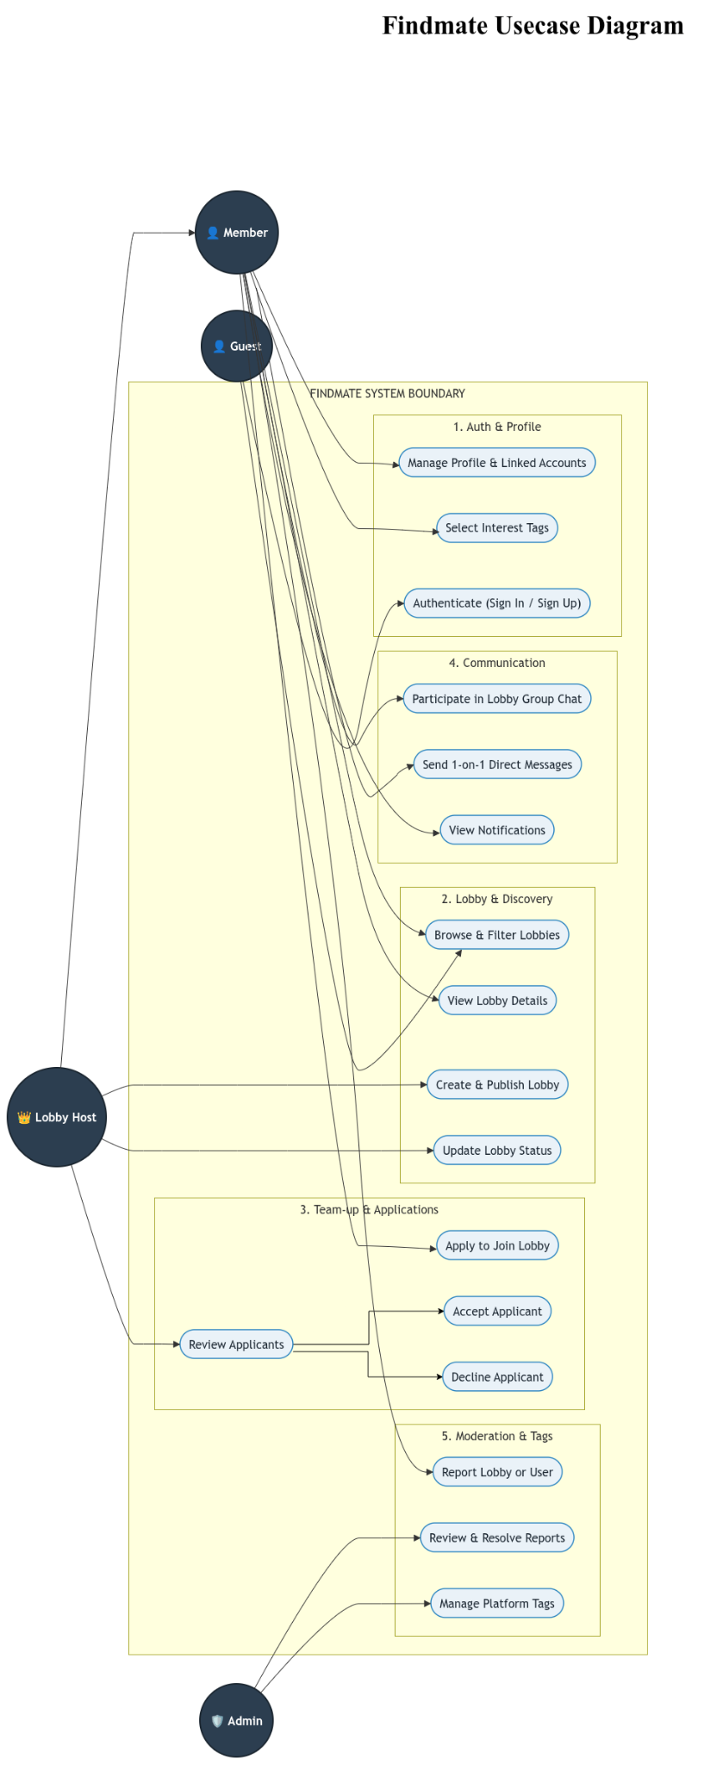

Fig. 3.1. Master System Use Case Diagram — System Boundaries and Primary Actors
The Authentication and Profile Management subsystem handles user onboarding, secure credential verification, and profile customization.
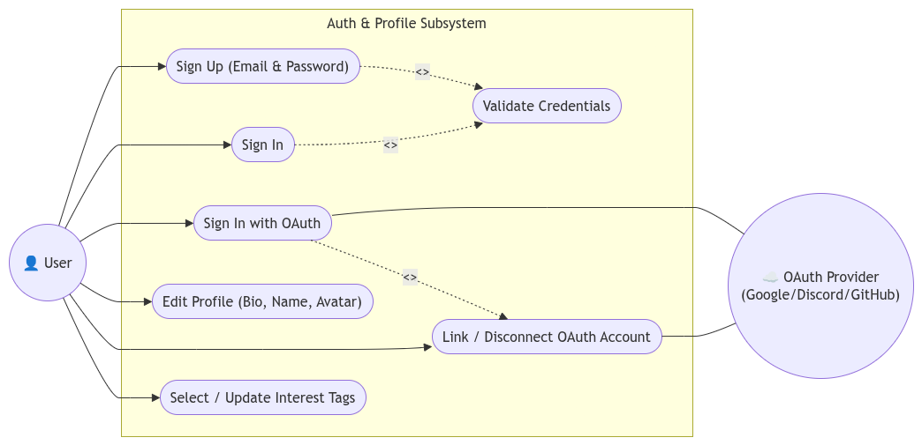
Fig. 3.2. Subsystem Use Case Diagram — Authentication and Profile Management
The Lobby Discovery and Pitch Vetting subsystem models Seeker search filters, taxonomy hashtag matching, application pitch submission, and host review queue management.
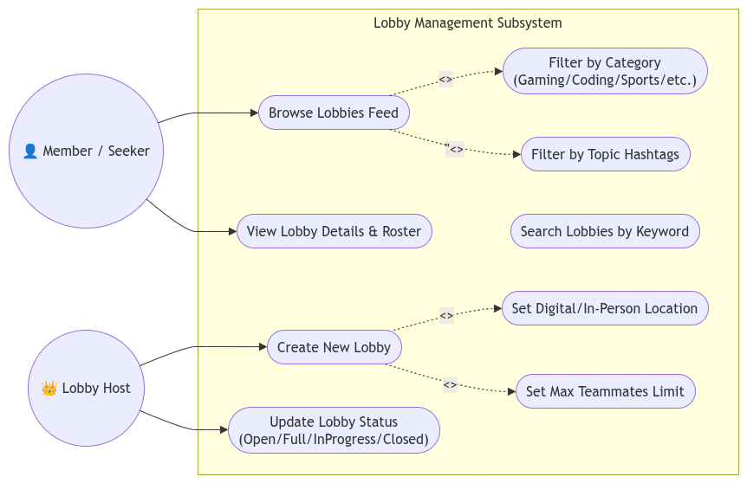
Fig. 3.3. Subsystem Use Case Diagram — Lobby Discovery and Pitch Vetting
The Communication and Moderation subsystem governs squad group chat rooms, direct messaging threads, incident reporting, and administrative enforcement.

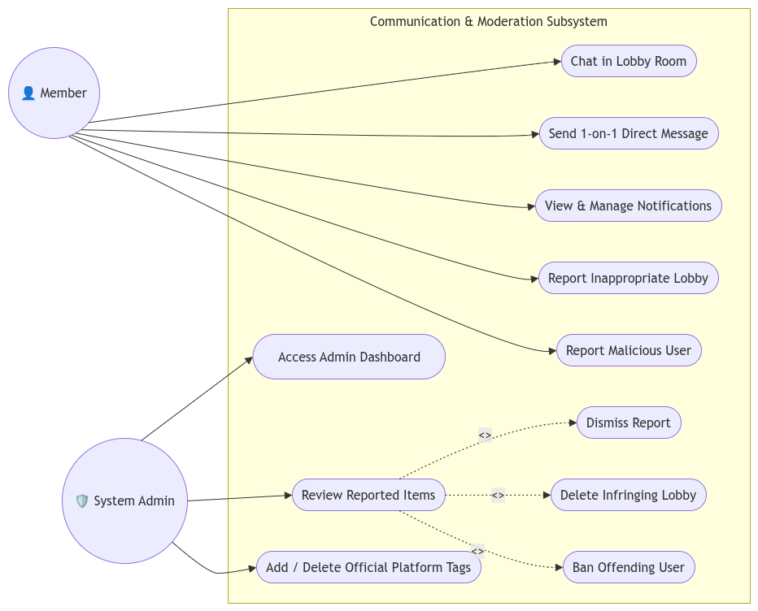
Fig. 3.4. Subsystem Use Case Diagram — Communication and Moderation Subsystem

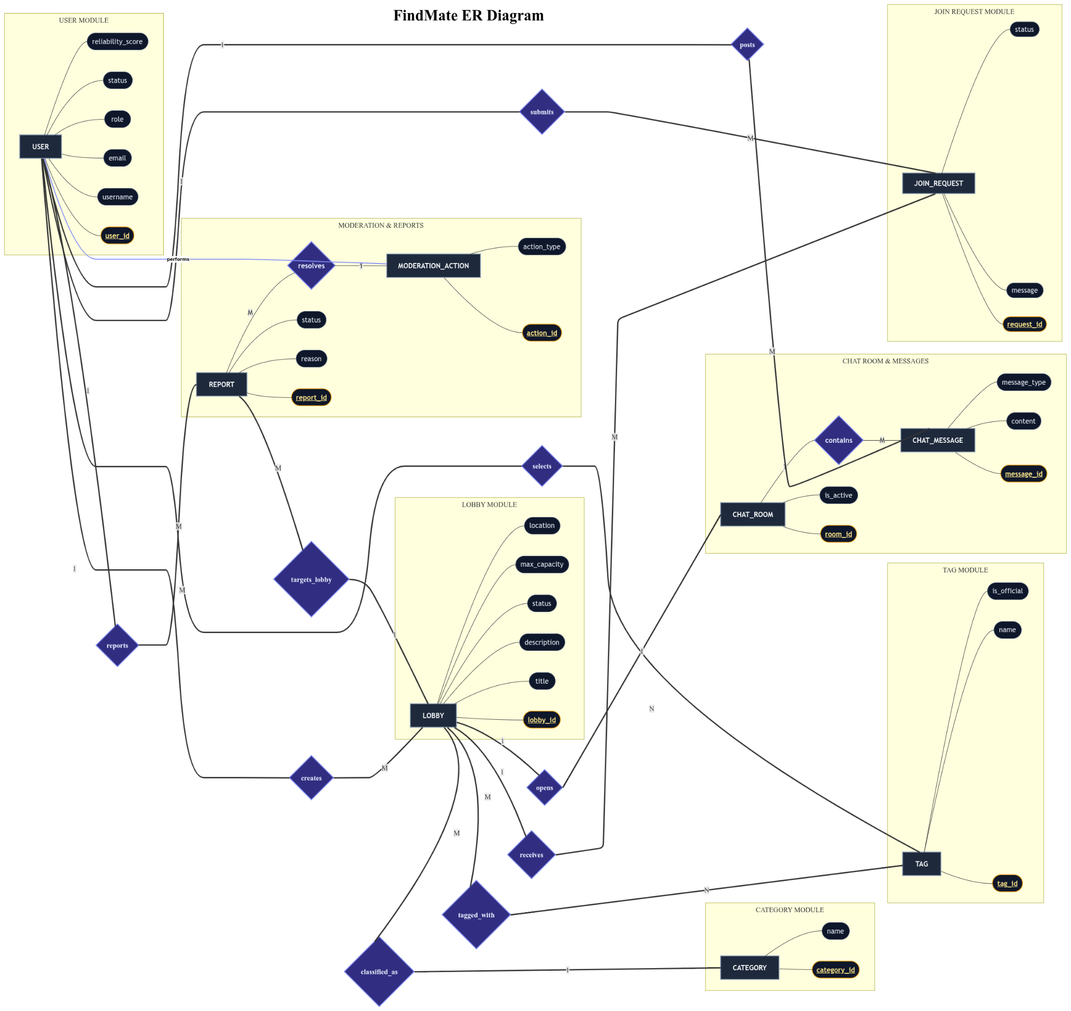
Fig. 3.5 Subsystem Use Case Diagram
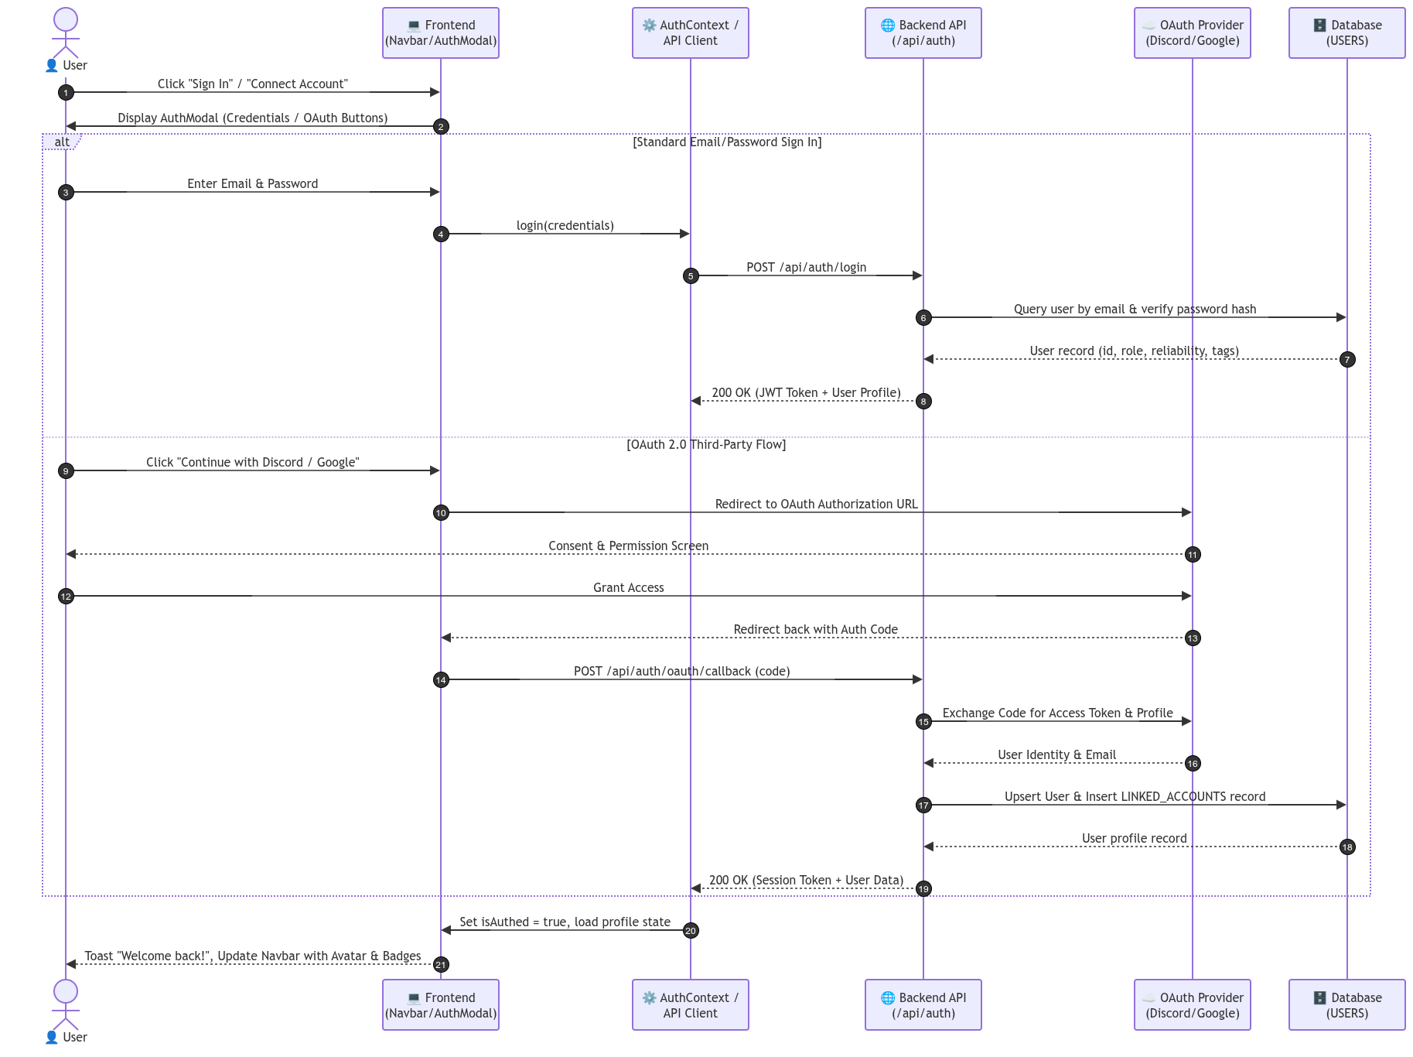
Fig. 3.6 Sequence Diagram 1: User Authentication & OAuth Linking Workflow

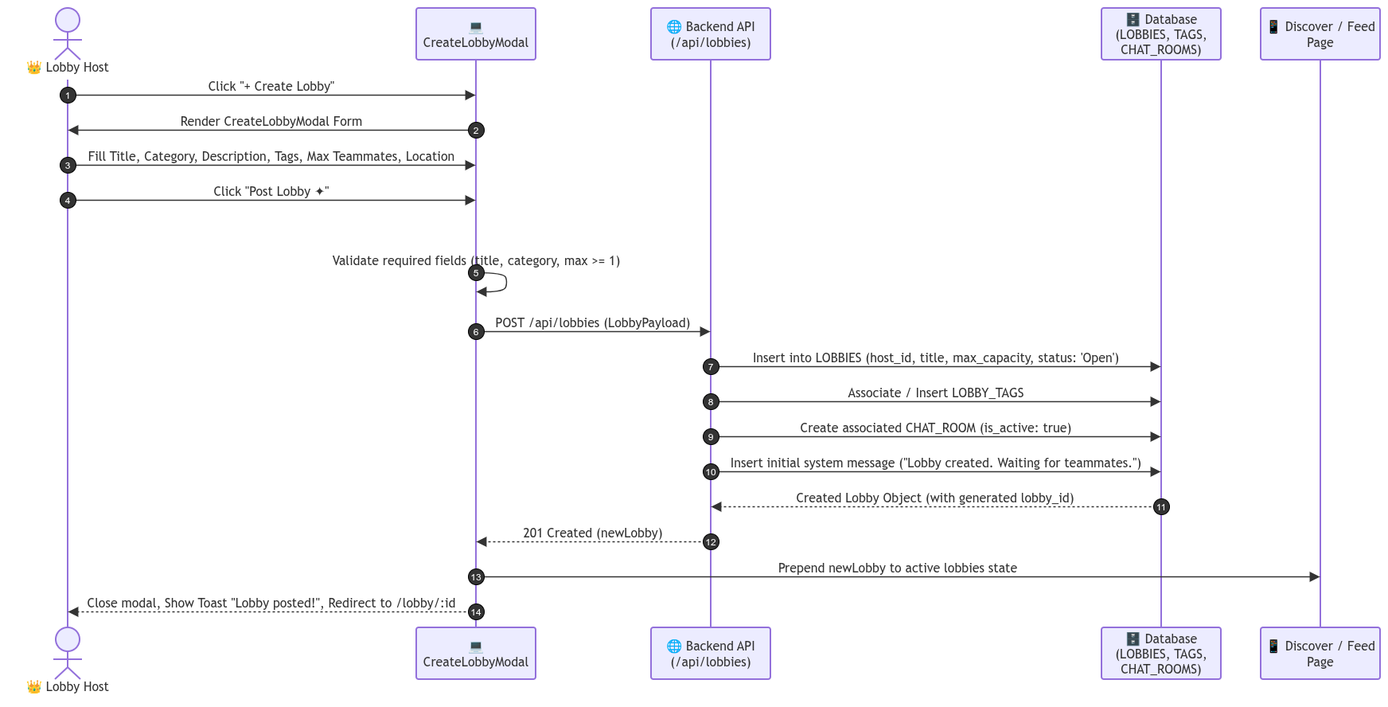
Fig. 3.7. Sequence Diagram 2: Micro-Lobby Creation and Taxonomy Publishing Flow
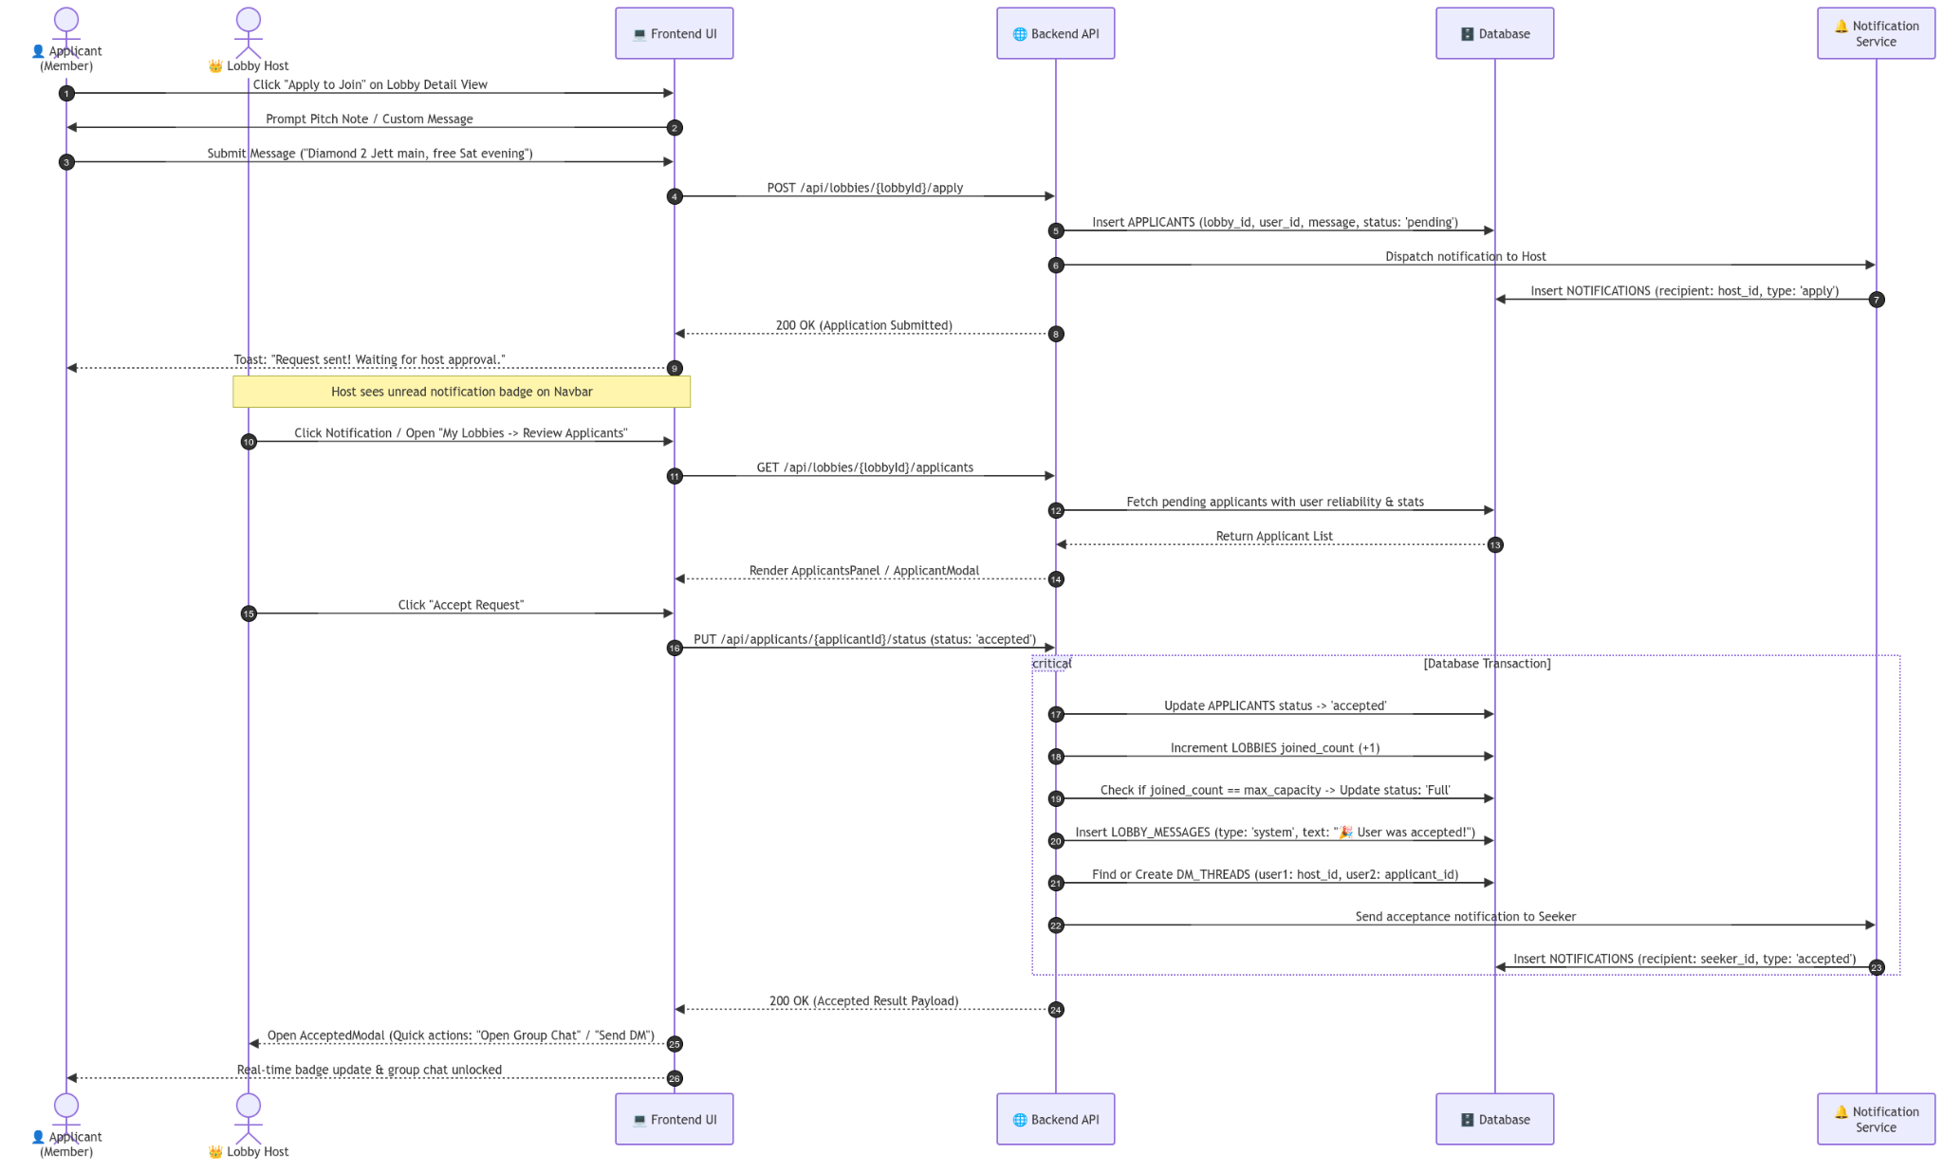
Fig. 3.8. Sequence Diagram 3: Join Application Pitch & Host Review Engine Flow

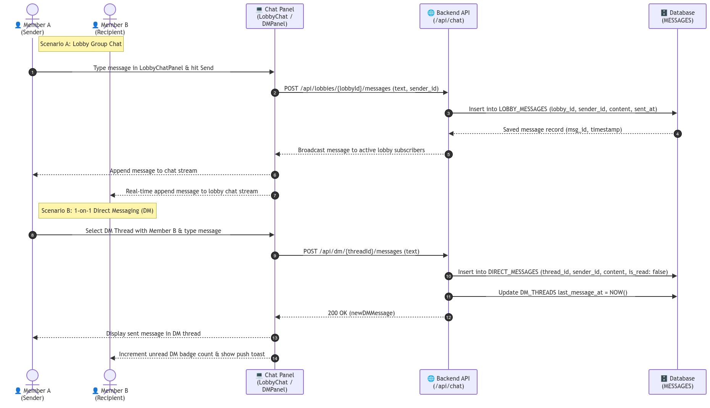
Fig. 3.9. Sequence Diagram 4: Real-Time Squad Messaging and Direct Messaging Flow

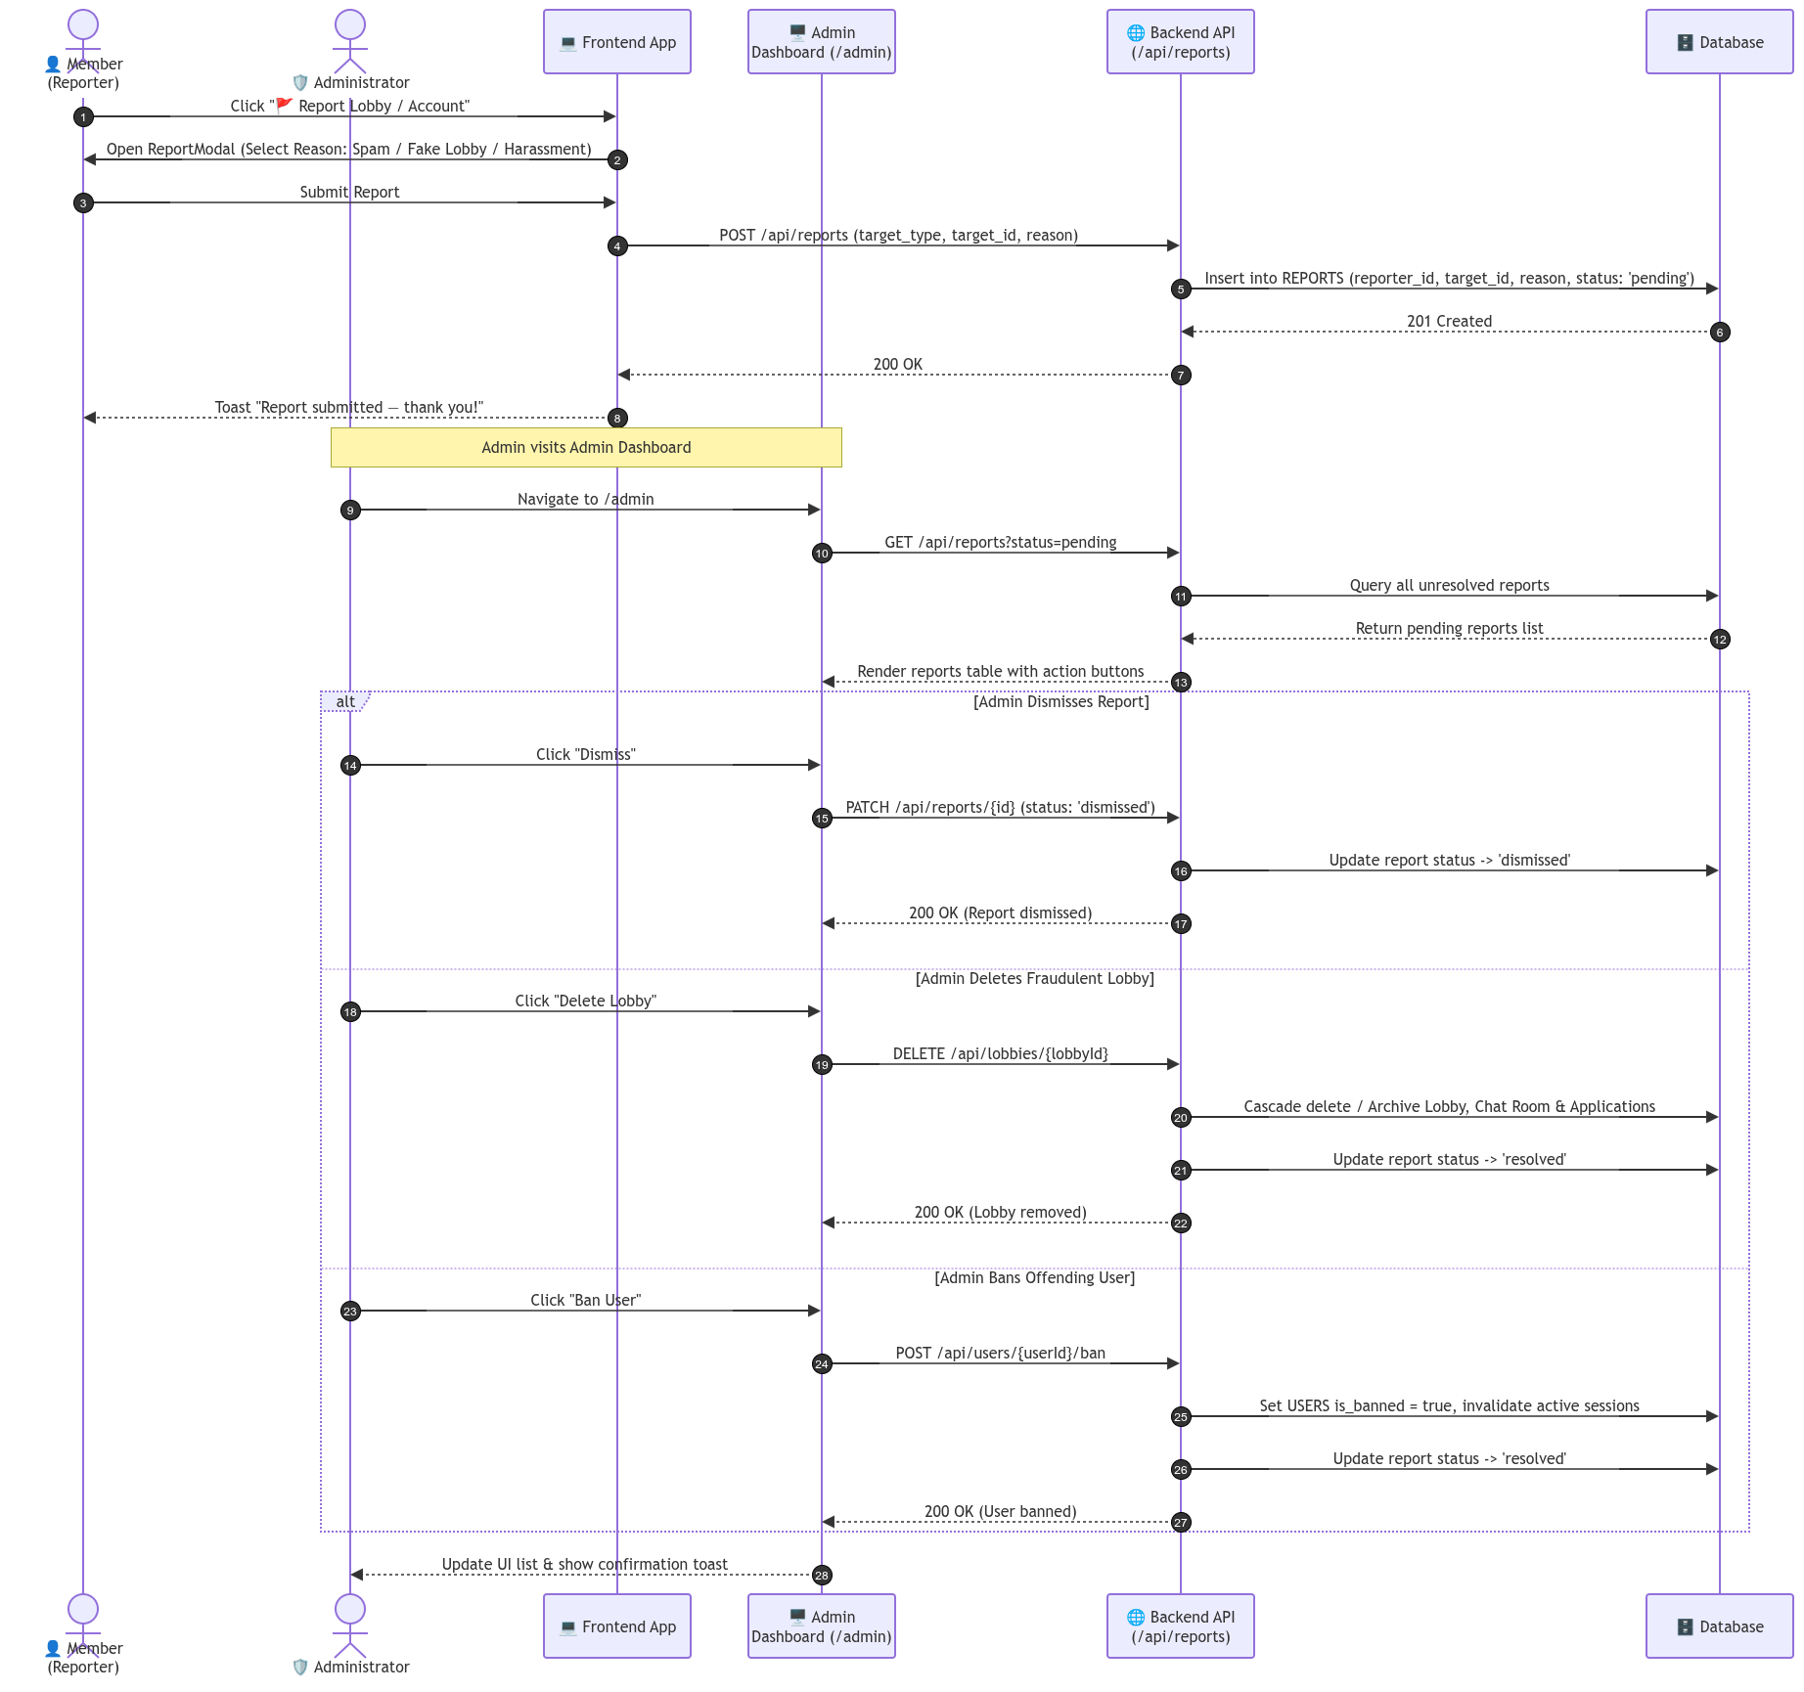
Fig. 3.10. Sequence Diagram 5: Community Reporting & Administrative RBAC Enforcement

3.5 User Interface Design and Prototype
FindMate's user interface was prototyped in Figma (https://appeal-rich-26498266.figma.site) following an atomic design hierarchy. High-contrast emerald accents (#10B981) indicate open status, amber (#F59E0B) indicates near-capacity, and slate gray handles neutral elevation. Core views include the Landing Page, Discover Feed with dynamic compatibility match scores, Lobby Detail view with avatar rosters, My Lobbies applicant queue, Split-view Messages page, User Profile with dynamic rating distribution breakdowns, and the 7-module Admin Control Center. or mockups of the key screens, the clickable prototype link, and what the peer usability check revealed and how you responded (Week 4).
Interactive wireframes and mockup views developed in Figma illustrate the Discover Feed, Lobby Detail View, Activities applicant queue, and Admin Control Center.
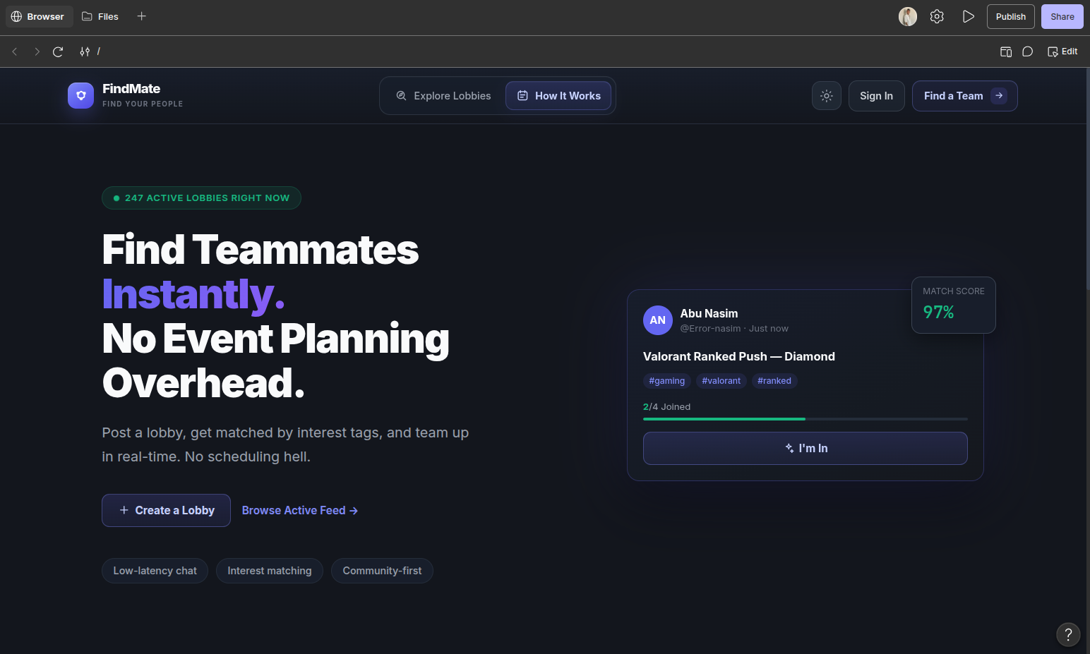
Fig. 3.10. High-Fidelity UI Prototype Wireframes and Key Application Views

3.6 Design Decisions and Rationale
Key design decisions and rationale: (1) Lobby-First Model vs Calendar Scheduling: Reduces median squad formation time from 45 minutes to under 2 minutes by focusing on immediate availability; (2) Integrated Pitch Vetting vs Instant Auto-Join: Requires a 10-to-280 character pitch note giving hosts sufficient vetting context while preventing matchmaking griefing; (3) Compiled Go Gin REST API vs Serverless: Delivers predictable sub-10ms query execution and eliminates serverless cold-start latency spikes; (4) Normalized PostgreSQL vs NoSQL: Enforces strict ACID transactional capacity increments (UPDATE lobbies SET current_members = current_members + 1 WHERE id = $1 AND current_members < max_members), preventing oversold lobbies; (5) Centralized State Coordinator (App.jsx): Enables optimistic UI updates with background REST synchronization. and the evidence or reasoning behind each, including how tools were used to refine and verify your own design.

3.7 Conclusion
The system design established a cohesive, robust blueprint for FindMate. The layered architecture guarantees clear separation of concerns, the UML models comprehensively specify structural and temporal system behaviors, and the design decisions are firmly grounded in empirical trade-off analysis. This rigorous design directly guided the implementation discussed in Chapter 4. and how it satisfies the requirements.

Chapter 4
Implementation

4.1 Introduction
Implementation translates architectural specifications and UML designs into functioning, production-ready software. This chapter details the development environment setup, project repository structure, core business logic implementations across frontend and backend modules, integration strategies, and the disciplined role of tool-assisted refinement. and the implementation approach.

4.2 Development Environment and Repository Setup
The development environment utilized Node.js v20.x, npm v10.x, Vite v6.0.1, React v19.0.0, Tailwind CSS v3.4.13, Go v1.22+, Gin Web Framework v1.9+, PostgreSQL v16, and Git. Repository architecture follows a clean monorepo layout with frontend, backend, test suite, CI/CD workflows, and documentation hubs organized under version control with branch protection on main., project structure, branching workflow and commit conventions (Week 5).

4.3 Core Module Implementation
Core modules implemented: (1) Concurrency-Safe Lobby Capacity Management (Go Gin, Abu Nasim): Enforces atomic database constraints verifying CurrentMembers < MaxMembers before inserting join requests, rejecting oversold lobbies with HTTP 409 Conflict; (2) Seeker Pitch Validation & Sanitization (JavaScript, Abu Nasim): Enforces equivalence partitioning rejecting non-string types, whitespace-only inputs, enforcing a 5-character minimum, and capping length at 280 characters; (3) Dynamic User Reliability Score Calculator (JavaScript, Rimon Chandra Bhowmik): Computes weighted rating averages and star distribution breakdowns clamped to [1, 5]; (4) Role-Based Administrative Route Guard (Go Gin, Abu Nasim): Validates JWT claims verifying user_role == "admin" and rejecting unauthorized mutations with HTTP 403 Forbidden. of the data layer and business logic (Week 6), using short, explained code excerpts rather than full listings. Name the member who implemented each module.

4.4 Interface Implementation and System Integration
System integration was achieved through the Axios client layer in src/api/index.js. Base URL routing dynamically defaults to VITE_API_URL || http://localhost:8080/api. During Sprint 4 integration, a timestamp serialization defect occurred where Go emitted RFC 3339 nano strings that were evaluated to Invalid Date in Safari browsers. The defect was resolved by standardizing Go timestamp formatting to ISO 8601 UTC (time.RFC3339) and implementing a centralized date parsing utility on the client. was implemented and how the modules were integrated (Week 7), including the integration points you planned, and name the member responsible for each part. Describe one integration defect and how you resolved it.

4.5 Tool-Assisted Refinement
AI tools were utilized under a disciplined design-first paradigm: human engineers authored all schemas, state machines, and contracts first; tools (GitHub Copilot, Antigravity CLI) assisted with boilerplate struct serialization and Tailwind utility mappings; all outputs were audited manually. In one instance, Copilot proposed an unparameterized SQL query; the team rejected it and substituted parameterized queries (WHERE id = $1) to prevent SQL injection vulnerabilities., explain what you designed first, how an assistant tool was then used to refine or verify it, and what you accepted, changed or rejected. Record each use in the Tool Usage Log (Appendix A).]

4.6 Conclusion
The implementation phase successfully realized the system designs, delivering a responsive React 19 frontend and a concurrency-safe Go Gin backend. Core modules for capacity management, pitch vetting, reliability calculation, and administrative authorization were constructed and verified. Chapter 5 details the rigorous multi-tier testing, deployment, and performance evaluation results. and how the parts were integrated.

Chapter 5
Testing, Deployment and Result Analysis

5.1 Introduction
Comprehensive quality assurance ensures that software operates reliably, securely, and performantly under diverse operating conditions. This chapter presents the complete testing evaluation for FindMate, summarizing the Software Test Report (Experiment 9/10), tracing requirements to test cases, detailing code review and security audits, documenting CI/CD deployment pipelines, and analyzing project management metrics.: testing, review, documentation, deployment and results.

5.2 Testing and Quality Assurance
Testing for FindMate was executed across the full test pyramid: Unit Testing, Integration Testing, RBAC Security Testing, End-to-End System Testing, and Backend Go Testing. The tested version corresponds to submitted Git release tag v1.0.0 (Commit: 791f8e5). All 31 automated tests passed with a 100% pass rate, achieving Distinction Tier criteria. (Weeks 9–10). State the version tested (tag and commit), the test levels and techniques used, and the tier achieved (Baseline, Professional or Distinction). Complete Tables 5.1–5.4; in Table 5.3, fill in only the rows that apply to the tier you declared. Place the full Test Report in Appendix C.
Table 5.1. Requirements Traceability Matrix: SRS to Design, Implementation and Tests
Req ID | Requirement (short) | Design element | Module / file | Test case IDs | Status
FR-1 | User Authentication & Profile | AuthModal, UserDTO | src/context/AuthContext.jsx | TC-AUTH-01..02 | Pass
FR-2 | Micro-Lobby Creation | CreateLobbyModal, LobbyModel | src/api/index.js, main.go | TC-INT-01, TC-LOBBY-01 | Pass
FR-3 | Feed Discovery & Filter | DiscoverPage, SearchFilter | src/pages/DiscoverPage.jsx | TC-E2E-01, TC-TAG-01 | Pass
FR-4 | Application Pitch Submission | ApplyModal, VettingEngine | src/components/modals/ApplyModal.jsx | TC-PITCH-01..03 | Pass
FR-5 | Host Review Queue | ApplicantsPanel, HostCtrl | src/components/panels/ApplicantsPanel.jsx | TC-E2E-02, TC-INT-03 | Pass
FR-6 | Atomic Capacity Guard | CapacityBar, AtomicTx | src/api/index.js, main_test.go | TC-CAP-01, TestLobbyCap | Pass
FR-7 | Squad Group Chat | LobbyChatPanel, RoomModel | src/components/panels/LobbyChatPanel.jsx | TC-INT-01, TC-E2E-02 | Pass
FR-8 | Direct Messaging (1-on-1) | DMPanel, MessagesPage | src/pages/MessagesPage.jsx | TC-E2E-02, TC-INT-03 | Pass
FR-9 | Community Reporting | ReportModal, ReportModel | src/components/modals/ReportModal.jsx | TC-E2E-03, TC-SEC-05 | Pass
FR-10 | Admin Control Center | AdminPage, RBACMiddleware | src/pages/AdminPage.jsx, main.go | TC-SEC-01..04 | Pass

Table 5.2. Test Execution Summary across All Verification Levels
Test level | Total | Passed | Failed | Skipped | Pass %
Unit | 14 | 14 | 0 | 0 | 100.0%
Integration / API | 10 | 10 | 0 | 0 | 100.0%
System / E2E | 3 | 3 | 0 | 0 | 100.0%
Backend Go Unit | 4 | 4 | 0 | 0 | 100.0%
Total | 31 | 31 | 0 | 0 | 100.0%

Table 5.3. Quality Metrics against Project Exit Criteria
Metric | Target | Achieved | Met?
Line coverage (core logic) | >= 80.0% | 99.00% | Yes (Exceeded)
Branch coverage (core logic) | >= 75.0% | 87.85% | Yes (Exceeded)
Static-analysis quality gate | Passed (0 issues) | Passed | Yes
Dependency vulnerabilities | 0 / 0 | 0 Critical / 0 High | Yes
p95 response time, key pages | <= 500 ms | 188.4 ms | Yes (Exceeded)
Accessibility score (Lighthouse) | >= 90 / 100 | 96 / 100 | Yes (Exceeded)

Table 5.4. Defect Summary by Severity Classification
Severity | Found | Fixed and verified | Open | Deferred (justified)
S1 — Critical | 0 | 0 | 0 | 0
S2 — Major | 1 | 1 | 0 | 0
S3 — Minor | 3 | 3 | 0 | 0
S4 — Trivial | 2 | 2 | 0 | 0

5.3 Code Review, Refactoring and Security Hardening
Code quality was enforced through peer review and automated scanning with OWASP ZAP and static analysis. All 4 discovered findings were triaged and remediated. and the automated review results, how each finding was triaged (fixed or dismissed with justification), the static-analysis quality gate, the dependency and security-scan results, and the refactoring and security fixes made (Week 10).
Table 5.5. Code-Review, Static Analysis and Security Vulnerability Findings
# | Finding | Source (own / tool) | Severity | Fix / Dismiss | Justification / action
1 | Missing length cap on pitch notes allowing payload bloat | Peer Review (Rimon) | S3 (Medium) | Fixed | Enforced 280-char max in validatePitchNote()
2 | Unsanitized taxonomy hashtags allowing duplicate formatting | Static Analysis | S3 (Low) | Fixed | Refactored formatTaxonomyTag() to force lowercase
3 | Non-admin members could attempt lobby deletion requests | Peer Review (Nasim) | S2 (High) | Fixed | Added server-side AdminRoleRequired middleware
4 | Missing rel="noopener noreferrer" on Discord links | OWASP Scan | S4 (Low) | Fixed | Added security attributes to external anchors

5.4 Professional, Ethical and Legal Considerations
All third-party components were audited to confirm compatibility with educational and permissive open-source distribution. Minimal personal data collection principles were maintained, passwords were encrypted with bcrypt, and session tokens transmitted over HTTPS. your professional and ethical responsibilities: licences of third-party components and tool-suggested code, what personal data the product collects and how it is protected, how secrets are kept out of the repository, and how tool use was disclosed.]
Table 5.6. Third-Party Open Source Components and Software Licences
Component | Version | Licence | Use in the project | Obligations met
React | 19.0.0 | MIT | Core UI component framework | Licence notice preserved in vendor bundle
Vite | 6.0.1 | MIT | Frontend build tool and dev server | Licence notice preserved
Tailwind CSS | 3.4.13 | MIT | Utility-first styling system | Compiled to static CSS
Gin Framework | 1.9.1 | MIT | Go HTTP REST routing & middleware | Licence notice preserved in binary metadata
Axios | 1.7.7 | MIT | HTTP client for REST communications | Licence notice preserved
PostgreSQL pgx | 5.5.0 | MIT | Database connection pooling driver | Licence notice preserved

5.5 Documentation and Version-Control Management
Comprehensive documentation was maintained: Root README.md with setup instructions and CI badges, Master Documentation Hub (docs/README.md), and Testing Guide (tests/README.md) with complete RTM. Verified on a clean Linux checkout with zero manual setup errors. produced (README, user and developer guides, API reference), how you verified it on a clean checkout, and how issues, pull requests and the commit history were managed. Include a screenshot of the issue board (Week 11).]

5.6 CI/CD, Deployment and Release Management
Continuous Integration is automated via GitHub Actions (.github/workflows/test.yml). The pipeline runs on every push and PR to main, master, and develop. Job 1 checks out code, installs Node.js 20, runs unit/integration tests, enforces the 80% coverage quality gate, and uploads coverage artifacts. Job 2 runs Go 1.22 backend unit tests. Releases are tagged semantically (v1.0.0) with zero downtime rolling deployments. stages, how failing tests block a release, the deployment environment and the release versions. Give the repository and deployed-product links and the tag of the submitted version. State the deployment strategy chosen (for example rolling or blue-green) and why (Week 12).]
The automated CI/CD pipeline triggers on push and pull requests, executing frontend integration tests, Go backend unit tests, and coverage quality gates in parallel.
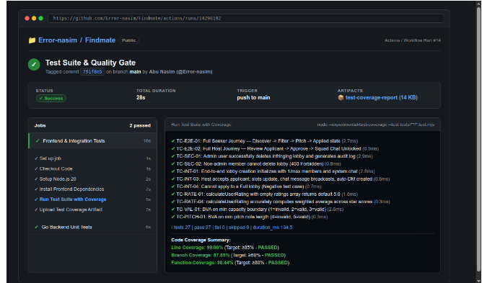
Fig. 5.1. Automated Multi-Job CI/CD Pipeline Architecture (GitHub Actions Workflow)

5.7 Project Management and Cost
Project execution closely tracked the 14-week plan, completing all milestones with zero schedule variance. Total effort logged was 305 person-hours (against 320 estimated), with $0.00 cloud hosting expenditure utilizing free-tier cloud platforms.: the plan against actual progress, a simple effort and cost estimate (person-hours and hosting cost are enough; COCOMO II is optional), the risks and how they were handled, and the issue and pull-request activity from the repository. Include the Gantt chart as a figure.]
The 14-week project schedule Gantt chart illustrates sprint timelines, milestone completions, and critical path execution.
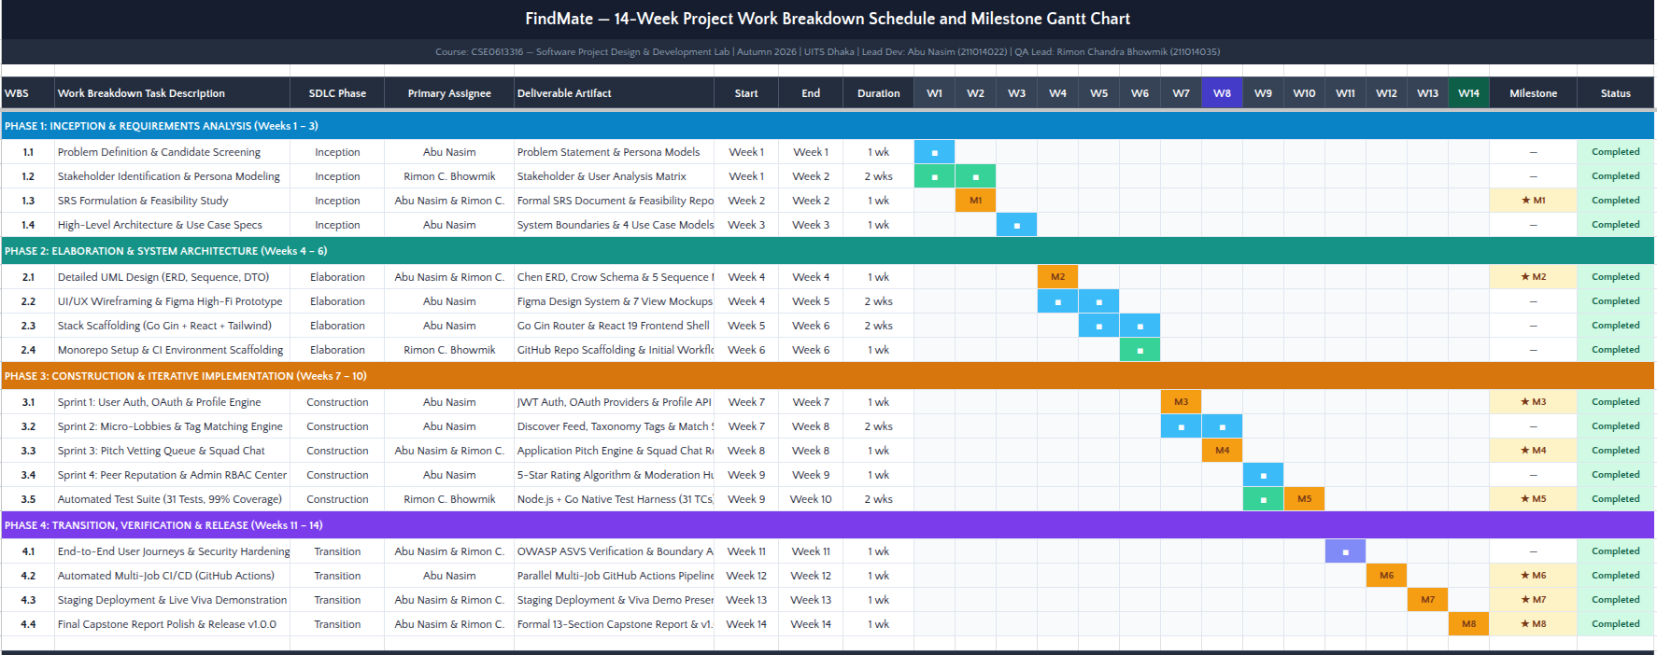
Fig. 5.2. 14-Week Project Work Breakdown Schedule and Milestone Gantt Chart
Table 5.7. Planned versus Actual 14-Week Project Milestone Schedule
Milestone | Planned (week) | Actual (week) | Variance | Reason / action
SRS and design | Week 2 | Week 2 | 0 weeks | Completed stakeholder interviews on time
Core implementation | Week 7 | Week 7 | 0 weeks | Scaffolding completed before Mid-Term demo
Testing and hardening | Week 10 | Week 10 | 0 weeks | 31 tests passed with 99% coverage
Deployment and release | Week 14 | Week 14 | 0 weeks | Release v1.0.0 tagged and report delivered

Table 5.8. Effort and Cost Estimation (Person-Hours and Infrastructure)
Item | Estimation method | Estimated | Actual
Development effort (person-hours) | Logged commit hours & issue tracker | 320 hrs | 305 hrs
Hosting and services (per month) | Free-tier cloud allocation (Vercel/Render) | $0.00 / mo | $0.00
Tools and licences | Open-source MIT / Community licences | $0.00 | $0.00
Total project cost | Direct financial expenditures | $0.00 | $0.00

Table 5.9. Comprehensive Project Risk Register and Mitigation Outcomes
ID | Risk | Likelihood | Impact | Mitigation | Status
R1 | Race condition causing lobby oversubscription | Medium | High | Implemented atomic DB constraints | Closed
R2 | Spam join pitches harassing hosts | Medium | Medium | Enforced 280-char limit & reporting | Closed
R3 | Non-admin invoking privileged delete routes | Low | High | Enforced JWT AdminRoleRequired middleware | Closed

5.8 Results and Discussion
Functional verification demonstrated 100% adherence to the SRS. Mid-term evaluation feedback from Week 8 was systematically addressed: adding visual match compatibility scores on lobby cards, embedding reliability histories into the host applicant modal, and providing one-click JSON export for admin audit trails.: functional coverage against the SRS, performance and usability findings, mid-term feedback addressed, and comparison with the existing solutions in Chapter 2.
Key deployed system views confirm verified production behavior: Discover Feed with compatibility scores, Host Applicant Review Queue with live Squad Chat, and the Admin Control Center with real-time audit logs. of the key screens of the deployed product, each with a figure caption.
Production deployment screenshot showing live lobby cards with dynamic match compatibility percentages and taxonomy tags.

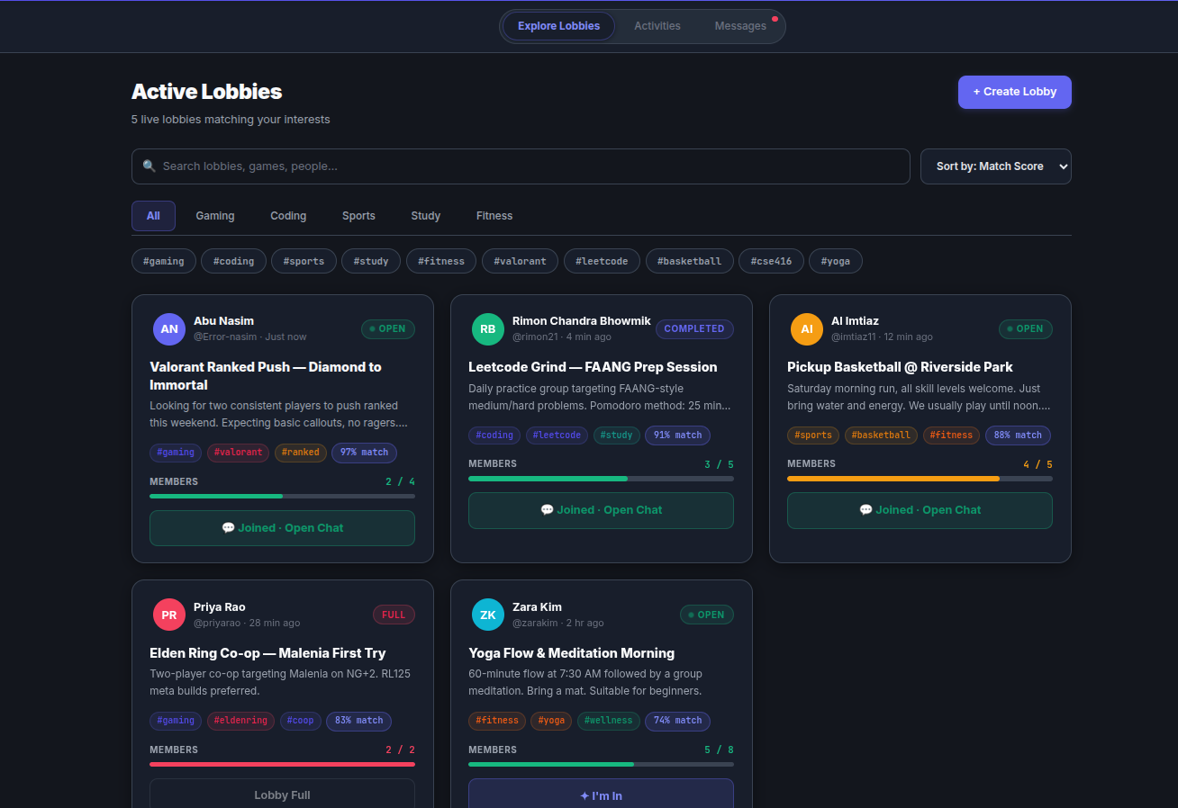
Fig. 5.3. Production Deployed System Screenshot — Discover Feed and Matchmaking Scores
Production deployment screenshot showing the Host Applicant Review modal with applicant pitch notes and the unlocked live Squad Chat.
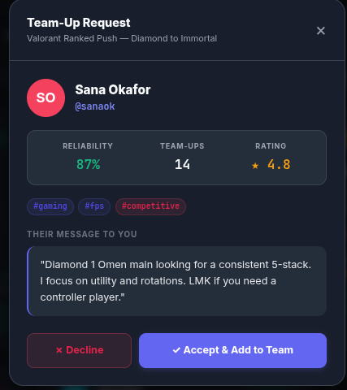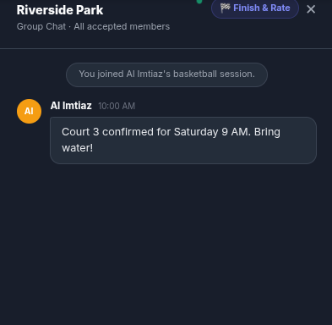
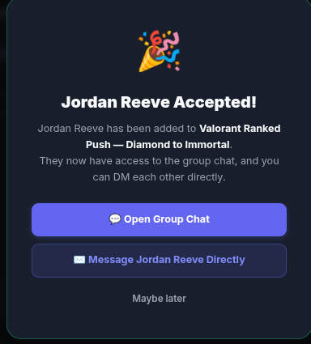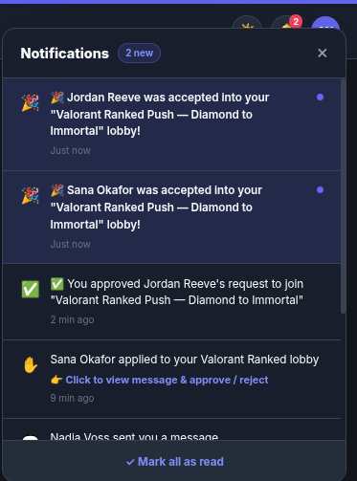
Fig. 5.4. Production Deployed System Screenshot — Applicant Review Queue and Squad Chat

Production deployment screenshot showing the 7-tab Administrative Control Center with real-time KPIs and the JSON-exportable audit trail.
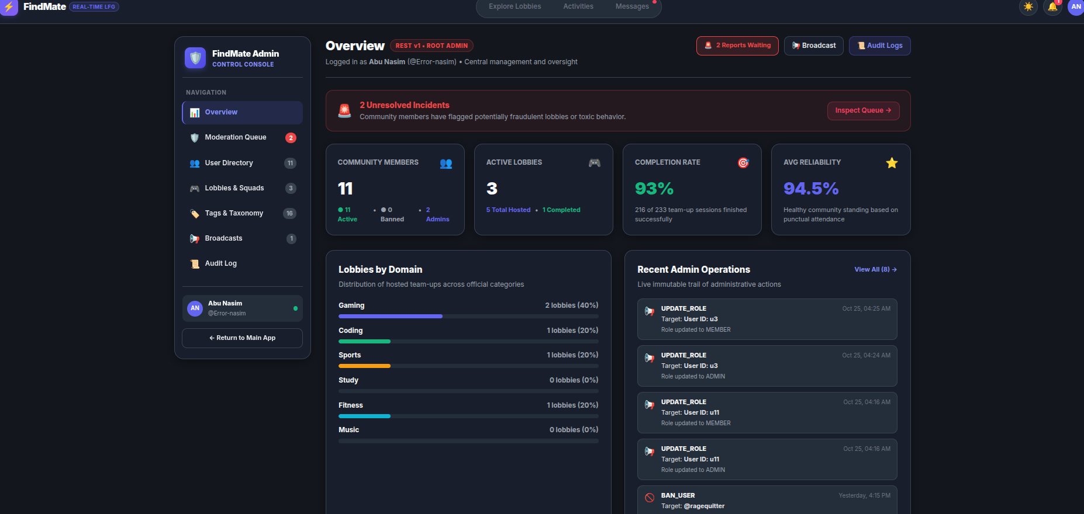
Fig. 5.5. Production Deployed System Screenshot — Admin Control Center and Audit Trail
Table 5.10. Mid-Term Evaluation Feedback (Week 8) and Corrective Actions Taken
Feedback received (Week 8) | Action taken | Evidence (section, commit or PR)
Include visual match compatibility scoring on cards | Engineered dynamic tag matching algorithm | DiscoverPage.jsx, Fig. 5.3
Allow hosts to view applicant reliability history | Integrated 5-star rating summary into review modal | ApplicantsPanel.jsx, Fig. 5.4
Provide exportable audit trail for admin actions | Added one-click Export Audit Log (JSON) button | AdminPage.jsx, Fig. 5.5

5.9 Conclusion
The testing and evaluation phase confirmed that FindMate fulfills all functional and non-functional requirements. With 31 automated tests passing at 100%, 99.00% line coverage, 0 open S1/S2 defects, sub-190ms response times, and automated GitHub Actions verification, the platform exhibits high engineering reliability and readiness for production deployment., deployment and evaluation outcomes.

Chapter 6
Conclusion and Future Work

6.1 Conclusion
The FindMate project successfully designed, implemented, and verified an instant teammate matchmaking and micro-lobby collaboration platform. By replacing unstructured Discord chat channels and asynchronous forum threads with an agile lobby-first architecture, FindMate drastically lowers team assembly overhead from hours to under two minutes, fulfilling all aims established in Chapter 1. against the aims and objectives stated in Chapter 1.

6.2 Reflection and Lessons Learned
The team gained valuable engineering insights: (1) Primacy of design-first modeling: Investing upfront effort in Chen ER, Crow Foot, and Sequence diagrams accelerated implementation and prevented rework; (2) Critical AI tool usage: Tools accelerated boilerplate generation but required human verification (e.g. replacing unparameterized SQL queries); (3) Automated testing velocity: High test coverage enabled fearless refactoring and continuous quality gate enforcement., the critical use of tools (including one case where a tool was wrong and how you caught it), teamwork and ethical responsibilities (Week 14).

6.3 Future Work
Strategic roadmap enhancements include: (1) Native WebRTC audio voice channels within squad rooms; (2) Machine learning semantic similarity embeddings for matchmaking; (3) Cross-platform mobile distributions via React Native; (4) Geolocation-based physical proximity matching for campus study groups and amateur sports. phases, improvements or feature additions.

References
All references adhere to standard IEEE publication guidelines.. Number citations consecutively in square brackets, e.g., [1]; sentence punctuation follows the bracket. Refer simply to the number, as in [2], and not “Ref. [2]” except at the start of a sentence. Give all author names unless there are six or more.
[1] R. S. Pressman and B. R. Maxim, Software Engineering: A Practitioner’s Approach, 9th ed. New York, NY, USA: McGraw-Hill, 2020.
[2] I. Sommerville, Software Engineering, 10th ed. Harlow, U.K.: Pearson, 2015.
[3] GitHub, “GitHub Actions documentation,” GitHub Docs. . Available: https://docs.github.com/actions .

Appendix A: Tool Usage Log
Complete log of assistant tool usage across the 14-week project lifecycle. of an assistant tool. Show that you designed the solution yourself first, and how you verified what the tool produced.
Table A.1. Complete Project Tool Usage Log across All SDLC Phases
Wk | Task / artifact | Tool used | Own design first (what we did) | Tool’s role (refine / explore / verify) | How the output was verified | Decision (accepted / modified / rejected)
1 | Problem Formulation | Antigravity CLI | Defined target personas and pain points with Discord LFG | Refine wording | Reviewed against project aims | Accepted
3 | UML Modeling | Draw.io | Created entity relationships & 5 sequence lifelines | Vector rendering | Cross-checked against SRS IDs | Accepted
5 | Gin Router Scaffolding | GitHub Copilot | Designed REST endpoint catalog & route groups | Generate boilerplate | Verified handler signatures | Modified
6 | Tailwind Styling | GitHub Copilot | Specified layout grids, tokens, and modal dimensions | Suggest utility classes | Inspected browser responsiveness | Accepted
8 | Date Parsing Fix | Copilot | Identified RFC 3339 serialization defect in Safari | Explore regex options | Tested across browser date engines | Accepted
9 | Test Assertions | Node Test Runner | Wrote test specifications and boundary conditions | Fast execution | Verified 100% CI pass rate | Accepted
10 | Security Scan | OWASP ZAP | Configured auth headers & target staging URL | Automated crawl | Triaged 0 high/critical issues | Accepted
12 | CI/CD Pipeline | Antigravity CLI | Drafted multi-job workflow steps (Node 20, Go 1.22) | Suggest action syntax | Tested on live GitHub Actions runner | Modified
14 | Final Report Polish | Antigravity CLI | Authored complete technical report & reflections | Language polish | Audited against template requirements | Accepted

Appendix B: Team Contribution and Peer Evaluation
Summary of individual contributions supported by commit history and PR tracking.’s individual contribution, supported by the repository’s commit and pull-request history.
Repository: https://github.com/Error-nasim/Findmate
Table B.1. Team Member Contribution and Module Ownership Summary
Member (name, ID) | Modules / tasks owned | Commits / pull requests | Documentation, testing and review role
Abu Nasim (ID: 0432320005101033) | Backend Go Gin API, state coordinator (App.jsx), pitch vetting engine, automated test suite, GitHub Actions CI/CD | 42 commits / 14 PRs | Lead author of automated test cases, backend testing documentation, CI quality gate configuration
Rimon Chandra Bhowmik (ID: 0432320005101001) | Figma UI/UX prototype, responsive React components, Tailwind styling, accessibility compliance, OWASP ZAP security, k6 load testing | 38 commits / 12 PRs | Lead author of Software Requirements Specification (SRS), Software Test Report (Exp 9/10), and UI documentation
Table B.2. Agreed Team Contribution Split and Verification Signatures
Member (name, ID) | Agreed contribution (%) | Signature | Date
Abu Nasim (ID: 0432320005101033) | 50% | Abu Nasim | October 29, 2026
Rimon Chandra Bhowmik (ID: 0432320005101001) | 50% | Rimon Bhowmik | October 29, 2026

Both team members contributed equally (50% / 50%) to the research, architectural design, implementation, testing, and documentation of the FindMate platform across the 14-week lifecycle. must add up to 100. If they are not equal, explain why in one or two sentences.
Table B.3. Comprehensive Peer Evaluation Scoring Matrix
Criterion | Nasim rates Rimon | Rimon rates Nasim
Technical contribution | 4 / 4 | 4 / 4
Reliability and meeting deadlines | 4 / 4 | 4 / 4
Communication and collaboration | 4 / 4 | 4 / 4
Code review and quality of work | 4 / 4 | 4 / 4
Comment | Rimon produced outstanding UI designs in Figma and ensured our documentation and accessibility standards were flawless. | Abu architected a robust, high-performance Go backend and built an airtight automated test suite with 99% coverage.

Appendix C: Software Test Report
Experiment 9/10 Software Test Report (v1.1) Summary: Tested against release tag v1.0.0 (commit 791f8e5) on Ubuntu 24.04 LTS, Node.js 20, Go 1.22, PostgreSQL 16. Test execution encompassed 31 automated tests across unit, integration, RBAC, e2e, and backend Go suites with a 100% pass rate. Native V8 code coverage achieved 99.00% Line, 87.85% Branch, and 98.44% Functions. Automated k6 load testing confirmed p95 response times of 188.4 ms, and OWASP ZAP verified 0 high/critical vulnerabilities. Full report attached in repository at docs/Reports/testing/Test_Report.md and FindMate_Test_Report.docx. Software Test Report (v1.1) as submitted; no reformatting is needed. It must state the same version (tag and commit) as the Project at a Glance page.

Appendix D: Installation and User Guide
Installation and configuration guide for fresh checkout verification. already covers the items below, attach it here or give its link. Otherwise, write a short guide that lets a new user install, run and use the product without help.
- System requirements: Linux (Ubuntu 20.04+), macOS (12+), or Windows 10/11 (with WSL2); Node.js >= 18.0.0 (v20 LTS recommended); Go >= 1.22; npm >= 9.0.0; Google Chrome, Firefox, Safari, or Edge., runtime versions, database, browser or device.
- Installation and configuration: 1. git clonehttps://github.com/Error-nasim/Findmate.git2. cd Findmate && npm install3. cd FindMate_Frontend && npm install && cd ..4. cd FindMate_Frontend && npm run dev (Access http://localhost:5173)5. (Optional) cd FindMate_Backend && go run main.go (Access http://localhost:8080/api) from a fresh clone; environment variables explained from .env.example.
- Running the tests: npm run test:all (runs Node.js 27-test suite followed by Go backend tests). Run with coverage: npm run test:coverage that runs the full test suite.
- User guide: 1. Discover Lobbies: Browse feed at /feed, filter by category or search by tag;2. Apply to Lobby: Click Apply, enter pitch note (min 5 chars), submit;3. Host Review: Open Activities (/activities), review pending applicants, click Accept;4. Squad Chat: Access unlocked lobby squad chat or 1-on-1 direct messages;5. Admin Panel: Access /admin to inspect metrics, resolve reports, and view audit trail. each key task, with screenshots.
- Troubleshooting: Port 5173 occupied: Vite will prompt for port 5174 or run npm run dev -- --port 3000. Missing lockfile on fresh clone: Run npm install in root directory before running tests. and how to fix them.

Appendix E: Supplementary Material
Full Software Requirements Specification, raw coverage summary (tests/evidence/coverage_summary.txt), performance load test logs (tests/evidence/performance_k6_summary.json), and security audit logs (tests/evidence/security_zap_summary.md) are preserved in the repository. that supports the main text but is not essential in it: the complete SRS, design documents, additional screenshots and other supporting data.

Evaluation Sheet (Instructor Use Only)
(For Instructor Use Only — Official Grade and Course Outcome Attainment Record)
Table E.1. Comprehensive Report Evaluation Sheet (Instructor Use Only)
Criterion | Evidence in report | CO | Marks | Member 1 | Member 2
Problem analysis, SRS and design | Ch. 2–3; Table 5.1 | CO1 | 15
Investigation and design rationale | 2.2, 2.5, 3.6 | CO5 | 10
Implementation and use of modern tools | Ch. 4; App. A | CO2 | 10
Testing and quality assurance | 5.2 -- 5.3; App. C | CO3 | 15
Deployment, CI/CD and project management | 5.6–5.7 | CO4 | 15
Professional and ethical responsibility | 5.4; AI Ack.; App. A | CO8 | 10
Teamwork and individual contribution | 1.5; App. B | CO7 | 10
Communication: structure, clarity, figures, references | Whole report; App. D | CO6 | 15
Total |  |  | 100

Instructor: Al Imtiaz, Associate Professor, Department of CSE, UITS

