

QATAR UNIVERSITY
DEPARTMENT OF COMPUTER SCIENCE AND ENGINEERING
CMPS - Object-Oriented Programming
Course Project Report
Spring 2026

Project Title

Online Visa Processing System

Submitted By:
- Hassan Abdus Salam - 202210576
- Hashir Khan – 202318103
- Abdulhadi Hassan - 202405764
- Ayham Mukahal- 202413731

Contents
Online Visa Processing System 1
Part I: Introduction 3
Part II: Project Objectives 3
Part III: System Design 3
Part IV: Added Methods and Enhancements 4
Part V: Screenshots of System Functionalities 6

Part I: Introduction
The purpose of our project is to design and implement an Online Visa Processing System using principles that employ the use of Object-Oriented Programming. The system simulates a real-world immigration office where applicants submit visa applications, officers review them, and administrators manage the whole system.
The project applies important OOP concepts such as inheritance, polymorphism, abstraction, encapsulation, composition, interfaces, and ArrayLists.
.

Part II: Project Objectives
The main objectives of this project are:
- Develop a menu produced in Java.
- Manage applicants, officers, and visa applications.
- Process Tourist, Student, and Work visas.
- Apply inheritance using subclasses of Application.
- Use polymorphism for fee calculation.
- Save and load system data using CSV files.
- Generate useful reports

Part III: System Design

Main Classes Used
Class | Purpose
Application | Parent abstract class for all visa applications
TouristVisa | Represents tourist visa requests
StudentVisa | Represents student visa requests
WorkVisa | Represents work visa requests
Applicant | Stores applicant information
Officer | Stores visa officer information
VisaProcessingSystem | Main management class
DataManager | Interface for file operations
DataLoader | Implements loading and saving CSV files
Main | Contains menu system

OOP Concepts Applied:
Encapsulation: Private attributes with getters/setters
Inheritance: Visa types extend Application
Polymorphism: calculateProcessingFees() overridden in subclasses
Abstraction: Application class is abstract
Composition: Application contains Applicant and Officer objects
Interfaces: DataManager interface implemented by DataLoader

Part IV: Added Methods and Enhancements

Class-VisaOfficeSystem
1. displayApplicationTabular(Application a)
Purpose:
Improves readability of application data instead of using raw toString().
2. displayApplicationsTabular(ArrayList<Application> app)
Purpose:
Provides a clean UI for listing applications (used across multiple features).
3. displayApplicationsBeforeDate(LocalDate date)
Purpose:
Adds reporting capability for date-based filtering.
4. calculateTotalRevenue()
Purpose:
Supports financial reporting for the system.
5. displayPendingApplications()
Purpose:
Helps admin monitor unprocessed applications.
6. applicantWithMostApplications()
Purpose:
Provides analytical insight into system usage.
7. Save()
Purpose:
Ensures data persistence before system exit.
Class-Application
1. approveApplication()
Purpose:
Sets application status to APPROVED.
2. rejectApplication()
Purpose:
Sets application status to REJECTED.
Class – Tester
1. adminMenu / officerMenu / applicantMenu (Scanner in, VisaOfficeSystem system)
Purpose:
These methods act as sub-controllers. They encapsulate the logic for different user roles, preventing the main method from becoming cluttered and allowing for a modular, role-based navigation system.
2. loadData(VisaOfficeSystem system)
Purpose:
Pre-populates the system with sample data for immediate testing and demonstration.
3. reportsMenu(VisaOfficeSystem system, Scanner in)
Purpose: Centralizes administrative tools for generating financial and statistical reports.
4. printApplications (Overloaded
Purpose: A versatile filtering tool used to display applications by status, date, or owner.
5. printApplicationRow(Application a)
Purpose: Ensures consistent, tabular formatting for all application lists in the console.
6. createVisaApplication
Purpose: A guided input process for creating specific Tourist, Student, or Work visa objects.

Part V: Screenshots of System Functionalities and Conclusion

Figure 1
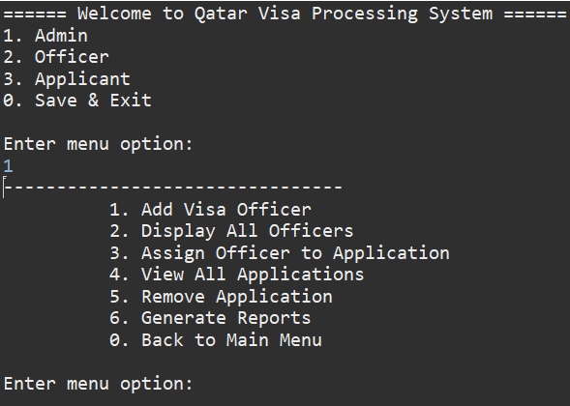
The input is 1 in the main menu, so the admin’s menu is accessed
Admin Functions:
Figure 2
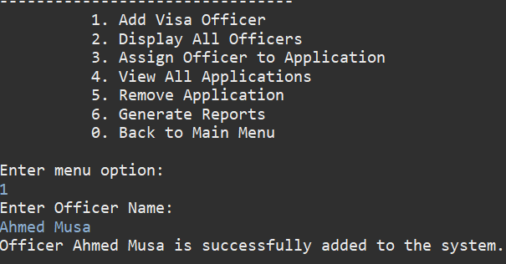
The input is 1 is the admin’s menu, so add Visa officer method is called

Figure 3
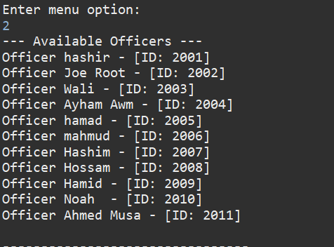
The input is 2 is the admin’s menu, so Display Visa officer method is called

Figure 4
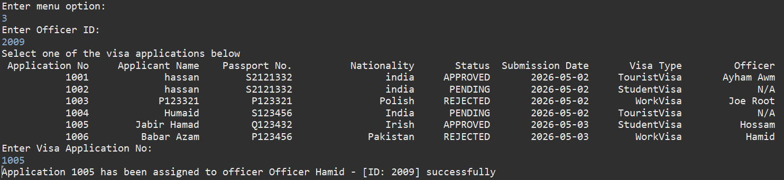
The input is 3 is the admin’s menu, so Assign Officer to Application method is called

Figure 5
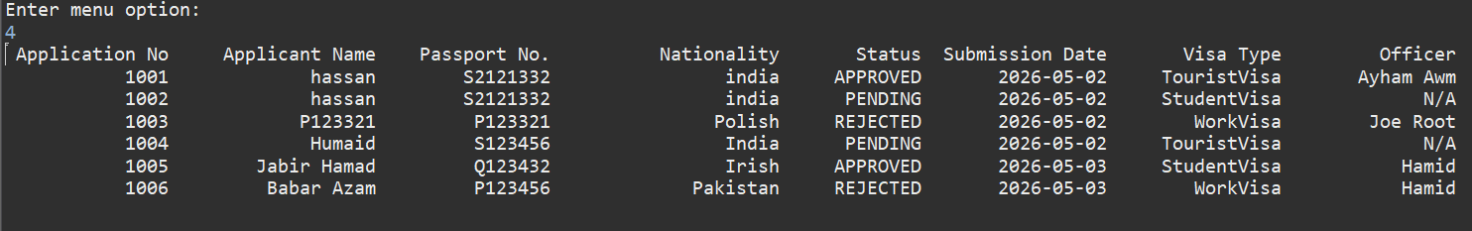
The input is 4 is the admin’s menu, so DisplayAllApplications method is called

Figure 6
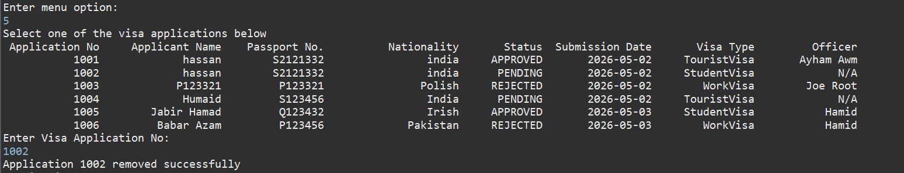
The input is 5 is the admin’s menu, so RemoveApplication method is called

Figure 7
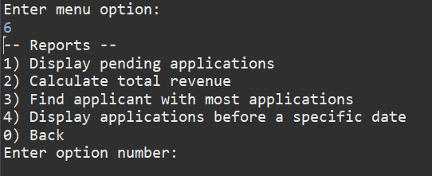
The input is 6 is the admin’s menu, so ReportMenu is called
Examples of Report Menu Methods:
Figure 8
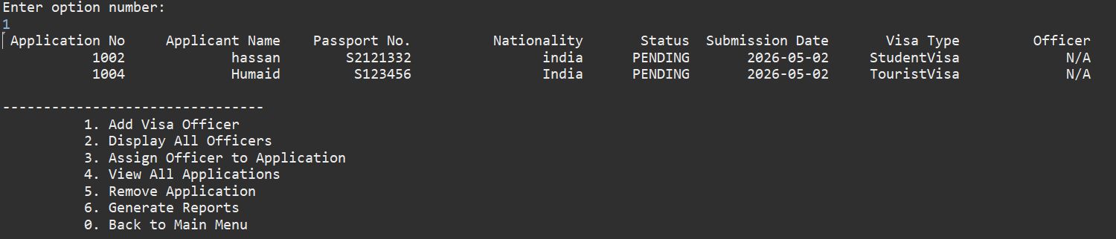
Displaying pending applications, first method of report menu
Figure 9
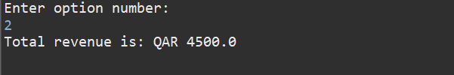
Calculating total revenue, second method of report menu
Figure 10
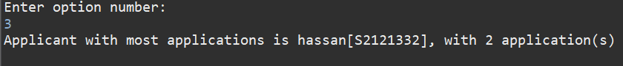
Finding the applicant with most applications, third method of report menu
Figure 11
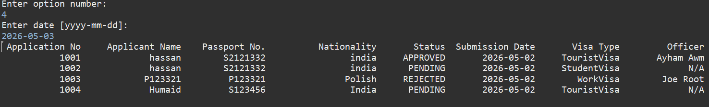
Displaying applications before specific date, fourth method of report menu
Figure 12
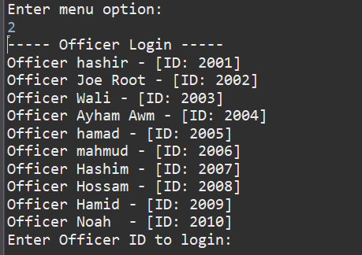
The input is 2 in the main menu, so the officer’s login is shown
Officer Functions:
Figure 13
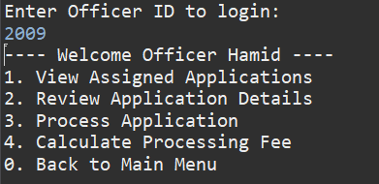
officer menu options
Figure 14
Displaying assigned Applications, function 1
Figure 15
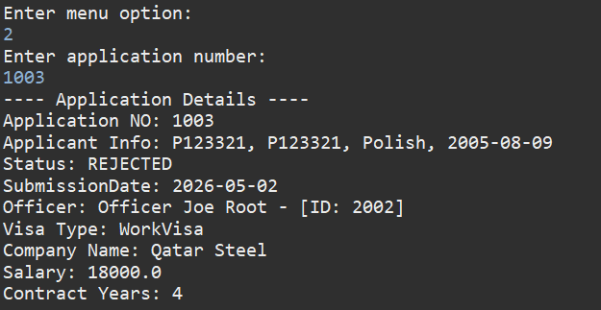
Reviewing applications details, function 2
Figure 16
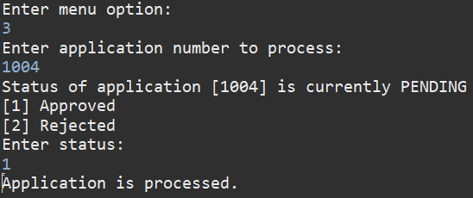
Processing applications, “1” to approve and “2” to reject, function 3

Figure 17
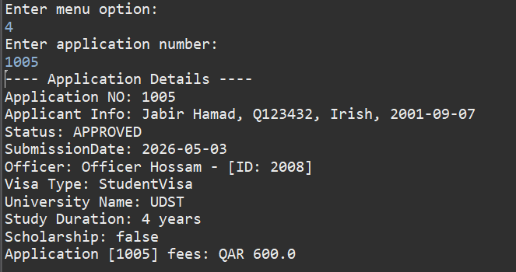
Calculating processing fee for an application, function 4
Figure 18
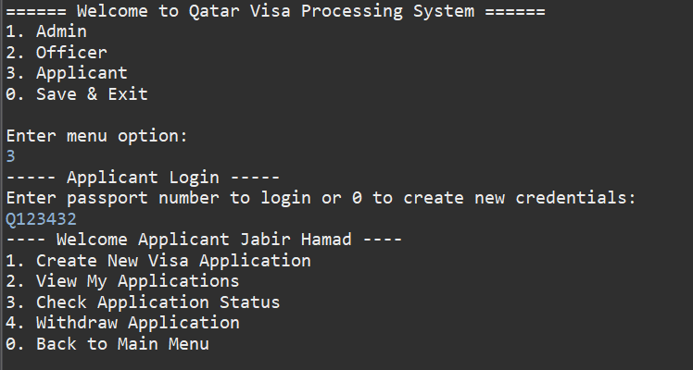
The input is 3 is in Main Menu, so Applicant’s menu is accessed

Conclusion:
This project successfully shows how the implementation of an Online Visa Processing System is performed, using Java and Object-Oriented Programming concepts. The system provides efficient management for applicants, officers, and administrators while maintaining persistent storage using CSV files.

