TEMASEK POLYTECHNIC
SCHOOL OF ENGINEERING

Diploma in Computer Engineering

Design Report
Object-oriented Programming
AY2026/2027 Apr

Submitted By

Sean Nathan Albus Policarpio Esguerra
Lu ShiCheng

PE04 – Group07
Project Title:
Sandwich Order System

Declaration of Originality

We are the originator of this work, and we have appropriately acknowledged all other original sources used as my reference for this work.
I/We understand that Plagiarism is the act of taking and using the whole or any part of another person’s work, including work generated by AI, and presenting it as my/our own.
I/We understand that Plagiarism is an academic offence
and if I am/ we are found to have committed or abetted the offence of plagiarism in relation to this submitted work, disciplinary action will be enforced.

Note:
1. This report should only cover items 1a, 1b & 2 of your project. No need to
include bonus features in this report.
2. The class diagram does not need to follow MVC for the design report.

A) Project Objectives
The objective of this project is to develop a digital, role-based sandwich ordering system for Super Sandwich Store. For customers, the application should provide an intuitive self-service interface to create orders with customisable bread types and ingredients, and to modify or confirm them with ease. For staff, the application should provide tools to create, edit, and delete bread types and ingredients on the menu, as well as view order summaries, monitor inventory, and calculate total sales to support daily operations efficiently. UML diagrams are produced before implementation to communicate the system design clearly, ensuring that stakeholders of Super Sandwich Store can understand the intended solution before development begins. These features are to be implemented in Java to leverage its object-oriented capabilities to ensure a maintainable and extensible codebase that minimises future technical debt as additional features may be added to enhance the application’s usage for users.

B) Project Design & Discussion
- Use Case Diagrams (include justification)

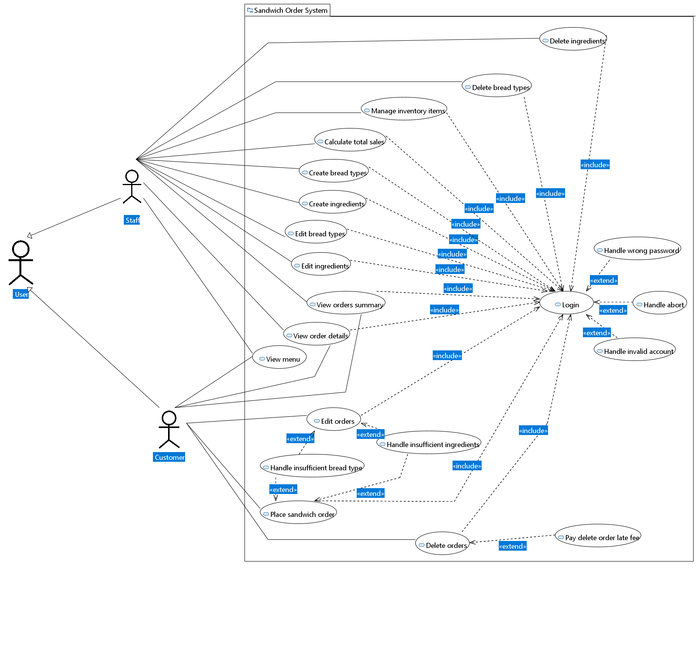

Justification:
Login is a use case that both the Customer and Staff actors’ use cases generally include as it serves as a similar, mandatory requirement before using the app itself. This ensures that all actions performed within the system are linked to authenticated users, and that each user is restricted to only the functions allowed for their respective roles.

Login has three <<extend>> relationships to handle edge cases. Although it is not explicitly specified in the requirements, handling these edge cases are necessary for the system’s stability and security. Handle Wrong Password extends Login when an incorrect password is entered, Handle Invalid Account extends Login when an unrecognised account is used, and Handle Abort extends Login when a user chooses not to proceed. Failing to account for these cases may result in crashes, unexpected behaviour, or security vulnerabilities such as unintended access to another user's account.

Confirm/Save is not modelled as a separate use case for either the Customer or Staff actor. This is because saving or confirming data to the data storage (vector) is not a distinct, goal-oriented task that an actor independently does. Rather, it is an internal system behaviour that occurs as part of completing another use case, such as Place Order or Create Bread and Ingredients.

- Customer
The Customer actor is directly associated with View Menu, Place Order, Edit Order, Delete Order, View Order Summary, and View Order Details use cases as derived from the project requirements and informed assumptions.

View Menu is associated with both the Customer and Staff actors as both need to be able to view available bread types and ingredients when placing, editing, or managing orders. View Menu does not have a Login <<include>> relationship, as browsing the menu does not require authentication. Although View Menu is not explicitly specified in the project requirements, it is a logical assumption that use cases such as Place Order and Edit Bread and Ingredients would require the actor to first be able to view the available items.

View Order Details is associated with both the Customer and Staff actors. Customers need to view their own orders to manage them through editing or deletion, while staff need to view orders across all customers. Although the scope of what each actor can view differs, both share the same underlying use case of viewing order details, and it is therefore modelled as a single shared use case rather than duplicated separately.

Login has an <<include>> relationship with Place Order, Edit Order, Delete Order, View Order Summary, and View Order Details for the Customer actor, as authentication must be completed before any of these actions can be performed. This ensures that orders are traceable to individual customers, and that customers are restricted from accessing staff-exclusive functions, to maintain system security and role separation.

For Edit Order and Delete Order, we defined them as separate use cases because they represent fundamentally different outcomes. Editing modifies the details of an existing order, whereas deleting permanently removes it from the system. Combining them into a single use case would misrepresent their distinct functional behaviours.

Place Order and Edit Order each have an <<extend>> relationship with Handle Insufficient Stock. This accounts for situations where the selected bread type or ingredients are out of stock and cannot be fulfilled. Although this is not explicitly specified in the requirements, not handling such cases for a major action could result in incomplete or invalid orders being placed, which would negatively impact both the customer experience and system integrity.

Delete Order has an <<extend>> relationship with Pay Delete Order Late Fee when deleted late such that the order had already been made or is being made in the process. Realistically, if a customer cancels an order that has already been prepared, the business would incur a loss. This use case handles such situations like requiring the customer to compensate for the cost incurred. Again, although this is not explicitly stated in the requirements, it is a practical assumption necessary to protect the business.

Select Bread Type and Select Ingredients are no longer modelled as separate use cases extending from Place Order. This is because the selection of bread type and ingredients is not an independent, goal-oriented task but rather an integral part of the ordering process itself. Separating them would fragment what is naturally a single, continuous interaction, and misrepresent the actual flow of placing an order.

- Staff
The Staff actor is associated with the use cases of View Menu, Create Bread and Ingredients, Edit Bread and Ingredients, Delete Bread and Ingredients, View Order Summary, View Order Details, Calculate Total Sales, and Manage Inventory, as derived from the project requirements.

View Order Summary and View Order Details are modelled as two separate use cases because a staff member may choose to view only the summary of all orders without needing to see the specifics of each individual order, and vice versa. Combining them into a single use case would force both actions to occur together or prevent the staff from accessing only the specifics of the order directly, which does not reflect how staff would realistically interact with the system.

Keep Track of Inventory has been rephrased to Manage Inventory, as the original phrasing was considered too vague in scope. Manage Inventory better reflects the active, system-supported nature of the function, which may encompass actions such as viewing current stock quantities and updating inventory record.

Other use cases are not further elaborated as they are relatively straightforward for staff.

- Generalisation
A generalisation relationship is modelled between Staff and Customer to a User, as both actors share common attributes such as name and email that are used for general login purposes. This reflects the object-oriented principle of inheritance, where shared behaviour and attributes are captured in a common base, while each actor retains their own distinct use cases and access privileges.

- Domain Class Diagram (no justification needed)

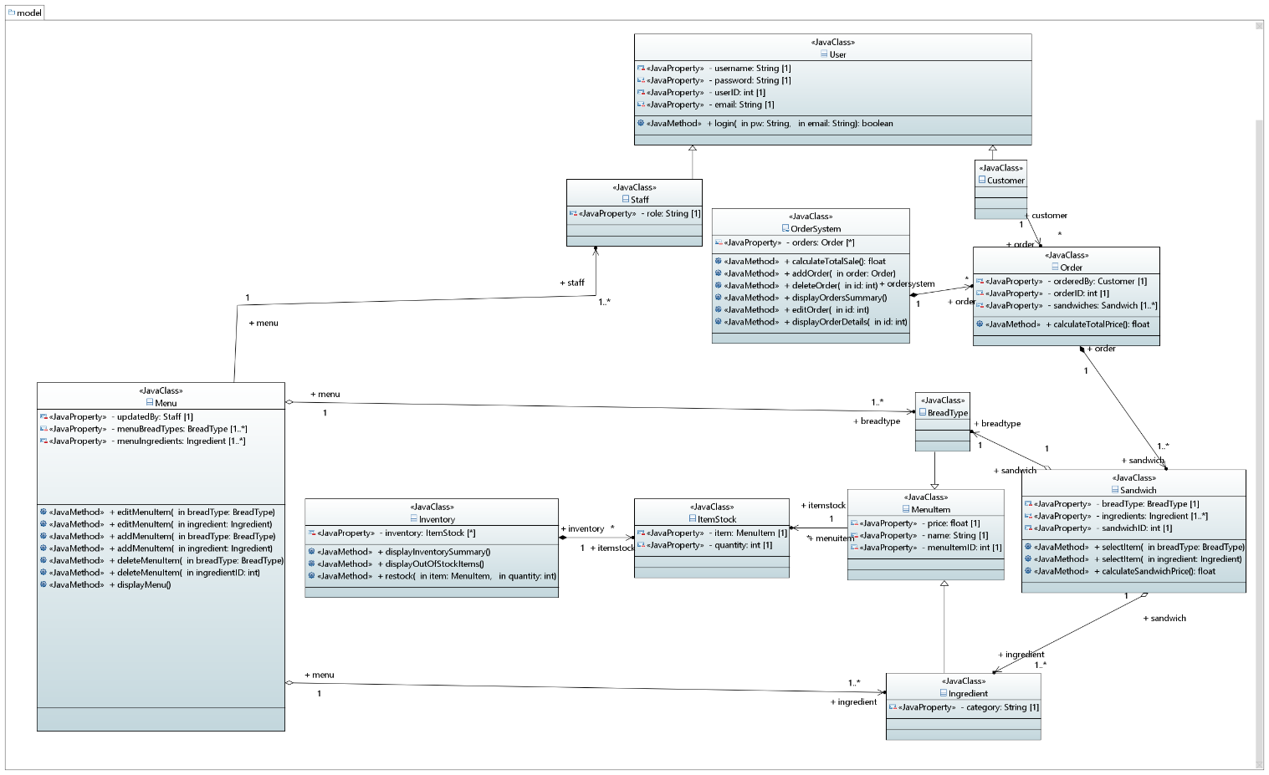

- Work Distribution

Tasks | Done by (who) | Completion(Y/N)
Create initial GitHub repository and files | Albus | Y
Create Use Case Diagram | Albus | Y
Create Class Diagram | Albus & Shi Cheng | Y
Write project objectives | Albus | Y
Write work distribution | Albus & Shi Cheng | Y
Write report conclusion | Albus & Shi Cheng | Y

C) Conclusion
State problems encountered, lessons learned and plan for the next stage.

In this project, there were some difficulties that arose during the early stages. Personally, we found configuring a shared GitHub repository within Eclipse to be very unintuitive, as neither of us had prior experience with version control integration on the IDE. We also had initial uncertainty around the scope of the design report, particularly around what qualified as a valid use case and how to assess whether something was too minor to warrant its own use case or whether it was simply part of a larger process. For instance, it was initially unclear whether actions like Confirm/Save should be modelled as independent use cases or treated as internal steps within an existing use case. We also had difficulty determining the correct multiplicity values in our class diagrams, as it was not always straightforward to reason about the relationships between classes quantitatively.

These challenges were addressed through proactive troubleshooting and communication. The GitHub issue was largely resolved by utilizing Claude AI for step-by-step guidance to aid our own understanding, though all written work and design decisions were completed independently. The uncertainty around what was considered a use case was similarly resolved through continuous clarification with our OOP lecturer. By doing so, we were able to confirm that actions such as Confirm/Save did not qualify as separate use cases as they are internal system behaviours rather than independent, goal-oriented interactions. Multiplicity was also clarified through consultation with our lecturer. Through this iterative process of questioning and refinement, we developed a more grounded understanding of how to apply use case modelling appropriately, and how object-oriented principles such as encapsulation and inheritance translate from theory into actual system design in class diagrams.

For the next stage, we will be coding the CRUD operations for Modules 1a and 1b using the domain class diagram as a guide while maintaining consistent progress through task delegation tracked on GitHub. We will also continue to communicate openly about work capacity and clarify doubts early to ensure a smooth collaboration experience.

