MECHANICS OF SOLIDS PROJECT / APPLICATION STUDY

A chiral honeycomb core for a morphing Eppler 420 airfoil
Displacement-controlled finite element comparison with a straight-web core
Uttej K.

Abstract
This study applies a hexachiral honeycomb to a deformable Eppler 420 airfoil section. The central lattice was mapped into the cambered profile and compared with a straight-web core of nearly the same mass. Both models used aluminium 6061-T6 and were analysed in Ansys Mechanical under a prescribed displacement immediately behind the middle section. At a 0.50 mm actuator stroke, the chiral section produced 0.529 mm of vertical trailing-edge travel, versus 0.418 mm for the straight-web section, while the required reactions were 96.01 N and 23.69 N. At a common trailing-edge travel of 0.50 mm, interpolation of the recorded data gave actuator strokes of 0.473 mm and 0.599 mm and actuation work of 0.02144 J and 0.00849 J, respectively. The chiral arrangement therefore used about 21% less stroke and 2.53 times as much work to reach that output. The study links the original unit-cell model to section-scale behaviour and identifies the stress and mesh checks needed before higher-stroke results can be used.
Keywords: hexachiral honeycomb, auxetic lattice, morphing airfoil, Eppler 420, finite element analysis, actuator work.

1. Introduction
The companion MOS project report [1] develops the hexachiral unit-cell mechanics, evaluates the analytical models using chiral_models.m [2] and compares them with a finite three-dimensional coupon. Its Eppler 420 chapter records the design, the reduced section model and the simulation data underlying this application study.
A morphing section can change camber by distributing deformation through its structure. The present comparison asks whether changing the internal architecture improves displacement transfer at comparable mass, and what that change costs in force, work and local stress. Spadoni and Ruzzene [3] provide the published reference architecture.

Scope
The numerical model represents a 20 mm-deep airfoil segment. The recorded quantities describe static actuation for this section. Aerodynamic loading, flight performance, full-wing bending, fatigue and experimental validation fall outside the reported simulation comparison.

02 / UNIT-CELL MECHANICS

2. From unit cell to airfoil core
The reference honeycomb has ring centres on a triangular lattice. Tangential ligaments join neighbouring rings with a consistent handedness. Under ideal in-plane dilation, the rings rotate in the same sense and the ligaments bend. Sections 4–7 of the companion report [1] derive the geometry and bending energy using rigid nodes and slender Euler–Bernoulli ligaments.
Let R be centre spacing, r the ideal tangent lever arm from a ring centre to the ligament centreline, ℓ the ideal straight ligament length, β its inclination to the centre line, t the in-plane ligament thickness and d the extrusion depth. The geometry gives
$l = \sqrt{R^{2} - 4r^{2}}, sin β = \frac{2r}{R}$ (1)
$I = \frac{dt^{3}}{12}, U_{lig} = \frac{6E_{s}I}{l}θ^{2}$ (2)
Here I is the second moment of area for in-plane bending, Es is the solid material modulus and θ is the common end rotation relative to the ligament chord in the ideal cell. At fixed ring spacing, attachment geometry and rotation, the cubic dependence on t explains why thickness changes strongly affect bending stiffness. It also motivates checking ligament thickness and mesh resolution after the mapping.
$ν_{eff} = -\frac{ε_{trans}}{ε_{ax}} → -1$ (3)
Equal in-plane strains in the limiting dilation mode give the value in Eq. (3). At R = 25 mm, r = 5 mm and t = 1 mm, the rigid-ring model with finite axial compliance gives ν ≈ −0.954 and E/Eₛ ≈ 1.741 × 10⁻³ [4]. These quantities describe an ideal periodic lattice. The mapped airfoil has finite boundaries, deformable rings, skins and changing local thickness. Its response is compared using tip travel, reaction, work and peak stress.
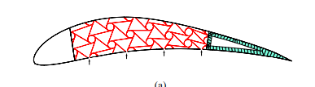
Figure 1. Published reference configuration used to guide the project CAD. The chiral truss occupies the middle of the Eppler 420 profile, ahead of a tapered cellular tail. Reproduced from Spadoni and Ruzzene [3, Figure 5(a)].
In the airfoil, the unit-cell mechanism provides a way to distribute deformation between the leading section and tail. The reaction to the actuator depends on the assembled load path through rings, ligaments, skins and boundaries. A compliant ideal dilation mode therefore does not, by itself, determine the stiffness measured at the actuator.

03 / GEOMETRY

3. Airfoil geometry and control case
The 330 mm chord follows the Eppler 420 coordinate set documented in the companion report [1, Section 10.1]. The project CAD uses a 20 mm extrusion and divides the section into a solid nose, an explicitly modelled middle body and a cellular tail. Let x increase from the nose to the trailing edge and z increase upward. The design uses the upper and lower ordinates at each chordwise position to map a flat lattice into the available thickness.
$h(x) = z_{u}(x) - z_{l}(x), z_{c,0}(x) = \frac{z_{u}(x) + z_{l}(x)}{2}$ (4)
$z(x, ζ) = z_{c,0}(x) + \frac{ζ}{H_{0}}h(x)$ (5)
The flat reference coordinate ζ is measured from its mid-height with H₀ = 60 mm. Mapping makes local ring shapes, ligament orientations and member thicknesses vary along the airfoil. The reference-lattice dimensions in Table 1 therefore describe the geometry before mapping. The ideal tangent lever arm in Section 2 and the CAD ring mean radius are separate geometric definitions.
Table 1. Dimensions and architecture of the project CAD. See Section 10.1 of the companion report [1].
CAD feature | Nominal value or layout
Eppler 420 chord c | 330 mm
Extrusion depth | 20 mm
Nose to middle / middle to tail | 45 mm / 235 mm from the nose
Middle / tail chordwise length | 190 mm / 95 mm
Chiral core | 21 rings in three staggered rows
Reference pitch / mean ring radius | 25 mm / 5 mm
Reference ligament / ring wall | 1 mm / 1 mm
Upper and lower boundary wall | 1 mm measured vertically
Chiral design tail webs | 0.8 mm chordwise thickness at 6 mm pitch

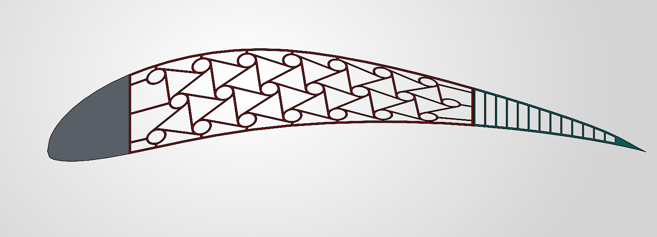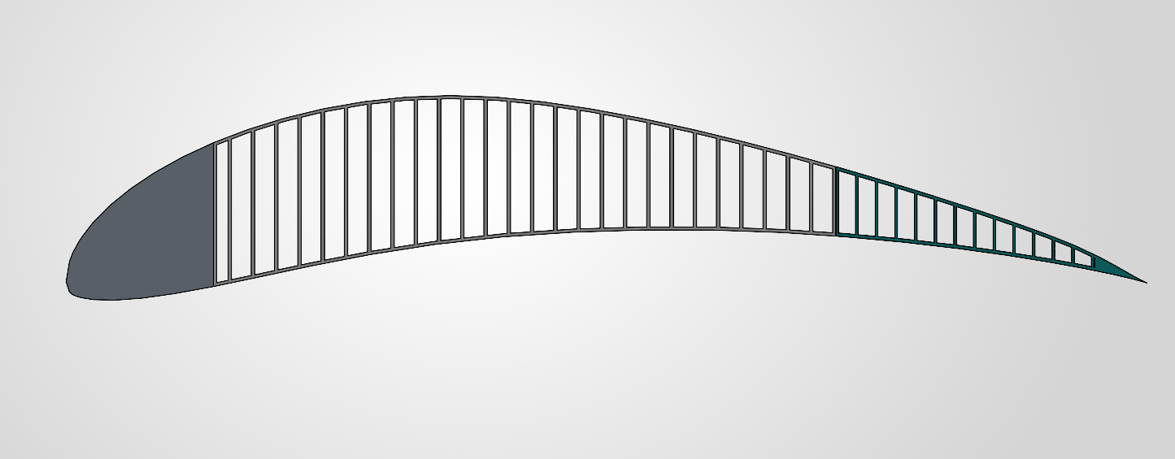
Figure 2. CAD sections of the two Eppler 420 configurations. Left, the chiral core uses circular rings and tangential ligaments. Right, the control uses straight webs in the middle section. Both configurations have a solid nose and a tapered webbed tail. Project CAD images.
The straight-web control places straight internal webs in the middle region and uses the corresponding nose, actuator and trailing-edge locations. The core masses in [5] cover the middle section and its associated skin. At 79.839 g and 80.649 g, the chiral and straight-web cores differ by 0.810 g, about 1.0% relative to the control. This comparison concerns two specific internal layouts and a common outer profile.

04 / SIMULATION METHOD

4. Displacement-controlled finite element study
The two models were analysed in Ansys Mechanical 2025 R1. All solid components were assigned aluminium 6061-T6. The solid geometry resolves the internal walls and ligaments explicitly. The material assigned to these parts is the parent alloy. Any effective auxetic response would emerge from deformation of the architecture.
Table 2. Reported analysis setup and output definitions. Sources: companion report [1, Section 10.3] and comparison workbook [5].
Setting | Applied in the comparison
Support | Fixed support on the side faces of the leading section (nose).
Actuation | Vertical prescribed displacement immediately behind the middle section, at the corresponding chordwise location in both models.
Ramp points | 0.25, 0.50, 0.75 and 1.00 mm of downward actuator stroke.
Tip measurement | Vertical displacement sampled at the end edge of the trailing section.
Reaction and stress | Vertical actuator reaction magnitude and maximum reported von Mises stress in the middle section.
Mesh sizing | Default for the nose and 0.8 mm nominal element size for the middle and tail of both models.
Loading scope | Displacement-driven actuation. The comparison workbook contains no aerodynamic pressure load case.

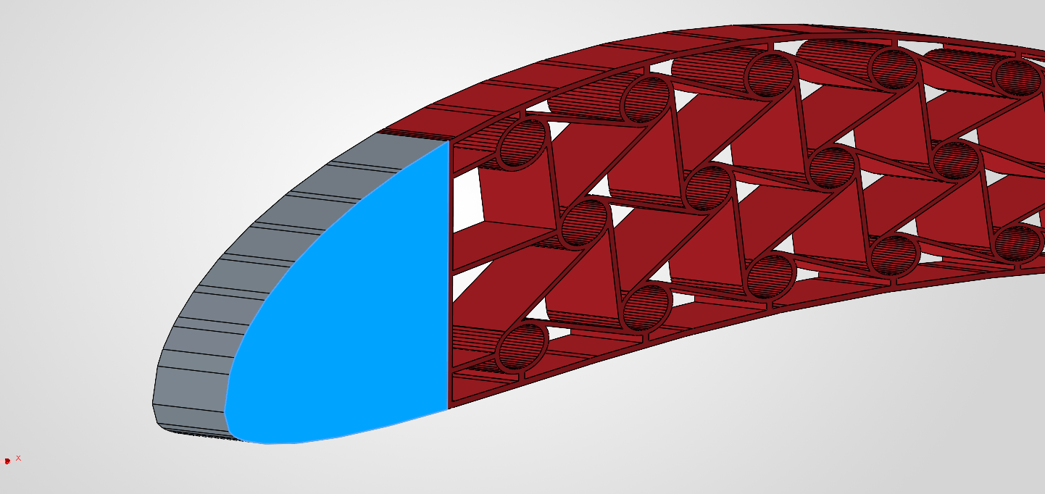
Figure 3. Leading-section support location in Ansys Mechanical. One of the side faces at the nose is highlighted blue. The project setup fixes the nose side faces in both models. Project screenshot.
The workbook stores downward actuator stroke q and downward tip travel dTE as positive magnitudes, and F as the magnitude of the vertical reaction at the actuator. The tip is free to respond to the imposed junction displacement. Comparing the same actuator stroke probes motion transfer and reaction. Comparing the same tip travel controls the motion delivered at the trailing edge.
The workbook records nominal mesh sizes but gives no mesh-convergence series. The material card values, contact formulation, coupling details and plasticity settings are not specified in the reported comparison. The 0.8 mm mesh setting is distinct from the 0.8 mm nominal thickness of the CAD tail webs.

05 / SECTION MODEL

5. Reduced structural model and comparison metrics
The reduced structural model in Section 10.2 of the companion report [1] idealizes the middle region as a uniform equivalent cantilever and the trailing section as a rigid extension that follows the rotation at the junction. The clamp is at x = a, the actuator at x = m and the trailing edge at x = c. Let L be the middle length, b the tail length, s the normalized middle coordinate, B the effective bending rigidity, and w the upward-signed displacement. The model treats q as a downward stroke.
$L = m - a = 190 mm, b = c - m = 95 mm, s = \frac{x - a}{L}$ (6)
$w(x) = 0 (x < a)$ (7)
$w(x) = -\frac{q}{2}(3s^{2} - s^{3}) (a ≤ x ≤ m)$ (8)
$w(x) = -q - \frac{3q}{2L}(x - m) (m < x ≤ c)$ (9)
The middle displacement follows the small-deflection solution for an end force. The extension in Eq. (9) matches both displacement and slope at x = m. The model predicts the following displacement gain and a linear relation between the stroke and reaction.
$d_{TE} = -w(c) = q[1 + \frac{3b}{2L}] = 1.75q$ (10)
$G_{d} = \frac{d_{TE}}{q}, k_{sec} = \frac{F}{q}, F_{beam} = \frac{3Bq}{L^{3}}$ (11)
The theoretical gain depends only on the lengths under these assumptions. Real deformation of the tail, the finite support and actuation areas, and load sharing with the skins can all change the gain. The effective rigidity B in Eq. (11) is a section property with units N·mm². It differs from the effective Young’s modulus of the ideal cell.

Actuation work
For a quasi-static monotonic ramp, the actuator work is the integral of force over actuator stroke. If the inputs use newtons and millimetres, the result is in N·mm and is divided by 1,000 to obtain joules. The workbook integrates the recorded points using trapezoids. Electrical input, actuator friction and any work recovered on unloading are outside this quantity.
$W(q) = \int_{0}^{q}{F(ξ) dξ}, W_{i} = W_{i-1} + \frac{1}{2}(F_{i-1} + F_{i})(q_{i} - q_{i-1})$ (12)

06 / RECORDED RESPONSE

6. Comparison at the same actuator stroke
The raw data in Table 3 come from the Chiral and Straight Web tabs of [5]. Appendix A shows the mesh inspection and stress curves. Appendices B and C show the final-step stress contours. The reaction curves are nearly linear across the recorded steps, with different slopes. Figure 4 uses the recorded simulation points. The zero-stroke origin is the workbook’s zero-load reference.
Table 3. Recorded vertical tip travel, actuator reaction magnitude and peak core stress [5].
Stroke  (mm) | Chiral tip  (mm) | Web tip  (mm) | Chiral force  (N) | Web force  (N) | Chiral stress  (MPa) | Web stress  (MPa)
0.00 | 0.00000 | 0.00000 | 0.000 | 0.000 | 0.000 | 0.000
0.25 | 0.26492 | 0.20884 | 47.966 | 11.846 | 111.860 | 20.296
0.50 | 0.52890 | 0.41768 | 96.007 | 23.693 | 224.400 | 40.591
0.75 | 0.79193 | 0.62652 | 144.120 | 35.539 | 337.510 | 60.887
1.00 | 1.05410 | 0.83536 | 192.310 | 47.386 | 450.990 | 81.182

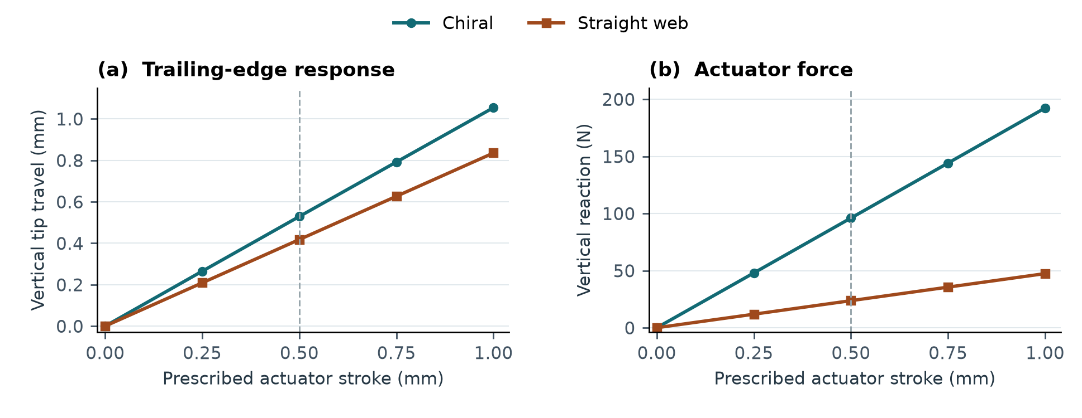
Figure 4. Responses to the prescribed actuator stroke. (a) Vertical trailing-edge travel. (b) Vertical actuator reaction. The dashed guide marks the 0.50 mm comparison stroke. Curves connect the recorded values from [5].

Response at 0.50 mm stroke
At the common 0.50 mm stroke, the chiral section moves the tip 0.52890 mm and the control moves it 0.41768 mm. This is a 26.6% increase in tip travel relative to the control. The associated forces, 96.007 N and 23.693 N, give a force ratio of 4.05 and secant stiffnesses of approximately 192.0 and 47.4 N/mm. The larger displacement gain coexists with a higher reaction stiffness at the actuator.
The chiral and straight-web gains are 1.058 and 0.835 mm/mm at this stroke. The chiral value is about 40% below the reduced model’s gain of 1.75 in Eq. (10). This gap shows that the uniform beam with a rigid extension is a useful reference for interpreting the motion, but it is too optimistic as a quantitative prediction of the modelled section. Additional shape and rotation measurements would be required to separate the contributions of the tail, skins and boundary conditions.

07 / MATCHED TIP TRAVEL

7. Comparison at the same trailing-edge travel
The common target is 0.50 mm. Both simulations bracket this target, with the chiral result between 0.25 and 0.50 mm of stroke and the straight-web result between 0.50 and 0.75 mm. A 1.00 mm tip target falls outside the straight-web data, which end at 0.83536 mm. No extrapolation is used.
For a target d* bracketed by two recorded tip values d₁ and d₂, λ locates the target within the interval. The workbook uses the same interpolation fraction for the associated actuator stroke and force. It integrates force over stroke only up to the interpolated target.
$λ = \frac{d* - d_{1}}{d_{2} - d_{1}}, q* = q_{1} + λ(q_{2} - q_{1})$ (13)
$F* = F_{1} + λ(F_{2} - F_{1}), W* = W_{1} + \frac{1}{2}(F_{1} + F*)(q* - q_{1})$ (14)
For example, the chiral tip target lies between 0.26492 and 0.52890 mm. It gives λ ≈ 0.89052 and q* ≈ 0.47263 mm. The work is the sum of the first full trapezoid from the origin and the partial trapezoid to q*. The reported target stress is interpolated between the peak values from the two neighbouring steps. The peak may change location during the ramp, so the interpolated value does not identify a specific hotspot.
Table 4. Comparison at a shared trailing-edge target. Values are interpolated from [5].
Metric at 0.50 mm tip travel | Chiral | Straight web
Actuator stroke (mm) | 0.473 | 0.599
Actuator force (N) | 90.75 | 28.36
Peak core stress (MPa) | 212.1 | 48.6
Actuator work (J) | 0.02144 | 0.00849

At the matched tip travel, the chiral design reduces required stroke by about 21.0%. Its force is about 3.20 times that of the control and its actuation work is 2.53 times as large. The straight-web design is preferable on force and work for this target, while the chiral design offers greater motion for a given actuator stroke. Matching tip displacement alone does not ensure that the two deformed camber lines coincide.

Stress and mesh interpretation
The chiral peak rises to 337.51 MPa at 0.75 mm stroke and 450.99 MPa at 1.00 mm. Locate each peak and check it against the yield strength of the assigned 6061-T6 material card. If a physically resolved region exceeds yield in a linear-elastic run, a suitable plasticity model is needed to interpret that stroke. Peaks near sharp joints, supports or load introduction can be mesh-sensitive. The 0.50 mm tip target avoids extrapolation and stays in the lower part of the recorded chiral stroke range, but it does not establish an elastic limit by itself.

08 / APPLICATION AND VERIFICATION

8. Camber change and next checks
The project’s intended application is continuous camber control. The structural results establish how the two airfoil sections move under imposed displacement. The thin-airfoil estimate follows Hunsaker et al. [6]. Section 10.2 of the companion report [1] gives the derivation for this geometry. The baseline camber comes from the upper and lower profile ordinates in Eq. (4). Let Δzc be the change in mean camber relative to that baseline.
$z_{c}(x) = z_{c,0}(x) + Δz_{c}(x), x(ϑ) = \frac{c}{2}(1 - cos ϑ)$ (15)
$Δc_{l} = -2\int_{0}^{π}{[\frac{d(Δz_{c})}{dx}]_{x=x(ϑ)} (1 - cos ϑ) dϑ}$ (16)
Equation (16) estimates the change in section lift coefficient at fixed angle of attack, measured from the original chord. It assumes small slopes and two-dimensional attached flow. The reduced structural model takes Δzc ≈ w(x), which yields an illustrative lift increment of about 0.022 at a 0.50 mm actuator stroke using the reduced model’s assumed shape. This is a theoretical sensitivity example. The measured tip response differs from the assumed shape model, and the Ansys workbook contains no deformed surface coordinates or flow solution.
A shape-based comparison should export the deformed upper and lower surfaces, interpolate them onto common chordwise positions and form Δzc. A smooth fit should precede differentiation. A single tip displacement gives no information about where the slope changes along the chord, even when two cores reach the same tip position. Drag, separation, pitching moment and performance under pressure require additional analysis.
Table 5. Verification steps for extending the static application study.
Check | What to measure or record
Mesh sensitivity | Refine thin ligaments, web junctions and the stress hotspot. Compare tip travel, actuator force and peak stress at the same stroke. Record element type, count and local sizing.
Boundary conditions | Confirm equivalent support faces, the same actuator reference location and displacement axis, and consistent body connections in both models.
Material response | Record the exact alloy card, yield strength and plasticity settings. If a converged hotspot exceeds yield, repeat with an appropriate constitutive model.
Shape under aerodynamic load | Extract camber and local curvature. Apply a defined pressure distribution or a coupled flow solution and compare load retention at a specified target shape.

09 / CONCLUSIONS AND SOURCES

9. Conclusions
The original project’s hexachiral cell mechanism informed the central architecture of a finite Eppler 420 section. The Ansys comparison shows that the specific chiral design transfers more motion to the trailing edge for a given actuator stroke. The gain at 0.50 mm stroke is 1.058 for the chiral core versus 0.835 for the straight-web control, while the cores differ in mass by about 1%.
At a shared 0.50 mm tip travel, the chiral core uses 21% less actuator stroke but 2.53 times as much work. The straight-web control therefore gives the lower actuation work for this target. The measured chiral gain is also below the reduced beam model’s 1.75 prediction. These results identify a trade-off among actuator stroke, force, work and stress for the tested section. High-stroke stress needs mesh and material checks, and aerodynamic performance remains to be assessed from the deformed profile under a defined flow condition.

References and project records
[1] Uttej K. Hexachiral Honeycomb Mechanics and Eppler 420 Airfoil Application. Companion project report (Hexachiral_Honeycomb_Project_Report.docx), 8 November 2026.
[2] chiral_models.m. MATLAB function for the three analytical lattice models.
[3] A. Spadoni and M. Ruzzene. Numerical and experimental analysis of the static compliance of chiral truss-core airfoils. Journal of Mechanics of Materials and Structures 2(5), 965–981 (2007). DOI
[4] A. Spadoni and M. Ruzzene. Elasto-static micropolar behavior of a chiral auxetic lattice. Journal of the Mechanics and Physics of Solids 60(1), 156–171 (2012). DOI
[5] Eppler420_Aerofoil_ANSYS_Comparison.xlsx. Simulation setup, recorded ramps, core masses and matched-travel calculations.
[6] D. F. Hunsaker, J. T. Reid and J. J. Joo. Geometric definition and ideal aerodynamic performance of parabolic trailing-edge flaps. International Journal of Astronautics and Aeronautical Engineering 4, 026 (2019). DOI

APPENDIX A / SIMULATION VISUALS

Ansys mesh inspection and stress results
Figure 5 compares the reported maximum equivalent stress in the middle section of each model. At 0.50 mm actuator stroke, the peak values were 224.40 MPa for the chiral core and 40.59 MPa for the straight-web core. Each plotted value is a maximum over the scoped region. Its location can vary with the load step.
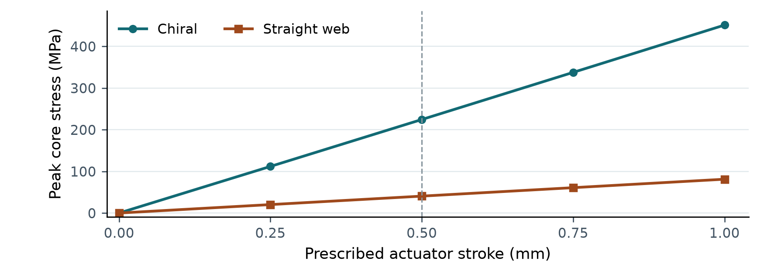
Figure 5. Peak core von Mises stress versus actuator stroke. The plot uses recorded Ansys values from the comparison workbook [5]. The dashed line indicates the common 0.50 mm actuator stroke.

APPENDIX B / FINAL-STEP CONTOURS

Equivalent stress across both airfoils
Figures 6 and 7 show the final saved step in Ansys Mechanical 2025 R1. The displayed static analysis time of 4 s corresponds to a prescribed actuator stroke of 1.00 mm in the comparison workbook [5]. Section 7 compares both designs at a common 0.50 mm of trailing-edge travel, which occurs at different actuator strokes.
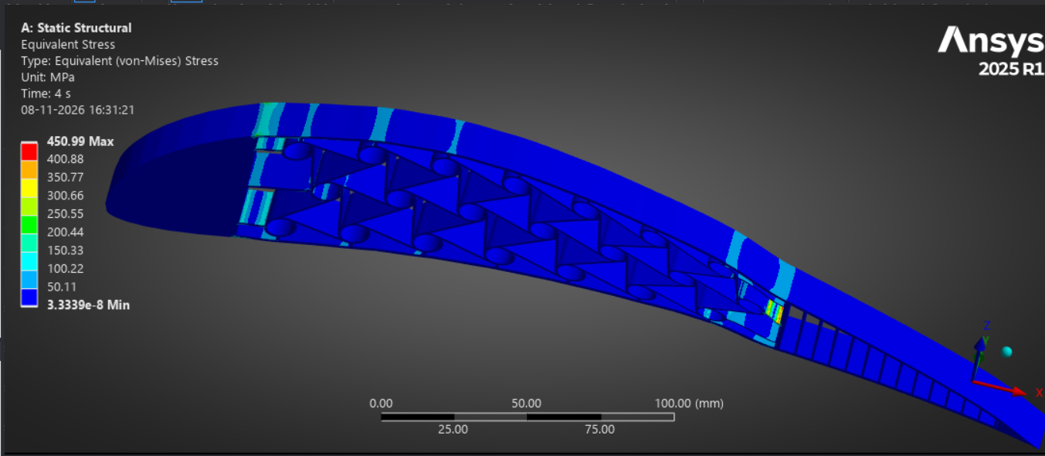
Figure 6. Chiral airfoil (Ansys system A). Final-step von Mises stress contour at 1.00 mm actuator stroke. The displayed maximum is 450.99 MPa. Project simulation screenshot.
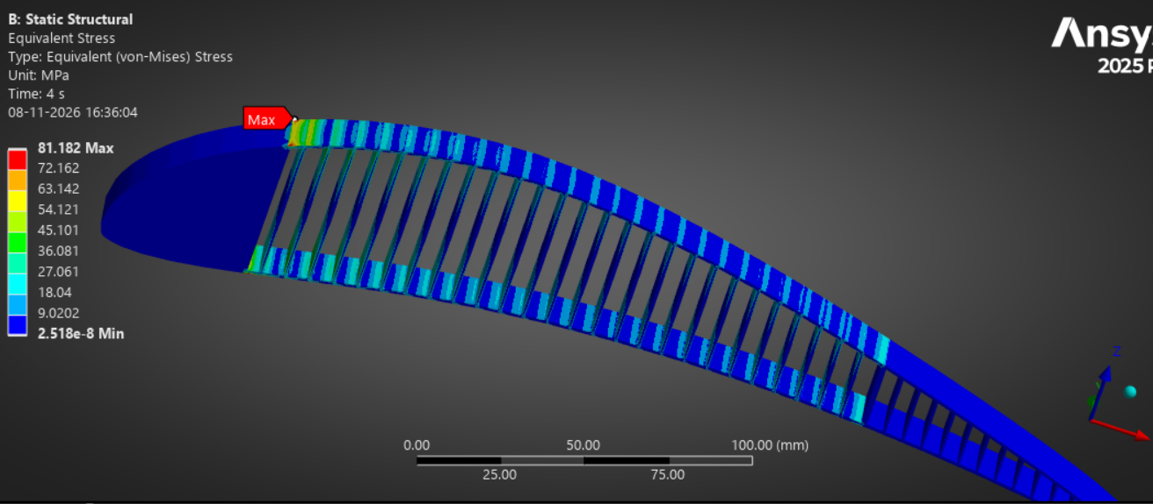
Figure 7. Straight-web airfoil (Ansys system B). Final-step von Mises stress contour at 1.00 mm actuator stroke. The displayed maximum is 81.182 MPa. Project simulation screenshot.
Each screenshot uses its own colour scale. Use the MPa legends to compare stress magnitudes across designs.

APPENDIX C / STRESS CONCENTRATIONS

Local views of the final-step contours
The close-ups show where the final-step stress concentrates in each design. The chiral contour highlights a band just ahead of the core–tail junction. The straight-web contour marks its maximum at the upper nose–core transition.
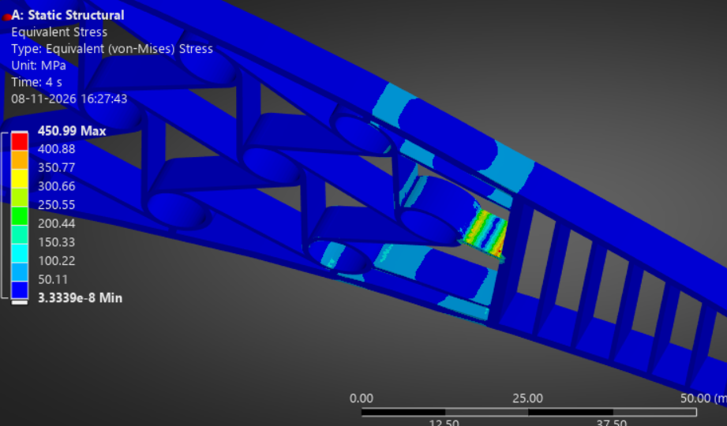
Figure 8. Chiral airfoil (system A). Close-up of the aft core near the actuation location at 1.00 mm actuator stroke. The legend reports a maximum of 450.99 MPa. Project simulation screenshot.
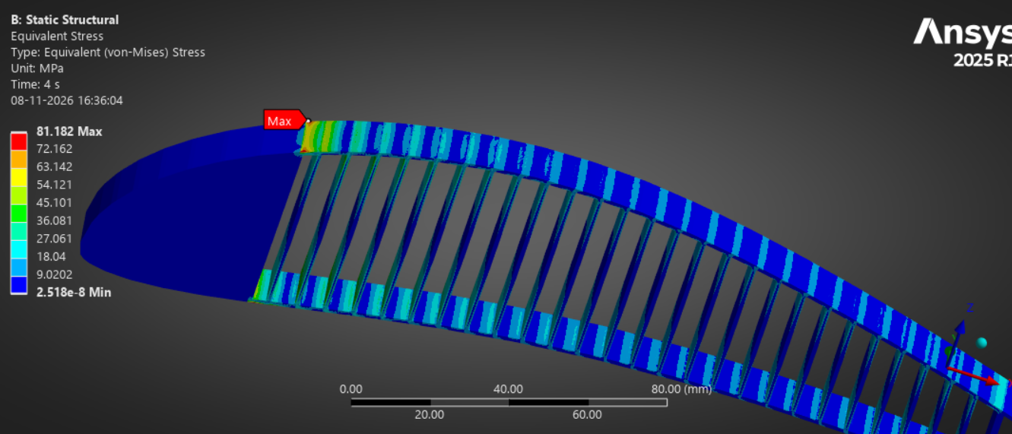
Figure9. Straight-web airfoil (system B). Close-up of the upper nose–core transition at 1.00 mm actuator stroke. The red marker indicates the displayed maximum of 81.182 MPa. Project simulation screenshot.
The local peak values should be checked for sensitivity to mesh refinement and the representation of supports and actuation before drawing strength conclusions.

