MECHANICS OF SOLIDS PROJECT

Hexachiral Honeycomb Mechanics and Eppler 420 Airfoil Application
Analytical derivation, MATLAB calculations and three-dimensional ANSYS studies
Uttej K. | 8 November 2026

Abstract
This project derives the in-plane properties of an ideal hexachiral honeycomb, evaluates the resulting equations in MATLAB form, and compares them with a finite three-dimensional compression specimen. The only coupon geometry reported has centre spacing R = 25 mm, in-plane ligament thickness t = 1 mm and ideal attachment radius r = 5 mm. Seven ANSYS load and mesh cases are reported. At the 1 mm reference stroke the simulation gives an apparent Poisson ratio of −0.8186 and an apparent Young modulus of 0.07525 MPa. The Spadoni–Ruzzene rigid-ring solution gives −0.9540 and 0.04527 MPa for the same analytical geometry and parent modulus. The mesh variations change apparent modulus by at most 1.24% relative to the reference, so these mesh changes explain little of the discrepancy. The planned physical comparison uses one printed coupon in a single compression run.
A separate application study maps a chiral core into a 330 mm chord Eppler 420 section and compares it with a straight-web core of nearly equal mass. At 0.50 mm of actuator stroke, the chiral tip travels 0.52890 mm compared with 0.41768 mm for the control. At 0.50 mm of matched tip travel the chiral design needs 21.0% less actuator stroke and 2.53 times the mechanical work. The comparison quantifies a trade-off between stroke and actuator effort for the modelled airfoil segment.

Report contents
1 Project scope and evidence
2–7 Unit-cell geometry, kinematics, energy and literature models
8 MATLAB function and baseline predictions
9 Finite coupon method, ANSYS runs and planned compression test
10 Eppler 420 design, structural model and ANSYS results
11 Project conclusions
References and project records
Appendix A Coupon probe readings and experimental data
Appendix B Complete MATLAB function

1 Project scope and evidence
The investigation has two scales. At the material scale, it asks how tangential ligaments and ring rotation produce in-plane auxeticity, and how closely an explicitly modelled finite lattice follows a periodic idealization. At the section scale, it asks how a mapped chiral core changes the actuator stroke and work required to move an airfoil trailing edge.
Evidence | Scope and role
Analytical unit cell | Small-strain planar model with rigid rings and slender ligaments. Closed-form properties use ideal geometry.
3D coupon in ANSYS | Finite lattice, local X compression, TPU modulus input of 26 MPa. R01–R07 are the complete baseline series from [9].
Eppler 420 in ANSYS | Separate aluminium section models, fixed nose and vertical actuator stroke. Work and stress comparisons use [10].
Reduced airfoil model | Equivalent cantilever and rigid tail, followed by an illustrative thin-airfoil calculation.
Sections 4–7 derive the unit-cell response and check the kinematics, the thin-ligament limit and the published prefactors. The coupon comparison uses the workbook depth of 10 mm and parent modulus of 26 MPa throughout. The airfoil has its own 20 mm extrusion, aluminium parent material and boundary conditions. Its local mapped ligament geometry is different from the regular coupon.

2 Notation
Symbol | Meaning | Unit
r | Ideal attachment lever arm to ligament centreline (map to CAD radii explicitly) | mm
R | Centre-to-centre spacing of neighbouring nodes | mm
L | Straight length of a ligament, between its two tangent points | mm
t, d | Ligament thickness (in plane) and depth (out of plane) | mm
β | Angle between a ligament and the line joining the node centres | degrees
E_{s} | Young’s modulus of the solid material | MPa
I | Second moment of area of a ligament cross-section | mm⁴
A_{n} | Lattice area per node | mm²
ε | Dilation strain, equal along X₁ and X₂ (taken positive for contraction) | –
φ | Rotation of every node | rad
ψ | Rotation of the ligament chord relative to the line of centres | rad
θ | End rotation of a ligament relative to its own chord | rad
M | End moment on a ligament | N·mm
E, K, ν | Effective in-plane Young’s modulus, 2D bulk modulus, Poisson’s ratio | MPa, MPa, –
tₙ | Ring-wall thickness, separate from ligament thickness | mm

3 Assumptions
- Rigid nodes. Nodes rotate without deforming in the analytical model. A hollow printed ring meets this assumption only approximately. Record ring-wall thickness tₙ separately and assess sensitivity to ring flexibility.
- Slender bending ligaments. Ligaments are Euler–Bernoulli beams. Sections 4–6 neglect axial compliance and transverse shear deformation; Section 7.2 restores axial compliance. A small t/L supports this approximation, but t/L < 0.1 and a relative-density threshold are screening heuristics, not universal validity criteria for this topology.
- Triangular lattice. Node centres form a triangular lattice of spacing R. Each node carries six ligaments, and each ligament is shared by two nodes, so there are 3 effective ligaments per node.
- Symmetry and deformation mechanism. Sixfold symmetry gives an isotropic classical in-plane response for the ideal lattice; it does not alone imply ν = −1. Uniform dilation is the compliant mechanism when rigid nodes rotate and ligament axial extension is suppressed. The finite-compliance model in Section 7.2 tests this limiting interpretation.
- Small strain and linear elastic material. The kinematics and beam energy are used to first order in displacement or rotation and second order in energy. They are not a finite-strain model.
- Bending-only limit. Axial extension is constrained in Sections 4–6, rather than made energetically free. For the baseline, restoring axial compliance in Section 7.2 lowers the modulus slightly and shifts ν above −1.

4 Geometry
In the ideal beam geometry, r is the perpendicular lever arm from the node centre to the ligament centreline, and L is measured between the ideal attachment points. The centreline tangent construction gives a right triangle with legs L and 2r and hypotenuse R. For CAD rings, state the outer and inner radii and map the attachment geometry to this idealization; do not silently mix outer-surface and centreline dimensions.
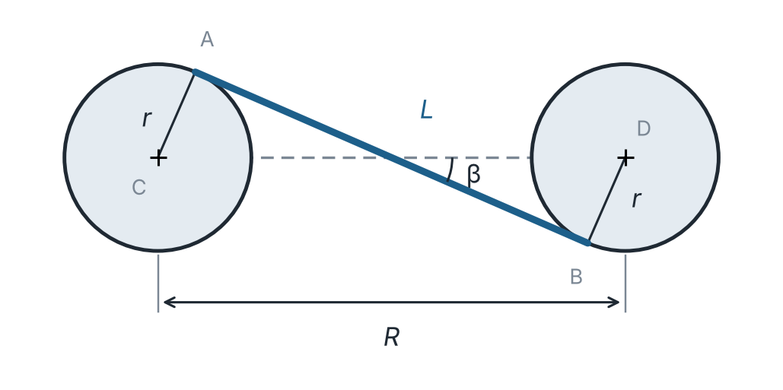
Figure 1. Two neighbouring nodes C and D joined by ligament AB (undeformed). The ligament crosses the line of centres at angle β.
$L=\sqrt{R^{2}-4r^{2}}$ (1)
$\sin{β}=\frac{2r}{R}, \cos{β}=\frac{L}{R}$ (2)
$I=\frac{dt^{3}}{12}$ (3)
$A_{n}=\frac{\sqrt{3}}{2}R^{2}$ (4)
Here A_{n} is the area of the lattice per node. It is the area of two equilateral triangles of side R, which matters later when counting ligaments per unit volume.

5 Kinematics and Poisson’s ratio
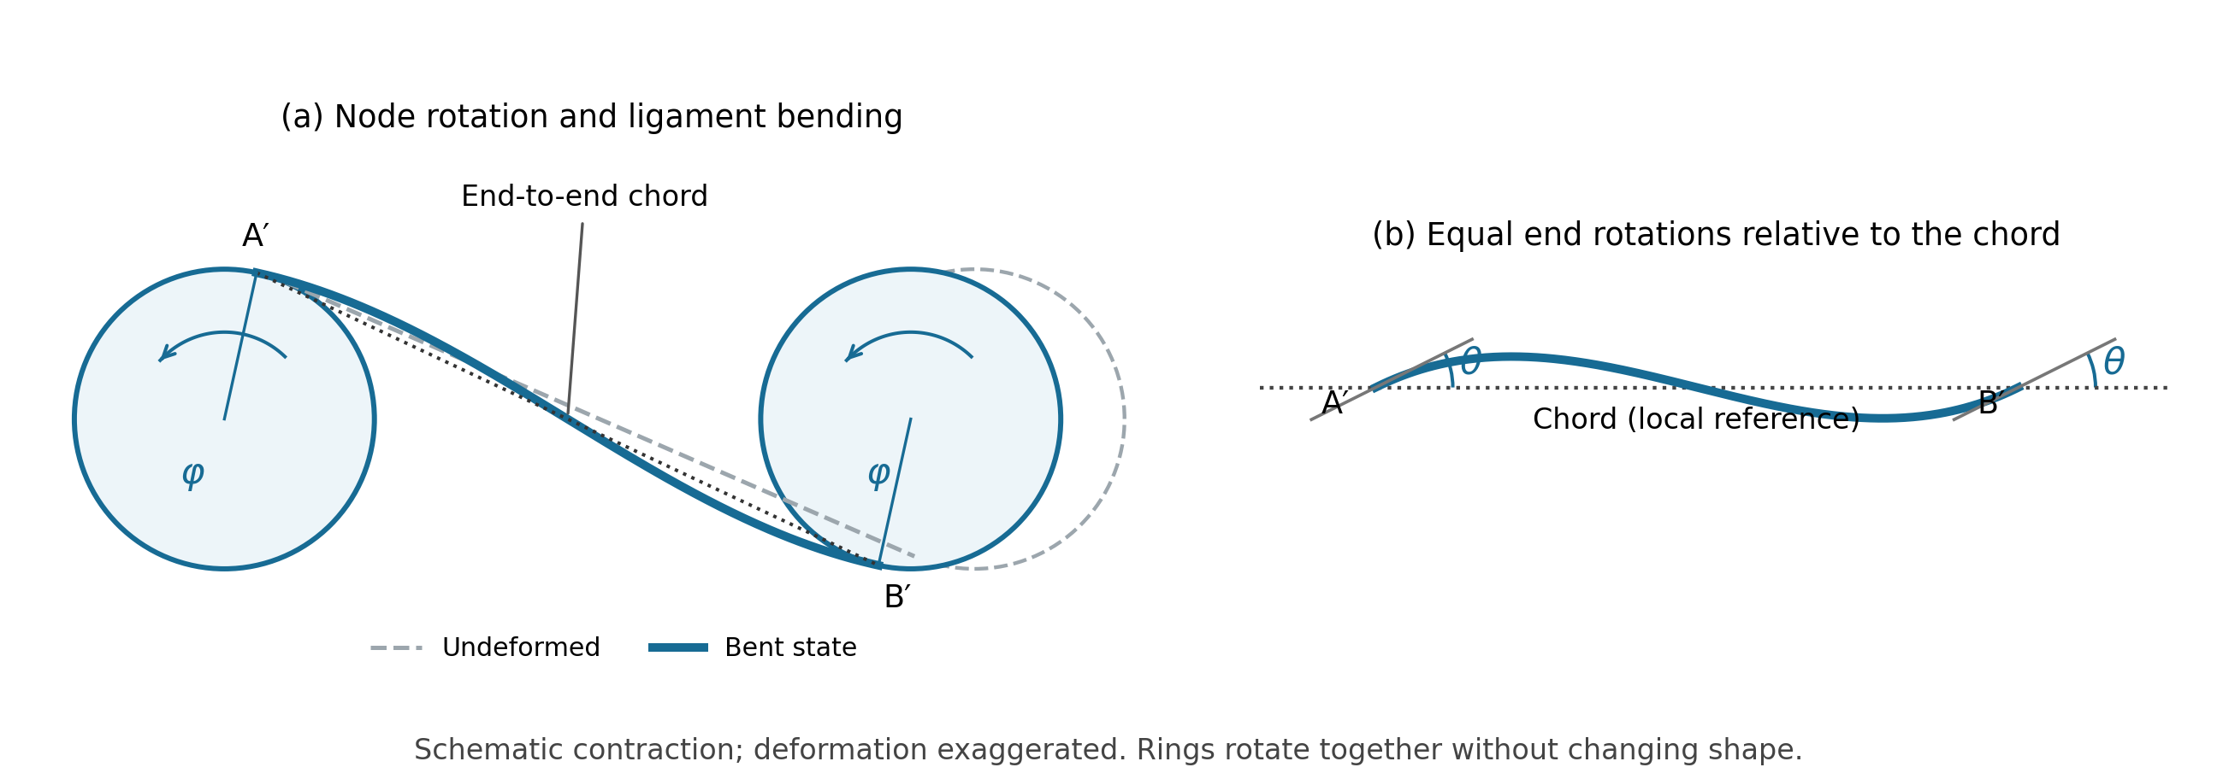
Figure 2. Bent state of a ligament during ideal lattice contraction. (a) The nodes rotate in the same sense through φ and the ligament bends into an S shape; the dotted chord joins its displaced attachment points A′ and B′. (b) In a local chord-aligned view, θ is the end-tangent rotation relative to the chord at both ends. The chord itself rotates clockwise by ψ in (a), giving θ = φ + ψ under the angle-magnitude convention used below. Deformation is exaggerated; the sketch is not a finite-strain solution.
As illustrated in Figure 2, during the ideal dilation mechanism, nodes rotate together and ligaments bend into an S shape. Inextensibility preserves a ligament’s centreline arc length, not its end-to-end chord length. Chord shortening is higher order and is neglected here. With θ denoting the end rotation relative to the chord, the first-order separation relation is
$D^{2}≈R^{2}-4rL{θ}$ (5)
$ε=1-\frac{D}{R}$ (6)
Using the contraction-positive strain definition in Eq. (6), linearization gives
$ε=\frac{2rLθ}{R^{2}} ⇔ θ=\frac{εR^{2}}{2rL}$ (7)
The chord of the ligament also turns relative to the line of centres, because the angle β changes as the ends rotate. From the same geometry, the chord rotation is, to first order,
$ψ=\frac{2r}{L}ε$ (8)
The end rotation relative to the chord is the sum of the node rotation and the chord rotation, θ = φ + ψ. Substituting and using R² − 4r² = L² gives the node rotation in terms of the strain:
$φ=θ-ψ=\frac{L}{2r}ε$ (9)
For the ideal uniform-dilation mechanism, the two normal strains are equal. Identifying this mechanism with the limiting uniaxial response gives
$ν_{12}=ν_{21}=-\frac{ε_{2}}{ε_{1}}=-1$ (10)
Equation (10) is a constrained, limiting response, not a general consequence of lattice symmetry. In an isotropic in-plane continuum G = E/[2(1 + ν)]; imposing ν = −1 at finite nonzero E is singular. Finite axial compliance gives a finite shear modulus and ν > −1 in the rigid-ring model. At fixed Es and geometry ratios, the physical thin-ligament limit has both E and G tending to zero, with G/E increasing. Edge effects, flexible rings and finite rotations can further change measured strain ratios.

6 Ligament energy and Young’s modulus
The derivation uses the cell-wall bending method described by Gibson et al. [2]. With equal rotations θ at both ends relative to the chord, the ligament deforms into an antisymmetric S shape. The slope–deflection equations give the end moment and the stored energy:
$M=\frac{6E_{s}Iθ}{L}$ (11)
$U_{lig}=Mθ=\frac{E_{s}dt^{3}θ^{2}}{2L}$ (12)
Each node has three effective ligaments, so the strain energy per unit volume of the lattice is the energy of three ligaments divided by the node volume A_{n} d. Substituting θ from Eq. (7) expresses it in terms of the macroscopic strain:
$u=\frac{3U_{lig}}{A_{n}d}=\frac{\sqrt{3}E_{s}t^{3}θ^{2}}{LR^{2}}=\frac{\sqrt{3}E_{s}t^{3}R^{2}}{4r^{2}L^{3}}ε^{2}$ (13)
For equal normal strains, the in-plane bulk modulus K is defined by σ = 2Kε, giving u = 2Kε². Thus the ligament energy determines K directly. In the limiting isotropic response ν → −1, E = 2K(1 − ν) → 4K. Applying this limiting relation gives the leading-order Young’s modulus
$E=\frac{\sqrt{3}}{2}E_{s}{\left(\frac{t}{L}\right)}^{3}{\left(\frac{R}{r}\right)}^{2}$ (14)
Using R² = L² + 4r², the geometric factor is (R/r)² = (L/r)² + 4. In the same limiting approximation, the in-plane bulk modulus is
$K=\frac{E}{4}$ (15)
Equation (14) is cubic in t at fixed r and R and is the thin-ligament limit of Eq. (20) at fixed nonzero r/R. Changing node size must specify which dimensions are held fixed; no universal monotonic trend is implied. The following is a first-order peak ligament bending-strain estimate. It does not include joint stress concentrations, ring deformation, print defects or a failure criterion:
$ε_{lig}=\frac{3tθ}{L}=\frac{3tR^{2}}{2rL^{2}}ε$ (16)

7 Verification and comparison with the literature

7.1 Energy-method check
As an internal consistency check, an energy approach of the type used by Mousanezhad et al. [4] is applied here to the ideal hexachiral cell. This is an adaptation, not an assertion that [4] publishes the following equations verbatim. Under uniform equal-biaxial loading, half-turn symmetry eliminates the ligament midpoint moment; rigid-node moment balance makes the bond force f act along the line of centres. Its transverse ligament component is f sin β. Summing the three bonds per node gives
$σ=\frac{\sqrt{3}f}{Rd}$ (17)
The bending energy of the six half-ligaments (length L/2, load f sin β at the free end) is ${ U}_{node} =\frac{f^{2} \sin^{2}β L^{3}}{8Es I}.$ Dividing by the node volume and equating it to σε gives the strain per unit stress, and from it the 2D bulk modulus:
$\frac{ε}{σ}=\frac{\sin^{2}{β}L^{3}}{\sqrt{3}E_{s}t^{3}}$ (18)
$K=\frac{σ}{2ε}=\frac{\sqrt{3}}{8}E_{s}{\left(\frac{t}{L}\right)}^{3}{\left(\frac{R}{r}\right)}^{2}$ (19)
Using the limiting relation E = 4K reproduces Eq. (14). This is an alternative calculation within the same rigid-node, small-strain model, not independent experimental validation.

7.2 Closed form of Spadoni and Ruzzene
Spadoni and Ruzzene [3] assemble beam stiffness matrices, with both axial and bending terms, for the hexachiral unit cell with rigid rings. With x = t/L, their closed forms for the effective modulus and Poisson’s ratio (their Eqs. 45 and 46) are
$\frac{E}{E_{s}}=\frac{4\sqrt{3}\left(1+x^{2}\right)x^{3}}{2x^{4}\cos^{2}{β}+2\sin^{2}{β}+6x^{2}}$ (20)
$ν=\frac{4x^{2}}{x^{4}\cos^{2}{β}+\sin^{2}{β}+3x^{2}}-1$ (21)
At fixed nonzero r/R (hence fixed nonzero sin β), taking x → 0 in Eq. (20) gives
$\frac{E}{E_{s}}→\frac{2\sqrt{3}}{\sin^{2}{β}}x^{3}=\frac{\sqrt{3}}{2}x^{3}{\left(\frac{R}{r}\right)}^{2}$ (22)
For finite x, Eq. (21) lies above −1. The shear modulus from [3], Eq. (48), is G/Eₛ = (√3/4)(x + x³). Thus G/E grows in the thin-ligament auxetic regime at fixed nonzero r/R even though both moduli tend to zero. Taking r/R toward zero first leads to a different limit.

7.3 Comparison with Prall and Lakes
The printed Eq. (14) of Prall and Lakes [1] gives the following expression, transcribed here without claiming that every step of its derivation is consistent:
$E_{P}=\sqrt{3}E_{s}{\left(\frac{t}{L}\right)}^{3}{\left(\frac{L}{r}\right)}^{2}$ (23)
The ratio of Eq. (14) to this expression is
$\frac{E}{E_{P}}=\frac{R^{2}}{2L^{2}}=\frac{1}{2\cos^{2}{β}}$ (24)
At R/r = 5, Eq. (24) gives E/E_{P} = 25/42 ≈ 0.595. Thus the printed Prall–Lakes expression is 1.68 times the present bending-only prediction. This is a comparison of ideal formulas, not proof that a physical specimen must follow either value. Table 1 summarizes the verifiable comparisons.
Table 1. Verified formula comparisons at r = 5 mm, R = 25 mm, t = 1 mm
Expression | E/Es | Comparison | Interpretation
Present Eq. (14) | 1.800 × 10⁻³ | Reference | Thin-ligament, rigid-node limit
Spadoni–Ruzzene Eq. (20) | 1.741 × 10⁻³ | E20/E14 = 0.9673 | Finite axial compliance; rigid rings
Prall–Lakes Eq. (23) | 3.024 × 10⁻³ | E_{P}/E14 = 1.680 | Printed formula; derivation inconsistency discussed below
A specific inconsistency is visible in [1], PDF page 4: the text counts 3/2 shared ribs but calls V = (√3/2)R²d a single triangular cell. A triangle of side R has area (√3/4)R²; the stated volume corresponds to two such triangles. At fixed volume and deformation, doubling the ligament count doubles the inferred modulus. This observation does not establish that Bornengo et al. deliberately corrected that issue. Differences in strain–rotation kinematics must also be reconstructed consistently before assigning the entire prefactor discrepancy to individual causes.

7.4 Comparison with Bornengo, Scarpa and Remillat [5]
Bornengo, Scarpa and Remillat [5] restate the Prall and Lakes [1] analytical modulus in terms of two dimensionless ratios defined in their notation as β = t/r (note that [5] uses β for the thickness-to-radius ratio rather than the ligament inclination angle) and α = L/r. Substituting these definitions into their Eq. (1) shows that β³/α = (t/r)³/(L/r) = (t/L)³(L/r)², which has the exact same dimensional scaling with t, L and r as Prall and Lakes’ Eq. (23):
$E_{B}=E_{s}\frac{\sqrt{3}}{2}\frac{{(t/r)}^{3}}{L/r}=\frac{\sqrt{3}}{2}E_{s}{\left(\frac{t}{L}\right)}^{3}{\left(\frac{L}{r}\right)}^{2}$ (25)
Equation (25) is half of the printed Prall–Lakes expression. The supplied paper does not establish that this arose from a deliberate ligament-count correction. In particular, increasing the number of ligaments at fixed volume cannot explain a halving of stiffness. The algebraic ratio to the present bending-only expression is nevertheless unambiguous:
$\frac{E}{E_{B}}=\frac{R^{2}}{L^{2}}=\frac{1}{\cos^{2}{β}}$ (26)
For R/r = 5, E/EB = 25/21 ≈ 1.190; at t = 1 mm, EB/Es ≈ 1.512 × 10⁻³, 16% below Eq. (14). Separately, Bornengo’s Table 1 does not reproduce its Eq. (1) under the stated definitions: at t/r = 0.05 and L/r = 4.6, 3.5 and 2.7, direct evaluation gives 10⁵EB/Es = 2.35, 3.09 and 4.01, whereas the table lists 1.18, 0.80 and 0.60. The equation and table therefore disagree in magnitude and trend; the available evidence does not identify whether the error is in the equation, table or parameter labels.

8 MATLAB function and baseline predictions
The attached chiral_models.m [11] is a MATLAB function file. Save it under that name, set the current folder to its location and call chiral_models(). Press Enter at the three prompts to use r = 5 mm, R = 25 mm and t = 1 mm. The function rejects R ≤ 2r. Physical dimensions should be positive and use the same length unit. It evaluates E/Eₛ and ν for the three models, prints a one-row comparison, and draws two analytical thickness sweeps at fixed r and R. Appendix B updates the comments and display labels to match this report. The numerical expressions are those of the supplied function.
The numbers below were independently recalculated from the same expressions and checked against the workbook’s Geometry models tab. The plots reproduce the mathematical sweep with the supplied grid of 60 points from 0.30 to 3.00 mm and add one finite-element point. MATLAB itself was unavailable for execution during report preparation. The thickness curves are equation evaluations, and their thicker end should be interpreted in light of the slender-beam assumption.
Table 2. Baseline analytical predictions and finite coupon result.
Model | E/Eₛ | E at Eₛ = 26 MPa (MPa) | ν
Project bending-only limit | 0.0017998 | 0.046796 | −1 (limit)
Spadoni–Ruzzene (SR) | 0.0017410 | 0.045267 | −0.954024
Prall–Lakes printed expression | 0.0030237 | 0.078617 | −1 (limit)
Bornengo et al. Eq. (1) | 0.0015119 | 0.039308 | —
ANSYS R01 finite coupon | 0.0028944 | 0.075254 | −0.818561
The ideal baseline has L = 22.91288 mm, β = 23.578°, L/R = 0.916515 and t/L = 0.043644. Per unit of contraction-positive dilation strain, the ring rotation is 2.2913 rad, the end rotation is 2.7277 rad and the peak ideal bending strain is 0.35714. For 1% dilation these are approximately 1.31°, 1.56° and 0.357%, respectively. The ideal bending result is independent of the common extrusion depth because d enters both ligament stiffness and homogenization volume.
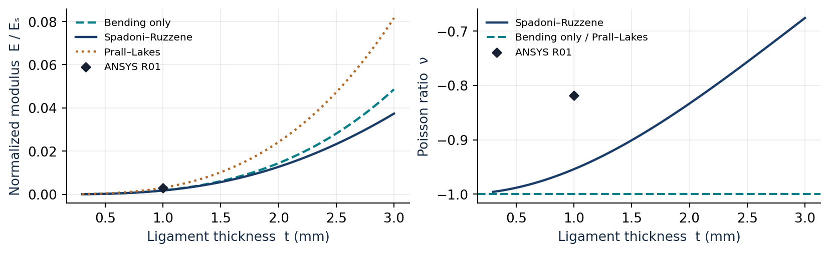
Figure 3. Recalculated MATLAB analytical sweep and the single R01 finite coupon point. Bornengo’s comparison formula is discussed in Section 7.4 and is outside the three-model function.

9 Three dimensional coupon simulation

9.1 Geometry, support and displacement probes
The coupon is an open-edge finite hexachiral patch. The input specimen envelope is W = 136 mm perpendicular to the loading axis and d = 10 mm out of plane. The nominal gross section for stress normalization is Wd = 1360 mm². The workbook uses r = 5 mm for the ideal calculation and records no separate ring wall, element order or global mesh size. The 3D solid rings are geometrically resolved. A representative probe setup scopes two ring faces with a deformable MPC remote point. These probes represent translations of the scoped rings without making the faces a rigid patch.
In Ansys Mechanical the driven side uses a prescribed local X translation. Local Y and Z are free at the driven faces. The opposing support is fixed, and the reaction is taken from that support in the same local coordinates. The X displacement in the setup image is +1 mm and drives the loaded side toward the support. The workbook records the stroke magnitude as positive, while axial and transverse gauge strains follow the conventional tension-positive sign.
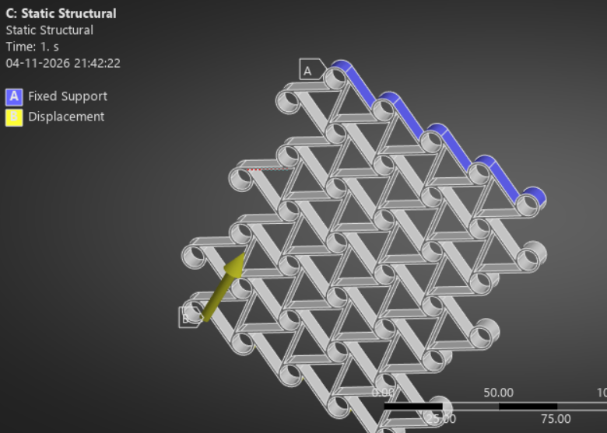 | 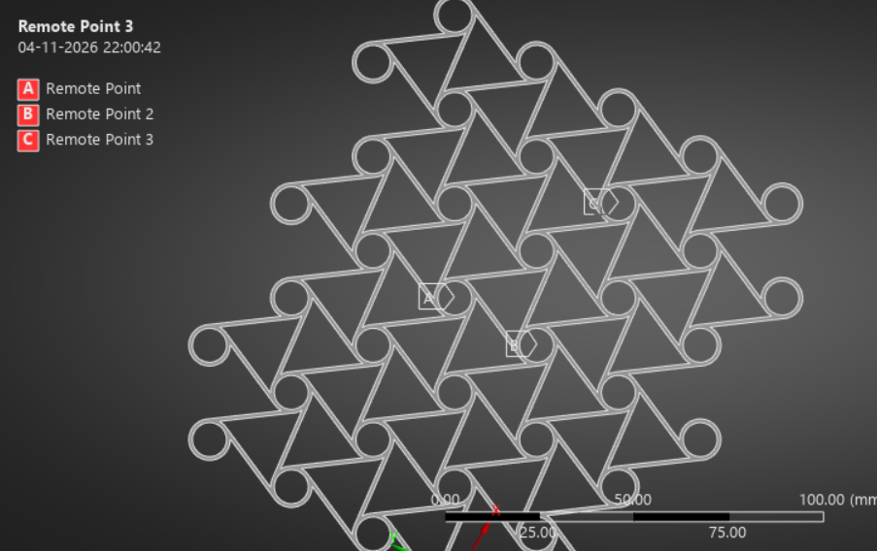
Figure 4. Project setup screenshots. Left, prescribed displacement and opposing support. Right, interior ring probes A, B and C. The gauges use B→C along local X and B→A along local Y.
With probe coordinates and components in the same local axes, the workbook uses the initial signed separations X_C − X_B = +43.30 mm and Y_A − Y_B = +25.00 mm. These are nominal gauge values recorded in [9]. The complete initial local coordinate triplets are absent from the results file, so exact alignment is a verification item. The three probe locations give one local axial and one local transverse gauge, with B common to both.
Δuₓ = uₓ(C) − uₓ(B) Δuᵧ = uᵧ(A) − uᵧ(B)
εₓ = Δuₓ / (X_C − X_B) εᵧ = Δuᵧ / (Y_A − Y_B) νₐₚₚ = −εᵧ / εₓ
σₙ = |Fₓ| / (Wd) Eₐₚₚ = σₙ / |εₓ| k = |Fₓ| / q
Here q is imposed stroke magnitude. Eₐₚₚ combines gross-section stress from the full reaction with interior gauge strain. k instead uses the imposed stroke and measures the force per unit of specimen-end motion. Both are secant quantities at the recorded stroke. With force in N and lengths in mm, σₙ and Eₐₚₚ are in MPa.

9.2 Recorded load and mesh cases
Table 3. Baseline coupon load and mesh schedule. Depth spacing is nominal d divided by the sweep division count.
Run | Condition | Stroke (mm) | In plane (mm) | Sweep divisions | Depth step (mm)
R01 | Baseline | 1.00 | 0.33 | 4 | 2.50
R02 | Half displacement | 0.50 | 0.33 | 4 | 2.50
R03 | Quarter displacement | 0.25 | 0.33 | 4 | 2.50
R04 | Double displacement | 2.00 | 0.33 | 4 | 2.50
R05 | 8-division depth check | 1.00 | 0.33 | 8 | 1.25
R06 | Coarse in-plane mesh | 1.00 | 0.50 | 4 | 2.50
R07 | Fine in-plane mesh | 1.00 | 0.25 | 4 | 2.50
Table 4. Independently recalculated results from [9]. Forces retain the sign of the support reaction. Stress uses the gross section.
Run | Fₓ (N) | εₓ (%) | εᵧ (%) | ν apparent | σₙ (kPa) | E (MPa) | 10³ E/Eₛ
R01 | −0.90163 | −0.88097 | −0.72113 | −0.8186 | 0.66296 | 0.075254 | 2.8944
R02 | −0.44986 | −0.43937 | −0.35119 | −0.7993 | 0.33078 | 0.075284 | 2.8955
R03 | −0.22603 | −0.21938 | −0.17314 | −0.7892 | 0.16620 | 0.075759 | 2.9138
R04 | −1.74430 | −1.77208 | −1.51883 | −0.8571 | 1.28257 | 0.072377 | 2.7837
R05 | −0.89106 | −0.88098 | −0.72114 | −0.8186 | 0.65519 | 0.074371 | 2.8604
R06 | −0.89832 | −0.88109 | −0.71925 | −0.8163 | 0.66053 | 0.074967 | 2.8834
R07 | −0.89033 | −0.88085 | −0.72139 | −0.8190 | 0.65465 | 0.074321 | 2.8585

Reference calculation
For R01, Δuₓ = 0.098560 − 0.480020 = −0.381460 mm and Δuᵧ = −0.039312 − 0.140970 = −0.180282 mm. The resulting strains are −0.00880970 and −0.00721128. The support reaction is −0.901630 N. Dividing its magnitude by 1360 mm² gives 0.000662963 MPa. Dividing by the axial strain magnitude gives Eₐₚₚ = 0.075254 MPa and Eₐₚₚ/Eₛ = 0.00289439. The common sign of the two strains confirms lateral contraction during axial compression.

Sensitivity to the imposed stroke
At fixed 0.33 mm in-plane sizing and four sweep divisions, νₐₚₚ becomes more negative as stroke rises from 0.25 to 2.00 mm, changing from −0.7892 to −0.8571. Doubling the reference stroke nearly doubles axial gauge strain, while the transverse contraction increases by a factor of about 2.11. The secant stiffness k decreases from 0.90412 N/mm at 0.25 mm to 0.87215 N/mm at 2.00 mm, and Eₐₚₚ falls by 3.82% from R01 to R04. These results show load dependence for this finite specimen. Ring rotation, gauge location and end effects can influence the trend, but the dataset does not isolate their contributions.

9.3 Mesh sensitivity and theory comparison
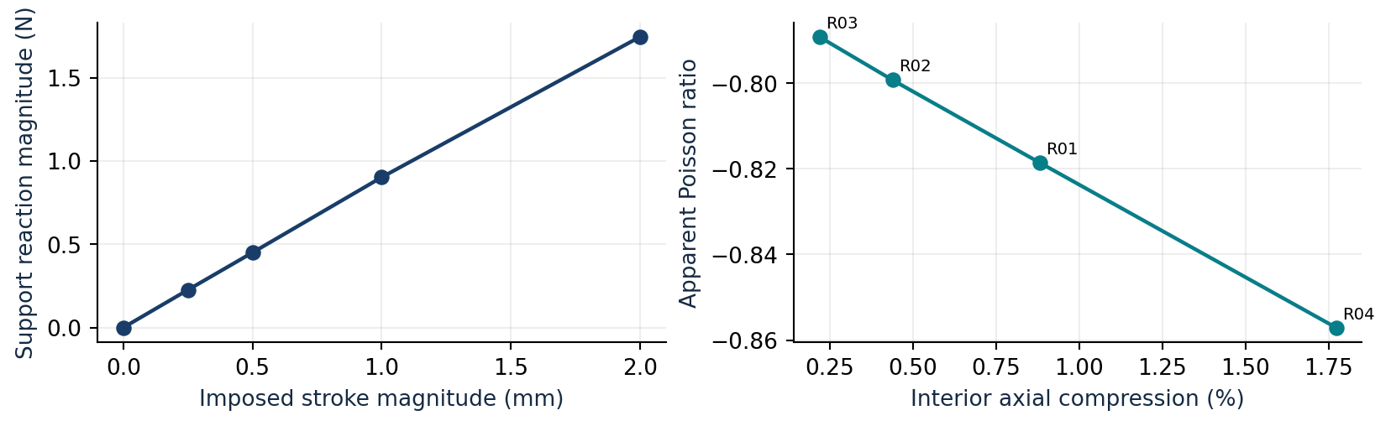
Figure 5. Stroke sensitivity at fixed reference mesh. The left curve includes a zero-load reference. The right curve uses the axial strain measured by the interior gauge.
Table 5. Differences relative to R01 at the same 1 mm stroke.
Change | Δν apparent | ΔE apparent (%) | Δ reaction magnitude (%)
R05 8-division depth check | −0.000012 | −1.173 | −1.172
R06 Coarse in-plane mesh | +0.002243 | −0.381 | −0.367
R07 Fine in-plane mesh | −0.000407 | −1.240 | −1.253
The depth check and fine in-plane run reduce Eₐₚₚ by approximately 1.17% and 1.24%. Across the three mesh checks the largest change in νₐₚₚ is 0.00225 and the largest reaction change is 1.25%. In-plane and through-depth refinement were checked separately. The coarse-to-reference-to-fine values are not monotone in Eₐₚₚ, so these runs support a practical sensitivity estimate for the reported outputs rather than a formal convergence order.
R01 is 0.1354 above the rigid-ring SR Poisson ratio and 66.2% above its normalized modulus. The sizes of these gaps exceed the observed mesh effects. The analytical prediction assumes an ideal repeating lattice under a homogenized in-plane stress state. In the specimen, missing edge ligaments, end constraints, ring flexibility and the use of short local gauges affect the comparison. The radius convention and gross width also matter. The Prall–Lakes modulus is numerically closer to R01, but its idealized ν = −1 and the different specimen conditions prevent that proximity from selecting a constitutive model.
A periodic unit-cell analysis with matched centreline geometry and parent properties would provide the closest direct check of SR. In the finite coupon, repeating the strain extraction over more interior ring pairs at the same stroke would quantify gauge sensitivity using the existing model. Physical validation would require dimensions and material properties measured on the actual printed specimen.

9.4 Single specimen compression test
One printed coupon with the nominal R01 geometry (R = 25 mm and t = 1 mm) will be tested in a single compression run. Record the measured dimensions and setup below. Table A3 records successive readings from that run. The comparison can assess agreement with ANSYS for this coupon. Estimating repeatability or specimen-to-specimen variation would require additional runs or coupons.
Specimen and test details | Experimental record
Specimen ID and test date
Material and print orientation
Measured spacing R and ligament thickness t (mm)
Measured coupon width W and extrusion depth d (mm)
Initial axial and transverse gauge lengths, if measured (mm)
Loading direction, end restraints and displacement measurement method
Use compression force and measured specimen-end shortening as the primary comparison. If the run reaches 1.00 mm of shortening, compare with R01 at that point. Calculate secant stiffness as force divided by shortening, and record crosshead travel separately. Fill the strain, Poisson ratio and modulus rows only if the corresponding interior gauges can be measured as described in Section 9.1.
Table 6. Single run comparison with ANSYS R01 at 1.00 mm specimen-end displacement.
Quantity | ANSYS R01 | Experiment (one run)
Compression force magnitude (N) | 0.90163
Secant stiffness (N/mm) | 0.90163
Axial gauge strain (%) | −0.88097
Transverse gauge strain (%) | −0.72113
Apparent Poisson ratio | −0.8186
Apparent Young’s modulus (MPa) | 0.075254

Observations and comparison notes

10 Eppler 420 airfoil application

10.1 Design and geometry mapping
The chiral mechanism is used here to distribute structural deformation within a continuous cambered section. Bornengo et al. [5] and the chiral airfoil study of Spadoni and Ruzzene [6] provide the application context. The project uses the normalized Eppler 420 ordinates (e420.dat) to define the section profile. The 330 mm chord, 20 mm extrusion and internal partitions are project design choices.
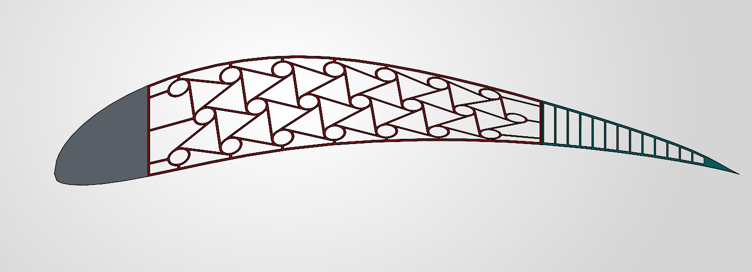 | 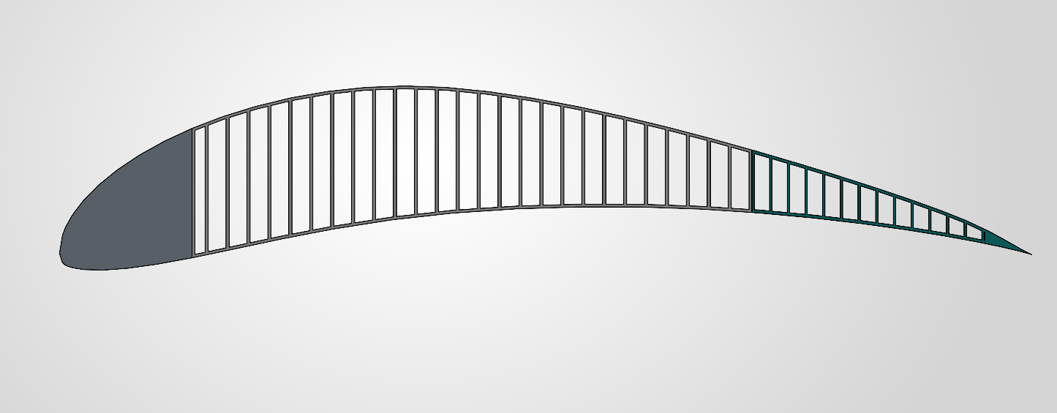
Figure 6. Project CAD of the Eppler 420 sections. Chiral middle core at left and straight-web control at right. Both designs use a solid nose and a cellular tail.
Feature | Selected design
Section and partitions | Chord c = 330 mm, depth = 20 mm, nose to middle at a = 45 mm and middle to tail at m = 235 mm.
Middle and tail length | Middle length L꜀ = 190 mm. Tail length b = 95 mm.
Chiral reference lattice | 21 rings in three staggered rows. Reference pitch 25 mm, mean ring radius 5 mm, ligament and ring wall thickness 1 mm.
Outer and tail walls | Upper and lower walls 1 mm vertically. Chiral tail webs 0.8 mm chordwise at 6 mm pitch.
Compared core masses | Chiral 79.839 g and straight web 80.649 g, including the middle section’s skin. Difference 0.810 g (1.0% of the control).
Let x increase aft from the nose, z increase upward, zᵤ(x) and zₗ(x) denote the profile ordinates, and ζ be the vertical coordinate of the flat lattice relative to its mid-height. Its reference height H₀ is 60 mm. The local profile thickness and initial camber are h = zᵤ − zₗ and z꜀,₀ = (zᵤ + zₗ)/2. The mapping is also described in the companion application paper [12, Section 3] and is given by
z(x, ζ) = z꜀,₀(x) + (ζ / H₀) h(x).
The mapping changes ring shape, local wall thickness and ligament orientation. The listed dimensions characterize the flat layout. In particular, a CAD mean ring radius is a separate definition from the ideal ligament-centreline lever arm r. The matched control replaces the chiral middle lattice with straight webs while using the corresponding outer profile, support and actuator positions.

10.2 Reduced section and actuation models
For a first structural estimate, the solid nose is taken as rigid, the middle as a uniform Euler–Bernoulli cantilever of effective bending rigidity B, and the tail as a rigid continuation of the junction tangent. This section-level B has units N·mm². The root of the equivalent beam is x = a, and the actuator gives downward stroke q at x = m. Define L꜀ = m − a, s = (x − a)/L꜀, and let w be upward-signed displacement.
w(x) = 0 for x < a
w(x) = −q(3s² − s³)/2 for a ≤ x ≤ m
w(x) = −q − [3q/(2L꜀)](x − m) for m < x ≤ c
The middle solution follows from the transverse end force on a clamped beam, w(a) = w′(a) = 0, w(m) = −q and zero end bending moment. The displacement and slope at the junction are −q and −3q/(2L꜀). The tail follows that slope. With b = c − m, the predicted tip travel, force and effective rigidity are
dₜₑ = −w(c) = q[1 + 3b/(2L꜀)] = 1.75q
Fᵦₑₐₘ = 3Bq/L꜀³, B = FL꜀³/(3q), G_d = dₜₑ/q, kₛₑ꜀ = F/q.
For a monotonic quasistatic stroke, the mechanical work is the integral of the resisting actuator force magnitude over stroke. The factor 1/1000 converts N·mm to J. For a linear force–stroke curve, W(q) = F(q)q/2000 in joules. For the discrete ANSYS data, work is evaluated as follows.
Wᵢ = Wᵢ₋₁ + (Fᵢ₋₁ + Fᵢ)(qᵢ − qᵢ₋₁)/2000 [J].
For target travel d* between consecutive tip readings d₁ and d₂, interpolate with λ = (d* − d₁)/(d₂ − d₁). Use this same fraction for each quantity recorded at those steps. A partial trapezoid gives the work from q₁ to q*.
q* = q₁ + λ(q₂ − q₁), F* = F₁ + λ(F₂ − F₁)
W* = W₁ + (F₁ + F*)(q* − q₁)/2000 [J].

Illustrative camber to lift estimate
For the thin-airfoil calculation [7], x(ϑ) = c(1 − cos ϑ)/2 and z꜀ = z꜀,₀ + Δz꜀. At small slopes under two-dimensional attached flow, with angles in radians relative to the original chord,
αₗ₌₀ = (1/π) ∫₀^π z꜀′[x(ϑ)] (1 − cos ϑ) dϑ, cₗ = 2π(α − αₗ₌₀)
Δcₗ = −2 ∫₀^π Δz꜀′[x(ϑ)] (1 − cos ϑ) dϑ.
Taking Δz꜀ ≈ w gives Δcₗ ≈ 0.04468 per mm of stroke. This gives 0.02234 at q = 0.50 mm and 0.223 at an illustrative stroke of q = 5 mm. At 5 mm the beam predicts 8.75 mm tip travel and 2.26° rotation. The 5 mm case and the lift increments are reduced-model calculations. The ANSYS structural ramp ends at 1 mm and provides no aerodynamic pressure or deformed-profile data for evaluating lift.

10.3 Airfoil finite element results
Both explicit solid sections were analysed in Ansys Mechanical 2025 R1 with aluminium 6061-T6 assigned throughout. The nose side faces were fixed. Prescribed vertical motion was applied immediately behind the middle section, and vertical motion was measured at the trailing edge. The workbook reports default nose sizing and 0.8 mm nominal middle and tail element sizing, distinct from the nominal tail web thickness. It supplies no separate mesh convergence series for these airfoil models.
Table 7. Airfoil ANSYS readings from [10]. Travel and vertical reaction are magnitudes. Stress is the peak reported equivalent stress in the middle section.
Stroke (mm) | Chiral tip (mm) | Web tip (mm) | Chiral force (N) | Web force (N) | Chiral stress (MPa) | Web stress (MPa)
0.00 | 0.00000 | 0.00000 | 0.000 | 0.000 | 0.000 | 0.000
0.25 | 0.26492 | 0.20884 | 47.966 | 11.846 | 111.860 | 20.296
0.50 | 0.52890 | 0.41768 | 96.007 | 23.693 | 224.400 | 40.591
0.75 | 0.79193 | 0.62652 | 144.120 | 35.539 | 337.510 | 60.887
1.00 | 1.05410 | 0.83536 | 192.310 | 47.386 | 450.990 | 81.182
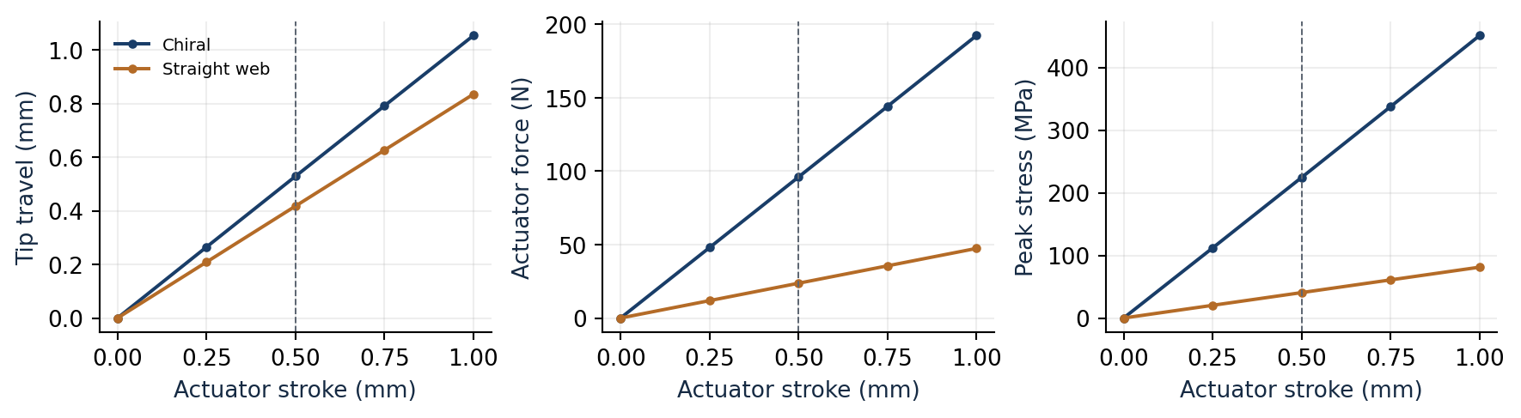
Figure 7. Recorded tip travel, actuator force and peak stress for the two sections. The vertical guides mark the 0.50 mm comparison stroke.
At 0.50 mm of actuator stroke, the chiral tip travels 26.6% farther and its actuator reaction is 4.05 times as high. The respective displacement gains are 1.058 and 0.835 mm/mm and the secant stiffnesses are 192.0 and 47.4 N/mm. The chiral gain is 39.6% below the reduced model’s 1.75. Tail flexibility, the distributed actuation and the actual stiffness distribution can affect the gain. The comparison gives no separate measurement of those effects.
Table 8. Interpolated comparison at a shared 0.50 mm trailing-edge travel.
Metric | Chiral | Straight web
Stroke (mm) | 0.47263 | 0.59854
Actuator force (N) | 90.75 | 28.36
Peak core stress (MPa) | 212.1 | 48.6
Mechanical work (J) | 0.02144 | 0.00849
At the shared target the chiral layout needs 21.0% less stroke, 3.20 times the actuator force and 2.53 times the work. The 0.50 mm tip target lies within both ramps. A 1 mm target lies beyond the straight-web data. The interpolated peak stress compares reported maxima and does not track one material point.

10.4 Stress and aerodynamic interpretation
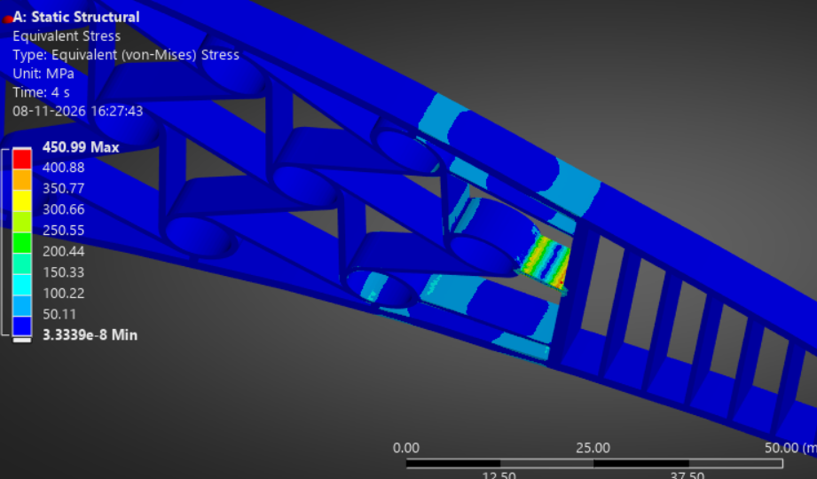 | 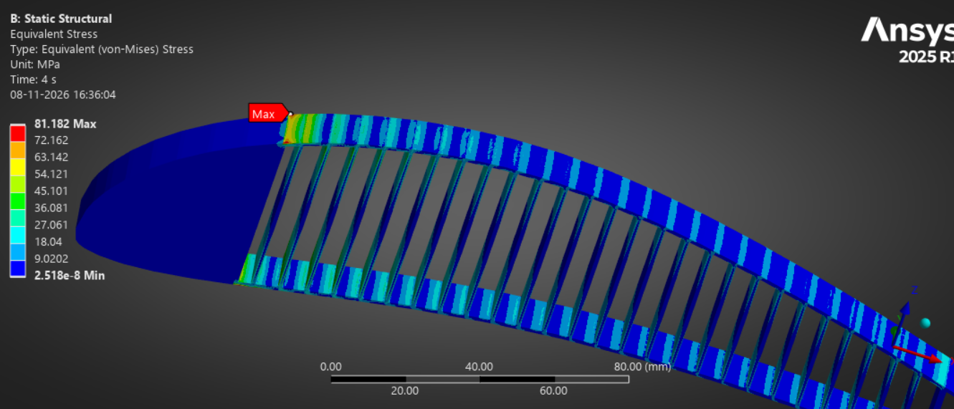
Figure 8. Project ANSYS close-ups at 1.00 mm actuator stroke. Left, the chiral core near the core–tail junction. Right, the straight-web control near the upper nose–core transition. Each panel has its own colour scale.
The chiral core peaks at 337.51 MPa at 0.75 mm of actuator stroke and 450.99 MPa at 1.00 mm. Both exceed the published nominal tensile yield strength of about 276 MPa for 6061-T6 [8]. Linear interpolation between 224.40 MPa at 0.50 mm stroke and 337.51 MPa at 0.75 mm puts the 276 MPa crossing at approximately 0.614 mm of actuator stroke. The chiral peak is below the typical value at both comparison points, 224.40 MPa at 0.50 mm actuator stroke and 212.08 MPa at 0.50 mm matched tip travel. The straight-web peak at 1.00 mm stroke is 81.182 MPa.
This crossing is a screening estimate from the reported peak stresses. The available records identify the alloy but do not show the assigned yield strength or plasticity law. Confirm both in ANSYS Engineering Data and check mesh sensitivity at the stress concentration. If an elastic solution exceeds the assigned yield strength at a resolved hotspot, repeat the higher-stroke cases with an appropriate elastic–plastic material law before using them to assess the response beyond yield.
The observed tip gains describe motion at one location. A camber comparison requires the full deformed upper and lower surfaces, interpolated onto a common chordwise grid. The change in their mean ordinate gives Δz꜀. Smoothing that curve before differentiation supports evaluation of the lift integral. Predicting pressure retention, pitching moment, separation, drag or flight performance would require additional loading or flow analysis. The companion application paper [12] preserves the detailed CAD, mesh and stress images.

11 Project conclusions
The bending mechanism explains the negative Poisson ratio of the hexachiral lattice and gives a cubic stiffness dependence on ligament thickness in the slender limit. Adding axial compliance moves the ideal baseline prediction to −0.9540. The finite TPU coupon shows lateral contraction in all seven ANSYS baseline runs. Its R01 apparent modulus and Poisson ratio differ from the ideal values by more than the mesh variations observed at the same stroke.
In the Eppler 420 section, the chiral core gives greater trailing-edge travel per unit of actuator stroke and requires higher force and work at the matched tip target. The chiral peaks at both 0.50 mm comparison points fall below the typical 6061-T6 yield value, while the 0.75 and 1.00 mm stroke peaks exceed it. The higher-stroke response therefore depends on confirming the material model and the mesh near the peak.

References and project records
[1] D. Prall and R. S. Lakes. Properties of a chiral honeycomb with a Poisson’s ratio of −1. International Journal of Mechanical Sciences 39(3), 305–314 (1997). Source
[2] L. J. Gibson, M. F. Ashby, G. S. Schajer and C. I. Robertson. The mechanics of two-dimensional cellular materials. Proceedings of the Royal Society A 382, 25–42 (1982). DOI
[3] A. Spadoni and M. Ruzzene. Elasto-static micropolar behavior of a chiral auxetic lattice. Journal of the Mechanics and Physics of Solids 60(1), 156–171 (2012). Source
[4] D. Mousanezhad et al. Elastic properties of chiral, anti-chiral, and hierarchical honeycombs: A simple energy-based approach. Theoretical and Applied Mechanics Letters 6, 81–96 (2016). Source
[5] D. Bornengo, F. Scarpa and C. Remillat. Evaluation of hexagonal chiral structure for morphing airfoil concept. Proceedings of the IMechE Part G 219(3), 185–192 (2005). Source
[6] A. Spadoni and M. Ruzzene. Numerical and experimental analysis of the static compliance of chiral truss-core airfoils. Journal of Mechanics of Materials and Structures 2(5), 965–981 (2007). Source
[7] D. F. Hunsaker, J. T. Reid and J. J. Joo. Geometric definition and ideal aerodynamic performance of parabolic trailing-edge flaps. International Journal of Astronautics and Aeronautical Engineering 4, 026 (2019). DOI
[8] A. Mehmood et al. Experimental study to optimize cold working, aging temperature, and time on the properties of AA6061 tubes: analysis using design of experiment. Frontiers in Materials 10, 1199099 (2023). DOI
[9] Hexachiral_Honeycomb_ANSYS_Results.xlsx. Coupon inputs and calculated results, R01–R07.
[10] Eppler420_Aerofoil_ANSYS_Comparison.xlsx. Simulation setup, recorded ramps, core masses and matched-travel calculations.
[11] chiral_models.m. MATLAB function for the three analytical lattice models.
[12] Uttej K. A chiral honeycomb core for a morphing Eppler 420 airfoil. Companion application paper (Eppler420_Chiral_Honeycomb_Application_Paper.docx).

Appendix A Coupon readings and test data
The components below are the signed local translations from the Nodal inputs tab of [9]. The same workbook stores the axial reaction, applied stroke, initial separations and mesh settings. The published tables use its recorded values. The earlier result screenshots served to document the setup.
Table A1. Individual probe displacements in mm.
Run | uₓ(A) | uᵧ(A) | uₓ(B) | uᵧ(B) | uₓ(C) | uᵧ(C)
R01 | 0.49402 | −0.039312 | 0.48002 | 0.14097 | 0.09856 | 0.02924
R02 | 0.24737 | −0.018923 | 0.23997 | 0.068874 | 0.049721 | 0.014135
R03 | 0.12378 | −0.0092751 | 0.11997 | 0.034009 | 0.024979 | 0.0069428
R04 | 0.98469 | −0.087317 | 0.96104 | 0.29239 | 0.19373 | 0.06191
R05 | 0.49401 | −0.039316 | 0.48002 | 0.14097 | 0.098557 | 0.029241
R06 | 0.49413 | −0.039273 | 0.48027 | 0.14054 | 0.098757 | 0.02918
R07 | 0.49391 | −0.039257 | 0.47994 | 0.14109 | 0.098532 | 0.029275
Table A2. Recalculated pair displacements and force per unit actuator travel.
Run | Δuₓ (mm) | Δuᵧ (mm) | k (N/mm)
R01 | −0.3814600 | −0.1802820 | 0.901630
R02 | −0.1902490 | −0.0877970 | 0.899720
R03 | −0.0949910 | −0.0432841 | 0.904120
R04 | −0.7673100 | −0.3797070 | 0.872150
R05 | −0.3814630 | −0.1802860 | 0.891060
R06 | −0.3815130 | −0.1798130 | 0.898320
R07 | −0.3814080 | −0.1803470 | 0.890330
Traceability. Coupon probe readings occupy Nodal inputs rows 6–12. The associated result formulas and values occupy Test results rows 7–13. The analytical baseline inputs and closed forms are on Geometry models row 7. In the airfoil workbook [10], the two ramp histories occupy rows 9–13 of Chiral and Straight Web. The matched-travel outputs are in Comparison rows 19–22. Appendix B lists the MATLAB function [11] alongside the equation numbers used in this report.
Table A3. Raw readings from the single compression run.
Reading no. | Compression force (N) | Crosshead travel (mm) | Specimen-end displacement (mm) | Axial gauge length (mm, if measured) | Transverse gauge length (mm, if measured)
Each row is a reading from the same loading run. Add rows for more readings from that run. If the interior gauges are tracked, record their initial lengths at the test reference state and use the ring pairs from Section 9.1.

Appendix B MATLAB function
Adapted from chiral_models.m [11]. Comments and display labels follow the report. The calculations are unchanged. Table 1 and Section 7 compare the ideal formulas.
%% CHIRAL HONEYCOMB - Three closed-form models
%
% Table 1 and Section 7 compare the ideal formulas. Table 2 gives
% baseline predictions and the finite coupon result.
% 1) Project bending-only limit, Eq. (14). The limiting nu is -1.
% 2) Spadoni-Ruzzene rigid-ring model with axial and bending
% compliance, Eqs. (20)-(21) in this report.
% 3) Prall-Lakes printed formula, Eq. (23). At R/r = 5 its modulus
% is 1.68 times the bending-only result (Section 7.3).
%
% E denotes E/Es. Multiply by the parent material modulus Es to
% obtain a dimensional modulus. Use consistent units for r, R and t.
% Call chiral_models() and enter dimensions or accept the defaults.
function chiral_models()
clc;
%% ---- geometry: always prompt for it ----
r0 = input('Node radius r (mm) [default 5]: ');
if isempty(r0), r0 = 5; end
R0 = input('Node spacing R (mm) [default 25]: ');
if isempty(R0), R0 = 25; end
t0 = input('Ligament thickness t (mm) [default 1]: ');
if isempty(t0), t0 = 1; end
if R0 <= 2*r0
error('Geometry is not valid: need R > 2*r (so that L = sqrt(R^2-4r^2) is real).');
end
fprintf('\nBaseline r=%.3g R=%.3g t=%.3g\n', r0, R0, t0);
[E14, nu14] = eq14(r0, R0, t0);
[E23, nu23] = eq23_prallLakes(r0, R0, t0);
[Esr, nusr] = eq20_spadoniRuzzene(r0, R0, t0);
fprintf(' Project bending-only limit E/Es = %.6e nu = %.4f\n', E14, nu14);
fprintf(' Prall & Lakes (1997) E/Es = %.6e nu = %.4f\n', E23, nu23);
fprintf(' Spadoni & Ruzzene (2012) E/Es = %.6e nu = %.4f\n\n', Esr, nusr);
%% ---- Normalized moduli for the selected geometry ----
fprintf('%-14s %14s %16s %14s\n', 'r,R,t', 'Bending-only', 'Spadoni-Ruzzene', 'Prall-Lakes');
fprintf('%-14s %14.4e %16.4e %14.4e\n', ...
sprintf('%g,%g,%g',r0,R0,t0), E14, Esr, E23);
%% ---- sweep t and plot all three E/Es curves (r, R fixed at input) ----
r = r0; Rfix = R0;
tvals = linspace(max(0.05, 0.3*t0), 3.0*t0, 60);
E14v = zeros(size(tvals)); Esrv = E14v; E23v = E14v;
nu14v = E14v; nusrv = E14v; nu23v = E14v;
for k = 1:numel(tvals)
[E14v(k), nu14v(k)] = eq14(r, Rfix, tvals(k));
[Esrv(k), nusrv(k)] = eq20_spadoniRuzzene(r, Rfix, tvals(k));
[E23v(k), nu23v(k)] = eq23_prallLakes(r, Rfix, tvals(k));
end
figure('Name','E/Es vs t');
plot(tvals, E14v, '--', 'LineWidth', 1.5); hold on;
plot(tvals, Esrv, '-', 'LineWidth', 1.5);
plot(tvals, E23v, ':', 'LineWidth', 1.5);
xlabel('ligament thickness t (mm)'); ylabel('E / E_s');
legend('Project bending-only limit','Spadoni & Ruzzene (2012)','Prall & Lakes (1997)','Location','northwest');
title(sprintf('r = %g mm, R = %g mm', r, Rfix)); grid on;
% --- overlay your own Ansys / physical-test points here, e.g.:
% ansys_t = [1.0];
% ansys_E = [ ... your measured E/Es values ... ];
% plot(ansys_t, ansys_E, 'ks', 'MarkerFaceColor','k', 'DisplayName','Ansys');
figure('Name','nu vs t');
plot(tvals, nu14v, '--', 'LineWidth', 1.5); hold on;
plot(tvals, nusrv, '-', 'LineWidth', 1.5);
plot(tvals, nu23v, ':', 'LineWidth', 1.5);
xlabel('ligament thickness t (mm)'); ylabel('\nu');
legend('Project bending-only limit','Spadoni & Ruzzene (2012)','Prall & Lakes (1997)','Location','southeast');
title(sprintf('r = %g mm, R = %g mm', r, Rfix)); grid on;
end % chiral_models
%% ======================= local functions =======================
function [E, nu] = eq14(r, R, t)
% Project bending-only limit, Eq. (14). The limiting nu is -1.
L = sqrt(R^2 - 4*r^2);
E = (sqrt(3)/2) * (t/L)^3 * (R/r)^2;
nu = -1;
end
function [E, nu] = eq23_prallLakes(r, R, t)
% Printed Prall-Lakes formula, Eq. (23). See Table 1 and Section 7.3.
L = sqrt(R^2 - 4*r^2);
E = sqrt(3) * (t/L)^3 * (L/r)^2;
nu = -1;
end
function [E, nu] = eq20_spadoniRuzzene(r, R, t)
% Spadoni & Ruzzene (2012), rigid-ring closed form with axial + bending
% ligament deformation. See Eqs. (20)-(21) of this report.
L = sqrt(R^2 - 4*r^2);
x = t / L;
c2 = (L^2) / (R^2);
s2 = 1 - c2;
E = (4*sqrt(3)*(1 + x^2)) / (2*x^4*c2 + 2*s2 + 6*x^2) * x^3;
nu = (4*x^2) / (x^4*c2 + s2 + 3*x^2) - 1;
end

