A Structured Approach to Insurance Claims Data Processing: From Manual Extraction to Automated Matching
Mayank
CUIET
Patiala,India
mayankk0704@gmail.com
Rajat Takkar
CUIET
Patiala,India rajat.takkar@chitkara.edu.in

Abstract
Insurance datasets often require multiple stages of processing, and handling insurance data in an efficient way is very important for assessing risk and making decisions accurately. This paper shows a realistic method to enhance the workflows of insurance data by following a three-stage progression involving manual extraction, dataset standardisation, automated matching, and further Data Analysis. At first, key details (which include Lost Location, Date of loss, Insured Address, Gross Loss, Property Damage, Type of peril, etc.) are taken out manually from reports that are usually not structured. This assisted with understanding challenges related to real-world data, but it also pointed out restrictions like inconsistency and wasting time. On this foundation, a new method was introduced, in which only the top priority document ( loss adjustor report) was chosen, and the data was extracted from it. The second phase involved consolidating datasets, where cleaning, aggregation, and validation logic were implemented using Power Query to standardise outputs and verify manually extracted data. These datasets were further combined and made uniform by utilising Power Query and SQL. The final phase introduced a matching system that linked claim records to exposure datasets using location-based and latitude/longitude logic. The results show that structured preprocessing and validation significantly improve the reliability of downstream matching operations. The total methodology shows how progressive enhancements in managing data can result in a more dependable and expandable system.
Keywords—Insurance Data Processing, Power Query, SQL, Python, Data Extraction, Automation, Claims Scoring, Data Transformation

I. Introduction
Large volumes of data are essential for underwriting, pricing, and claims management within the industry. While final output products are structured, a considerable part of the source material comes from semi-structured or even unstructured sources such as policy documents, claim records, and adjusters' notes. This means that there is a significant discrepancy between datasets that are ready for analysis and raw data.
Manual intervention is often performed in practice to fill the gap, especially during the initial data pre-processing stages. Manual processing allows for contextual comprehension of data, yet its scalability and reliability are quite limited.
As the volumes of data have grown significantly over time, this issue required a more comprehensive and sustainable solution. Minor variations within datasets could cause major issues within subsequent steps. This need became a driving force behind the research that has been carried out within this study.
The methodology chosen by this project does not consist in the automation of one particular step but rather uses a staged approach
Three different stages have been used within this project. During the first stage, manual data extraction was performed to obtain the important data from claim documentation for analysis purposes.The second stage addressed ambiguity by consolidating and standardizing data fields using Power Query and SQL. The final stage applied this cleaned structured claims data to get the matched result from the exposure data.
It begins with understanding the data through manual extraction, followed by consolidating and standardizing datasets, and finally implementing an automated scoring system. This progression ensures that each stage builds upon the previous one, resulting in a more reliable system.

II. PROBLEM STATEMENT
Insurance data is structured data, but with a lot of inconsistencies. During an initial manual review of claims data, there were many problems in text, numeric and location fields. In text fields, there were various casing, indentation, spacing and formatting (in Date of loss field) errors.

This caused inconsistencies and mismatches for analysis and automation. In numeric fields, they were stored as text and had currency symbols, commas and other ambiguous entities. This caused numerical operations to be non-robust without proper conversion. so we cannot aggregate values representing the same quantity due to those abnormalities.This caused problems with sorting, filtering and comparisons.

Direct transformations without normalization caused inconsistencies.Loss location data had further ambiguities. Fields like loss location and insured address were not structured well and had partial and ambiguous information that can’t be trusted.
Another limitation was the relationship between data sets. Claim data and exposure data had no uniform structure, so direct field comparisons were not always possible. Matches required data to be transformed to a comparable structure.These issues showed that simple preprocessing was not adequate.

A systematic approach was required, including manual data understanding followed by standardization and validation, followed by application of matching logic to clean data.

FieldType | Issue Observed | Impact
Text Fields | Casing, spacing inconsistencies | Matching errors
Numeric Fields | Stored as text, currency symbols | Conversion issues
Date Fields | Multiple formats | Comparison failure
Location Data | Inconsistent structure | Matching difficulty
Multi-values | Mixed delimiters | Parsing errors

II. PRELIMINARYWORK: MANUAL DATA EXTRACTION
The initial phase of the work was about manual data extraction using claims data which was semi-structured insurance reports. These reports included loss adjustor summaries, claim description, loss amounts and supporting documentations, where relevant data was embedded.
The primary objective during this phase was to identify and extract attributes required for downstream processing. This included loss locations, date of loss, peril type, gross loss, etc. Each of these fields were examined to understand how values were represented.
A key observation during this phase was the lack of standardization and formatting. For example, location data could appear as a full address in one case or just a city name in another. This made direct extraction non-trivial rather than simple identification.

III.DATA CONSOLIDATION AND STANDARDIZATION
A. Initial Observations
When working with aggregating datasets from the manual extraction from the phase1, it was initially assumed that all the datasets would follow a similar structure.
However upon closer inspection, several inconsistencies and abnormalities were identified. These fields appeared similar, often behaved differently when processed, and certain columns contained unexpected values or formats.
This required multiple iterations of cleaning logic before a A stable approach could be established. So that it can be use for further data modelling

B. Text Standardization
Text fields presented issues such as inconsistent casing, extra whitespace or trailing spaces, and hidden characters. These were addressed using transformation functions.
Text.Upper(Text.Trim([Field]))

While this may appear simple, applying it consistently across all relevant fields significantly improved data quality.

C. Multi-Delimiter Complexity
In certain situations, a single field had values that were separated by pipe characters, commas, and line breaks all at once.
The first solutions applied did not work correctly because they used normal string-splitting methods, resulting in either partial or erroneous output. This problem was overcome through the use of tokens.
This alone made the solution much more reliable.

D. Currency Handling
Currency values required careful handling, as they often contained symbols and formatting inconsistencies. A direct replacement approach was initially considered but later refined to avoid affecting non-currency fields.
The final implementation involved:
- Identifying relevant columns
- Removing symbols selectively
- Preserving numerical accuracy

E. CAT CLAIMS HANDLING SYSTEM
Due to ambiguity in the reports, there were inconsistencies in the fields where it mentions where a claim is a catastrophic claim or a non-catastrophic claim. Data consisted of values such as NON-WEATHER AND NON-CAT, Non-CAT etc which did not match the format that was required by the modelling team. A logical categorisation of such fields was required which can:

- Identifying relevant type of fields (Nonweather and non-cat -> should have fallen under the category of Non-Weather and Non-CAT)
- Removal of “Unknows”

IV.AUTOMATED CLAIMS SCORING SYSTEM AND CLAIMS AND EXPOSURE DATA MATCHING
Building upon the standardized dataset, an automated claims scoring system was developed using Power Query. Which was used to find matches from claims data within the exposure dataset. The system is designed to process structured datasets efficiently by applying a series of transformations, matching operations, and scoring logic.

A. Design Approach
The scoring system was designed with simplicity and reliability in mind. Instead of relying on complex models, the focus was on building clear and explainable logic.

B. Matching Logic
Matching between datasets was performed using partial comparisons rather than exact matches. This was particularly useful in cases where data was inconsistent. Using Loss locations that are in the claims database to find matches in the entire exposure data. The logic was further improved by converting the fields to a standard location format and then dividing the fields into individual character tokens using space, commas, and pipe delimiter as a differentiator. Further using Jaccard on the token sets which helps in balancing the overlap against overall lexical variety, which was well suited for our case as it was doing a fuzzy match and where the tokens may be added or dropped.
Jaccard = (a as nullable text, b as nullable text) as number =>

let
A = Tokenize(a),
B = Tokenize(b),
inter = List.Intersect({A,B}),
uni = List.Union({A,B})
inifList.Count(uni)=0then0.0else Number.From(List.Count(inter)) /
Number.From(List.Count(uni)).

This approach allowed for more flexible matching and reduced the impact of minor inconsistencies.

C. Weighted Model Algorithm
While a simple binary scoring system was initially implemented, it was later observed that not all fields contribute equally to determining a match. This led to the introduction of a weighted scoring model.
To validate the matched data with the exposure date, a scoring system was required, and by using zip codes, state codes, and name similarity matches, a new scoring system was prepared that used zip codes.
The idea was to use the zip code in further internal tokens. For example, if the zip code is 1001, the logic divides the zip into “1”, “0”, “0”, “1” and searches it as a separate token in the exposure dataset. Once the zip code is found in the exposure dataset, it searches further using each character individually. If the entire list of characters matched, it returned a score of 100, if four matched, it returned a score of 60; and if three matched, it returned 30. If only 2 matched or non-matched, there was no score returned.
Once the zips were scored, the weightage shifted to the state code. If the state code matched the exposure dataset, a perfect score of 100 was returned
Once the state code matched, the logic shifted to find the name similarity using fuzzy matching (0.8 as a threshold)
As a result, a total score was given to a specific dataset (if all the zips matched 190 and if the state code matched 100 – the final

score would return 290) and top 5 candidates from the exposure dataset were chosen to represent the matched result
with the top candidate as the exact match.
D. Debugging & Audit
One of the key learnings during this phase was the importance
of debugging. In several instances, the output did not match
expectations, which required tracing the transformations step
by step.
To address this, an audit function was introduced. This allowed
intermediate values to be inspected, making it easier to identify
and fix issues.

V. PRACTICAL IMPLEMENTATION INSIGHTS
Some lessons learned from this work are:
First, it is essential to treat data cleaning as a continuous
process and not just one-time activity. Thus, it should be
integrated at every stage of the processing, using periodic
checks for proper management of the data.
Second, the importance of incremental development is
noted. When all transformations are performed at once,
errors occurred which could not be identified easily. In
contrast, when the transformations were done step-by-step,
It helped in identifying and solving problems.
Third, it was noticed that sometimes simpler logic led
to more successful outcomes. Although more complex
methods have been used, but they do not guarantee
better performance.
This learning was reflected in the design of the system.

VI. TECHNICAL CONTRIBUTION
The primary contribution of this research lies in the development of a structured and scalable approach to insurance data processing. The integration of tokenization techniques, modular transformation functions, and weighted scoring logic provides a robust framework for handling complex datasets.
Furthermore, the introduction of an audit function enhances the reliability and transparency of the system, making it suitable for real-world applications. This work demonstrates how practical data engineering techniques can be effectively applied to solve domain-specific challenges in the insurance industry.

VII. RESULTS AND DISCUSSION
The introduction of the automation system was associated with many advantages concerning the manual procedure and labour techniques. There was a dramatic improvement in processing time, while the consistency of the results was also enhanced significantly. Standardization of the data and transformations increases efficiency and effectiveness, and allows the automation process to operate properly with bigger databases. The most essential conclusion that can be drawn from the present research is the significance of the quality of the data in the assessment of the efficiency of the automated system. Such methods as normalization and tokenization were highly effective in enhancing the accuracy of matching and the overall performance, but they were based on manually extracted data. Furthermore, the modular architecture of the transformation functions facilitated enhanced maintainability and scalability.

Nevertheless, certain constraints persist. The system's efficacy
is contingent upon the quality of the input data, and intricate
edge cases may still necessitate manual intervention. Despite
these challenges, the overall advantages of automation
significantly surpass its limitations
.
TABLE I: DATA CLEANING IMPROVEMENTS
Stage | Issue | Logic | Result
Text | Case issues | Upper + Trim | Clean text
Currency | Symbols | Removal logic | Numeric values
Parsing | Delimiters | SplitAny | Structured data

TABLE II: SCORING AND MATCHING

Stage | Issue | Logic | Result
Matching | Exact fails | Partial ZIP | Better match rate
Scoring | Rigid | Conditional | Flexible output
Debugging | Errors hidden | Audit | Traceable results
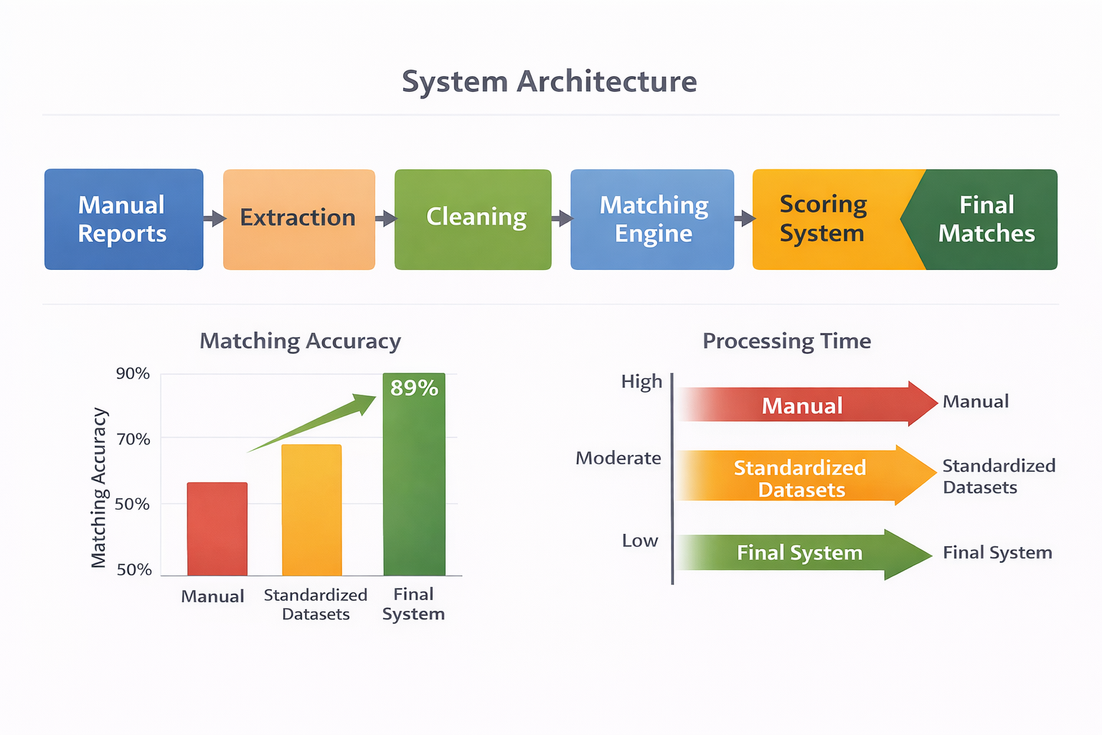

VIII. ACKNOWLEDGMENT
The author would like to thank WNS Global Services and the QBE Data Pricing Team for their support and guidance throughout this project and research.

The initial phase of this study involved manual extraction of data from insurance reports. Key fields identified included date of loss, cause of loss, insured details, claim value, and policy information.
This process required interpreting unstructured text and converting it into structured formats. While effective for smaller datasets, it lacked scalability and consistency. These limitations highlighted the need for automation.

IX. CONCLUSION AND FUTURE WORK
This study represents a comprehensive approach to improving not only insurance data but data as a whole and processing through the integration of manual insights, data standardization techniques, and automated scoring systems. Although the preliminary manual stage gave useful insights, its application was impractical for extensive operations. The later adoption of Power query, Python and SQL enhanced efficiency, precision and the capacity for incorporating advanced technologies, including NLP (Natural Language Processing), to facilitate more effective management of unstructured data, along with development of an AI model designed to mitigate discrepancies.

X. References
1) Microsoft Documentation, “Power Query M Language Specification,” 2023. [Online]. Available: https://learn.microsoft.com/powerquery-m

2) Microsoft Documentation, “Data Transformation and Cleaning Using Power Query,” 2023. [Online]. Available: https://learn.microsoft.com/power-query/

3) Microsoft Power BI Team, “Fuzzy Matching and Similarity Algorithms in Power Query,” 2022.

4) J. Leskovec, A. Rajaraman, and J. Ullman, Mining of Massive Datasets, Cambridge University Press, 2020.

5) A. Broder, “On the resemblance and containment of documents,” Compression and Complexity of Sequences, IEEE, 1997.

6) H. Haddaway et al., “Data Quality Issues in Large-Scale Insurance Datasets,” Journal of Data Science and Analytics, vol. 6, pp. 44–58, 2021.

7) McKinsey & Company, “Modernizing Claims Data for Operational Efficiency,” McKinsey Insurance Practice, 2022.

8) Deloitte Insights, “Automation in Insurance: Improving Claims Accuracy,” Deloitte Consulting, 2021.

9) Accenture, “Intelligent Automation for P&C Insurance,” Accenture Insurance Report, 2020.

10) ISO, “ISO 9001:2015 – Data Quality Requirements for Insurance Processes,” International Organization for Standardization, 2015.

11) Python Software Foundation, “Python Standard Library:TextProcessing,”2023.Available: https://docs.python.org/
12) T. Cohen, “Fuzzy String Matching Techniques for Structured and Unstructured Data,” IEEE Access, 2020.

13) S. Bird, E. Klein, and E. Loper, Natural Language Processing with Python, O’Reilly Media, 2009.

14) A. Kumar and P. Mitra, “Preprocessing Techniques for Real Insurance Data,” International Journal of Data Engineering, 2022.

15) M.A.Hall,“Handling Imbalanced Data and Inconsistent Records,” IEEE Transactions on Knowledge and Data Engineering, 2019.

16) IBM Analytics, “Best Practices for Data Standardization and Tokenization,” IBM Data Engineering Whitepaper, 2021.

17) Google Research, “Evaluation of Similarity Measures for Noisy Text,” Google AI Publications, 2019.

18) H. Garcia-Molina, “Data Cleaning: Problems and Approaches,” IEEE Data Engineering Bulletin, 2018.

