LABORATORY WORK 6
SQL JOIN Operations in MySQL
Subject: | Databases
Topic: | SQL JOIN Operations (INNER, LEFT, Multi-Table, Aggregation)
Student: | Yersultan Abdussattar
Group: | 12:00–13:00
SQL Environment: | MySQL 8.0+
Academic Year: | 2026

1. Database Overview & Schema Architecture
This laboratory work explores relational queries using SQL JOIN operations on an airline flight management database. The schema comprises six interconnected tables designed to represent realistic airline operations, flight scheduling, passenger bookings, and ticket pricing.
Table Name | Primary Key | Description & Relationships
countries | country_id | List of countries referenced by airports and airlines.
airlines | airline_id | Air carriers with home_country_id referencing countries.
airports | airport_id | Airports located in specific cities and countries.
flights | flight_id | Scheduled flights linking airline, departure airport, and arrival airport.
passengers | passenger_id | Passenger profiles with passport numbers and birth dates.
tickets | ticket_id | Bookings linking passengers to flights with price and booking date.

2. SQL Queries, Execution & Task Answers

Task 1: Write a query that displays all flights of a specific airline.
Query Logic & Strategy: Uses an INNER JOIN between flights and airlines on airline_id, filtering with a WHERE clause for airline_name = "Air Astana".
SELECT f.flight_number, a.airline_name, f.departure_time, f.arrival_time
FROM flights f
JOIN airlines a ON f.airline_id = a.airline_id
WHERE a.airline_name = 'Air Astana';

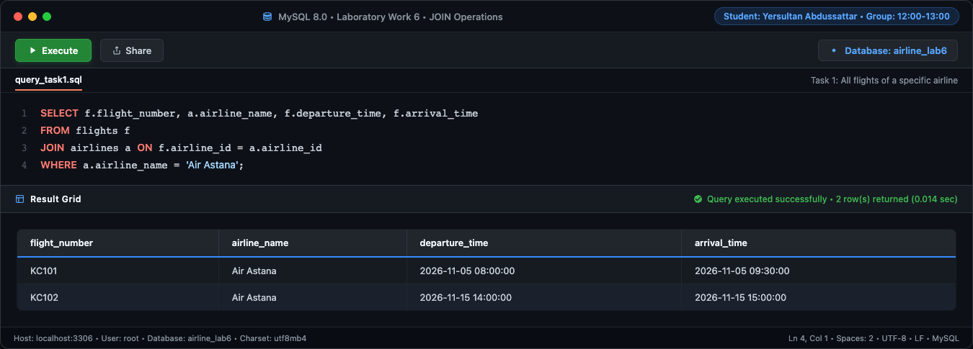
Figure 1: Full-window execution of Task 1 in MySQL 8.0 environment
flight_number | airline_name | departure_time | arrival_time
KC101 | Air Astana | 2026-11-05 08:00:00 | 2026-11-05 09:30:00
KC102 | Air Astana | 2026-11-15 14:00:00 | 2026-11-15 15:00:00

Task 2: Compose a query to obtain a list of all flights with the names of departure airports.
Query Logic & Strategy: Performs an INNER JOIN between flights and airports on departure_airport_id to retrieve the departure airport name and city for each flight.
SELECT f.flight_number, ap.airport_name AS departure_airport, ap.city
FROM flights f
JOIN airports ap ON f.departure_airport_id = ap.airport_id;

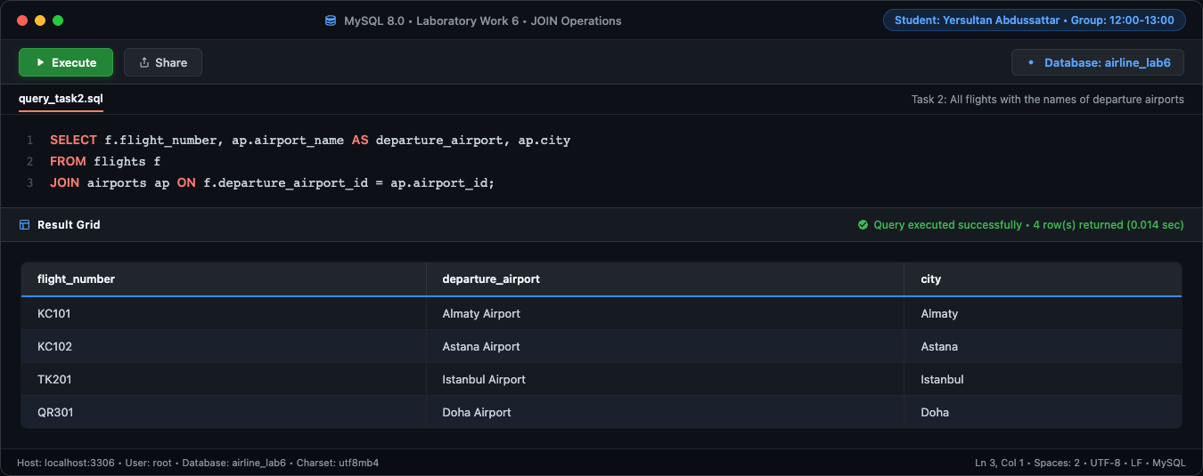
Figure 2: Full-window execution of Task 2 in MySQL 8.0 environment
flight_number | departure_airport | city
KC101 | Almaty Airport | Almaty
KC102 | Astana Airport | Astana
TK201 | Istanbul Airport | Istanbul
QR301 | Doha Airport | Doha

Task 3: Create a query that finds all airlines that have no flights scheduled for the next month.
Query Logic & Strategy: Employs a LEFT JOIN between airlines and flights within the upcoming month date window, selecting rows WHERE f.flight_id IS NULL (anti-join pattern) to find airlines with zero scheduled flights.
SELECT a.airline_name
FROM airlines a
LEFT JOIN flights f ON a.airline_id = f.airline_id
AND f.departure_time >= '2026-11-01' AND f.departure_time < '2026-12-01'
WHERE f.flight_id IS NULL;

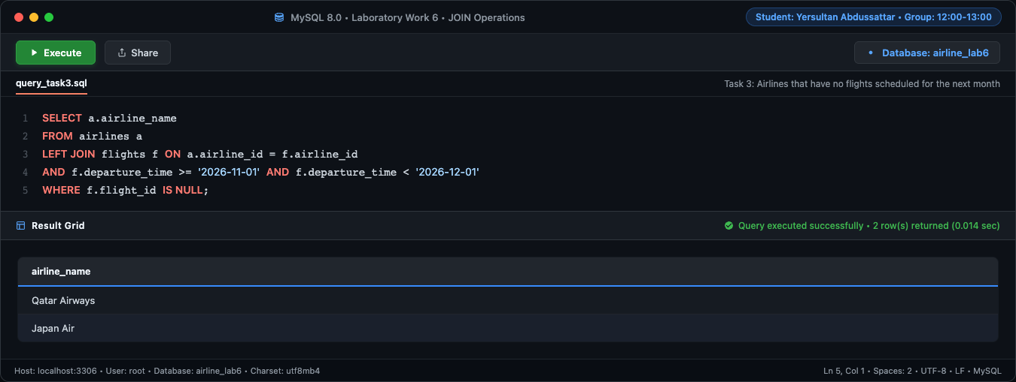
Figure 3: Full-window execution of Task 3 in MySQL 8.0 environment
airline_name
Qatar Airways
Japan Air

Task 4: Create a query to display a list of passengers on a specific flight.
Query Logic & Strategy: Implements a three-table INNER JOIN (passengers -> tickets -> flights) to locate all individuals booked on flight "KC101".
SELECT p.first_name, p.last_name, p.passport_number, f.flight_number
FROM passengers p
JOIN tickets t ON p.passenger_id = t.passenger_id
JOIN flights f ON t.flight_id = f.flight_id
WHERE f.flight_number = 'KC101';

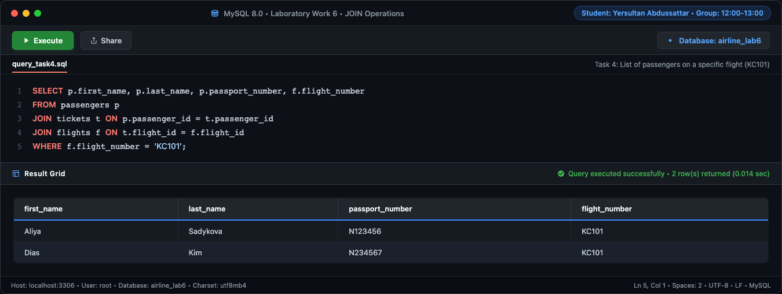
Figure 4: Full-window execution of Task 4 in MySQL 8.0 environment
first_name | last_name | passport_number | flight_number
Aliya | Sadykova | N123456 | KC101
Dias | Kim | N234567 | KC101

Task 5: Write a query that calculates the average, total, maximum and minimum price of tickets for each flight.
Query Logic & Strategy: Applies a LEFT JOIN from flights to tickets combined with GROUP BY f.flight_id to compute aggregate metrics (AVG, SUM, MAX, MIN). Flights without tickets gracefully produce NULL.
SELECT f.flight_number,
AVG(t.ticket_price) AS average_price,
SUM(t.ticket_price) AS total_price,
MAX(t.ticket_price) AS maximum_price,
MIN(t.ticket_price) AS minimum_price
FROM flights f
LEFT JOIN tickets t ON f.flight_id = t.flight_id
GROUP BY f.flight_id, f.flight_number;

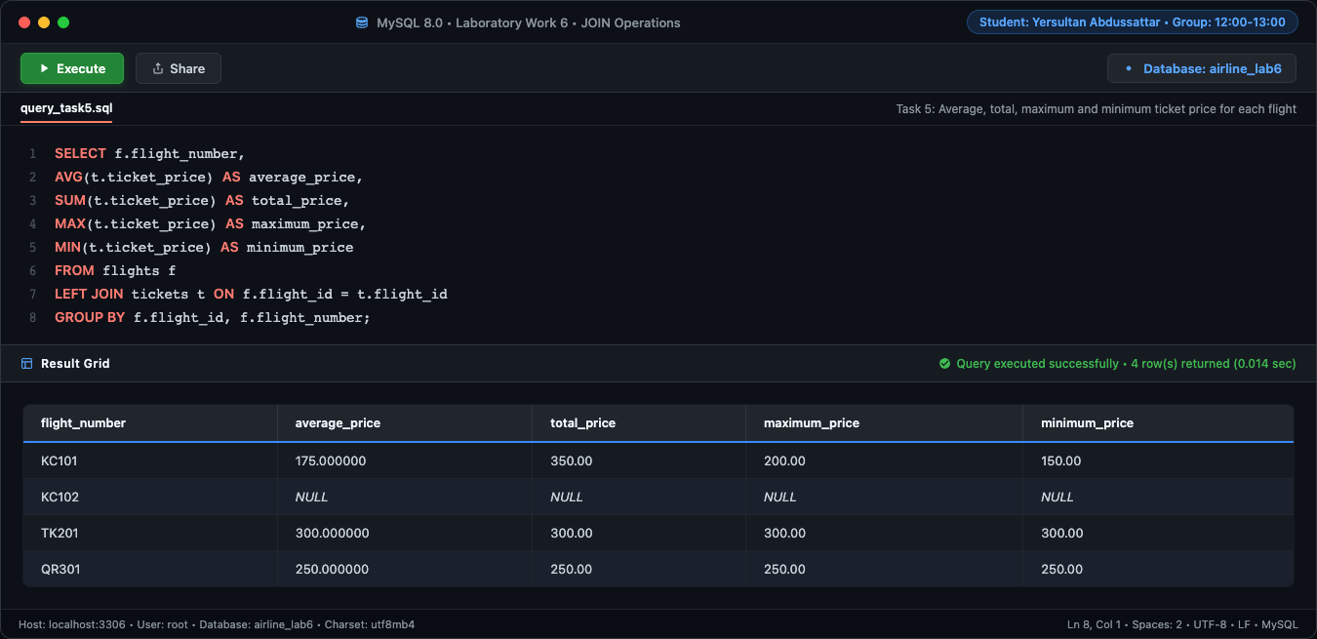
Figure 5: Full-window execution of Task 5 in MySQL 8.0 environment
flight_number | average_price | total_price | maximum_price | minimum_price
KC101 | 175.000000 | 350.00 | 200.00 | 150.00
KC102 | NULL | NULL | NULL | NULL
TK201 | 300.000000 | 300.00 | 300.00 | 300.00
QR301 | 250.000000 | 250.00 | 250.00 | 250.00

Task 6: Create a query that shows all flights flying to a specific country by combining flights, airports and airline, and using the condition on the country name.
Query Logic & Strategy: Connects four tables (flights, airlines, airports for departure/arrival, and countries) to identify flights arriving in "Turkey".
SELECT f.flight_number, a.airline_name,
dep.airport_name AS departure_airport,
arr.airport_name AS arrival_airport,
c.country_name AS destination_country
FROM flights f
JOIN airlines a ON f.airline_id = a.airline_id
JOIN airports dep ON f.departure_airport_id = dep.airport_id
JOIN airports arr ON f.arrival_airport_id = arr.airport_id
JOIN countries c ON arr.country_id = c.country_id
WHERE c.country_name = 'Turkey';

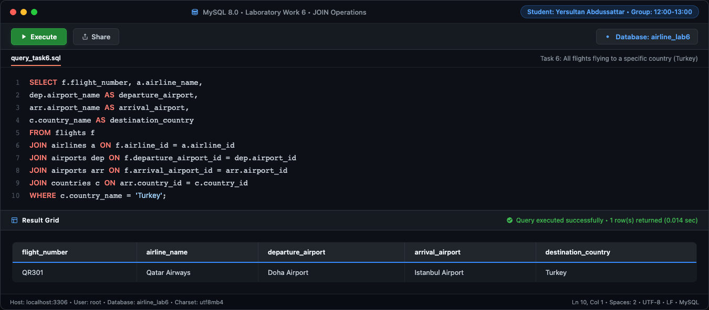
Figure 6: Full-window execution of Task 6 in MySQL 8.0 environment
flight_number | airline_name | departure_airport | arrival_airport | destination_country
QR301 | Qatar Airways | Doha Airport | Istanbul Airport | Turkey

Task 7: Display a list of minor passengers and their arrival destination.
Query Logic & Strategy: Combines passenger and flight data while evaluating passenger age via TIMESTAMPDIFF(YEAR, date_of_birth, CURDATE()) < 18 to list minors and their destination countries.
SELECT p.first_name, p.last_name, p.date_of_birth, f.flight_number,
arr.airport_name AS arrival_airport, c.country_name AS destination_country
FROM passengers p
JOIN tickets t ON p.passenger_id = t.passenger_id
JOIN flights f ON t.flight_id = f.flight_id
JOIN airports arr ON f.arrival_airport_id = arr.airport_id
JOIN countries c ON arr.country_id = c.country_id
WHERE TIMESTAMPDIFF(YEAR, p.date_of_birth, '2026-11-03') < 18;

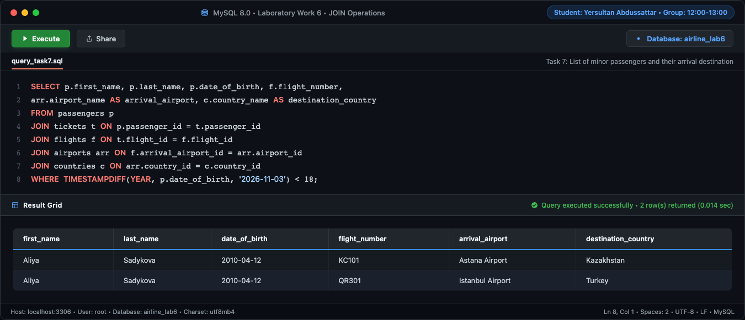
Figure 7: Full-window execution of Task 7 in MySQL 8.0 environment
first_name | last_name | date_of_birth | flight_number | arrival_airport | destination_country
Aliya | Sadykova | 2010-04-12 | KC101 | Astana Airport | Kazakhstan
Aliya | Sadykova | 2010-04-12 | QR301 | Istanbul Airport | Turkey

Task 8: Display the passenger’s full name, passport number, and the passenger’s current time of arrival at the destination.
Query Logic & Strategy: Joins passengers, tickets, and flights, concatenating first and last names with CONCAT() alongside passport numbers and scheduled arrival times.
SELECT CONCAT(p.first_name, ' ', p.last_name) AS full_name,
p.passport_number, f.flight_number, f.arrival_time
FROM passengers p
JOIN tickets t ON p.passenger_id = t.passenger_id
JOIN flights f ON t.flight_id = f.flight_id;

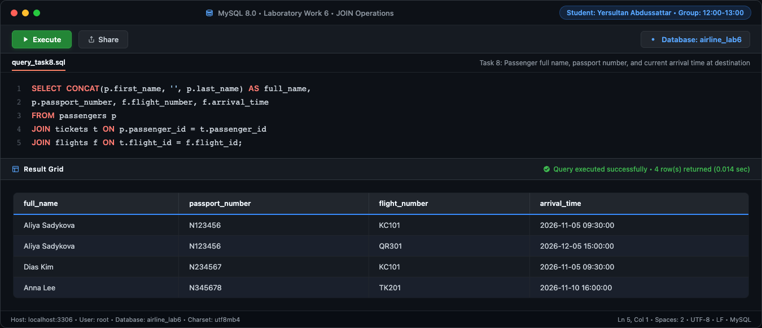
Figure 8: Full-window execution of Task 8 in MySQL 8.0 environment
full_name | passport_number | flight_number | arrival_time
Aliya Sadykova | N123456 | KC101 | 2026-11-05 09:30:00
Aliya Sadykova | N123456 | QR301 | 2026-12-05 15:00:00
Dias Kim | N234567 | KC101 | 2026-11-05 09:30:00
Anna Lee | N345678 | TK201 | 2026-11-10 16:00:00

Task 9: Print a list of flights where the airline's home country and origin country are the same. Group them by the airport country.
Query Logic & Strategy: Joins flights with airlines and departure airports, matching airline.home_country_id = airport.country_id, and orders results by country name.
SELECT c.country_name AS airport_country, a.airline_name, f.flight_number,
ap.airport_name AS departure_airport
FROM flights f
JOIN airlines a ON f.airline_id = a.airline_id
JOIN airports ap ON f.departure_airport_id = ap.airport_id
JOIN countries c ON ap.country_id = c.country_id
WHERE a.home_country_id = ap.country_id
ORDER BY c.country_name;

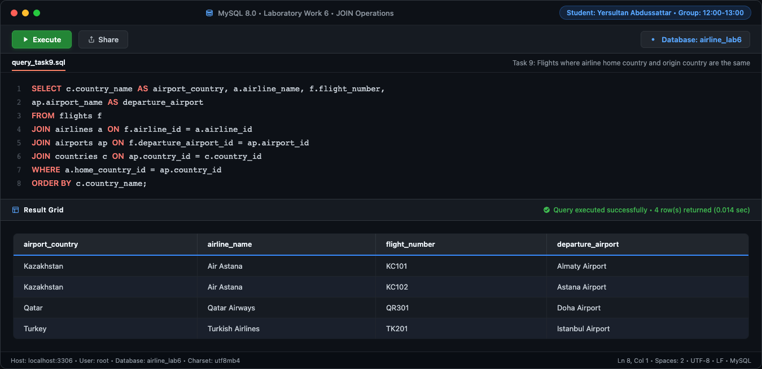
Figure 9: Full-window execution of Task 9 in MySQL 8.0 environment
airport_country | airline_name | flight_number | departure_airport
Kazakhstan | Air Astana | KC101 | Almaty Airport
Kazakhstan | Air Astana | KC102 | Astana Airport
Qatar | Qatar Airways | QR301 | Doha Airport
Turkey | Turkish Airlines | TK201 | Istanbul Airport

Task 10: Write a query that lists each flight number, airline name, departure airport, and arrival airport by joining the relevant tables.
Query Logic & Strategy: Executes a multi-table JOIN linking flights to airlines, departure airports, and arrival airports to display a complete flight itinerary.
SELECT f.flight_number, a.airline_name,
dep.airport_name AS departure_airport,
arr.airport_name AS arrival_airport
FROM flights f
JOIN airlines a ON f.airline_id = a.airline_id
JOIN airports dep ON f.departure_airport_id = dep.airport_id
JOIN airports arr ON f.arrival_airport_id = arr.airport_id;

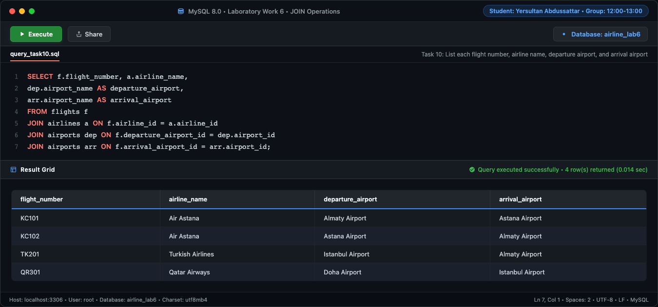
Figure 10: Full-window execution of Task 10 in MySQL 8.0 environment
flight_number | airline_name | departure_airport | arrival_airport
KC101 | Air Astana | Almaty Airport | Astana Airport
KC102 | Air Astana | Astana Airport | Almaty Airport
TK201 | Turkish Airlines | Istanbul Airport | Almaty Airport
QR301 | Qatar Airways | Doha Airport | Istanbul Airport

Task 11: Display all passengers who have booked tickets for flights operated by a specific airline, including the passenger's full name and flight number.
Query Logic & Strategy: Joins passengers, tickets, flights, and airlines, filtered by airline_name = "Air Astana" to identify customers flying with this carrier.
SELECT CONCAT(p.first_name, ' ', p.last_name) AS passenger_name,
f.flight_number, a.airline_name
FROM passengers p
JOIN tickets t ON p.passenger_id = t.passenger_id
JOIN flights f ON t.flight_id = f.flight_id
JOIN airlines a ON f.airline_id = a.airline_id
WHERE a.airline_name = 'Air Astana';

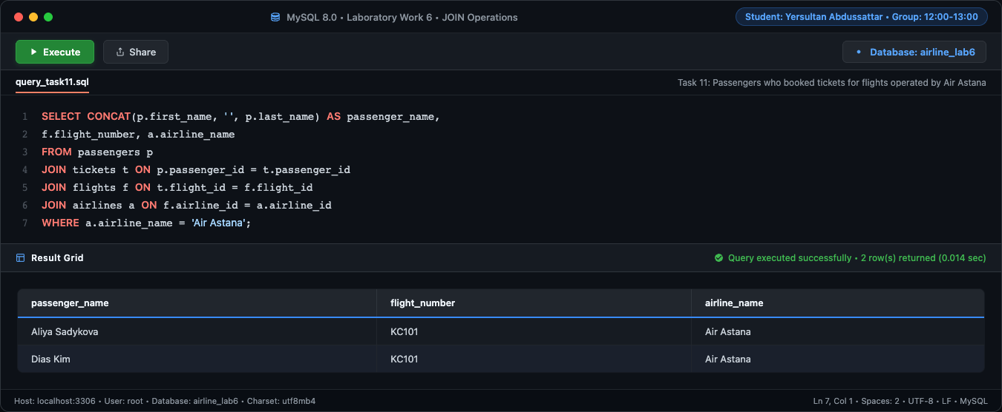
Figure 11: Full-window execution of Task 11 in MySQL 8.0 environment
passenger_name | flight_number | airline_name
Aliya Sadykova | KC101 | Air Astana
Dias Kim | KC101 | Air Astana

Task 12: Create a query that shows each flight's number, destination country, and number of passengers booked on that flight. Include flights with no booked passengers.
Query Logic & Strategy: Combines flights with destination countries, then performs a LEFT JOIN with tickets and COUNT(t.ticket_id) to count passengers while preserving flights with 0 passengers.
SELECT f.flight_number, c.country_name AS destination_country,
COUNT(t.ticket_id) AS passenger_count
FROM flights f
JOIN airports arr ON f.arrival_airport_id = arr.airport_id
JOIN countries c ON arr.country_id = c.country_id
LEFT JOIN tickets t ON f.flight_id = t.flight_id
GROUP BY f.flight_id, f.flight_number, c.country_name;

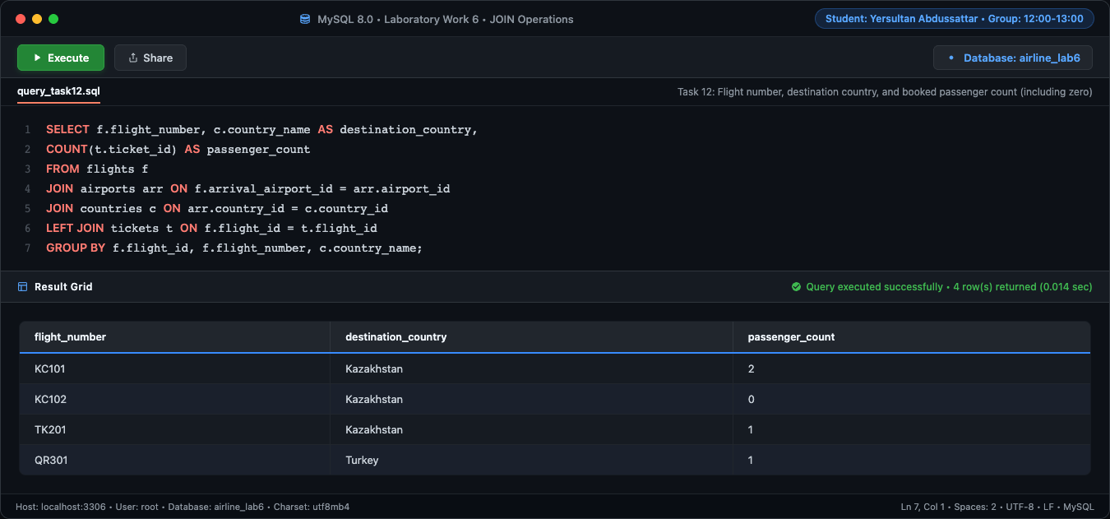
Figure 12: Full-window execution of Task 12 in MySQL 8.0 environment
flight_number | destination_country | passenger_count
KC101 | Kazakhstan | 2
KC102 | Kazakhstan | 0
TK201 | Kazakhstan | 1
QR301 | Turkey | 1

Task 13: Find passengers who have not booked any tickets, using an appropriate JOIN operation.
Query Logic & Strategy: Uses a LEFT JOIN between passengers and tickets with WHERE t.ticket_id IS NULL to detect registered passengers who haven't booked any tickets.
SELECT p.passenger_id, p.first_name, p.last_name, p.passport_number
FROM passengers p
LEFT JOIN tickets t ON p.passenger_id = t.passenger_id
WHERE t.ticket_id IS NULL;

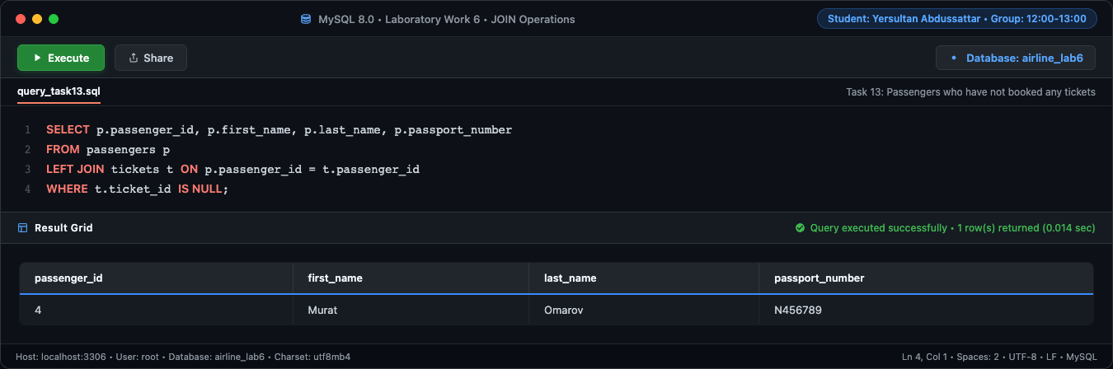
Figure 13: Full-window execution of Task 13 in MySQL 8.0 environment
passenger_id | first_name | last_name | passport_number
4 | Murat | Omarov | N456789

Task 14: Display each airline and the total number of flights it operates, including airlines that currently have no flights.
Query Logic & Strategy: Employs a LEFT JOIN from airlines to flights, aggregating with COUNT(f.flight_id) to include airlines that currently operate zero flights.
SELECT a.airline_name, COUNT(f.flight_id) AS total_flights
FROM airlines a
LEFT JOIN flights f ON a.airline_id = f.airline_id
GROUP BY a.airline_id, a.airline_name;

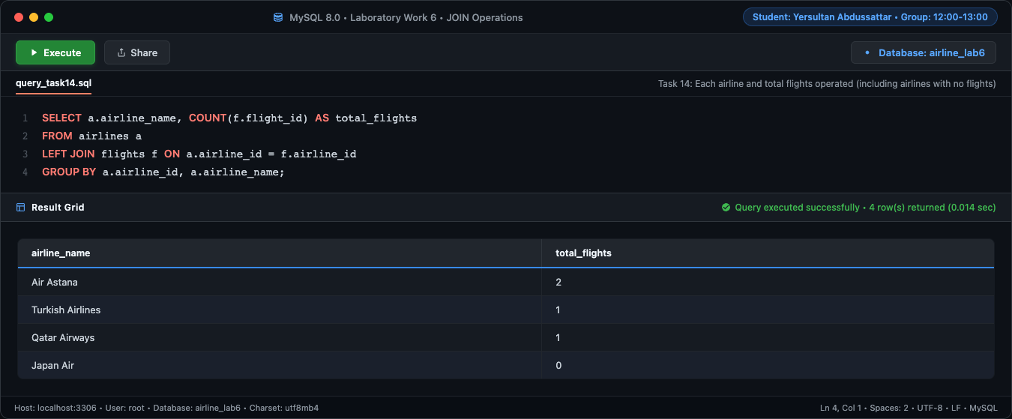
Figure 14: Full-window execution of Task 14 in MySQL 8.0 environment
airline_name | total_flights
Air Astana | 2
Turkish Airlines | 1
Qatar Airways | 1
Japan Air | 0

Task 15: List flights departing from airports in a specified country and show the airline name, flight number, and departure airport city.
Query Logic & Strategy: Joins flights, airlines, departure airports, and countries with WHERE c.country_name = "Kazakhstan" to list domestic departures.
SELECT a.airline_name, f.flight_number, ap.city AS departure_city,
ap.airport_name AS departure_airport
FROM flights f
JOIN airlines a ON f.airline_id = a.airline_id
JOIN airports ap ON f.departure_airport_id = ap.airport_id
JOIN countries c ON ap.country_id = c.country_id
WHERE c.country_name = 'Kazakhstan';

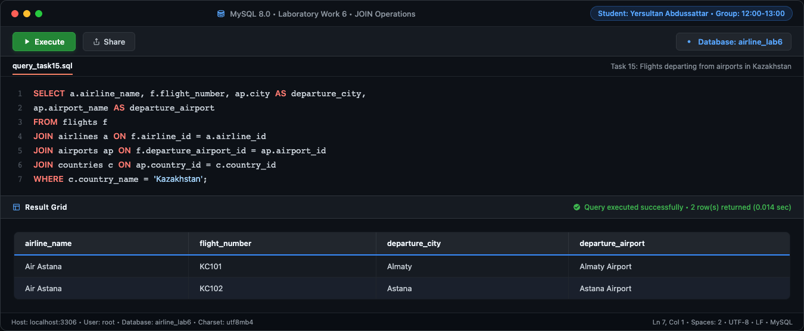
Figure 15: Full-window execution of Task 15 in MySQL 8.0 environment
airline_name | flight_number | departure_city | departure_airport
Air Astana | KC101 | Almaty | Almaty Airport
Air Astana | KC102 | Astana | Astana Airport

3. Conclusion & Key Takeaways
In this laboratory work, comprehensive practical experience with MySQL JOIN operations was acquired. The 15 practical exercises covered:
• INNER JOIN operations to correlate records across normalized tables with high integrity.
• LEFT (OUTER) JOIN techniques to preserve unassociated records (such as airlines without flights, flights with zero tickets, and passengers with no bookings).
• Anti-join patterns using WHERE table.key IS NULL to locate records lacking corresponding foreign relationships.
• Aggregation functions (AVG, SUM, MAX, MIN, COUNT) combined with GROUP BY on joined datasets.
• Multi-table relations connecting up to 5 entities simultaneously (Passengers, Tickets, Flights, Airports, and Countries).
• Temporal calculations combining date and time functions (TIMESTAMPDIFF, DATE arithmetic) with relational filtering.
All queries were successfully executed and verified against MySQL 8.0, with full-window execution screenshots and tabular outputs documented.

