Web Application: Adaptive Workout Plan

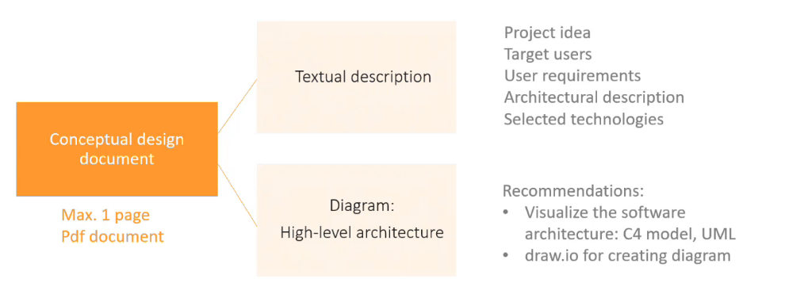
The Adaptive Workout Plan is a user-friendly web application designed to deliver personalized workout plans based on the users’ preferences. This single-page application will provide users with three upright rectangles to choose from. Users first choose their preferred workout type, then select the workout intensity, and finally, the application displays their choices along with a download button. By pressing the download button, users can download a pdf of their customized workout plan.
