# Python Web Basics Exam – Recipes

*Recipes is an application where you can add, edit and delete your own recipes. You can also open a details page of each recipe to see the time needed for the recipe, the ingredients and the full description.*

## Skeleton

You are provided with all the **html pages**, all the **images** and the **CSS** for the project.

## Database

You will need **1 model**:

* **Recipe**
  + - **title** - Character field with **max length** of **30 characters**
    - **image_url** - URL field
    - **description** - Text field
    - **ingredients** - Character field with **max length** of **250 characters**
    - **time** - Integer field

## Routes

* **'**[**/**](http://localhost:8000/)**'** - home page
* **'**[**/create**](http://localhost:8000/create)**'** - create recipe page
* **'**[**/edit/:id**](http://localhost:8000/edit/:id)**'** - edit recipe page
* **'**[**/delete/:id**](http://localhost:8000/delete/:id)**'** - delete recipe page
* **'**[**/details/:id**](http://localhost:8000/details/:id)**'** - recipe details page

## Pages

### Home Page – 30p

If there are **no recipes** created yet:

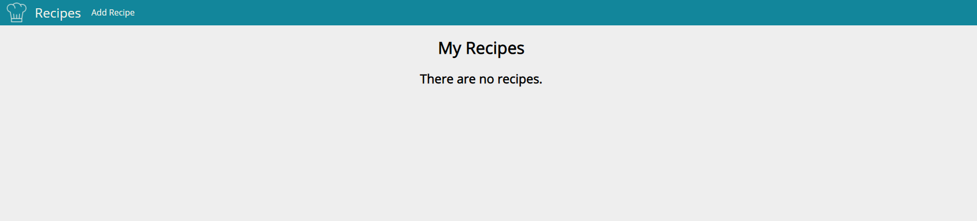

If there **are recipes**:

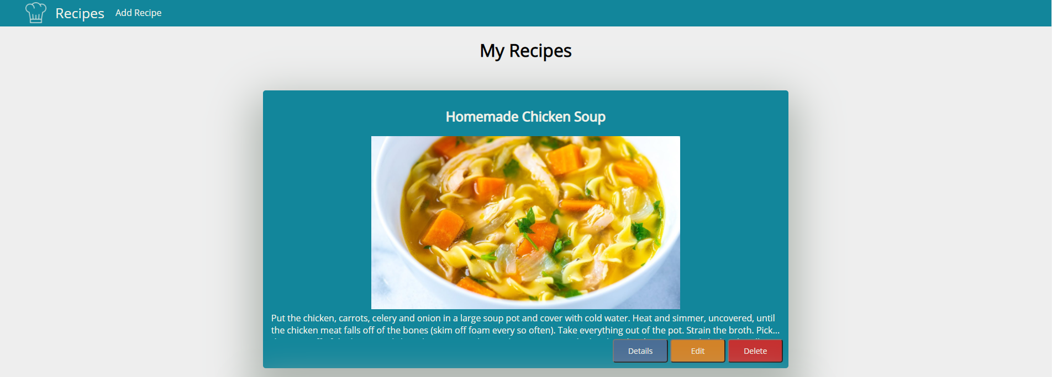

### Create Recipe Page – 20p

The ingredients should be **separated** by **", "**. After the button is clicked, **create** the recipe and redirect to home.

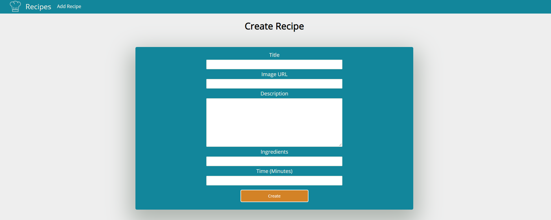

### Edit Recipe Page – 15p

The form must be **filled** with the **data** of the **recipe** we want **to edit.** When the button is clicked, **edit** the recipe and redirect to home.

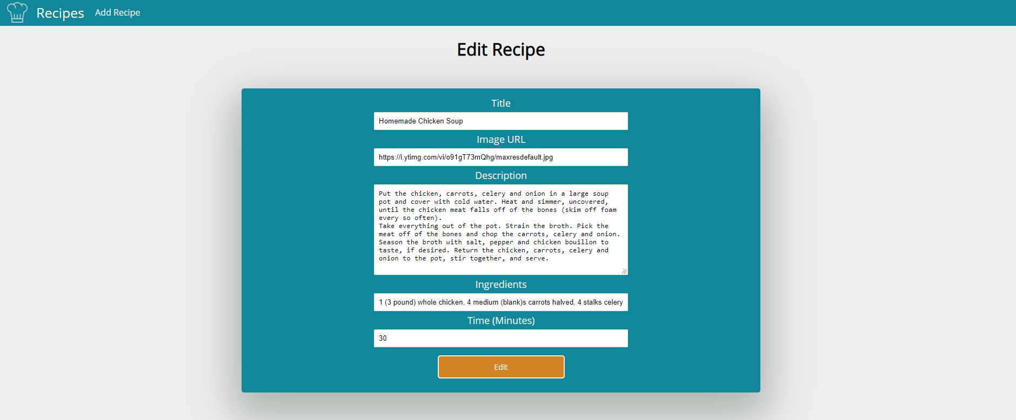

### Delete Recipe Page – 15p

The form must be **filled** with the **data** of the **recipe** and the **fields** should be **disabled**. When the button is clicked, **delete** the recipe and redirect to home.

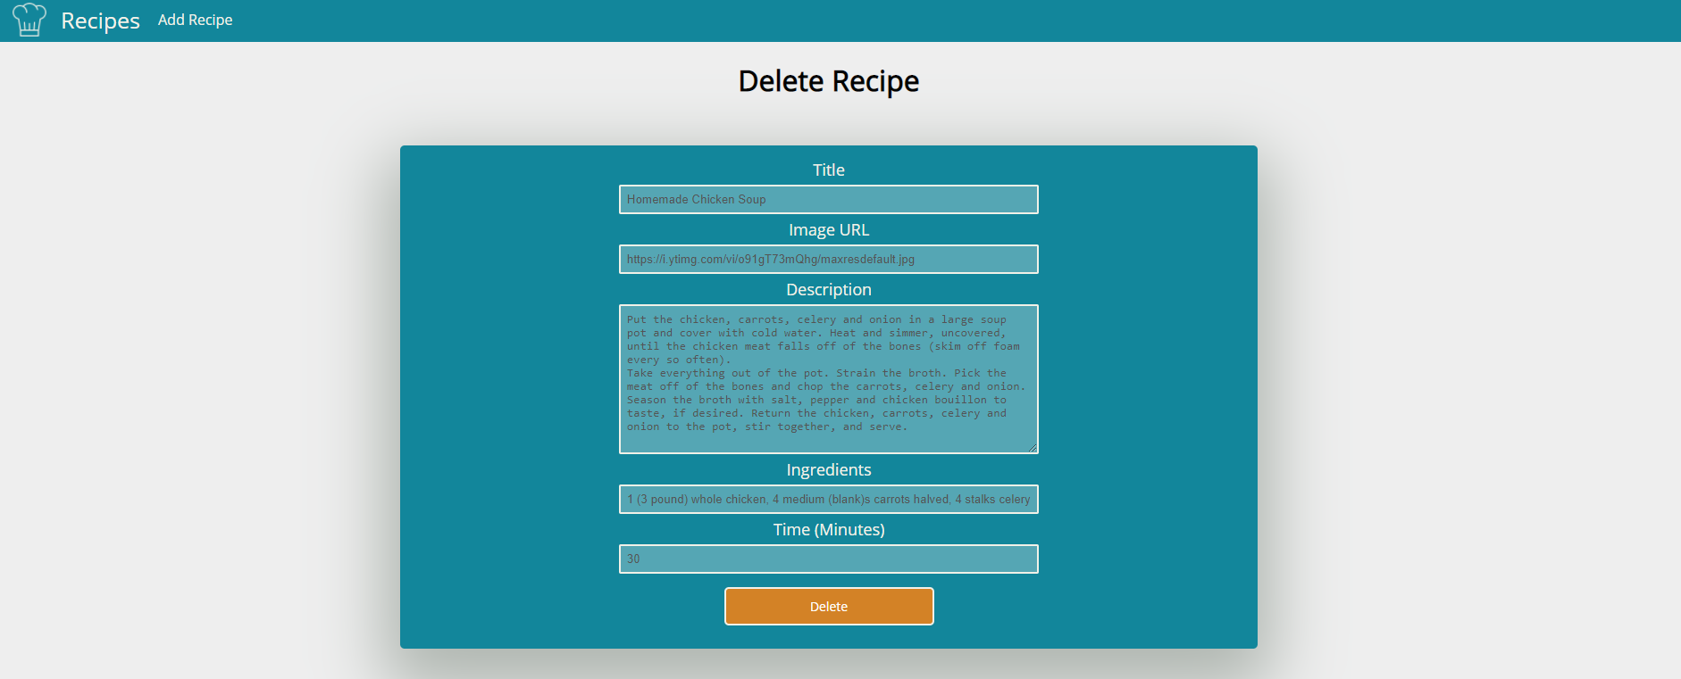

### Recipe Details Page – 20p

Fill the **needed data**. The **ingredients** should be separate **"li"** items.

{% extends 'base.html' %}  
{% block content %}  
 <div class="container">  
 <h1>My Recipes</h1>  
 {% if not recipes %}  
 <h2>There are no recipes.</h2>  
 {% else %}  
 {% for recipe in recipes %}  
 <div class="items-container">  
  
 <div class="item">  
 <h2>{{ recipe.title }}</h2>  
 <img class="detail-img" src="{{ recipe.image_url }}" alt="{{ recipe.title }}-image">  
 <div class="recipe-info">  
 {{ recipe.description }}  
 </div>  
 <div class="buttons-container">  
 <a class="button detail" href="{% url 'details recipe' pk=recipe.id %}">Details</a>  
 <a class="button edit" href="{% url 'edit recipe' pk=recipe.id %}">Edit</a>  
 <a class="button delete" href="{% url 'delete recipe' pk=recipe.id %}">Delete</a>  
 </div>  
 </div>  
 {% endfor %}  
 {% endif %}  
 </div>  
 </div>  
</body>  
</html>  
{% endblock %}

