Auratty👑
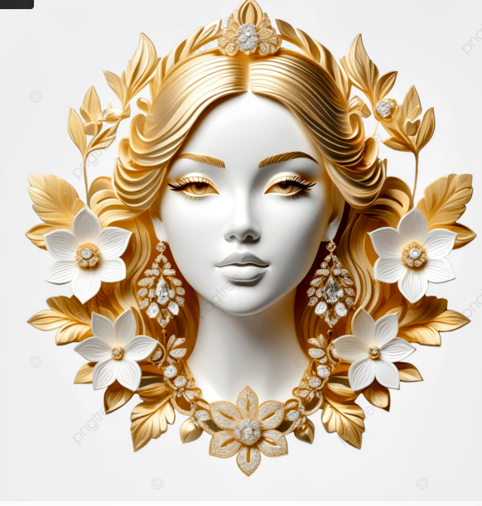
The presence of a woman is the presence of survival
The aura of a woman is more than a speech of confidence
Empowering women, building a solid tomorrow
Mz_Erttie💫

