[**Veri Bilimi Nedir?**](https://www.youtube.com/watch?v=lWNhypq_qs4&list=PLk54I7lqQSsbOg7eN2vGUKcvwcZ7ZlT5W)

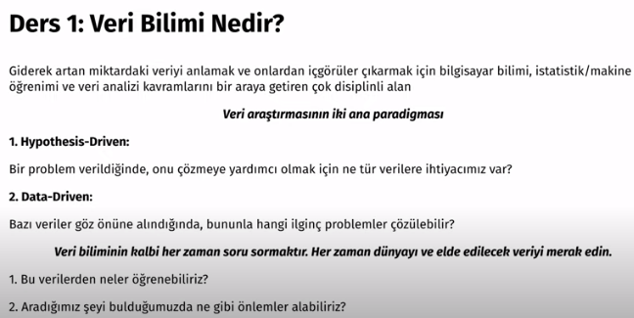

[**Veri Türleri**](https://www.youtube.com/watch?v=Fw1zrLTYQWo&list=PLk54I7lqQSsbOg7eN2vGUKcvwcZ7ZlT5W&index=2)

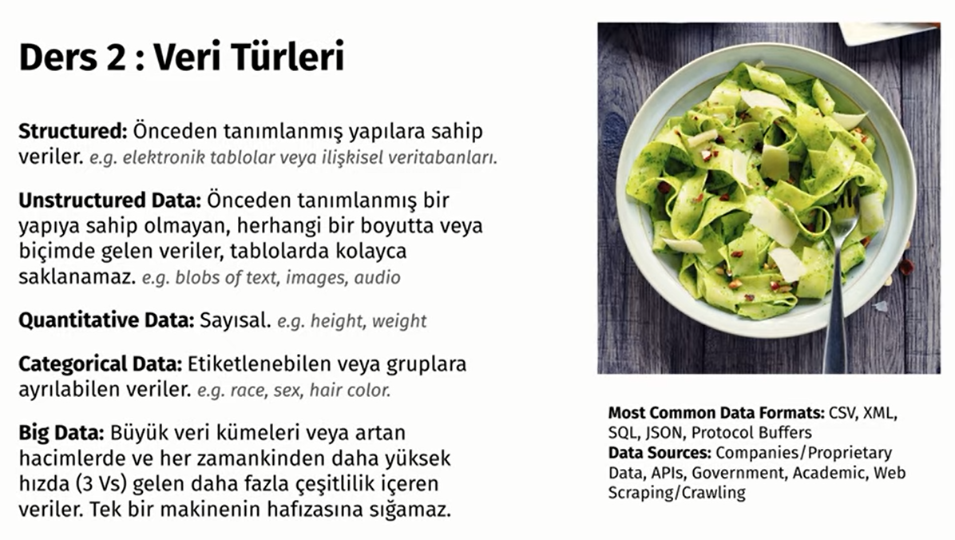

[**Veri Biliminde Problem Tipleri**](https://www.youtube.com/watch?v=d_rWEZQnNjk&list=PLk54I7lqQSsbOg7eN2vGUKcvwcZ7ZlT5W&index=3)

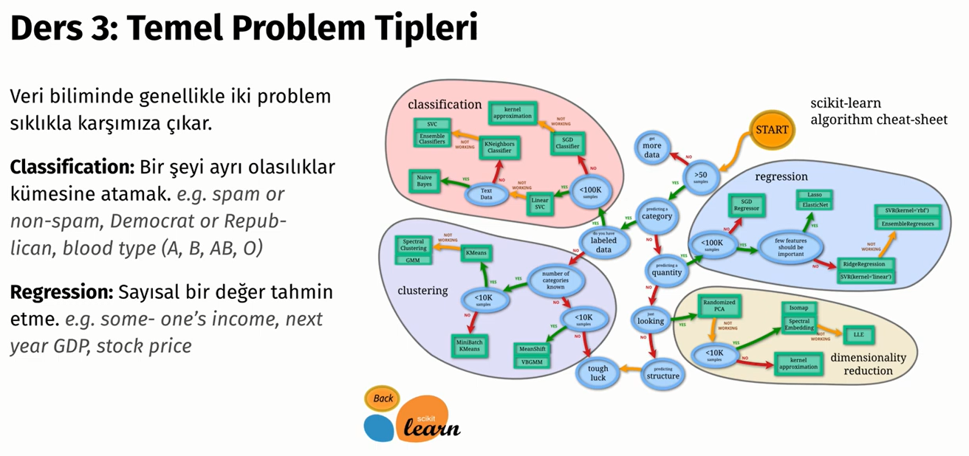

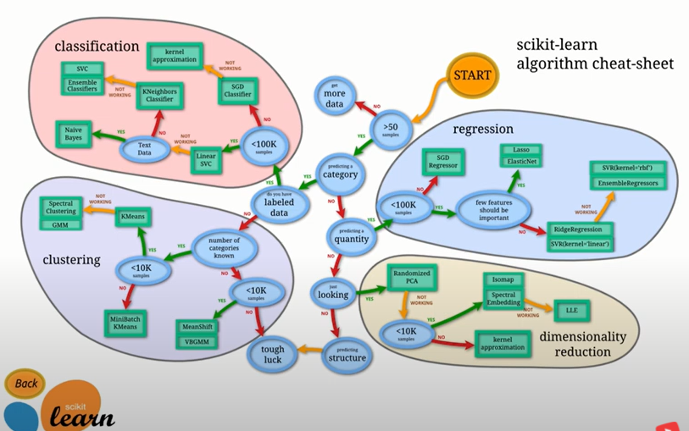

[**Veri Biliminde Betimsel İstatistikler**](https://www.youtube.com/watch?v=cZxDMazrDbg&list=PLk54I7lqQSsbOg7eN2vGUKcvwcZ7ZlT5W&index=4)

