Number Plate Recognition
Digital Image Project Report
https://www.youtube.com/watch?v=8dHSCbkvT8k

Resul Kayım
17290106
Computer Engineering Department
Ankara University, Turkey
17290106@ogrenci.ankara.edu.tr
Ertuğrul Safa Bağdatlı
17290085
Computer Engineering Department
Ankara University, Turkey
17290106@ogrenci.ankara.edu.tr

Abstract—Number Plate Recognition is a widely used system for many purposes. Image Processing system is the essential key of Number Plate Recognition systems. OCR (Optical Character Recognition) is also used for reading the image of a car plate and giving an output in text format which the image is obtained by several filtering processes. To recognize a plate of a car has a lot of uses, automatic tollgate systems or car parks can be examples of civil usage of Number Plate Recognition systems. And in some cases, like car theft or fining a criminal or tracking a suspect Number Plate Recognition systems can be helpful. In Number Plate Recognition, with help of Image Processing the plate of a car is recognized and after the finding the plate OCR systems processes the image of plate and convert to a text string. In this given research paper, a full algorithm of Number Plate Recognition system is shown.
Keywords—number plate recognition (NPR), optical character recognition (OCR), image processing, image filters, number plate segmentation

Introduction

In recent years, thanks to the rapid developments of computer technologies, automatic number plate recognition (ANPR) or other name license plate recognition (LPR) played a great role in systems like traffic monitoring, automatic toll car park systems [1], tax collection [2], automatic vehicle parking system [3], vehicle speed detection [4], security control for restricted areas [5], unattended parking zones [6], electronic toll collection [7], traffic law enforcement [8].
The British Police Scientific Development Branch first invented License Plate Recognition Technology in 1976. Earlier prototypes were premature with low accuracy readings and only functioned under restrictive laboratory conditions that made real world application nearly impractical. [9]
At the present time we have a huge number of monitoring devices like CCTVs. These cameras always functioning and watching everything and with help of these devices we can easily identify the car and the owner of the car.
Identifying a car from a picture is dependent on identifying the car’s license plate since it is unique to every vehicle. After some systematic steps and processes we can identify the license plate. These processes have two core steps which are firstly detecting car or number plate area and secondly recognizing the characters of the detected number plate. Visualization of these steps and the flow of the project can be seen in the Fig. 1.
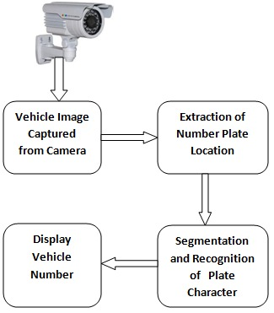
Fig. 1. Number Plate Recognition System Block Diagram
First process of these core steps is mostly done by image processing systems. After applying some filters to an image, the car number plate is highlighted. But the key part in here is which filter to apply and in what order and what will be the applied filter’s parameters. To find such a sequence it needs deeply understanding in image processing methods.
After detecting the number plate of a car, final step is recognizing the character. To recognize the characters of the number plate we use EasyOCR, which is a python package that perform optical character recognition. But before character recognition stage we need to prepare the number plate. To do such preparation we perform some image processing filters that are like what we use to detect the number plate.
The further explanation in this document mostly concentrates on the first steps of the number plate recognition which is detecting the number plate of a car through image processing methods.

Extraction of Number Plate Location
Thanks to the breakthrough development of technology, in today’s world we do not lack any device for monitoring or rendering processes. The main problem lies in the coding which can be solved with help of artificial intelligence methods. But in this project, we won’t discuss about artificial intelligence, but we will focus on how to solve this problem with only help of image processing methods.

Image Processing Methods
Image processing methods try to get a useful information from an image through some filtering operations. Image processing mainly focus on preprocessing an image before the main process of all system, in our situation the main process is handled by image processing. To achieve our goal, we use some basic but very helpful filters like gray scaling or increasing the contrast.

Gray Scale Filtering
Firstly, we acquire an image of a car, after the resizing the original image which can be seen in Fig. 2, to a specific format which is 800 x 600, we convert the image’s colors to shades of gray which can be seen in Fig. 3. Although gray scaling an image might seem redundant, it has a huge help for future filtering. Before gray scaling an image, the image has three color attributes which are red, green and blue. All color attributes can vary from 0-255 and since we have three attributes it can be a lot of variables but after converting image to shades of gray, we only have 256 options, hence we greatly decreased the number of options. Thus, we will have much faster results while applying our filters and we can use filters more comfortably.
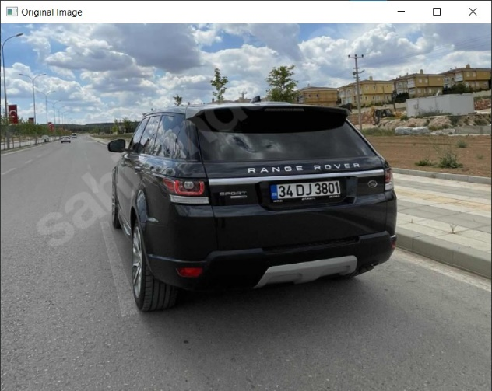
Fig. 2. Original format of an acquired image.
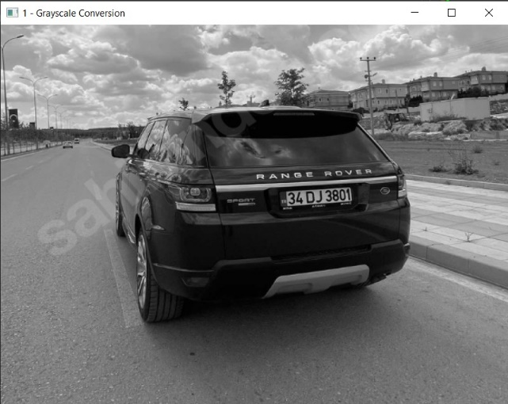
Fig. 3. Gray scaled version of the given image.

Contrast Increaser
After we convert original image to gray scaled image, we need to increase the contrast to make clear the frame of number plate. Firstly, we take original image and do some histogram equalization in small patches, purpose of doing this equalization is while increasing the background details it reduces contrast, but we apply this filter very little so in result it doesn’t change much with respect to original image, the output of this filter can be seen in Fig. 4. After equalization we scale the color of image to gray shade. Finally, we merge both enhanced image and firstly obtained gray scaled image to further increase the contrast which can be seen in Fig. 5.
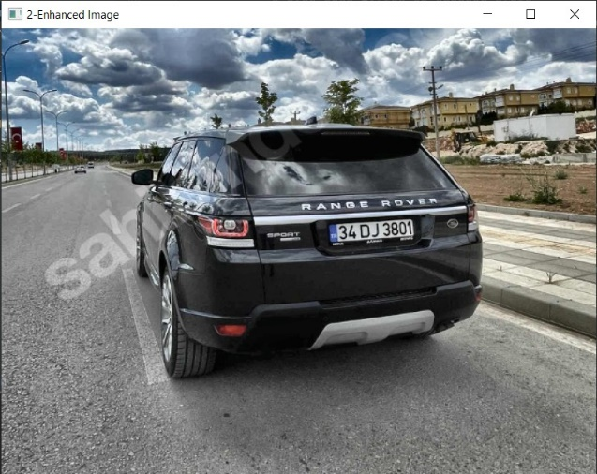
Fig. 4. After image of histogram equalization filtering.
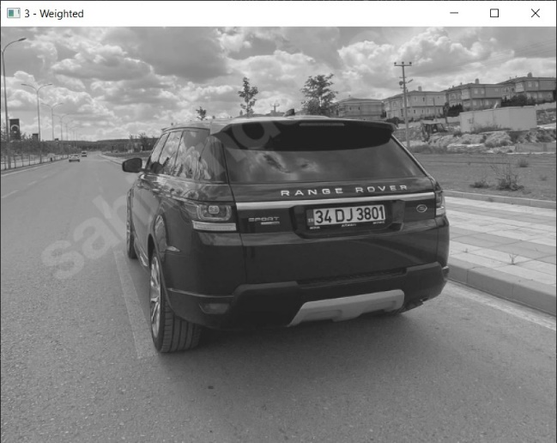
Fig. 5. Merged image of two images.

Blurring the Image
After the contrast increasing processes, we have a high contrast image but with a lot of background noise. To decrease the background noise, we use blurring filters. Final output can be seen in Fig. 6. But since we don’t want to distort the image too much, we apply the blurring filter very little.
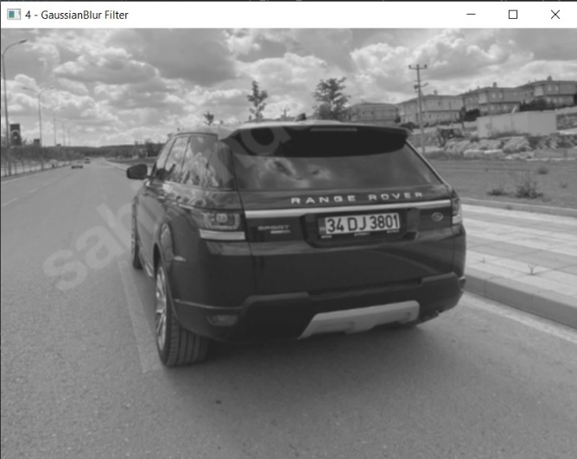
Fig. 6. Blurred image of a car.

Edge Detection
The most crucial part of our image processing system is edge detection filter. We use finalized blurred image to detect the edges. To detect the edges, we use canny edge detector which is a multi-stage algorithm. The first stage of this algorithm is blurring the image since edge detectors are susceptible to background noises. The next stage is where the main edge detection is being done with help of Sobel kernel. After detecting the edges in the next stage, unwanted pixels are removed through some suppression function. And the final stage is deciding which edges are real edges to do such operation we need two threshold values and do some calculations. Finished image can be seen in Fig. 7.
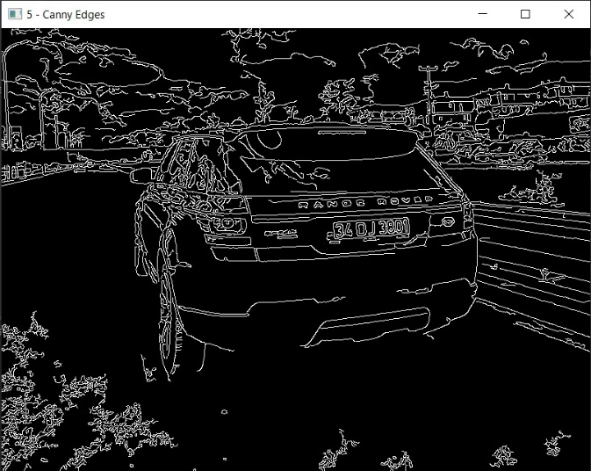
Fig. 7. Image after edge detection filter.

Finding Contours
After a set of filtering processes, we need to find the contours of the image from the edge detected version of the image. After finding and drawing the contours, we must sort them according to the area of the contours. And while choosing the contours we had to pick closed circuit contours which are fully connected through lines. Image of all chosen contours can be seen in Fig. 8. Then we take 30 contours that have maximum area than the others which can be seen in Fig. 9. The purpose of taking 30 top contours is making the algorithm more efficient. Finally, we loop over all the chosen contours to find satisfied contour according to our parameters. And the resulting contour is the number plate of the car. Only remaining problem is the character reading.
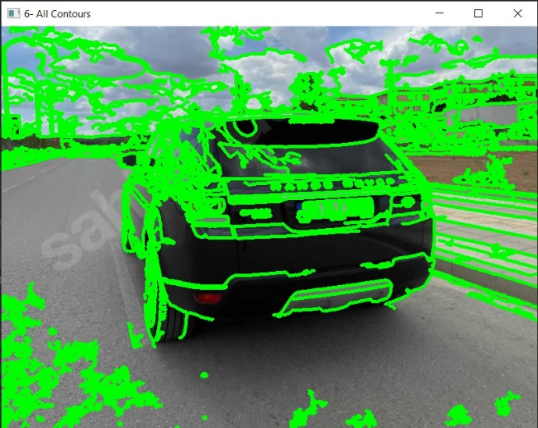
Fig. 8. After drawing all the contours of the image.
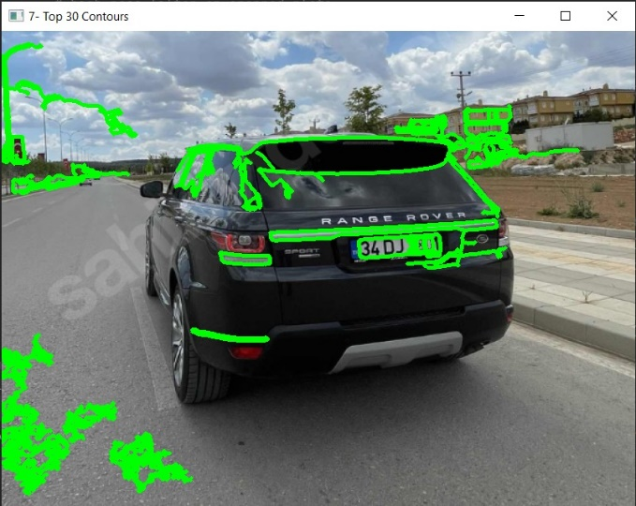
Fig. 9. Top 30 contours of the image.

Recognition of Plate Character
After finding the contour of number plate which is the most like a rectangle, we find the location and size of the contour. And according to these parameters we extract our number plate from the original image which can be seen in Fig. 10. Now our number plate can look ready to character recognition but the most usen OCR libraries doesn’t work very well, the resulted output through EasyOCR can be seen in Fig. 11. Thus, we should preprocess the number plate which we cropped from the original image.

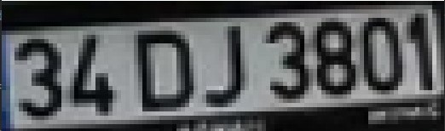
Fig. 10. Extracted number plate from the image.
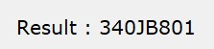
Fig. 11. Result of the image through EasyOCR.

Background Noise Removing
The first stage of preprocessing of the cropped number plate image is contrast reducer filtering. But this time we don’t use normal methods for decreasing the contrast instead we use like a low pass filtering which does clear the image through removing the unused details from cropped plate. To do such process we first apply blurring filter with a huge window size, as a result we get an over blurred image. This process looks unnecessary but after we extract the overly blurred image from the original cropped number plate, we acquire an image cleaned from unnecessary details. The result of these processes can be seen in Fig. 12.
Fig. 12. The image after noise removing.

Clarifying the Image
After we acquire the image from background noise filter, we resize the image for further filtering. After removing the background noise, the image is very blurred for character recognition operation. To clarify the image, we use same function when we used for the contrast increasing of the original input. For this function we need two input images and better results we don’t use the same image directly. The first image is the image that we acquired after background noise removal operation, and for the second image we use the same image after using a filter on it. The purpose of the filter that we use is black and white converter which use thresholding method. The output of this black and white converter filter can be seen in Fig. 13. Finally, we have both only background noise removed image and black and white converted image, now we merge both those images which can be seen in Fig. 14.

Fig. 13. The image after black and white converter

Fig. 14. Merged image.

Dilation Filter
After merging process, we now have an image that is almost ready to OCR operation. The final filter we will apply is dilation filter. After merging process, the image has clear characters but since they are very thick it is hard to read for EasyOCR, so we need to make them thinner. To acquire such result, we use dilation filter. As a result of this filter our characters are thinner which is nearly perfect for character recognition operation. The result of this filter can be seen in Fig. 15.

Fig. 15. Dilated image.

Final Image and Result text
After several processing the image is ready for optical character recognition operation. The comparison of the first cropped image from original image and resultant image of digital image processes can be seen in Fig. 16.
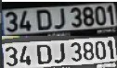
Fig. 16. Comparison of the cropped image and the preprocessed image.
The final image is ready for optical character recognition operation. For OCR operation we use EasyOCR which returns a string. If we didn’t preprocess the cropped image, EasyOCR would still work but not very efficiently and sometimes it gives not wanted results, an example of these unwanted result can be seen in Fig. 17, which we use the cropped image but not preprocessed any filter. And the final output from EasyOCR after preprocessing the cropped image can be seen in Fig. 18.

Fig. 17. Wrong result of the image before preprocessing.
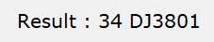
Fig. 18. Final output of EasyOCR.

Conclusion
In this project, an autonomous number plate recognition system is created with help of digital image processing methods. Firstly, an acquired image is processed under some filters. After some digital image processing, coordinate and size of the number plate of the car is calculated. Then, the number plate is extracted from original image. This cropped image is processed under some filters. And the final image is ready for optical character recognition function which is EasyOCR in our case. And finally characters the number plate of the car is recognized. The presented method can be used for a lot of areas like toll booth and parking areas.

References
- C. Anton Sat ria Prabuwono and Ariff Idris, "A Study of Car Park
Control System Using Optical Character Recognition," in
International Conference on Computer and Electrical Engineering,
(2008): 866-870.
- You-Shyang Chen and Ching-Hsue Cheng, "A Delphibased rough
sets fusion model for extracting payment rules of vehicle license tax
in the government sector," Expert Syst ems with Applicat ions, vol.
37, no. 3, (2010): pp. 2161- 2174.
- A Albiol, L Sanchis, and J.M Mossi, "Detection of Parked Vehicles
Using Spat iotemporal Maps," IEEE Transact ions on Intelligent
Transportat ion Systems, vol. 12, no. 4, (2011): 1277-1291.
K. Elissa, “Title of paper if known,” unpublished.
- Chaithra, B., Karthik, K.V., Ramkishore, D. and Sandeep, R.,
September. Monitoring Traffic Signal Violat ions using ANPR and
GSM. In 2017 Internat ional Conference on Current Trends in
Computer, Electrical, Electronics and Communicat ion (CTCEEC),
IEEE, (2017): (pp. 341-346).
- Kulkarni, P., Khatri, A., Banga, P. and Shah, K., “Automatic number
plate recognition (anpr) system for indian conditions”, In 2009 19th
International Conference Radioelektronika, IEEE, (2009): 111-114.
- Singh, A. and Vaidya, S.P., “Automated parking management system
for ident ifying vehicle number plat e”, Indonesian Journal of
Elect rical Engineering and Computer Science, vol. 13, no. 1, (2019):
77-84.
- Ahmed, S., Tan, T.M., Mondol, A.M., Alam, Z., Nawal, N. and
Uddin, J., “Automated Toll Collect ion System Based on RFID
Sensor.” In 2019 Internat ional Carnahan Conference on Security
Technology (ICCST), IEEE, (2019): 1-3.
- Setoshita, S., Andrei, C., Phillips, S., Salem, H.H., Seidowsky, R.,
Yao, M., Chin, K.K., Chen, K. and Ikeda, Y., “Smart Use of Roads”,
ITF Research reports (Doctoral dissertat ion, IFSTTAR) , 2019.
- Licenseplatesrecognition.com. 2022. How License Plate Recognition Works. [online] Available at: <https://www.licenseplatesrecognition.com/how-lpr-works.html#:~:text=The%20British%20Police%20Scientific%20Development,Plate%20Recognition%20Technology%20in%201976.> [Accessed 12 May 2022].

