**Questions:**

1. Define weathering

The chemical, biological or physical damage to an object over an extended period of time

1. Define erosion

The transportation of sediment from one location to another

2. 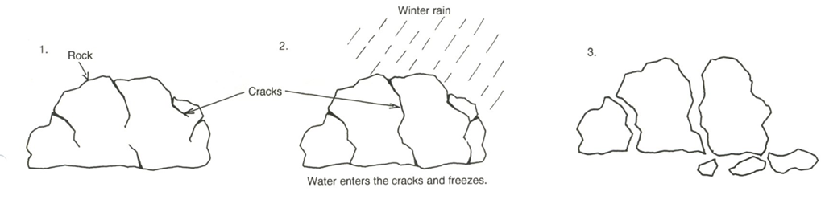

Analyse the diagrams

1. Explain what happened to the rock above

 The water from the winter rain entered the crack and froze

1. Is this an example of weathering or erosion?

 Weathering

1. Look at the diagram of a cliff that is being weathered. Describe the ways in which it is being weathered. Explain why the rock is being worn away.

Due to weathering s

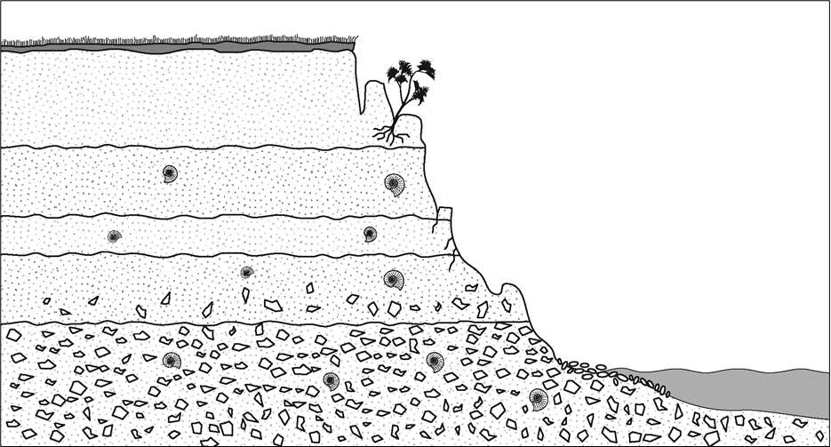

1. A collector at a river measured the distribution of particle size, and graphed the results. Five samples were collected from the sites indicated on the map, but only four samples are shown in the histograms below. Sites I and L are missing.

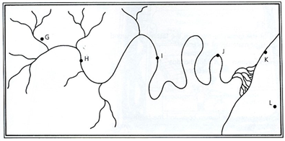A) Identify which histogram came from which location, and explain why

|  |  |  |  |
| --- | --- | --- | --- |
|  | **Histogram** | **Suggested Location** | **Explanation** |
| **1** | C:\Users\jwils736\AppData\Local\Microsoft\Windows\INetCache\Content.MSO\25FF0E3C.tmp |  |  |
| **2** | C:\Users\jwils736\AppData\Local\Microsoft\Windows\INetCache\Content.MSO\3FB75BAA.tmp |  |  |
| **3** | C:\Users\jwils736\AppData\Local\Microsoft\Windows\INetCache\Content.MSO\48460148.tmp |  |  |
| **4** | C:\Users\jwils736\AppData\Local\Microsoft\Windows\INetCache\Content.MSO\9E861E96.tmp |  |  |

1. The diagram below show the erosion of two waterfalls over a period of time. The diagrams are mixed up
2. 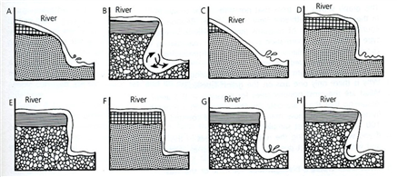

Identify which pictures belong to **Waterfall 1** and which to **Waterfall 2**. For each waterfall, indicate the correct order of the events showing the **progress of erosion**. Mark them as 1-1, 1-2 etc

|  |  |
| --- | --- |
| **Waterfall 1:** |  |
| **Waterfall 2:** |  |

1. Each waterfall is composed of two different types of rocks. Which rock is the harder and which is the softer rock in each waterfall? Rearrange the diagrams below from hardest to softest, and explain why:

|  |  |  |
| --- | --- | --- |
|  | **Rock Layer** | **Explanation** |
| **Hardest** | C:\Users\jwils736\AppData\Local\Microsoft\Windows\INetCache\Content.MSO\51117A42.tmp |  |
|  | C:\Users\jwils736\AppData\Local\Microsoft\Windows\INetCache\Content.MSO\7902D3A0.tmp |  |
|  | C:\Users\jwils736\AppData\Local\Microsoft\Windows\INetCache\Content.MSO\92049AAE.tmp |  |
| **Softest** | C:\Users\jwils736\AppData\Local\Microsoft\Windows\INetCache\Content.MSO\84CA0AEC.tmp |  |

1. As rivers carry the particles towards the sea, the particles become**smaller, more rounded and more even in their size.** A geologist collected samples of sediment from different locations in a river valley. The samples he/she collected are shown in squares 1, 2, 3 and 4 below.

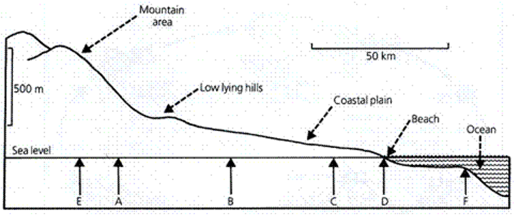

1. Identify which site (A-D) each sample was collected from and explain why in the table below.
2. Infer what size and shape sediments would you expect to find if you collected sample 5 at **site E, near the mountain top**and sample 6, at **site F, under the ocean**. Draw the samples in boxes 5 and 6 and **explain** your decision below.

|  |  |  |
| --- | --- | --- |
|  | **Site** | **Explanation** |
| C:\Users\jwils736\AppData\Local\Microsoft\Windows\INetCache\Content.MSO\C271F0F8.tmp |  |  |
| C:\Users\jwils736\AppData\Local\Microsoft\Windows\INetCache\Content.MSO\4E2A99C6.tmp |  |  |
| C:\Users\jwils736\AppData\Local\Microsoft\Windows\INetCache\Content.MSO\56CC11C4.tmp |  |  |
| C:\Users\jwils736\AppData\Local\Microsoft\Windows\INetCache\Content.MSO\22139072.tmp |  |  |
| 5. | E |  |
| 6. | F |  |