**DAY - 3 MARKET PLACE ASSIGNMENT**

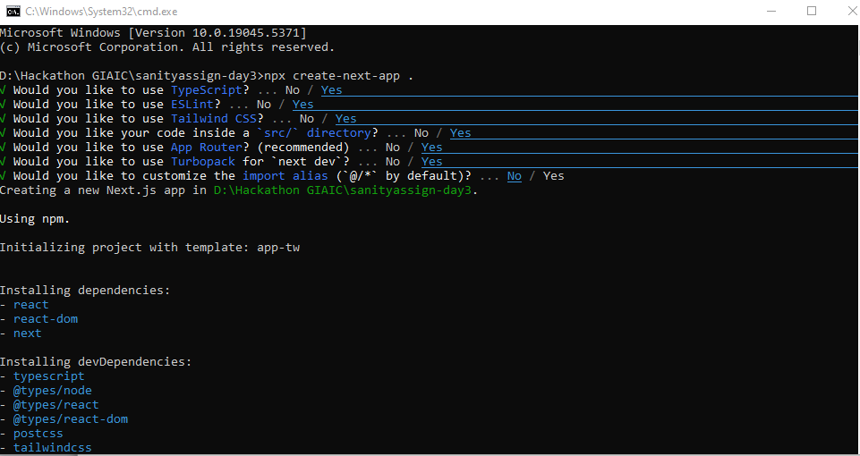

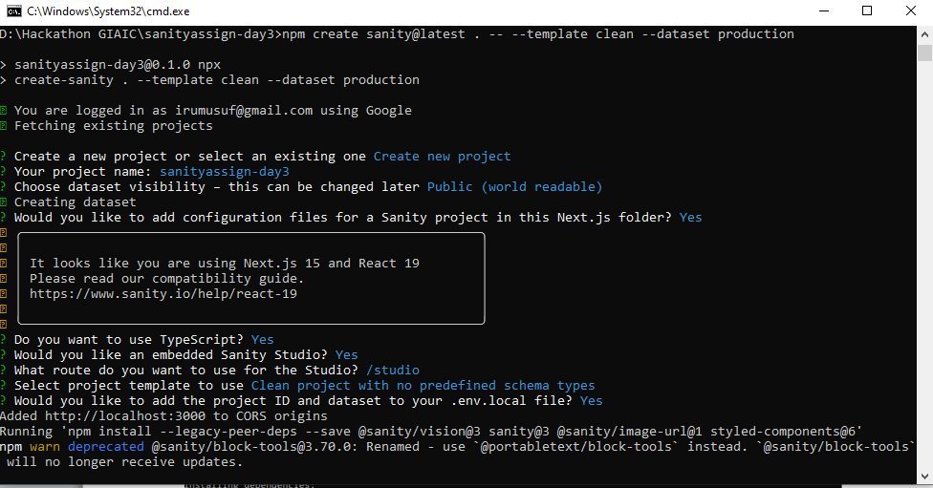

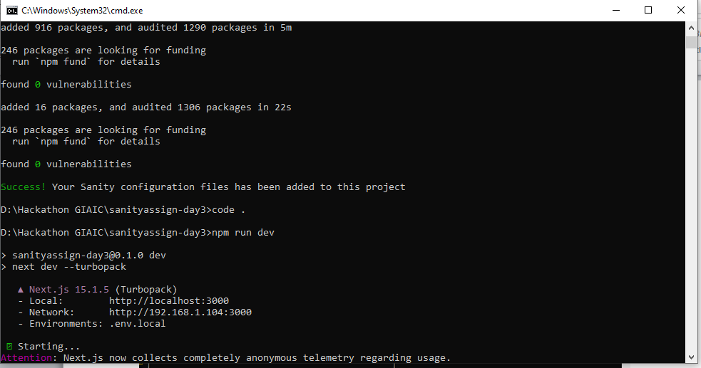

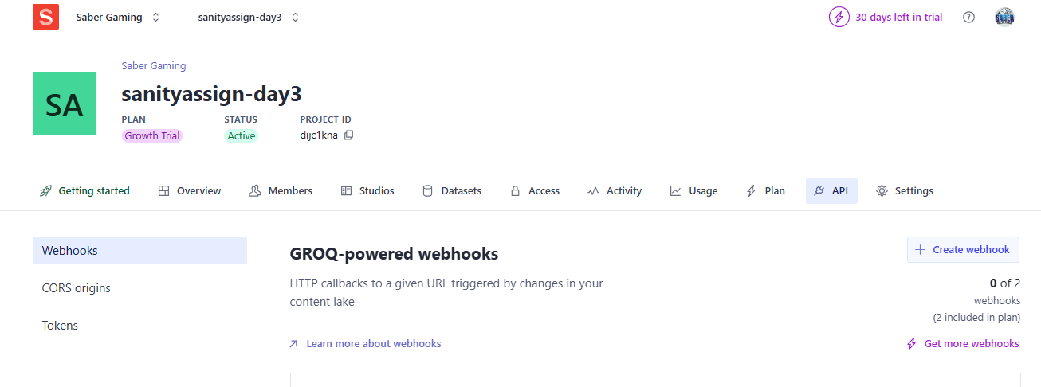

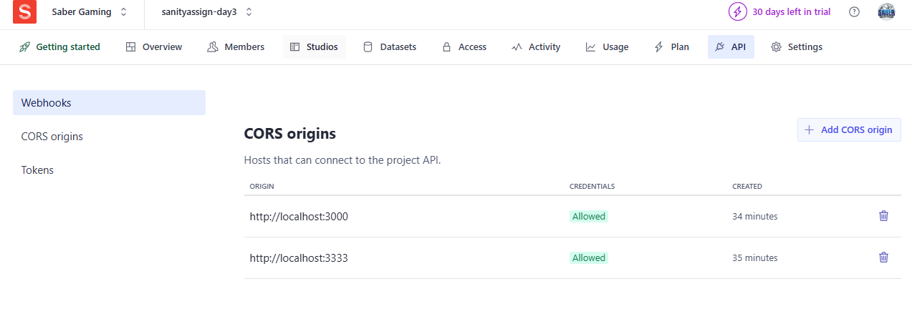

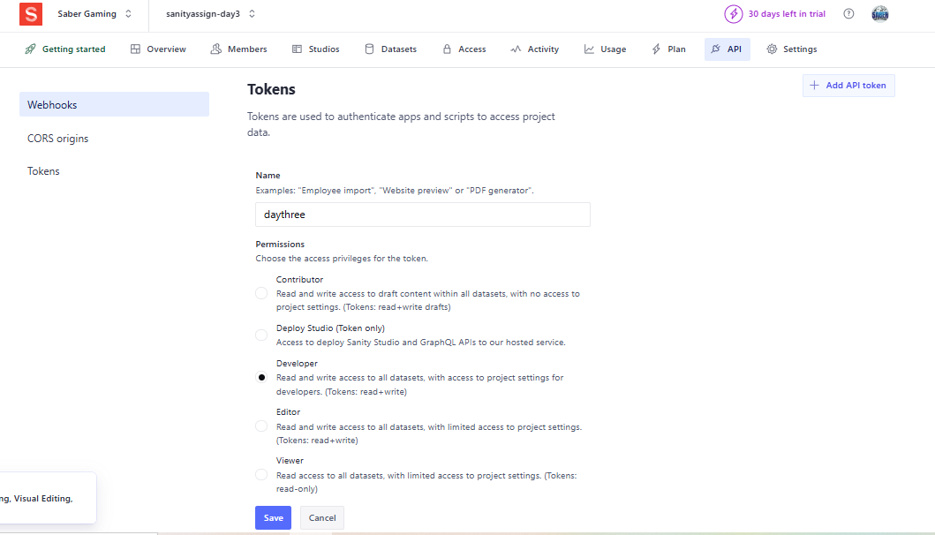

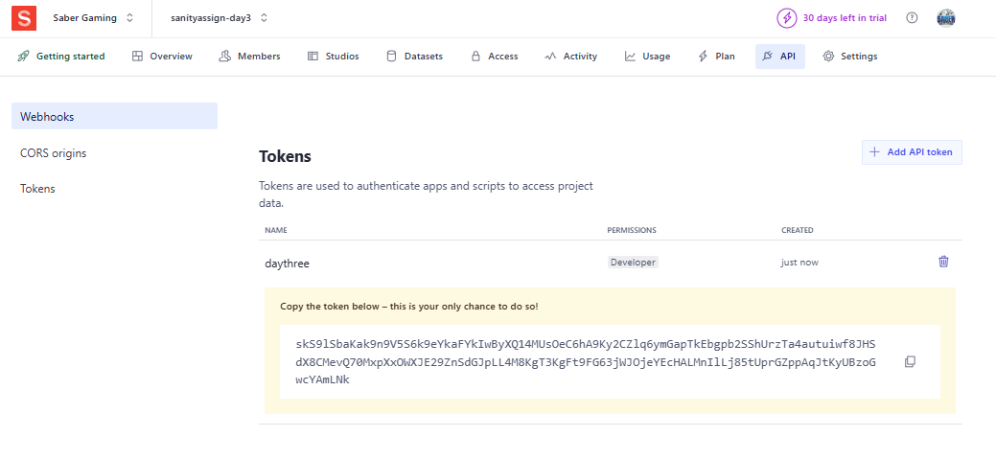

**API TOKEN**

**skS9lSbaKak9n9V5S6k9eYkaFYkIwByXQ14MUsOeC6hA9Ky2CZlq6ymGapTkEbgpb2SShUrzTa4autuiwf8JHSdX8CMevQ70MxpXxOWXJE29ZnSdGJpLL4M8KgT3KgFt9FG63jWJOjeYEcHALMnIlLj85tUprGZppAqJtKyUBzoGwcYAmLNk**

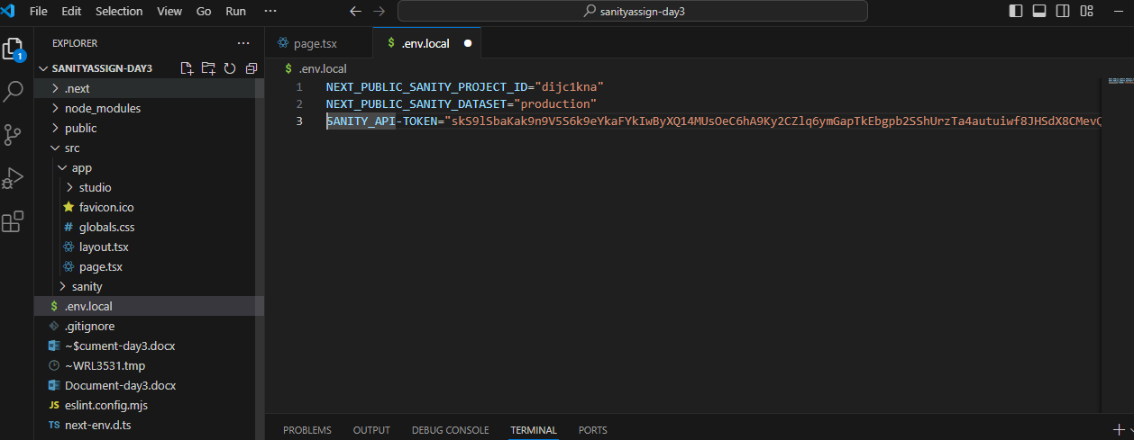

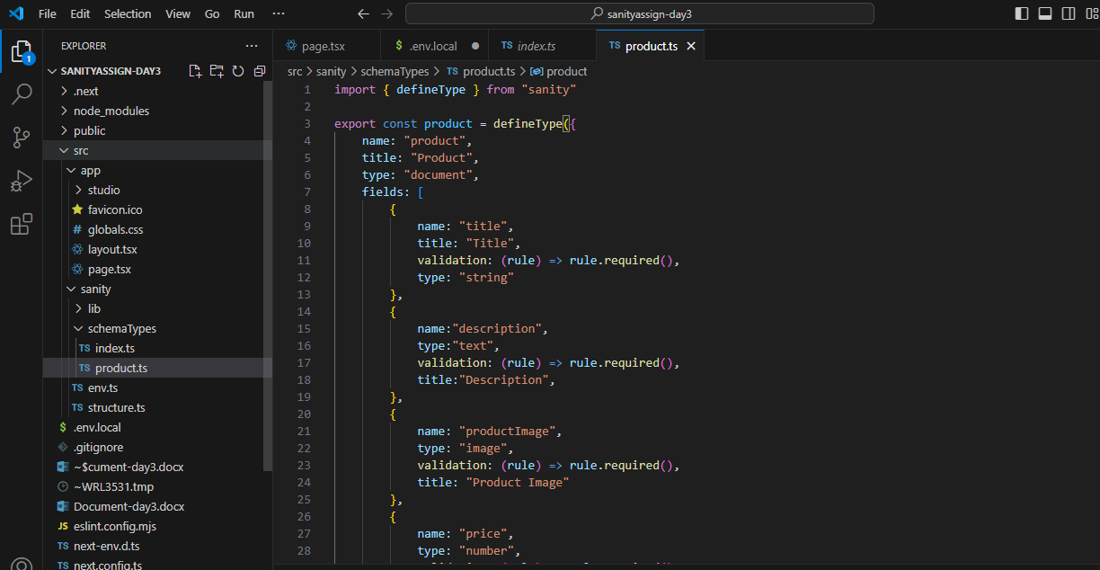

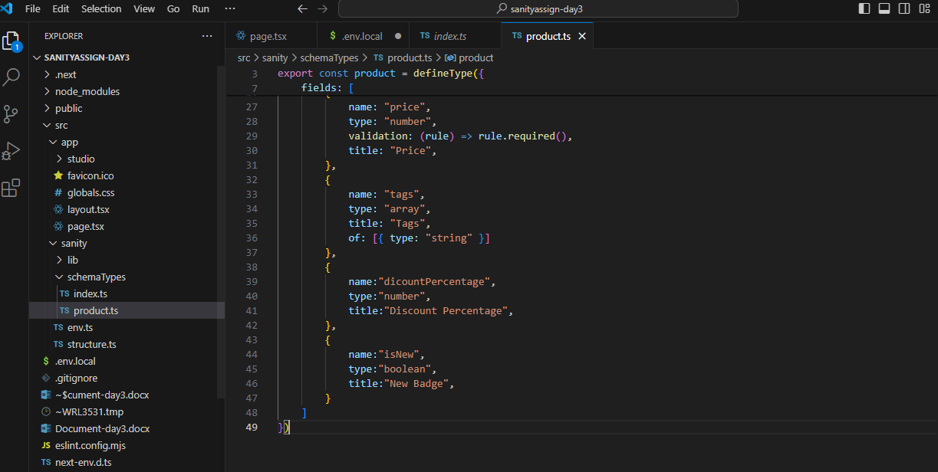

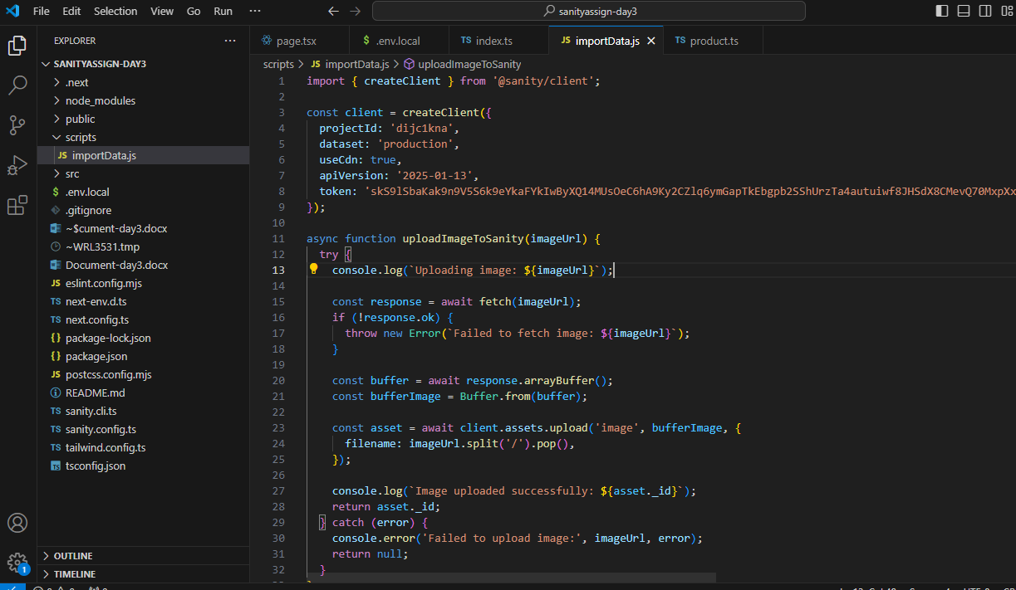

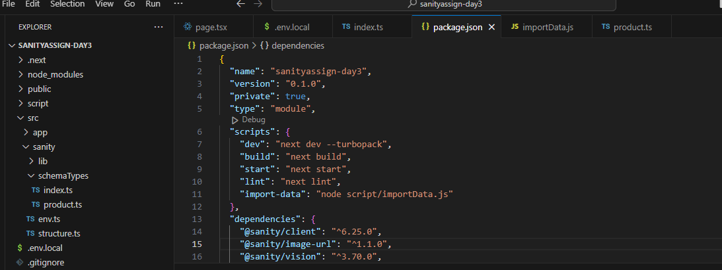

**npm install @sanity/client axios dotenv (run on terminal)**

**node scrip/importData.js (add "type": "module", & "import-data": "node script/importData.js" in package.json file)**

**npm run import-data (run on terminal, data will be add in sanity)**

