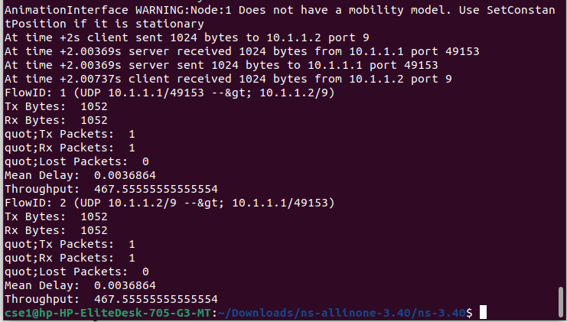

1024

8

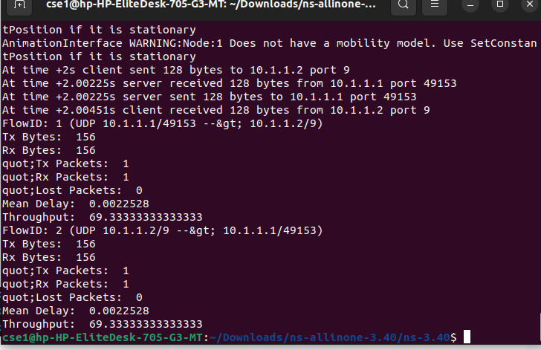

128

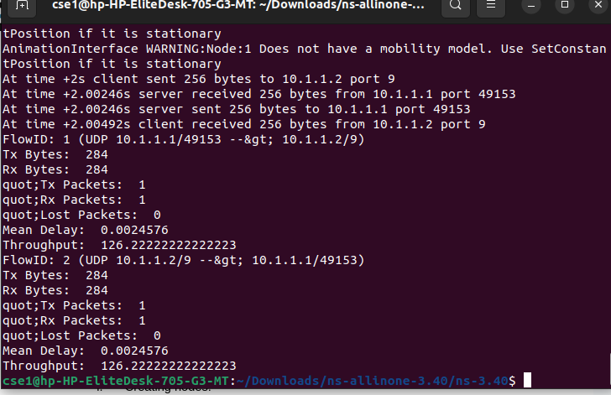

256

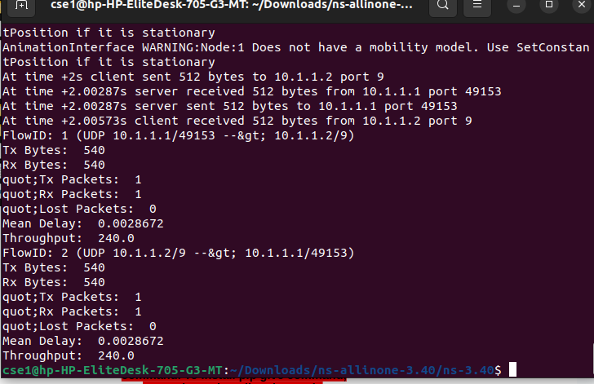

512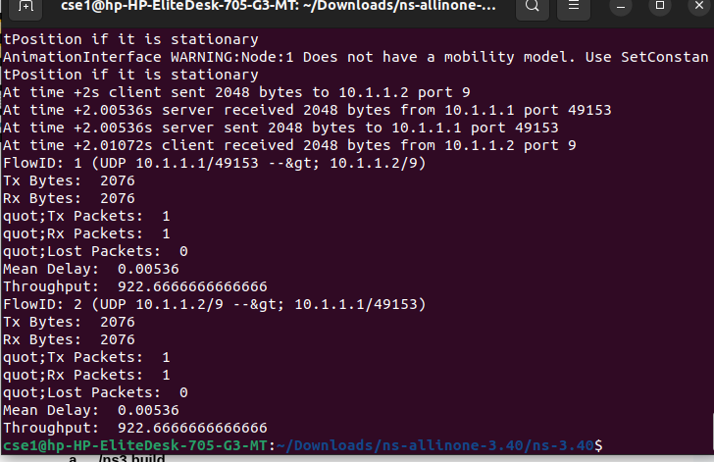

2048

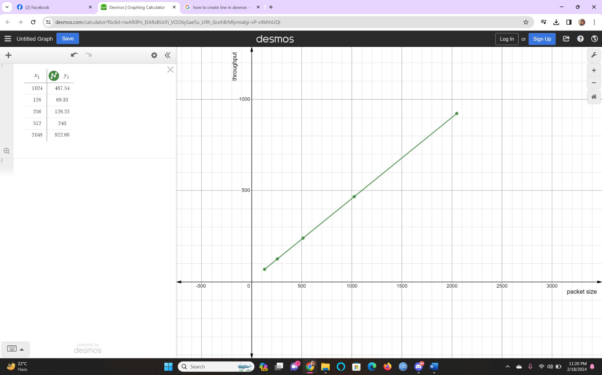

The graph shows a linear relationship between packet size and throughput. The data points for packet sizes [128, 256, 512, 1024, 2048] bytes correspond to throughputs [69.33, 126.23, 240, 467.54, 922.66]. As the packet size increases, so does the throughput, indicating that larger packets are transmitted with higher efficiency, possibly due to reduced overhead or more effective use of network resources. The linearity of the graph suggests that the network is not experiencing any significant issues such as congestion or errors that would otherwise lead to a non-linear throughput increase.