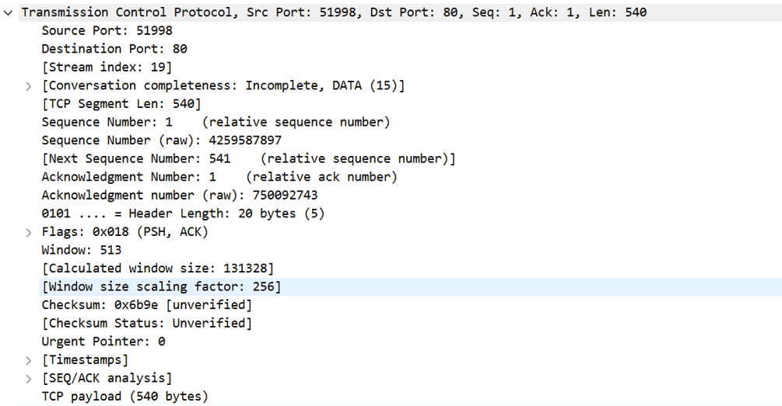

**transport layer**

1. *Source Port (51998)*: The port on the client machine from which the request is sent.

2. *Destination Port (80)*: The standard port for HTTP traffic, indicating an HTTP request.

3. *Sequence Number*: Used to keep track of the bytes in the data stream from the client to the server.

4. *Acknowledgment Number*: Used to keep track of the bytes in the data stream from the server to the client.

5. *Header Length*: The length of the TCP header, indicating how much of the packet is header versus data.

6. *Flags*: The PSH (Push) flag prompts the receiving end to push the data to the application as soon as possible, and the ACK (Acknowledgement) flag indicates that the packet is acknowledging receipt of data.

7. *Window*: The size of the receive window, which controls the flow of data to prevent a sender from overwhelming a receiver.

8. *Checksum*: Used for error-checking of the header and data.

9. *TCP payload*: The actual data being transmitted, which in this case would be the HTTP request or response.

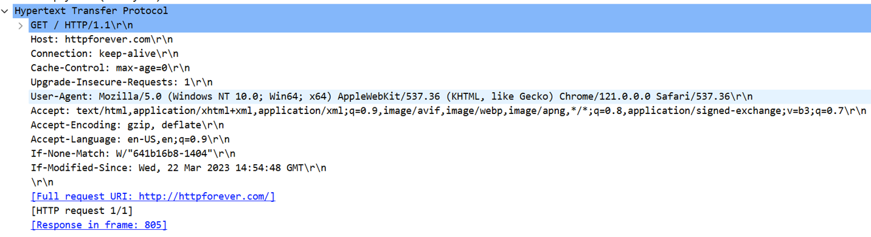

The image shows the HTTP header for an HTTP GET request, which is part of the application layer in the OSI model:

- GET / HTTP/1.1: This is the request line, indicating the method (GET), the path of the resource (/), and the HTTP version (1.1).

- Host: Specifies the domain name of the server (httpforever.com).

- Connection: Advises the server to keep the connection open for further requests (keep-alive).

- Cache-Control: Directives for caching mechanisms (max-age=0, indicating no caching).

- User-Agent: Provides information about the client's software (browser type and operating system).

- Accept: Specifies the media types that the client can process.

- Accept-Encoding: Indicates the content encoding (gzip, deflate) the client can handle.

- Accept-Language: Indicates the client's preferred languages (en-US, en).

- If-None-Match / If-Modified-Since: Conditional headers used for cache validation.

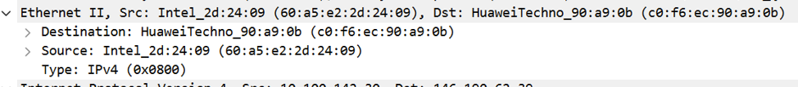

**This is a data link layer**

In here we have:

1.source Mac Address: Intel_2d:24:09(60:a5:e2:2d:24:09)

2. Destination Mac Address: HuaweiTechno_90:a9:0b(c0:f6:ec:90:0b)

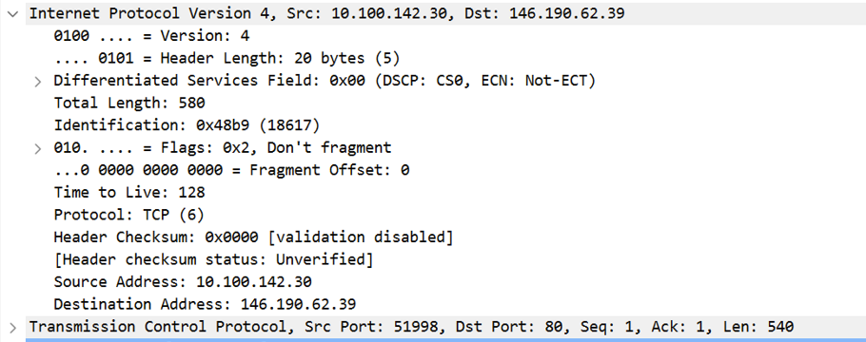

**This is the network layer**

The source Ip: 10.100.142.30

The destination IP: 146.190.62.39

Source Port:51998

Destination Port:80 (http request)

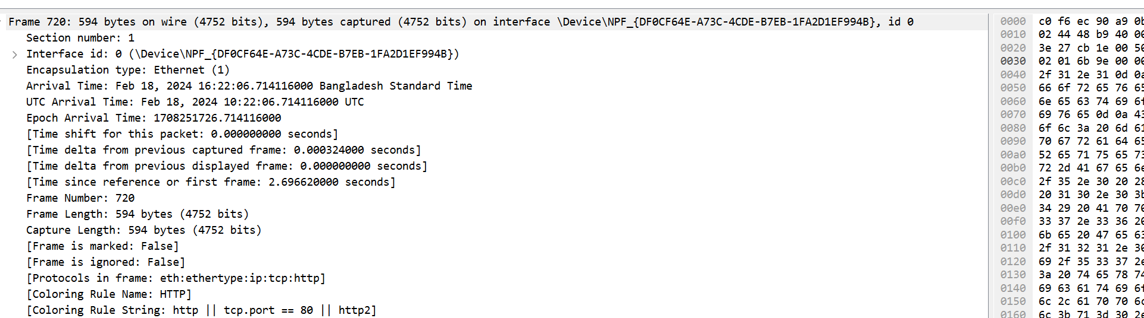

The shows a network packet capture for Frame 720, which contains several layers of data transmission:

1. *Ethernet Layer*: This layer provides the hardware addressing and encapsulation necessary for local network segment delivery. It includes the source and destination MAC addresses.

2. *IP Layer*: This layer is responsible for routing the packet to the correct destination IP address across networks. This would include the source and destination IP addresses

3. *TCP Layer*: This layer ensures reliable delivery of the packet to the correct port on the destination machine. It would include the source and destination ports, sequence number, acknowledgment number, and other control information .

4. *HTTP Layer*: This layer carries the HTTP request or response data. In the case of an HTTP request, this would include the request method, URI, and headers. In the case of an HTTP response, it would include the status code, status message, and headers.