Tongue Colour Classification in TCM with Noisy Labels via Confident-Learning-Assisted Knowledge Distillation
In olden days diseases will be identified based on tongue colour and this technique mostly used in Traditional Chinese medicines (TCM). To predict disease experts will analyse tongue colour and later this task was automated using deep learning algorithms but this algorithms performance was not up to the mark because of tongue images scarcity or presence of Noisy labels. To overcome from this issue author of this paper employing two different modules such as Teacher and student.
Teacher module get trained on Noisy and clean images and then assigned threshold to each image features and if image features are clear then it will have high threshold and this will be input to Student module which will get trained on threshold based features. After training student module will predict labels with maximum probability and ignore feature which has less threshold so noisy images and their labels will be avoided.
In propose work author using Resnet18 as the backbone teacher module for features threshold calculation and then using Activation function to filter out noisy label features and then applying Attention model (activation and attention will get run through student module) to select optimize features for label prediction and this model is called as E-CA2-ResNet18.
E refers to activating Activation Function
CA2 refers to Attention module
ResNet18 as the backbone model
Author has compare propose E-CA2-ResNet18 performance with many existing algorithms such as VGG16, MobileNetV2 and many more but training all this algorithms may take much time so we have implemented VGG16 as the existing and E-CA2_ResNet18 as the propose work.
To train above algorithms author has manually collected tongue images from Hospitals and have not publish on internet so we downloaded images from Google and used as dataset. In below screen we are showing dataset details
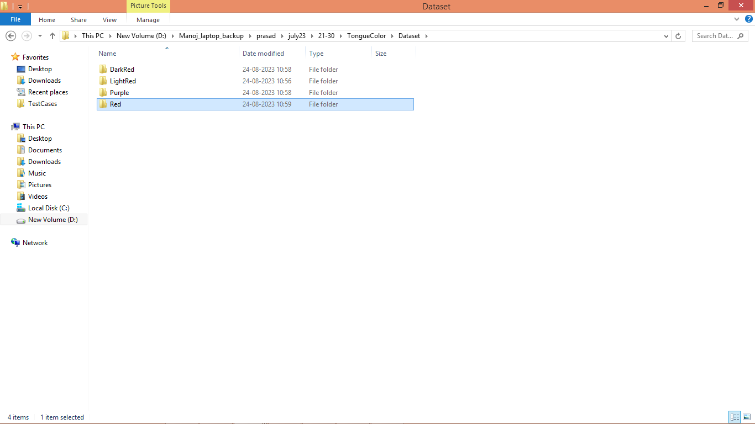
In above Dataset folder we have 4 different images for 4 different colours and just go inside any folder to view related images like below screen
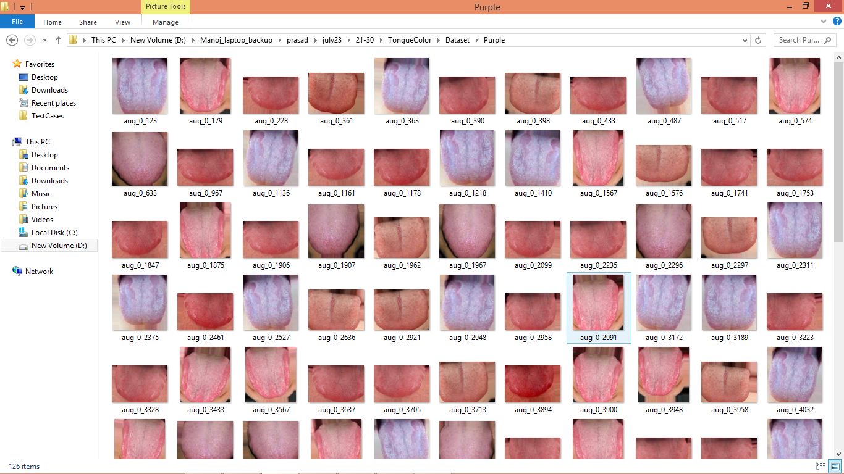
In above screen we can see images with purple and light red colour and by using above images will train and test all algorithm performances and in above dataset we can see NOISY images also as some are red and some are purple in same class.
Extension Concept
In propose work after employing ResNet18, Activation and Attention algorithms author has manage to get accuracy between 93 to 96%. Propose E-CA2-ResNet18 has already achieved optimized features by segregating Noisy and clean labels, so as extension we have extracted all optimized features from propose E-CA2-ResNet18 and then retrain with Random Forest to form hybrid model and this hybrid model giving more accuracy compare to propose and existing algorithms.
SCREEN SHOTS
We have coded this project using JUPYTER notebook and below are the code and output screens with blue colour comments
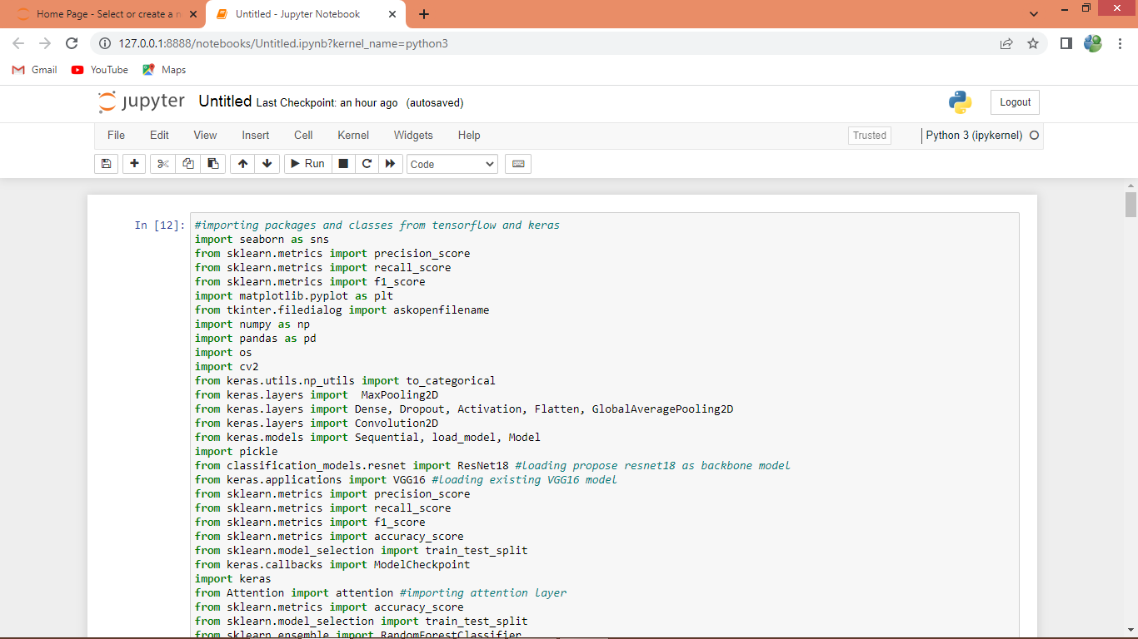
In above screen importing require python packages and classes
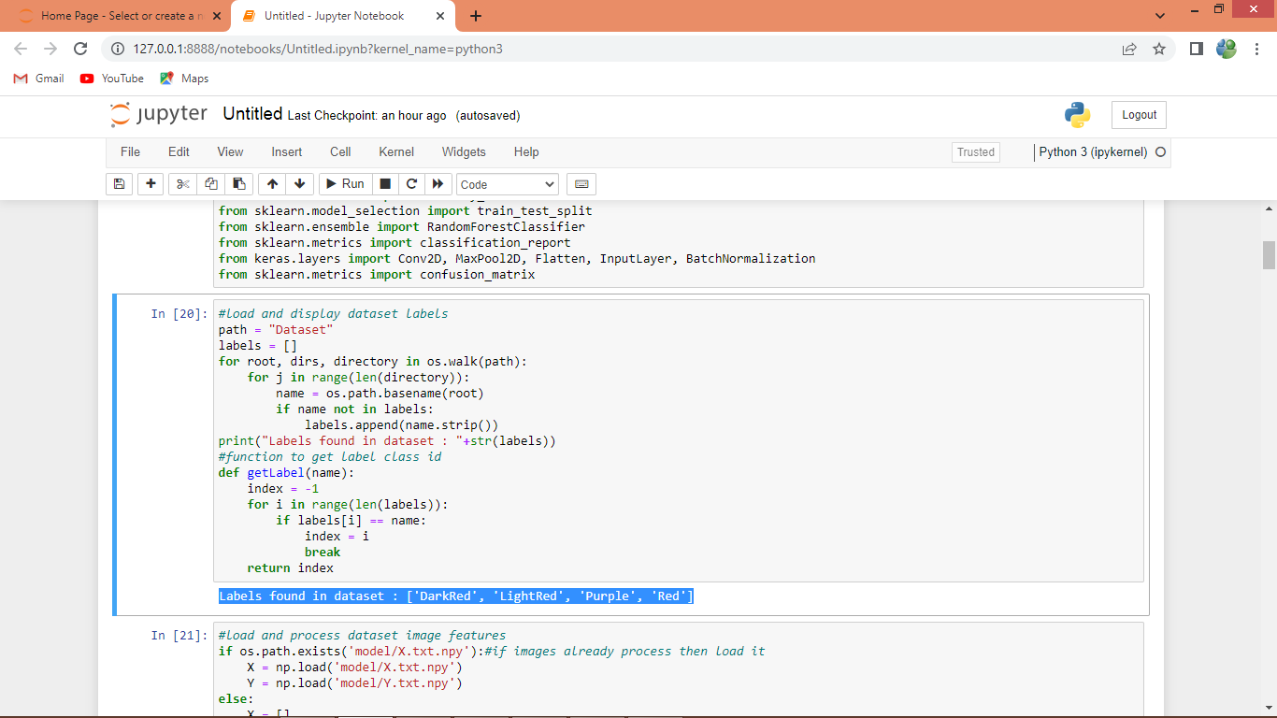
In above screen finding and displaying different labels found in dataset
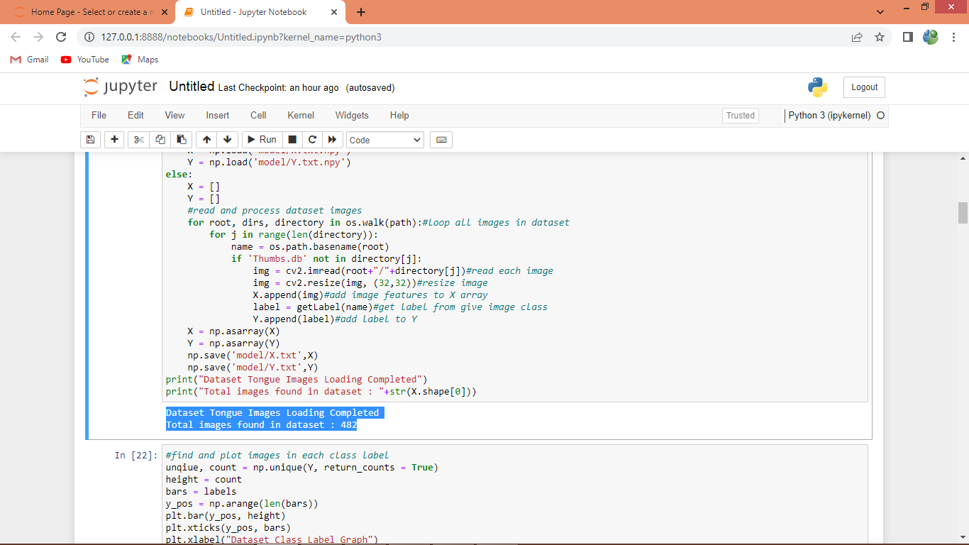
In above screen looping and reading all images from dataset and then resizing and extracting features and labels and then adding to array variables for training and then displaying total loaded images
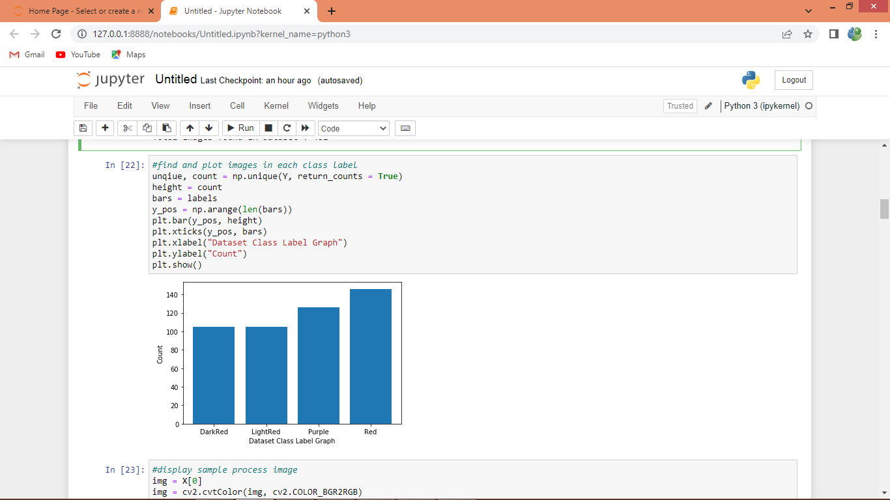
In above screen finding and plotting graph of class labels and their count available in dataset where in graph x-axis represents Tongue Colour and y-axis represents count
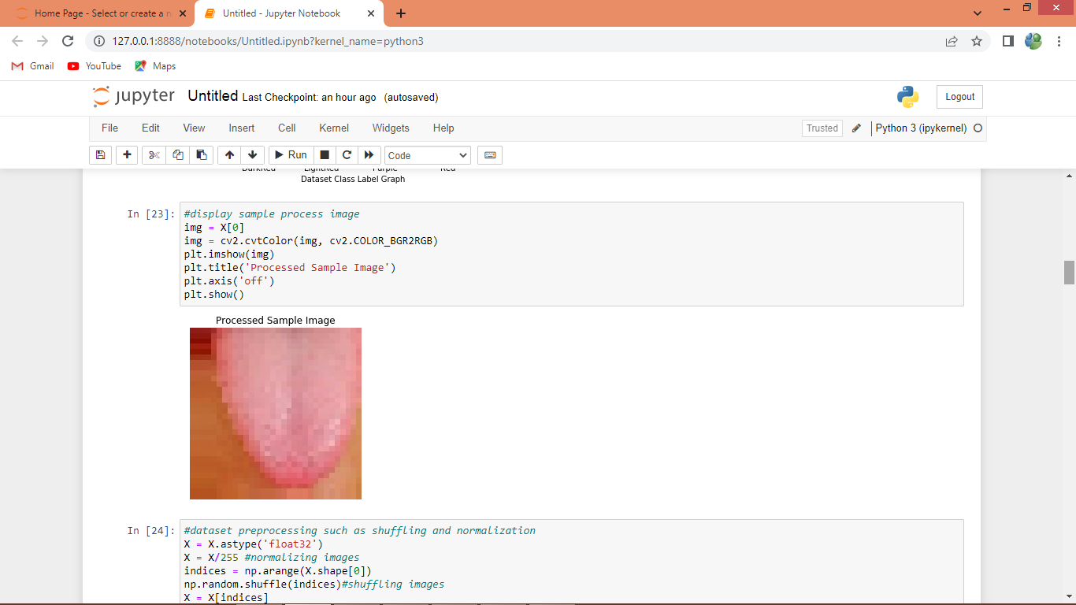
In above screen displaying sample process Tongue image
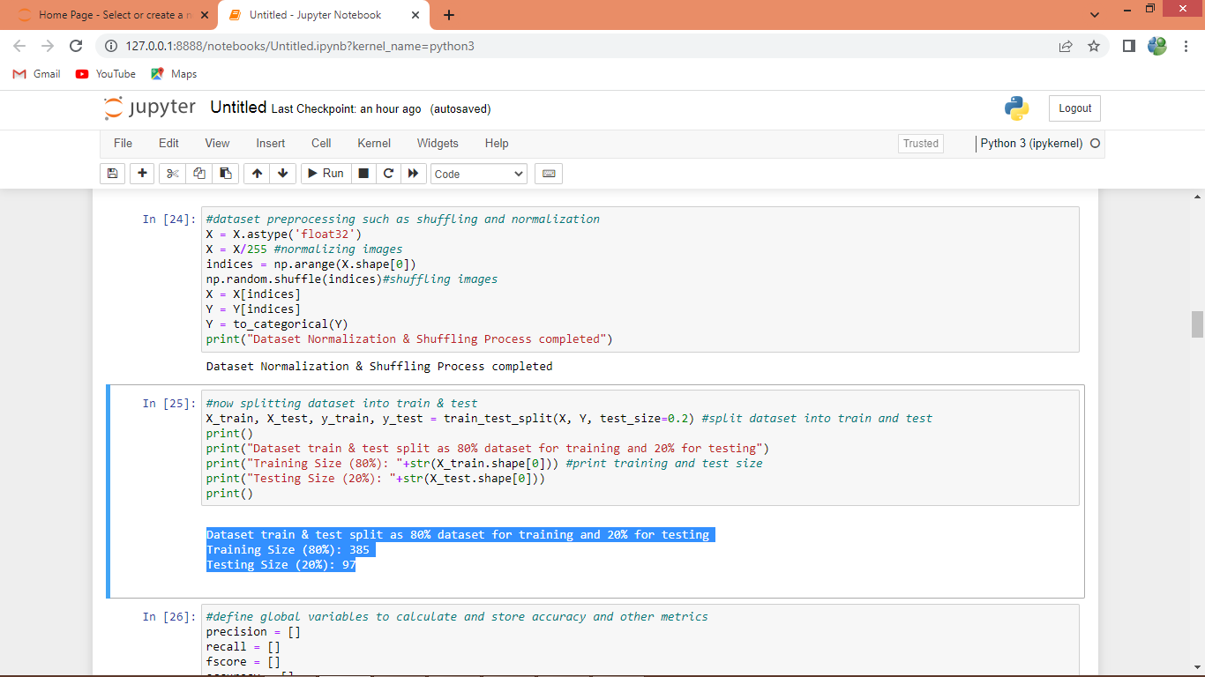
In above screen applying pre-processing techniques such as normalization, shuffling and splitting dataset into train and test where application using 80% images for training and 20% for testing
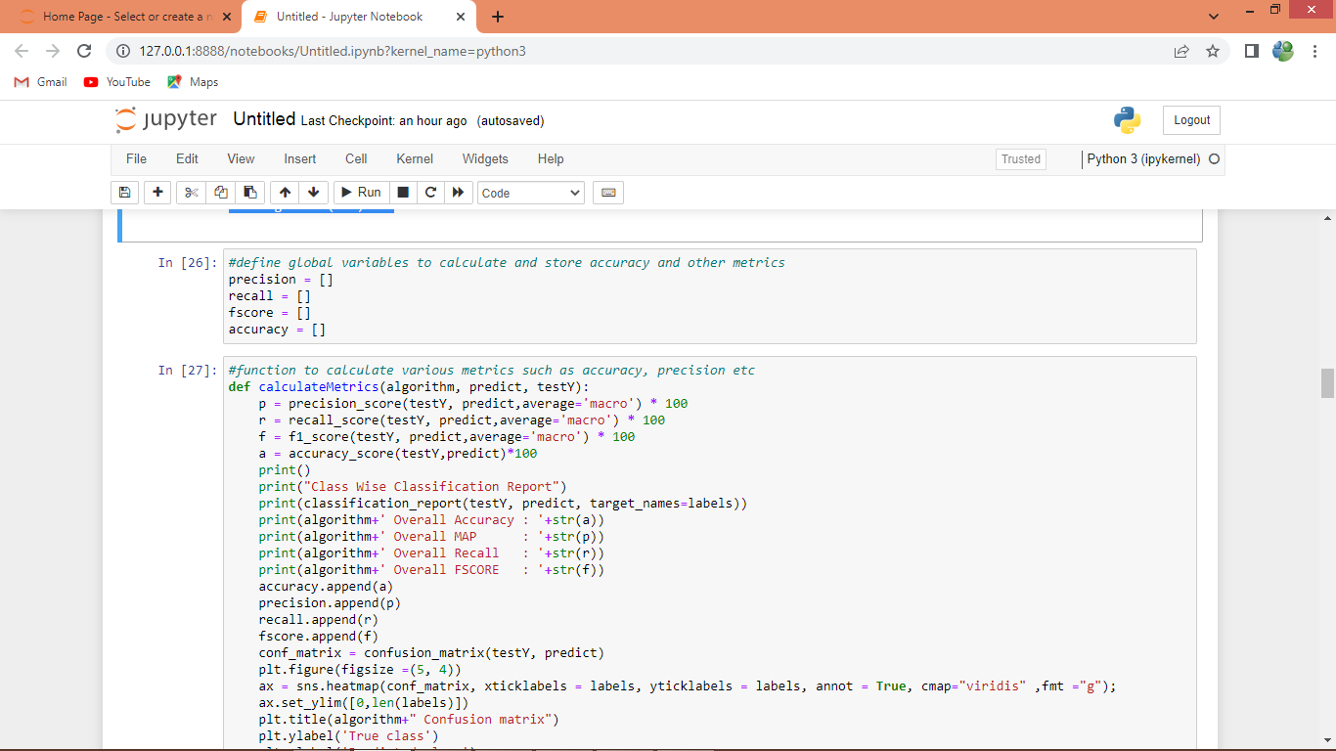
In above screen defining function to calculate accuracy and other metrics
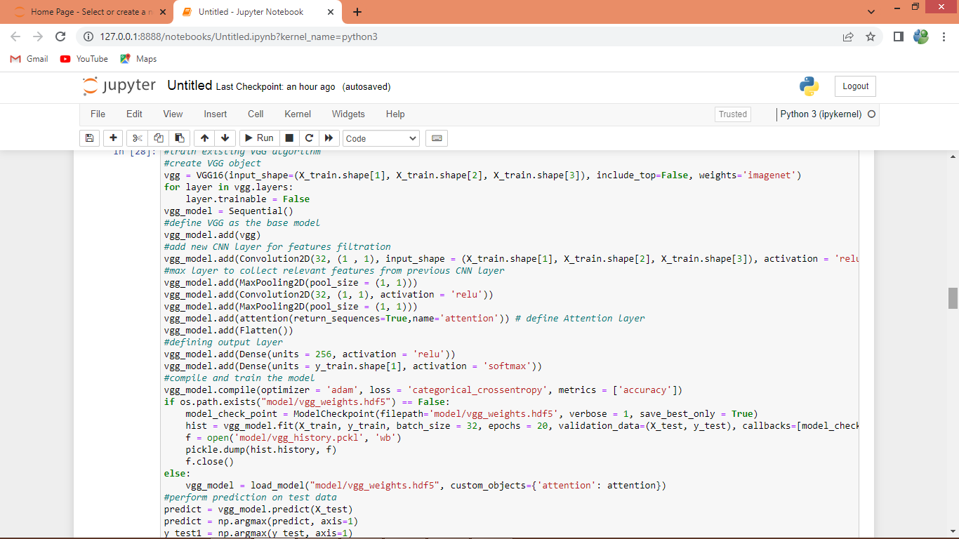
In above screen training existing VGG16 algorithm and after executing this block will get below output
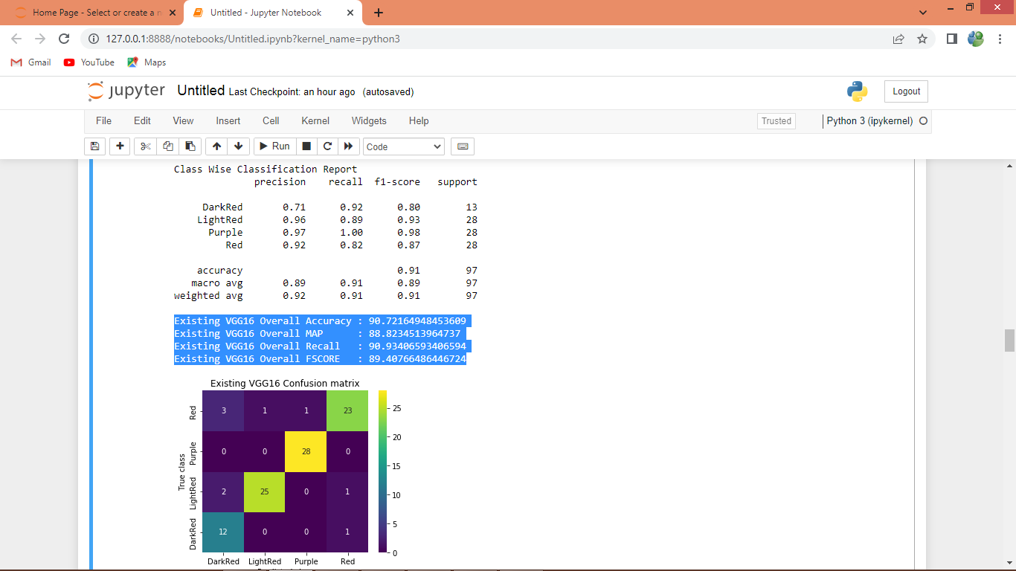
In above screen first we are displaying classification report for each class label and then in blue colour text displaying VGG16 overall MAP (mean absolute precision) as 88%. In confusion matrix graph x-axis represents predicted labels and y-axis represents True Labels and all different colour boxes contains correct prediction count and all blue boxes contains incorrect prediction count or noisy predicted labels
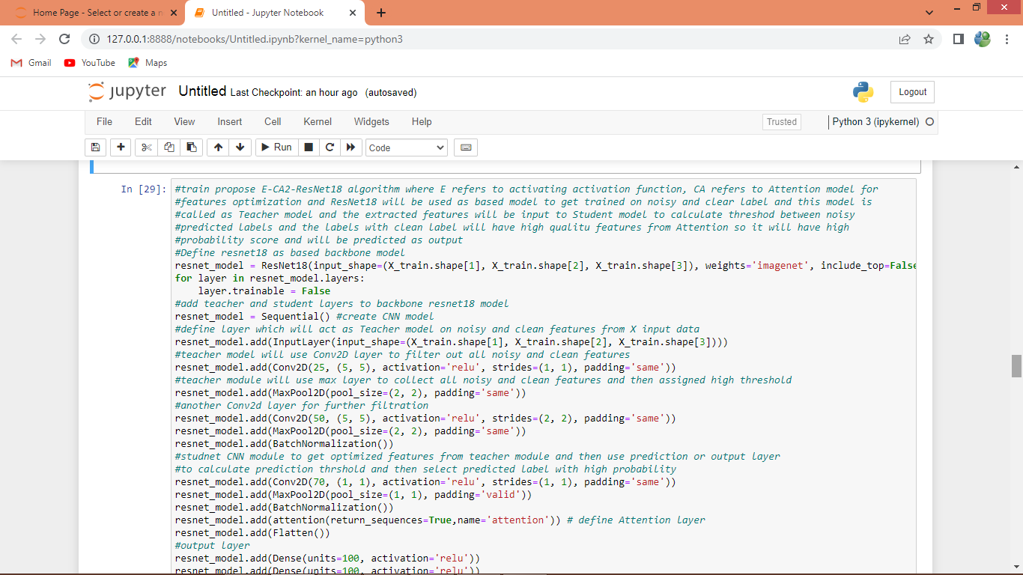
In above screen training propose E-CA2-ResNet18 Teacher and Student model and can read blue colour comments to know about coding and after executing above block will get below output
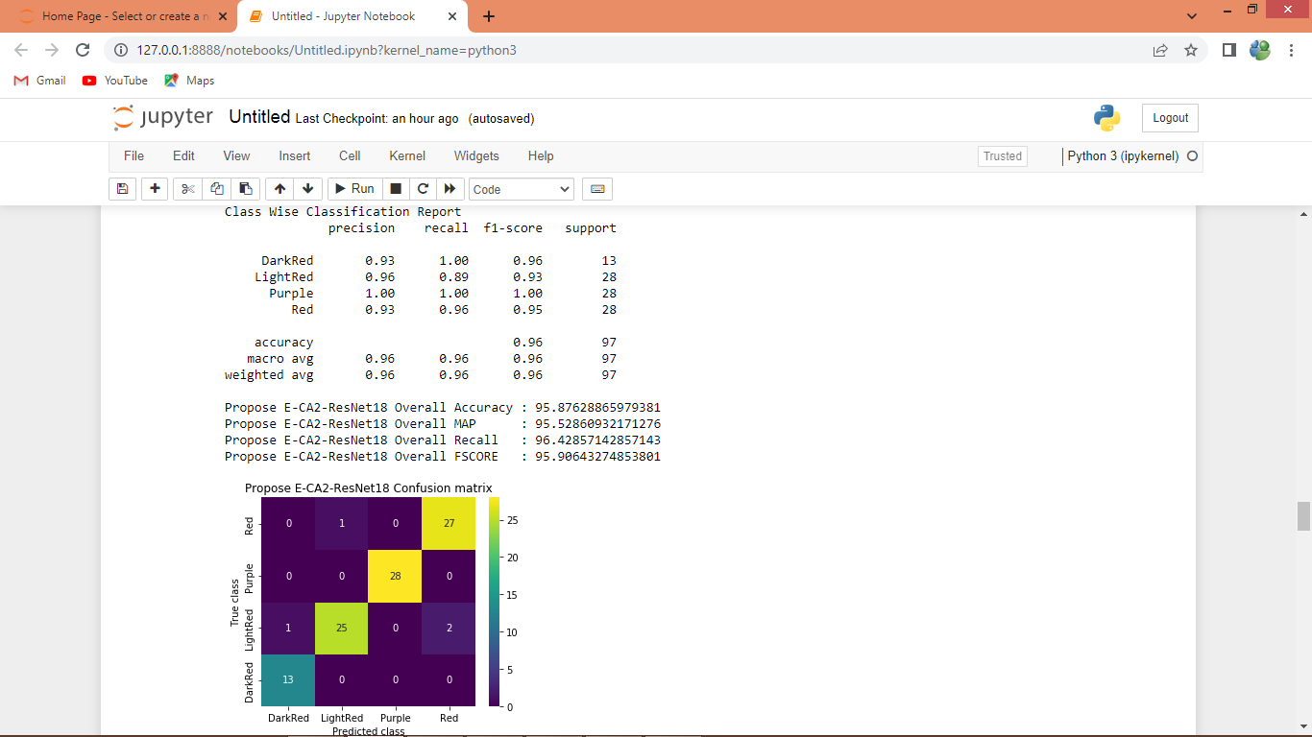
In above screen propose E-CA2-ResNet18 got MAP as 95% and this is higher than existing VGG16
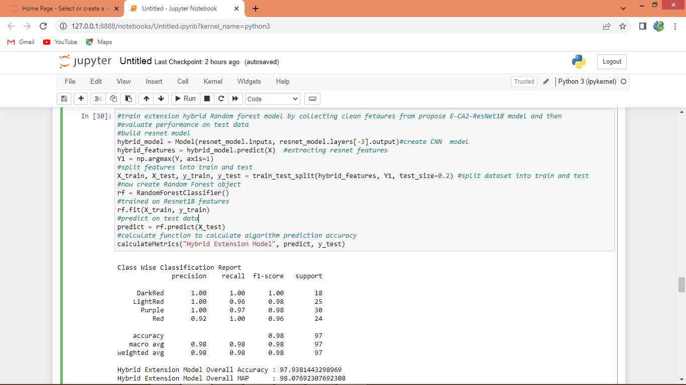
In above screen we are defining extension hybrid model by extracting features from propose E-CA2-ResNet18 model and then retraining with Random Forest to further enhance accuracy and below is the extension model accuracy
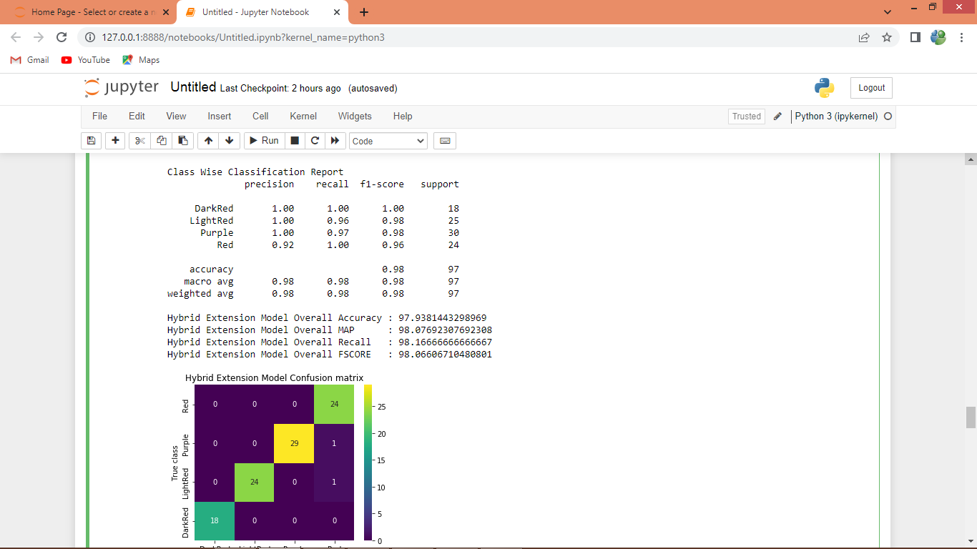
In above screen extension hybrid E-CA2-ResNet18-Random Forest got 98% as MAP and extension got high MAP compare to propose and existing algorithm
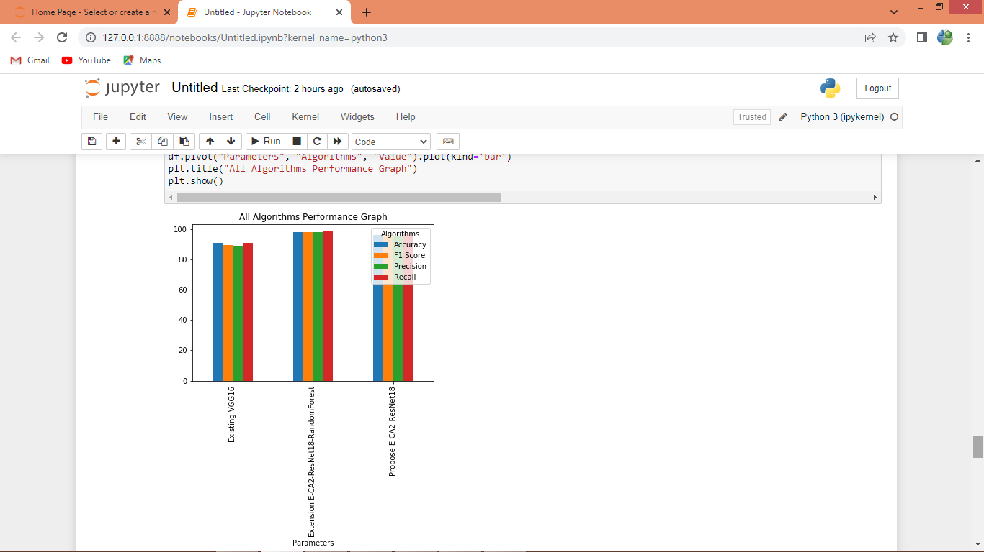
Above is the performance graph of all algorithms where x-axis represents algorithm names and y-axis represents Precision, accuracy, recall and FSCORE in different colour bars
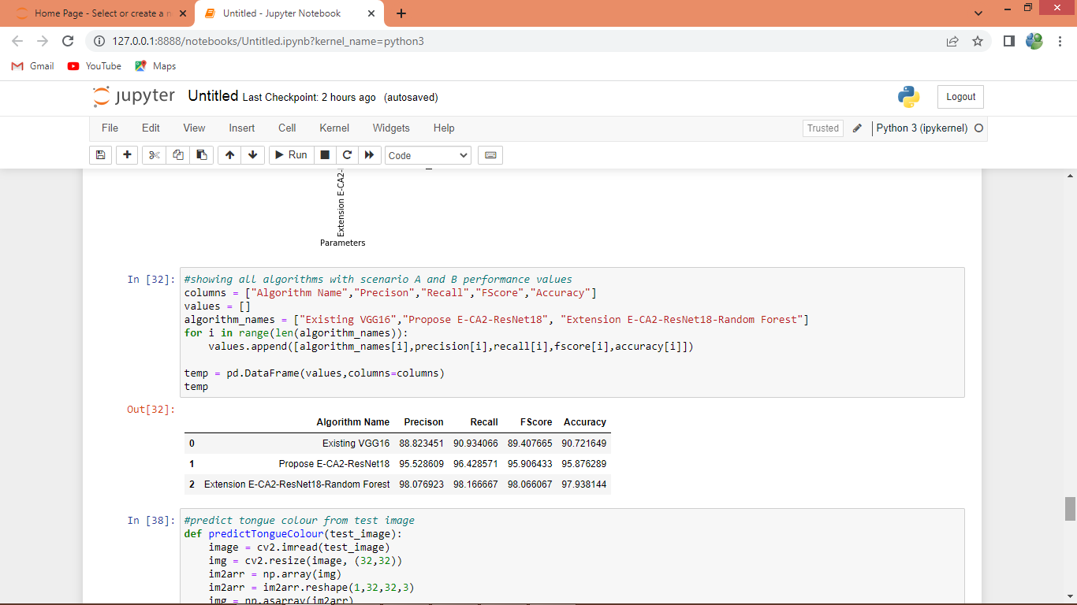
In above screen displaying all algorithm performance in tabular format
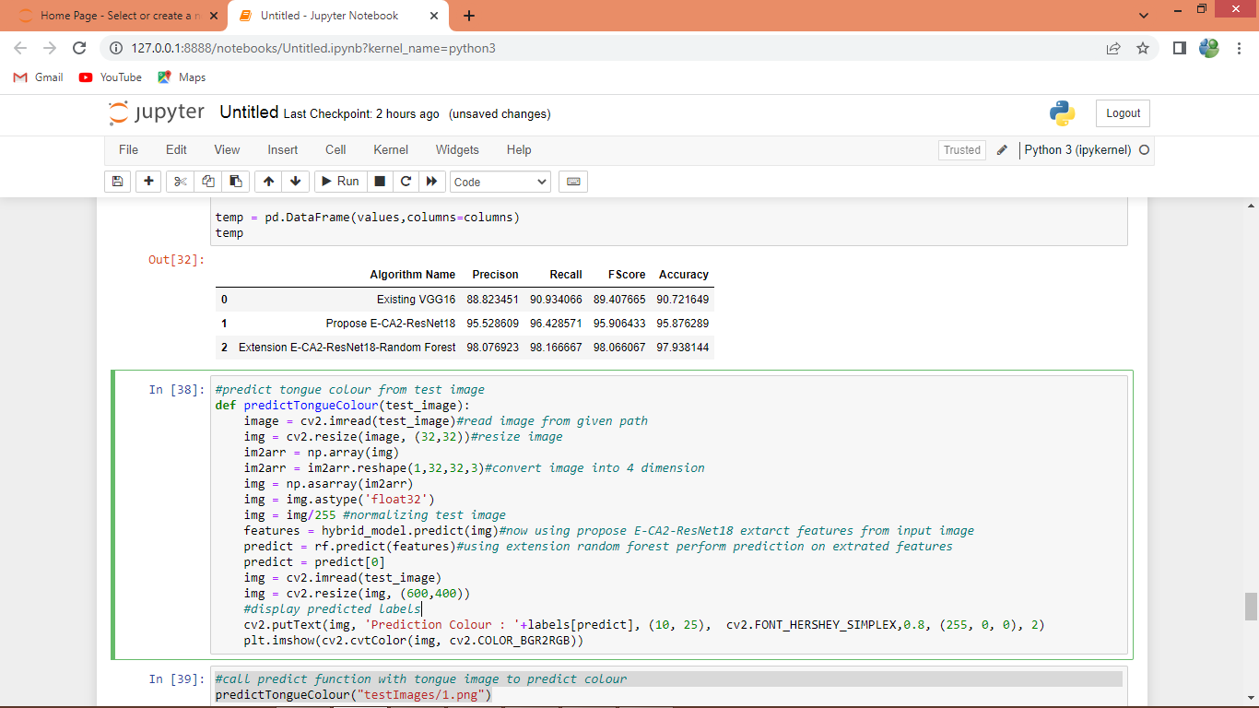
In above screen defining predict function which will read image from input path and then extract features using Propose E-CA2-Resnet18 and then perform prediction on extracted features using Random Forest and will get below output
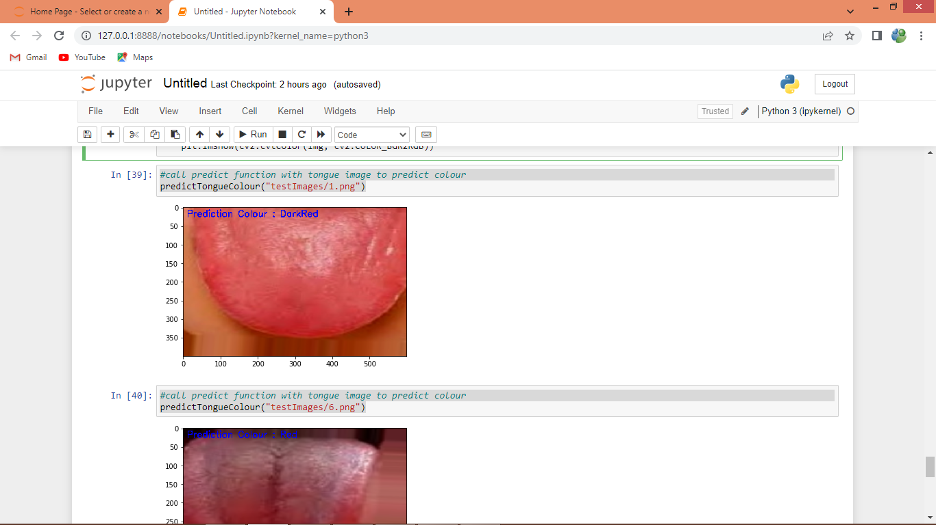
In above screen calling predict function with image path and then displaying predicted tongue colour output in blue colour text
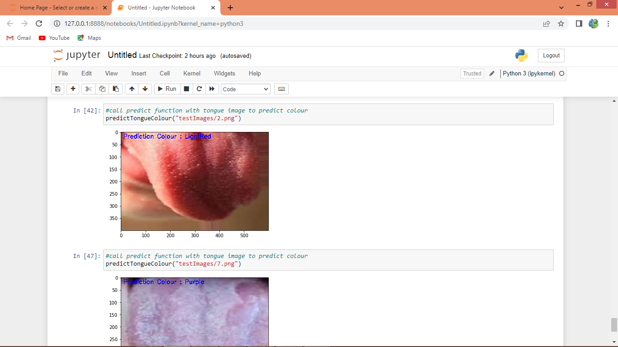
Above is another image output

