# Filter and Simple Application

After we know how to get the frequency image from origin image and transfer frequency image to normal image, we can apply filters on the frequency image to process image. We write a command line program to do this work and show all process.

## Filters

A filter is a matrix and also a image that have same size of image we want to process. The value of the matrix means how much the point in frequency image at the position can pass. For example the raw image is 300 times 300, the frequency image and the filter is also 300 times 300, in the position (100,200), the value of filter is 0.6 and the value of frequency image is 300, after frequency image pass the filter, the value of it will become 300 time 0.6 equals 180.

The filter have two classes, low pass filter and high pass filter. Low pass filter will let low frequency pass and high pass filter will let high frequency pass. The result is after passing low pass filters, the image will become blur and after pass high pass filters, the line in image will be enhance, for example the hand writing will be more clear.

There are three commonly used filters, ideal, butterworth and Gauss filter.Firstly is the ideal filter, the ideal filter is the most basic filter.The formula of low pass ideal filter like $H\left(u,v\right)=\left\{\begin{aligned}1 D(u,v)≤D_{0} \\ 0 D(u,v)>D_{0}\end{aligned}\right.$, and the high pass is: $H\left(u,v\right)=\left\{\begin{aligned}0 D(u,v)≤D_{0} \\ 1 D(u,v)>D_{0}\end{aligned}\right.$. H(u,v) is the value of the filter matrix at the position (u,v) and D(u,v) is the distance of point (u,v) to the center, $D_{0}$ is a custom value. The visualization of them are:

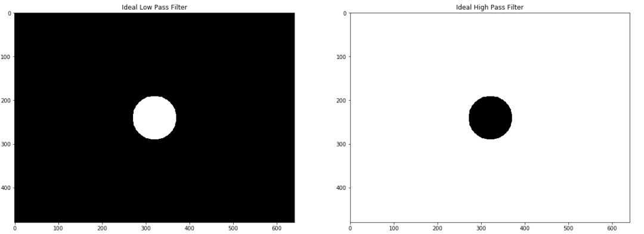

The ideal filter is absolute, all value in it are 0 or 1. In low pass filter, We think all point in the center circle with radius $D_{0}$ are low frequency, and all low frequency will times 0 when it pass the filter, namely, all low frequency part will vanished. High pass is similar.

Second is the butterworth filter. The formula of low pass is: $H(u,v)=\frac{1}{1+{[D(u,v)/D_{0}]}^{2n}}$, and the high pass is: $H(u,v)=\frac{1}{1+{[D_{0}/D(u,v)]}^{2n}}$, H(u,v) is the value of the filter matrix at the position (u,v) and D(u,v) is the distance of point (u,v) to the center, n and $D_{0}$ is a custom value. The visualization is:

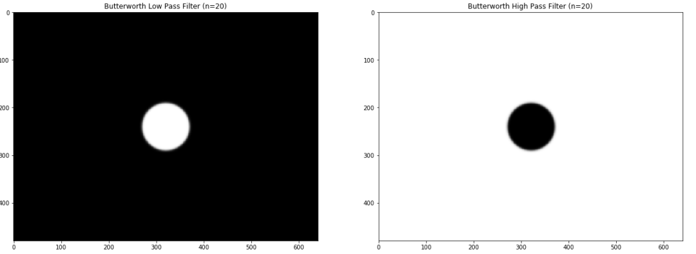

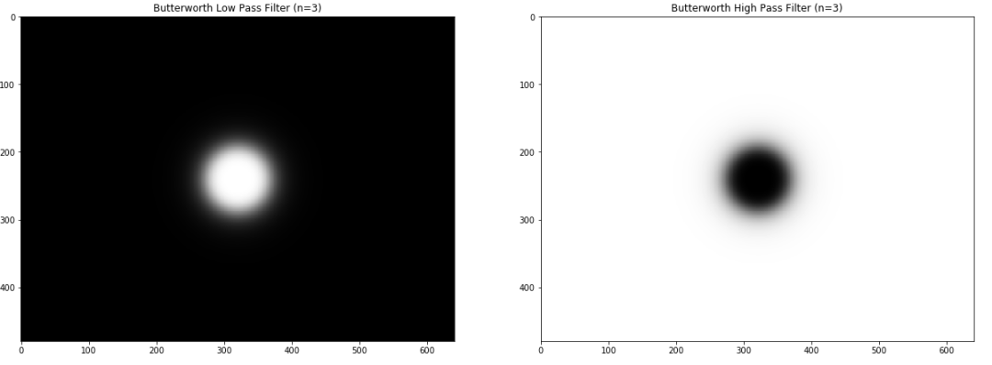

From the visualization, we can see the filter is similar with ideal, but it add some transition effects on the edge of the central circle. The n will affects the degree of the transition effects and the $D_{0}$ will affects the size of the circle.

Finally, lets introduce the Gauss filter.The formula of low pass is: $H(u,v)=e^{−D^{2}(u,v)/2D_{0}^{2}}$, and the high pass is: $H(u,v)=1−e^{−D^{2}(u,v)/2D_{0}^{2}}$. H(u,v) is the value of the filter matrix at the position (u,v) and D(u,v) is the distance of point (u,v) to the center, $D_{0}$ is a custom value that decide the size of the central circle.the visualization is:

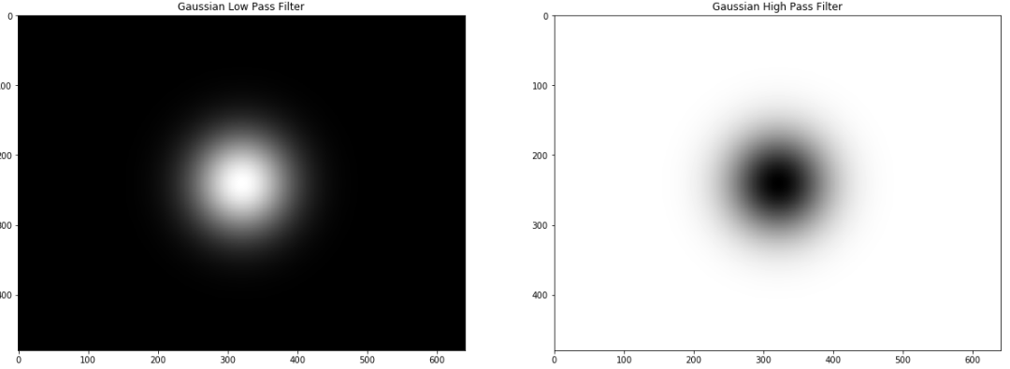

Compare with the butterworth filter,it just add more transition effects.

The effects of them is different.There is a example to compare them.The image below is the result image after pass ideal, butterworth, Gauss low pass filter respectively.

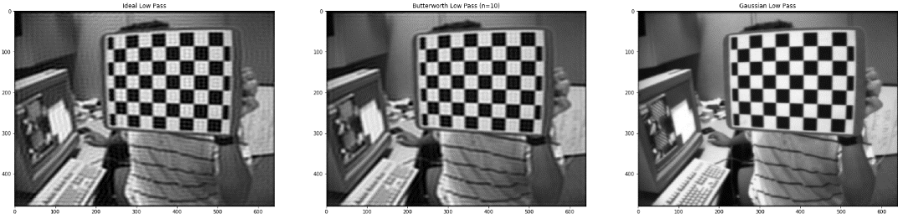

And The image below is the result image after pass ideal, butterworth, Gauss high pass filter respectively.

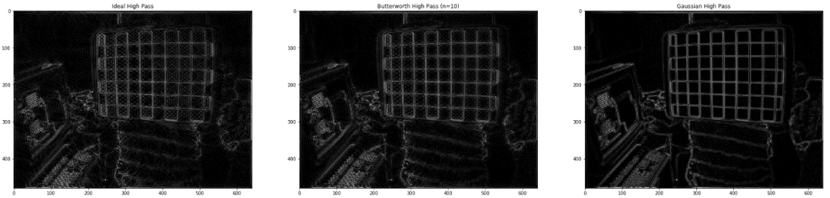

We can find there are many noisy in the result of ideal and butterworth filter and the result of Gauss filter is more smooth. In most of time, Gauss filter is the greatest.

## Application

The process of using filter have three steps. First we should use fast Fourier transfer to get the frequency image of raw image. Then we should use each value in frequency image times the value in filter image at same position. Thirdly we do inverse Fourier transfer to the image we get in second steps and get the result. The image below shows a example of using butterworth low filter:

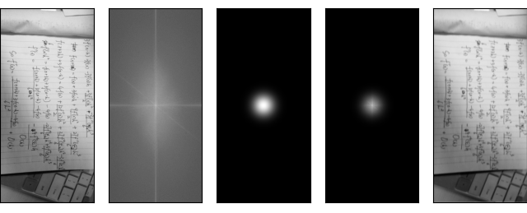

First image is the gray scale image of raw image, second is the frequency image of it, third is the filter and finally is the result image.We can see the result image has been blurred. A commonly used application is the buffing function in photo process. And the image blow is a result of butterworth high pass filter:

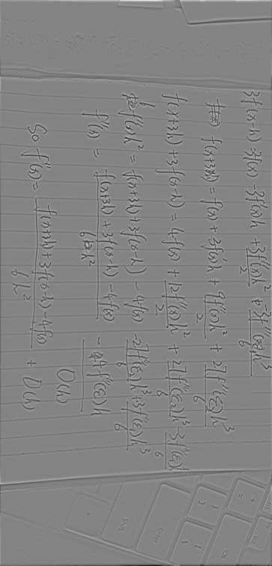

Because the high pass filter can enhance the line in image, so we can use it sharp the hand writing like the before example shows.

I write a command line program to do the work, the repository in github of it: <https://github.com/walkureHHH/gauss_butterworth_filter> .The usage and using example are in README.md .