**数据库查询实验**

2110611 信息安全 纪潇洋

1、给出职工中所有男性的所有信息（empid,empname,age,sex,edpid）

SELECT empid, empname, age, sex, depid FROM employee WHERE sex = '男';

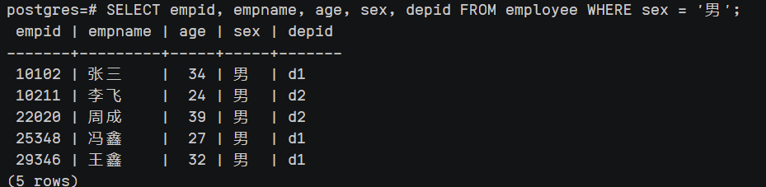

2、统计“李”性职工信息，按年龄降序排序。（empid,empname,age,location）

SELECT e.empid, e.empname, e.age, d.location

FROM employee e

JOIN department d ON e.depid = d.depid

WHERE e.empname LIKE '李%'

ORDER BY e.age DESC;

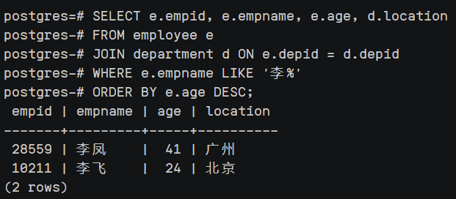

3、给出每位职员参与项目的最高预算和最低预算（empname，highestbudget，lowestbudget）

SELECT e.empname, MAX(p.budget) AS highestbudget, MIN(p.budget) AS lowestbudget

FROM employee e

JOIN workson w ON e.empid = w.empid

JOIN project p ON w.proid = p.proid

GROUP BY e.empname;

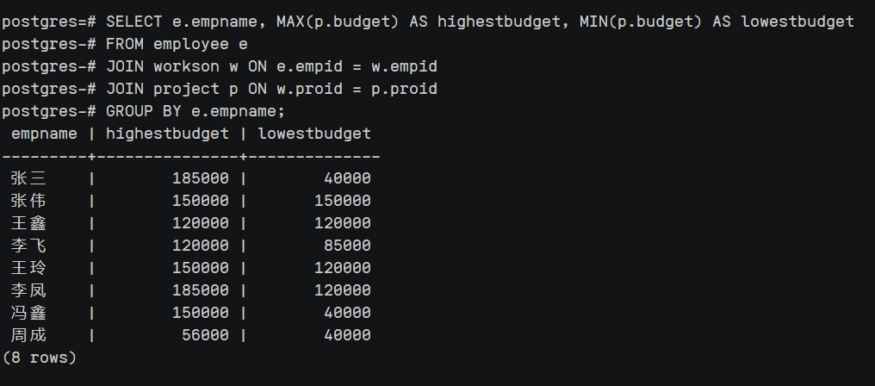

4、给出所有项目超过一个的员工的id和参加的项目个数（empid, num）

SELECT empid, COUNT(proid) AS num

FROM workson

GROUP BY empid

HAVING num > 1;

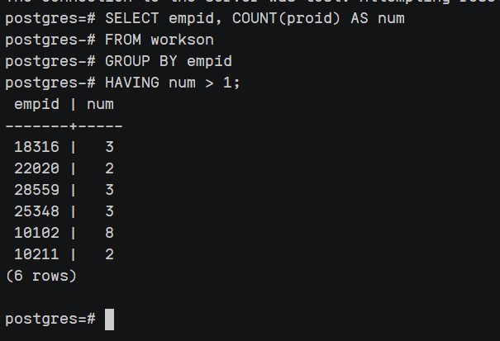

1. 给出项目种类号为“c2”且预算最多的项目。（proid，projectname，budget）

SELECT proid,projectname,budget

FROM project

WHERE catid='c2' and budget>=all (select budget from project where catid='c2' );

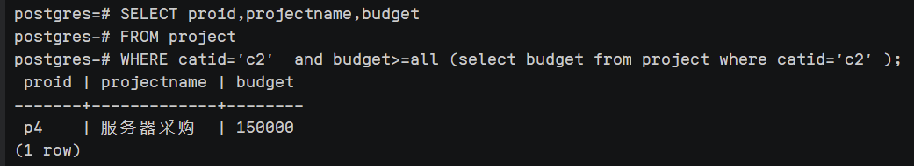

1. 给出参加“产品推广”项目，但不担任职位的员工的信息，（empid,empname，age,sex.depid）

select employee.empid, employee.empname, employee.age, employee.sex, employee.depid

from employee

inner join workson on employee.empid = workson.empid

inner join project on workson.proid = project.proid

where project.projectname = '产品推广' and workson.job is null;

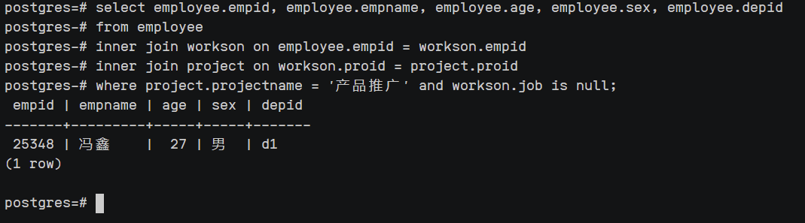

1. 给出工号为“10102”的员工每类项目的参加总数，若没有参加过某类项目，则参加项目总数显示为0（catid，proNum）

select c.catid, count(ws.empid) as pronum

from category as c

left join project as p on c.catid = p.catid

left join workson as ws on p.proid = ws.proid and ws.empid='10102'

group by c.catid;

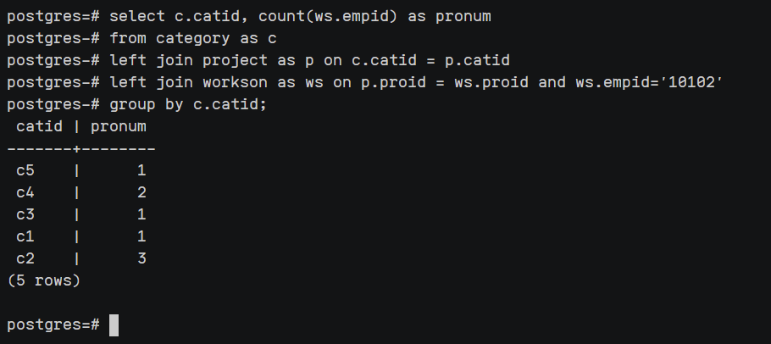

1. 给出没有参与“软件类”项目女性职工的信息（empid,empname, age,sex,depid)】

SELECT empid, empname, age, sex, department.depid

FROM employee

INNER JOIN department ON employee.depid = department.depid

WHERE sex='女'

AND empid NOT IN (

SELECT empid FROM workson

INNER JOIN project ON workson.proid = project.proid

INNER JOIN category ON project.catid = category.catid

WHERE category.catname = '软件类'

);

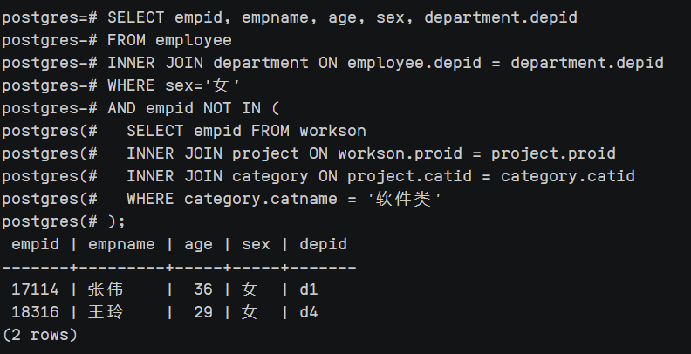

1. 给出有30岁以上男性员工的地点名称和该地男员工最大年龄，结果按最大年龄升序排序

select department.location, max(employee.age) as max_age

from employee join department on employee.depid = department.depid

where employee.age >= 30 and employee.sex = '男'

group by department.location

order by max_age asc;

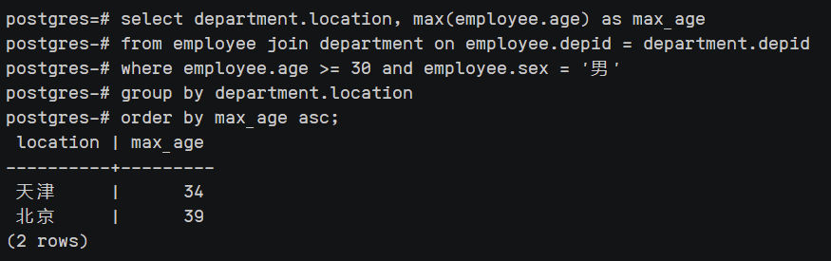

10、给出在广州工作的、参加“'产品推广'”项目的职员id、姓名及他们参加的项目个数（empid, empname, procnt）

select e.empid, e.empname, COUNT(w.proid) as procnt

FROM employee e

NATURAL JOIN workson w

NATURAL JOIN department d

NATURAL JOIN project p

WHERE d.location = '广州' AND e.empid IN

(SELECT empid FROM workson NATURAL JOIN project WHERE projectname = '产品推广')

GROUP BY e.empid, e.empname;

