

Deliverable 1



Thando Ndlovu

Table of Contents

Use Cases and Actors 2

The Process 2

Use Case Diagram 3

Activity Diagram 4

Class Diagram 5

# Use Cases and Actors

## The Process

|  |  |  |
| --- | --- | --- |
| **The Use Case** | **The User**  **(Registered/Non-Registered)** | **The Database** |
| Register and Login | Unregistered User: Creates an eccentric handle for their account.  Registered User: Enters his or her username and password to access the system. | Unregistered User: Data entered by the user will be validated before being stored in the database to be called when the user logs in again.  If the registered data matches the data in the database, access is granted to the user. |
| Search | A user searches for another person with whom they want to communicate. | The search query's information/handle is called and checked in the database. The user will be shown if it is available; else, an error message will occur. |
| Start/Store Conversation | After a chat has been located using a search, the user can now initiate that conversation. Non-searched: Because some chats will be on the "Recent Chats" page, a user can start a conversation without looking for it or the user. | All conversations are recorded in the database so they can be retrieved later. |
| Add/Update Contacts | A user saved a contact so they could get to them later. | Any time a user adds a contact, the database immediately updates the contact list to allow for the addition of the new contact. |
| Highlight the Chats | The user has the option to choose and highlight a chat whenever they want. | Since all chats are recorded in the database, they must first be displayed to the user before being highlighted. This allows the user to choose the chat that they wish to highlight. |

# Use Case Diagram

# Activity Diagram

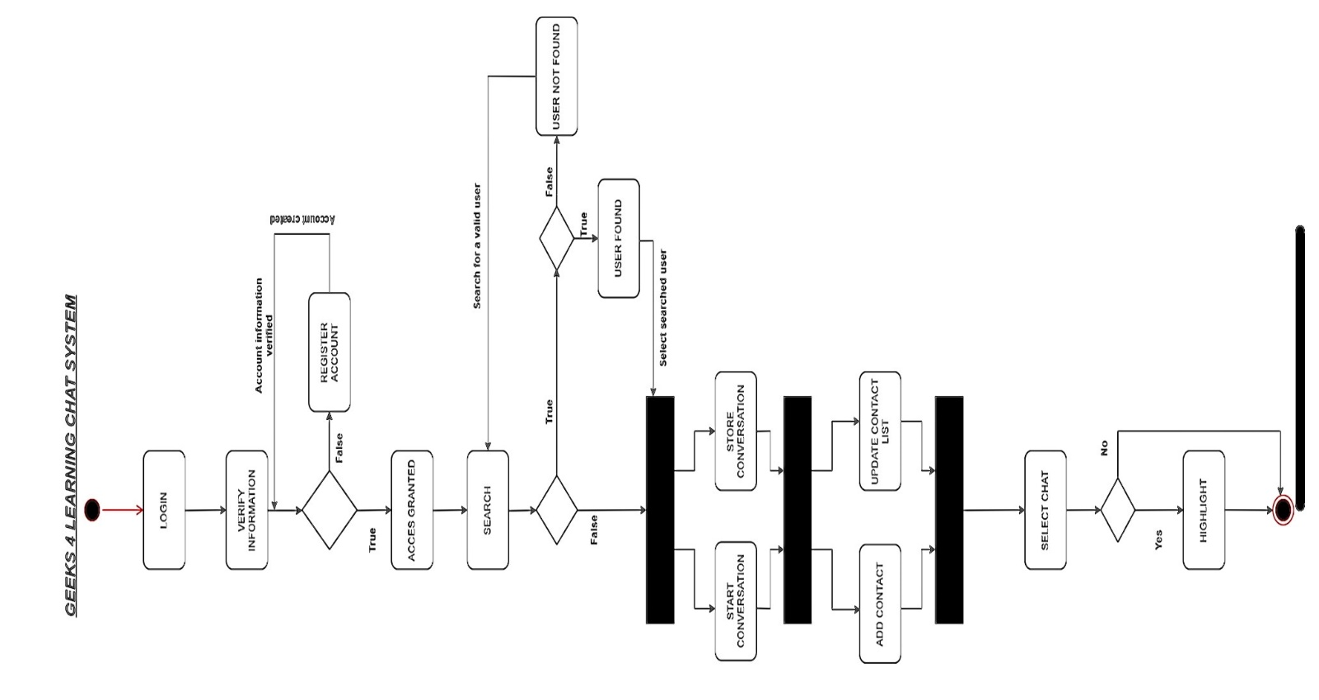

# Class Diagram

