area_standardization

## Different species richness standardisations

### Load data

used (Mb) gc trigger (Mb) max used (Mb)  
Ncells 573522 30.7 1308181 69.9 660905 35.3  
Vcells 1059919 8.1 8388608 64.0 1800423 13.8

Linking to GEOS 3.10.2, GDAL 3.4.1, PROJ 8.2.1; sf_use_s2() is TRUE

Loading required package: sp

Loading required package: spData

To access larger datasets in this package, install the spDataLarge  
package with: `install.packages('spDataLarge',  
repos='https://nowosad.github.io/drat/', type='source')`

Registered S3 method overwritten by 'ape':  
 method from   
 plot.mst spdep

### Area standardization

#### Standardize by inhabitable area

Divide species richness by area of botanical country - icesheets.

#### Species-area-curve

Fit species-area-curve, then divide species richness by theoretical species richness of botanical country.

#### Species-area-curve, >1000 species

Fit species-area-curve, but for countries with > 1000 species only. Then divide species richness by theoretical species richness of botanical country.

#### Divide PD by SR

Alternative to SES.PD: simply divide PD by SR.

### Plot maps

## Species richness maps

plot_grid(sr_map, SR_area_map, SR_SAC_map, SR_SAC1000_map, ncol = 2,   
 labels=c("A","B","C","D"), label_fontface=1)

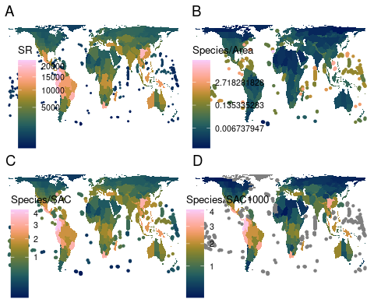

## Phylodiversity maps

plot_grid(pd_map, pd_ses_map, PD_SR_map, ncol = 2,   
 labels=c("A","B","C"), label_fontface=1)

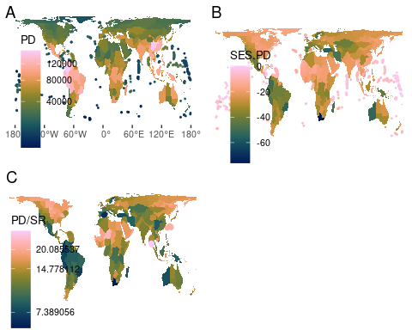

## Hotspots

table(bi_class(shp2, x = SR_area, y = SES.PD, style="jenks", dim = 4)$bi_class) # 7 hotspots

1-1 1-2 1-3 1-4 2-4 3-4 4-4   
 18 93 148 72 17 6 1

table(bi_class(shp2, x = SR_SAC, y = SES.PD, style = "jenks", dim = 4)$bi_class) # 19 hotspots

1-2 1-3 1-4 2-1 2-2 2-3 2-4 3-1 3-2 3-3 3-4 4-1 4-2 4-3 4-4   
 33 75 48 6 39 48 30 6 16 24 17 6 5 1 1

table(bi_class(shp2, x = SR_SAC1000, y = SES.PD, style = "jenks", dim = 4)$bi_class) # 15 hotspots

Warning in classInt::classIntervals(.data[[var]], n = dim, style = style): var  
has missing values, omitted in finding classes

1-1 1-2 1-3 1-4 2-1 2-2 2-3 2-4 3-1 3-2 3-3 3-4 4-1 4-2 4-3 NA-2   
 1 33 77 5 3 38 40 11 8 15 18 11 6 6 4 1   
NA-3 NA-4   
 9 69

table(bi_class(shp2[shp2$richness>1000,], x = richness, y = SES.PD, style = "jenks", dim = 4)$bi_class) # 8 hotspots

1-1 1-2 1-3 1-4 2-1 2-2 2-3 2-4 3-1 3-2 3-3 3-4 4-1 4-2   
 1 43 95 38 4 32 21 9 8 10 7 1 5 2

# Top 2.5% (= 9 or 7 bot countries) instead:  
(nrow(shp2)/100)*2.5

[1] 8.875

shp2$LEVEL_NAME[order(shp2$SR_area, decreasing=T)][1:9]

[1] "Selvagens" "South China Sea"   
[3] "District of Columbia" "C. American Pacific Is."  
[5] "Mozambique Channel Is." "Bermuda"   
[7] "Norfolk Is." "Ogasawara-shoto"   
[9] "Kazan-retto"

shp2$LEVEL_NAME[order(shp2$SR_SAC, decreasing=T)][1:9]

[1] "Ecuador" "Colombia" "Costa Rica"   
[4] "District of Columbia" "Peru" "Panama"   
[7] "China South-Central" "Brazil Southeast" "Mexico Southwest"

shp2$LEVEL_NAME[order(shp2$SR_SAC1000, decreasing=T)][1:9]

[1] "Ecuador" "Colombia" "Costa Rica"   
[4] "Peru" "Panama" "China South-Central"  
[7] "Mexico Southwest" "Brazil Southeast" "Cape Provinces"

shp2$LEVEL_NAME[order(shp2$PD_obs, decreasing=T)][1:9]

[1] "Colombia" "China South-Central" "Peru"   
[4] "Venezuela" "Ecuador" "Bolivia"   
[7] "Brazil Southeast" "Vietnam" "China Southeast"

shp2$LEVEL_NAME[order(shp2$SES.PD, decreasing=T)][1:9]

[1] "Tuvalu" "Chagos Archipelago" "Marshall Is."   
[4] "Tokelau-Manihiki" "Christmas I." "Nauru"   
[7] "Pitcairn Is." "Mozambique Channel Is." "Southwest Caribbean"

shp2$LEVEL_NAME[order(shp2$PD_SR, decreasing=T)][1:9]

[1] "Tuvalu" "Chagos Archipelago" "Line Is."   
[4] "Tokelau-Manihiki" "Nauru" "Mozambique Channel Is."  
[7] "Cocos (Keeling) I." "Pitcairn Is." "Gilbert Is."

shp2$LEVEL_NAME[order(shp2$SES.PE, decreasing=T)][1:9]

[1] "Western Australia" "Queensland" "New South Wales"   
[4] "Laos" "Borneo" "China Southeast"   
[7] "Victoria" "Thailand" "New Caledonia"

dim <- 4  
# regular  
shp2$PE_hotspot <- bi_class(shp2, x = WE, y = SES.PE, style = "jenks", dim = dim)$bi_class  
shp2$PD_hotspot <- bi_class(shp2, x = richness, y = SES.PD, style = "jenks", dim = dim)$bi_class  
  
# area  
shp2$PE_hotspot_area <- bi_class(shp2, x = WE_area, y = SES.PE, style = "jenks", dim = dim)$bi_class  
shp2$PD_hotspot_area <- bi_class(shp2, x = SR_area, y = SES.PD, style = "jenks", dim = dim)$bi_class  
  
# SAC  
shp2$PE_hotspot_SAC <- bi_class(shp2, x = WE_SAC, y = SES.PE, style = "jenks", dim = dim)$bi_class  
shp2$PD_hotspot_SAC <- bi_class(shp2, x = SR_SAC, y = SES.PD, style = "jenks", dim = dim)$bi_class  
  
# SAC >1000  
shp2$PE_hotspot_SAC1000 <- bi_class(shp2, x = WE_SAC1000, y = SES.PE, style = "jenks", dim = dim)$bi_class

Warning in classInt::classIntervals(.data[[var]], n = dim, style = style): var  
has missing values, omitted in finding classes

shp2$PD_hotspot_SAC1000 <- bi_class(shp2, x = SR_SAC1000, y = SES.PD, style = "jenks", dim = dim)$bi_class

Warning in classInt::classIntervals(.data[[var]], n = dim, style = style): var  
has missing values, omitted in finding classes

thicc_lines <- shp2[which(shp2$area<min.area),]

Getting the top 2.5% (or 5%) of each variable produces no overlap between a species richness measure and a phylodiversity measure.

hs

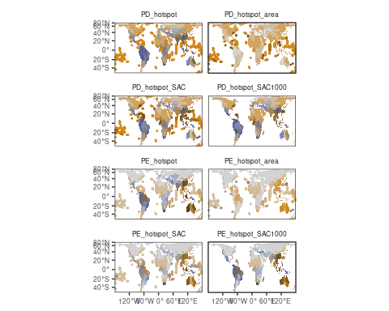

#table(shp2$PD_hotspot)  
hsyes <- c("3-3", "3-4", "4-3", "4-4") # this is more inclusive than currently in the manuscript (PE 3-3)   
  
ggplot() +  
 geom_sf(df.mlt, mapping = aes(fill=value%in%hsyes), color = NA, size = 0.1, show.legend = FALSE) +  
# bi_scale_fill(pal=my_pal, dim=dim, na.value="white") +  
 geom_sf(data=thicc.mlt, lwd=1, aes(col=value%in%hsyes), show.legend=F)+  
# bi_scale_color(pal=my_pal, dim=dim, na.value="white")+  
 coord_sf(expand=F)+  
 facet_wrap(~group, ncol=2)+  
 theme(strip.background=element_blank())

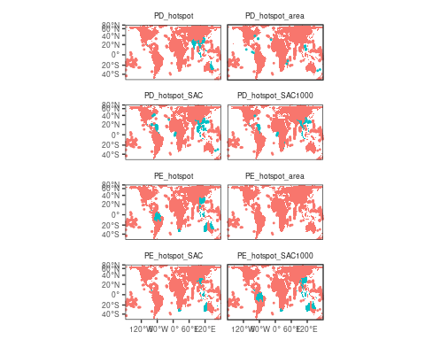

Clustering = “jenks”, 4 groups. Hotspots are in blue.

* strictly dividing by area: only island hotspots. This patterns is stable for up to 5000 species (there are enough islands)
* dividing by SAR-curve SR yields more balanced results, with small differences (islands)