**RESUME**

**PERSONAL INFORMATION**

Name: Rastin Shahrokhi

Location: Isfahan, Iran

Cell: +989129336709

Email: [rastin.shahrokhi@gmail.com](mailto:rastin.shahrokhi@gmail.com)

LinkedIn: [www.linkedin.com/in/rastinshahrokhi/](http://www.linkedin.com/in/rastinshahrokhi/)

GitHub: [www.github.com/RT-SHAHROKHI](http://www.github.com/RT-SHAHROKHI)

**EDUCATION**

* **Master's Student of Information Technology Eng.,** Sheikh Bahaee University, Isfahan, Iran 2022 - Present
* **BA in Computer Eng.,** Sheikh Bahaee University, Isfahan, Iran (Cumulative Grade Point Average: 17.29 out of 20) 2018 - 2022

Thesis Title: Eye (Gaze) Tracking Using Image Processing (in Python)

**SKILLS**

* Python, C, C++, C#, VHDL, Assembly, MATLAB, PHP, SQL, JavaScript
* MySQL, MySQL, Php My Admin, Apache Web Server, WampServer, XAMPP
* Windows, Windows Server, Linux
* Microsoft Visual Code, Microsoft Visual Studio, Anaconda Navigator, Active HDL, Code Vision, Proteus 8 Professional, Cisco Packet Tracer

**UNIVERSITY PROJECTS**

(All mentioned projects include writing reports and presenting.)

|  |  |  |  |
| --- | --- | --- | --- |
| **Project-Title** | **Course-Title** | **Project-Type** | **Credits of the course/total credits of bachelor and final grade** |
| Eye (Gaze) Tracking Using Image Processing (in Python) | Bachelor’s Final Project  (Thesis / Information Technology Project) | Personal project | 3 out of 140 - 20 out of 20 |
| Artificial Intelligence Project | Artificial Intelligence and Expert Systems | Personal project | 3 out of 140 - 19 out of 20 |
| Object Oriented Programming in C++ | Advanced Programming | Personal project | 3 out of 140 - 20 out of 20 |
| Programming the Microchip ATmega16 in C | Microprocessor Lab. | Personal project | 1 out of 140 - 20 out of 20 |
| SQL Project: Design and Implementation of Airline Flight Database | Database | Group project | 3 out of 140 - 17.50 out of 20 |
| Python: Machine Learning and Deep Learning Applications Presentation | Design of Programming Languages | Group project | 3 out of 140 - 18 out of 20 |
| Quantum Computers Presentation | Research and Presentation Method | Group project | 2 out of 140 - 20 out of 20 |
| Linux Presentation | Operating Systems Lab. | Group project | 1 out of 140 - 18.25 out of 20 |
| IPsec Presentation | Computer Networks Lab. | Group project | 1 out of 140 - 16.50 out of 20 |
| Computer Hardware & Software Presentation | Computer Workshop | Group project | 1 out of 140 - 19.75 out of 20 |
| Customer Relationship Management Presentation | Principles of Information Technology | Group project | 3 out of 140 - 18 out of 20 |

**AWARDS**

(All mentioned certificates are attached)

* Top Student of Sheikh Bahaee University (6th Student out of 100) Certificates 2022
* Certificate of Achieving the Third Rank of the Sharif University of Technology Spaghetti Coding Contest December 5, 2019
* Certificate of Participation in FMRI Analysis Using Machine Learning Approaches Workshop May 29, 2022
* Certificate of Completion of “KASBBATOR” Business Course for Empowering Elites and the Top Talents in the Field of Business (Isfahan Chamber of Commerce, Industries, Mines and Agriculture) July to October 2022

**LANGUAGES**

• Persian

• English

**INTERESTS**

• Artificial Intelligence (Deep Learning / Machine Learning)

• Programming and Software Development

• Image Processing / Computer Vision

• Human-System Interaction

• Internet of Things

• Singularity

• Robotics

• Quantum Computing

**PICTURES OF CERTIFICATES**

1. 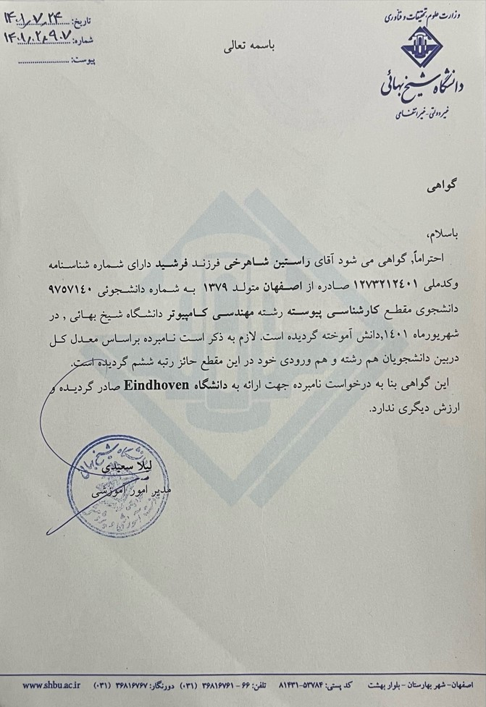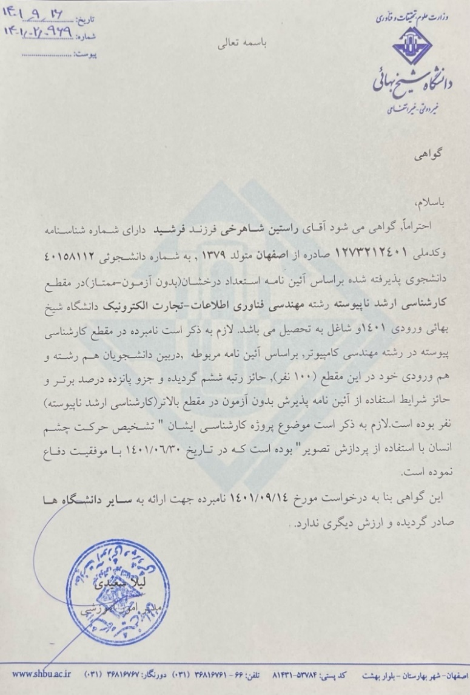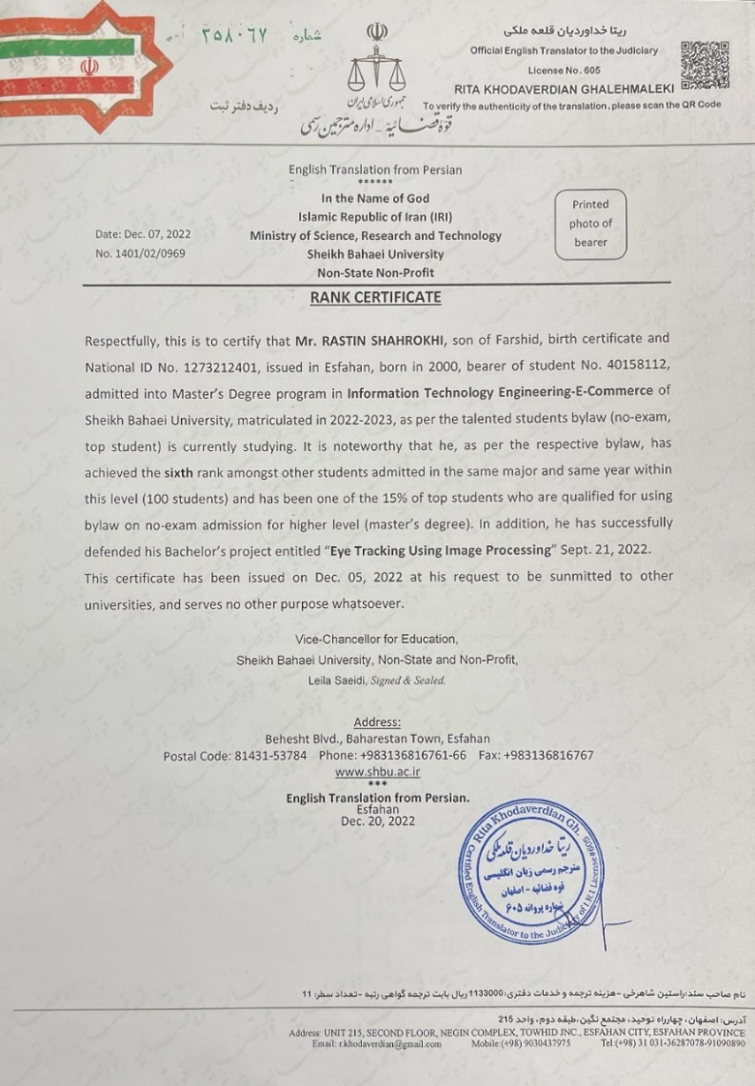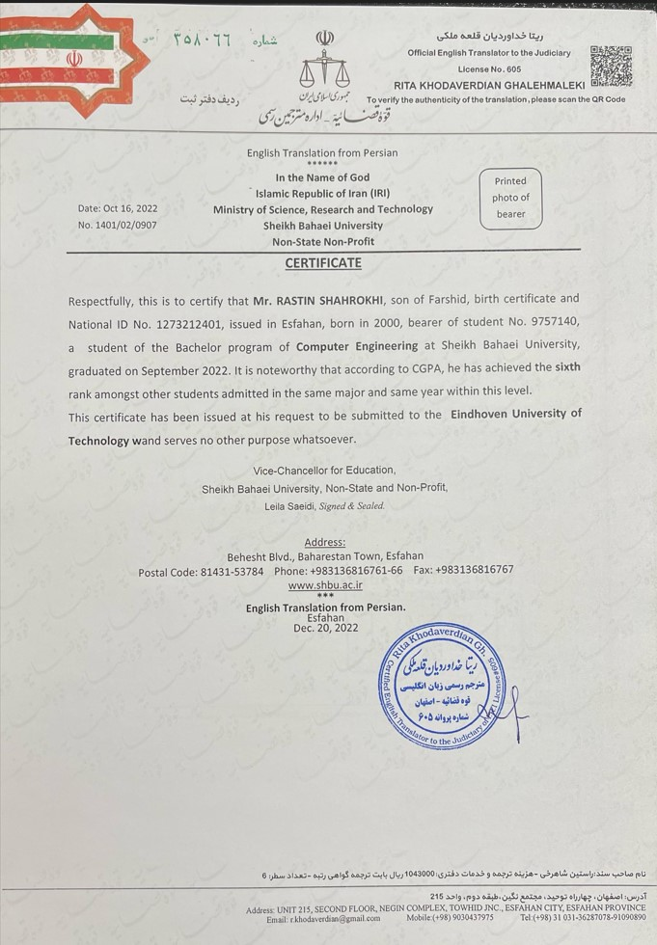Top Student of Sheikh Bahaee University (6th Student out of 100) Certificates:

2- Certificate of Achieving the Third Rank of the Sharif University of Technology Spaghetti Coding Contest:

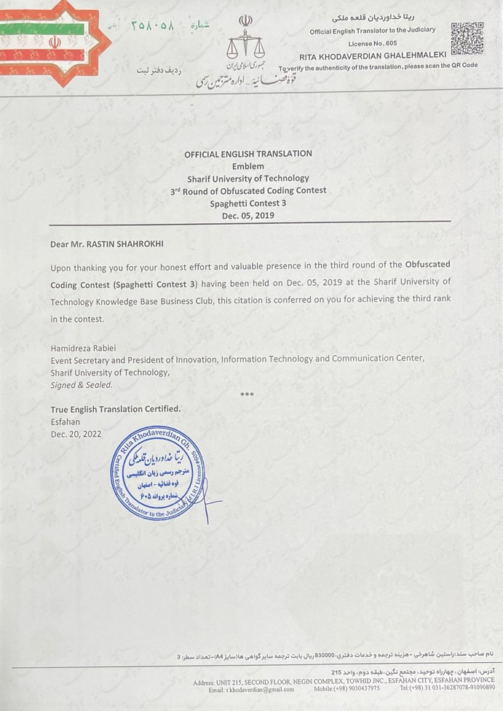

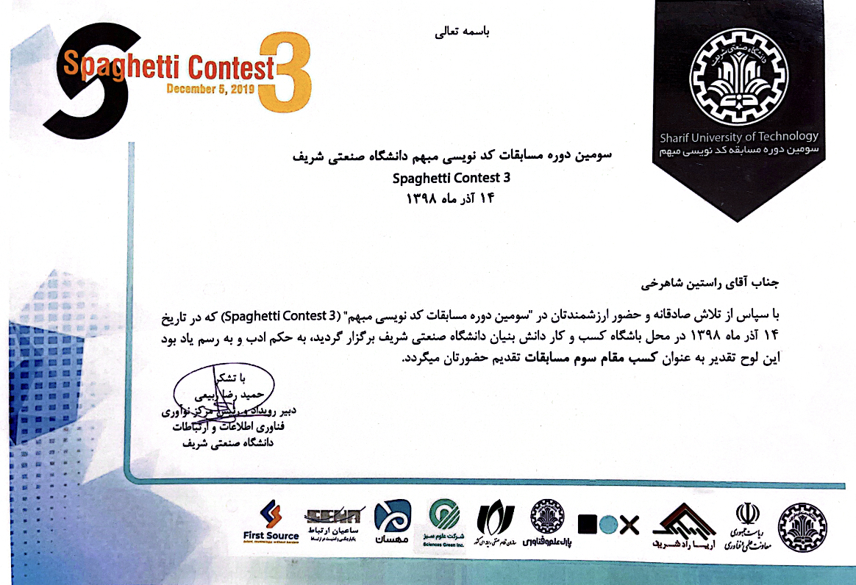

1. 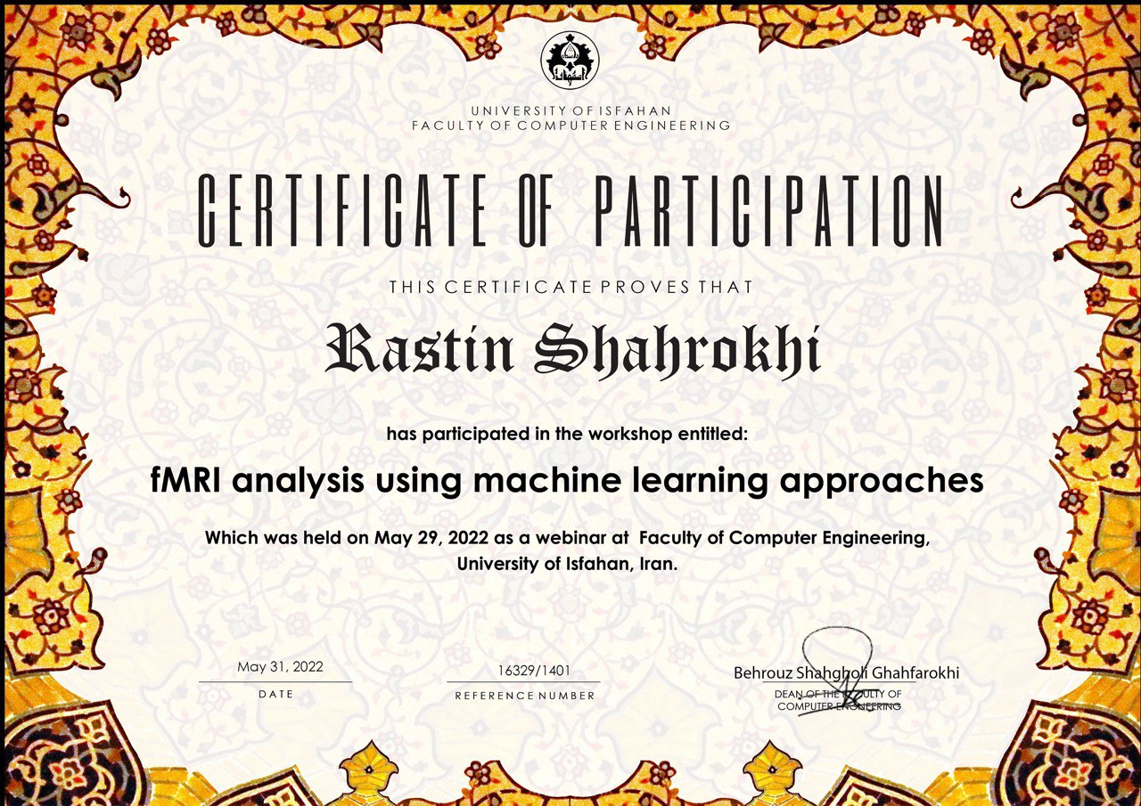 Certificate of Participation in FMRI Analysis Using Machine Learning Approaches Workshop:
2. 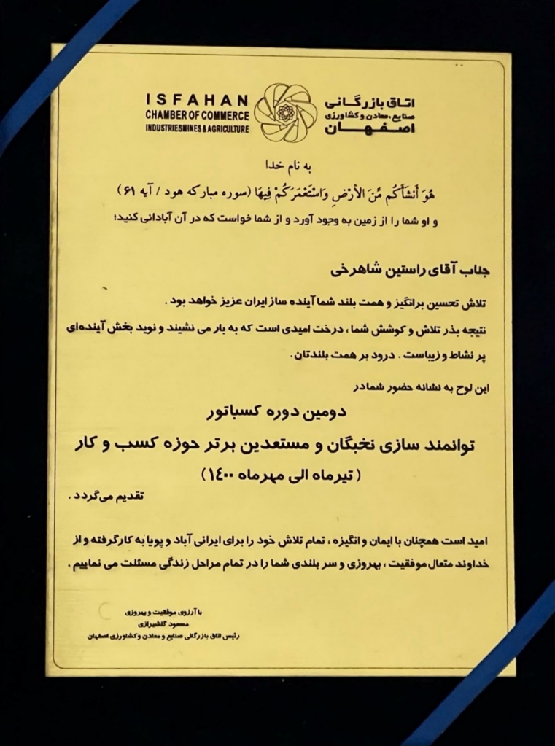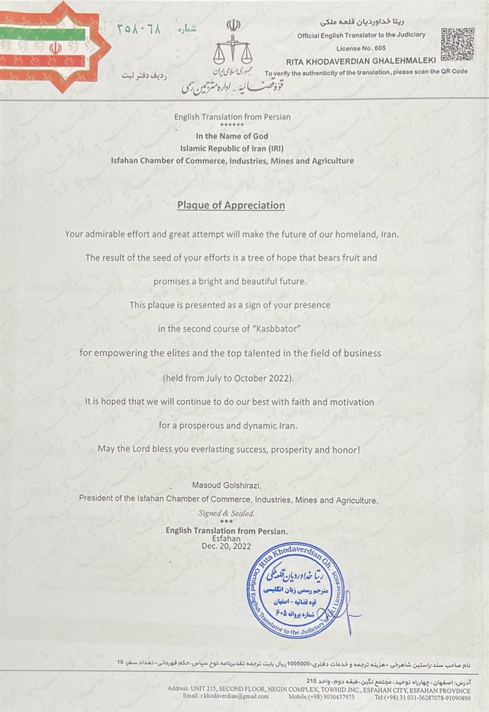 Certificate of Completion of “KASBBATOR” Business Course for Empowering Elites and the Top Talents in the Field of Business (Isfahan Chamber of Commerce, Industries, Mines and Agriculture):