1. Questions on Big-O Analysis. (25 marks)

1. Consider a polynomial function of order 𝑘 given by 𝑓(𝑛) = 𝑎k𝑛k + 𝑎k-1𝑛k-1 + ∙∙∙ + 𝑎0. Formally demonstrate that 𝑓(𝑛) ∈ Ο(𝑛k). Full marks for using basic definitions and concepts.

[12 marks]

**Big-O Rules: Drop smaller terms**

If f(n) = (1 + h(n)) with h(n) -> 0 as n -> ∞. Then, f(n) is O (1).

**Big-O Multiplication Rules**

Suppose two equations 𝑓1(𝑛) is Ο(𝑔1(𝑛)) and 𝑓2(𝑛) is Ο(𝑔2(𝑛)). From the definition, there exists positive constants c1, c2, n1 and n2 such that 𝑓1(𝑛) ≤ c1𝑔1(𝑛) for all n ≥ n1 and 𝑓2(𝑛) ≤ c2𝑔2(𝑛) for all n ≥ n2. Let n0 = max {n1, n2}. Multiplying 𝑓1(𝑛) and 𝑓2(𝑛) gives 𝑓1(𝑛) 𝑓2(𝑛) ≤ c1c2𝑔1(𝑛)𝑔2(𝑛) for all n ≥ n0. So, 𝑓1(𝑛)𝑓2(𝑛) is O(𝑔1(𝑛)𝑔2(𝑛)).

𝑓(𝑛) = 𝑎k𝑛k + 𝑎k-1𝑛k-1 + ∙∙∙ + 𝑎0

𝑓(𝑛) = nk (𝑎k+ 𝑎k-1/n+ ∙∙∙ + 𝑎0/nk)

As n -> ∞, (𝑎k+ 𝑎k-1/n+ ∙∙∙ + 𝑎0/nk) -> (𝑎k+ 0 + ∙∙∙ + 0) -> ak and 𝑓(𝑛) -> nkak by Drop smaller terms.

O(nk) is trivially O(nk) and O(ak) is O(1).

With Big-O Multiplication Rules, O(𝑓(𝑛)) = O(nkak) = O(nk) O(ak) = O(nk)O(1) = O(nk*1) = O(nk)

So, 𝑓(𝑛) is O(nk) or 𝑓(𝑛) ∈ Ο(𝑛k).

1. Refer to the definition of Big-O in the lecture materials. In particular, the condition for which one can state that 𝑓(𝑛) is Ο(𝑔(𝑛)) is defined. Briefly explain why the notation 𝑓(𝑛) ∈ Ο(𝑔(𝑛)) is preferred compared to 𝑓(𝑛) = Ο(𝑔(𝑛)). Full marks for using basic definitions and concepts and mathematical formulation.

[13 marks]

𝑓(𝑛) is Ο(𝑔(𝑛)) if and only if there exists positive constants c and n0 such that 𝑓(𝑛) ≤ c𝑔(𝑛) for all n ≥ n0. In mathematical notation, ∃c > 0, n0 such that ∀n ≥ n0, 𝑓(𝑛) ≤ c𝑔(𝑛).

f: N+ -> R+ and g: N+ -> R+ where N+ = {1,2,3, …} and R+ = {x ∈ R| x ≥ 0} assuming that f(n) ≥ 0, ∀n ≥ 1. For convenience, the function is sometimes relaxed to f(n) ≥ 0, ∀n ≥ N for some constant N.

O(n) can be thought of as the set of all functions whose growth is no worse than linear for sufficiently large n. Hence, it can be thought of as the infinite set {1, 2, …, log n, 2 log n, …, n, 2n, 3n, …, n+1, n+2, …}. So, 3n+5 is O(n) is just the statement that 3n+5 is in this set or 3n+5 ∈ O(n).

We should avoid writing big-O notations in the form 𝑓(𝑛) = Ο(𝑔(𝑛)). As an example, if 𝑓(𝑛) is Ο(n), then f(n) is also Ο(n2) because if f(n) grows no worse than linear for sufficiently large n, then f(n) must also grow no worse than quadratic for sufficiently large n. If we write 𝑓(𝑛) = Ο(n) and f(n) = Ο(n2). Then this implies that Ο(n) = Ο(n2) which is incorrect as Ο(n) ⊂ Ο(n2). Instead, we should write 𝑓(𝑛) ∈ Ο(n) and f(n) ∈ Ο(n2).

2. Questions on Binary Search Tree, Heap, Balanced Binary Search Tree, Basic Data Structures (stack/queue)

(a)

(b)

(c)

As the upgrade request and cancellations is in O(log n) time. This will mean that it traverse through the list with a time complexity of O(log n) just to update the customer’s request for upgrade or cancel it’s upgrade (to change its status is O(1). Thus. O(1 + log n) would mean O(log n) (Big-O Rules: Drop smaller terms)). As for the k-highest-priority flyers on the waiting list is O(k log n) time. It would mean that. It undergoes k times as there are k seats available for the upgrade to business class / first class. As the time complexity for traversing the list is O(log n). to under go it k times for upgrading the customers will be O(k * log n). Thus, O(k log n).

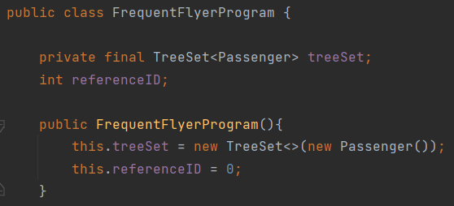

This is the public class for our program named FrequentFlyerProgram. The constructor initializes a new TreeSet using the Passenger comparator. TreeSet uses Red-Black Tree in its implementation. The referenceID is also set to 0.

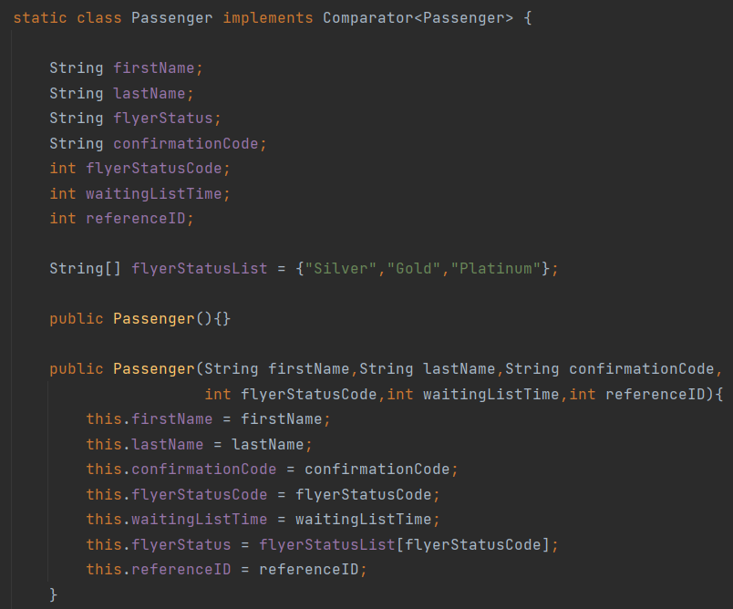

This is the Passenger class and it holds information about the passenger.

Passenger() – Used to initialize the comparator in the TreeSet

The constructor with the 6 parameters creates a new Passenger object with the given parameters which is saved inside the TreeSet.

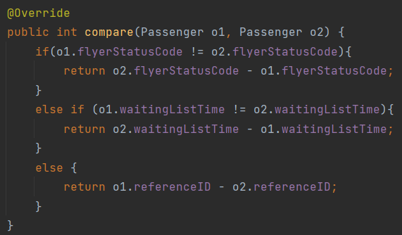

This is the comparator for the Passenger class. It is used to compare 2 passenger objects inside the TreeSet. It is used in the search, insert and delete functions of the TreeSet.

Pseudocode:

Algorithm reqUpgrade(record, customer)

checkRecord = record;

While (checkRecord != null)

If(checkRecord.rank > customer.rank)

checkRecord = checkRecord.right

Else if(checkRecord.rank < customer.rank)

checkRecord = checkRecord.left

Else If(checkRecord.timeReq < customer.timeReq)

checkRecord = checkRecord.right

Else If(checkRecord.timeReq > customer.timeReq

checkRecord = checkRecord.left

Insert(customer)

Balancing(record)

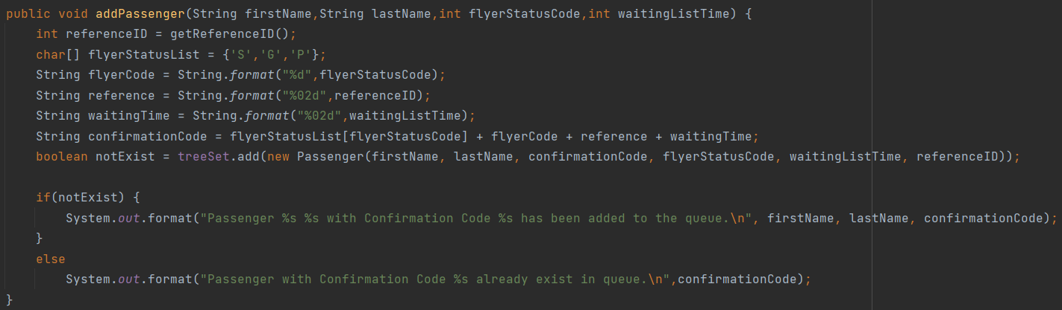

This is the addPassenger method which creates new Passenger object and inserts it into the TreeSet. A unique comfirmation code is also generated for each passenger. As an example, S20110 means the passenger has platinum rank, referenceID of 01 and waitingTime of 10. The new passenger is only inserted if no duplicates exist in the TreeSet.

Algorithm removeReq(record, code)

rankCode = code[1]

refNum = code[2] + code[3]

timeReq = code[4] + code[5]

checkRecord = record;

While (checkRecord != Code)

If(checkRecord.rankCode < rankCode)

checkRecord = checkRecord.left

else if(checkRecord. rankCode > rankCode )

checkRecord = checkRecord.right

else if(checkRecord. timeReq > timeReq)

checkRecord = checkRecord.right

else if(checkRecord. timeReq < timeReq)

checkRecord = checkRecord.left

else if(checkRecord.refNum > refNum)

checkRecord = checkRecord.right

else if(checkRecord. refNum < refNum)

checkRecord = checkRecord.left

if(checkRecord == NULL)

return false

delete(checkRecord)

balance(record)

return true

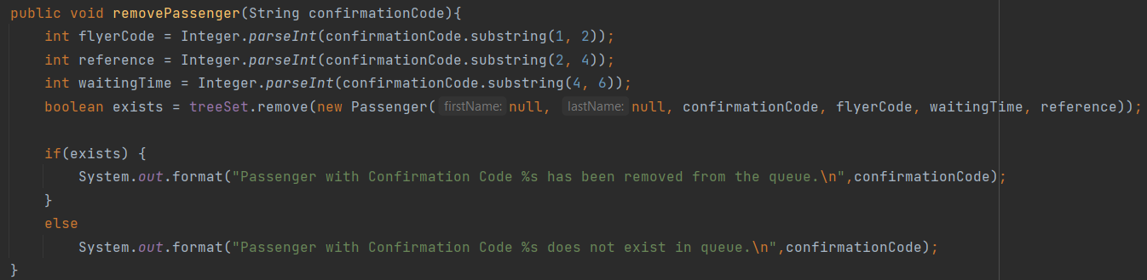

This is the removePassenger method which removes a passenger object from the TreeSet. It converts the confirmationCode of the passenger into rank, referenceID and waitingTime which is used to create a temporary passenger object. The passenger is deleted from the TreeSet if a duplicate is found.

Algorithm upgrade(k, record)

While(k != 0)

checkRecord = record

While(checkRecord.left != null)

checkRecord = checkRecord.left

remove(checkRecord)

k := k - 1;

balance(record)

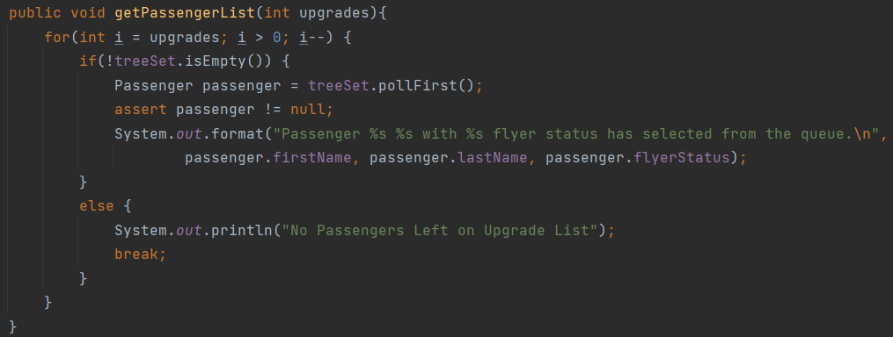

This is the getPassengerList method which returns k passengers with the highest priority.