**Cahier des charges du projet**

**“photoStockage”**

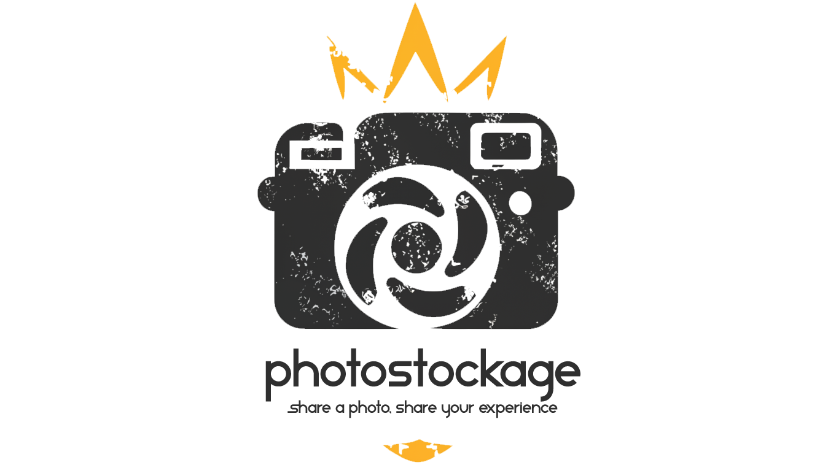

Index

I. Introduction p. 1-2

II. Objectives

i. Functional objectives

ii. Non-functional objectives

III. Stakeholders

i. Project Team

ii. End Users

IV. Requirements

i. Functional requirements

ii. Non-functional requirements

V. Technical Specifications

i. Platforms

ii. Technology Stack

iii. Integration

VI. Design and User Experience

i. Wireframes

ii. Maquettage

iii. User Journey

iv. Visual design

VII. Data Management

i. Data Models

ii. Data Storage

VIII. Testing and Quality Assurance

i. Testing strategy

ii. Quality Criteria

IX. Project Timeline and Milestones

i. Phases

ii. Milestones

X. Resources

XI. Legal and Compliance

i. Intellectual Property

ii. Compliance

XII. Conclusion

i. Summary

XIII. Additional

i. Documentation

1. Introduction

Project overview

“photoStockage” is a website / platform that enables users to freely download and utilize high-quality photographs for any purpose. The platform also encourages users to upload and share their own photographs and experiences, creating a diverse collection of images. The core functionality of "photoStockage" includes user registration, photo uploading, photo downloading, photo saving, and liking of photos, as well as photo browsing for inspiration.

"photoStockage" addresses the need for easy access to high-quality photos without the need for expensive licenses or annoying credits to websites and creators. The service is free, allowing users to download and upload high-quality photos for personal and commercial use without legal complications. Unlike other websites that charge for commercial usage, impose heavy restrictions on usage, and have availability limitations, "photoStockage" eliminates these barriers by providing a library of images that can be used freely, as long as users agree to the terms of service. However, it is important to note that the platform cannot effectively enforce its terms of service, and users who use photos in unlawful ways will be reported to the authorities.

The target audience of the website includes photographers seeking inspiration for their next project, content creators, graphic designers, web developers, marketing professionals, small and large companies, students, and educators.

The main selling points of "photoStockage" are its free pricing model, with no hidden fees, premium memberships, or subscription-based content. Additionally, the platform's simplicity and user-friendly interface make it easy to use. The spirit of a community and the feeling of contributing to making projects better while sharing stories and experiences are also key selling points.

The main goals of this platform are to create a comprehensive, user-driven webpage for free photography sharing, fostering a community of photographers, photography enthusiasts, and users who contribute to a resource pool, and providing easy access to high-quality images for various users.

The objectives of this project are to promote the value of shared resources and open, truly free content, establish "photoStockage" as a leading platform for free photo sharing, increase brand visibility and recognition, and support the creative industry by providing a resource pool at no cost, which will enhance brand loyalty and user engagement.

Scope

The platform's features include user account creation, photo uploading, downloading, sharing, and management, advanced searching and filtering options for photos, a legal agreement confirmation for photo usage, GDPR compliance, community features such as liking photos and saving downloaded and liked photos, and a mobile-friendly design for usage on various devices.

The target browsers include all major browsers, such as Chrome, Firefox, and Edge, as well as support for older versions of Internet Explorer. The mobile-friendly user interface allows ease of use for both desktop and mobile users worldwide, as the platform is not region-locked or restrictive, making it accessible to any user with internet access.

"photoStockage" does not offer direct photo editing tools, such as cropping or adjusting lighting, as part of its features. Additionally, the platform does not support memberships, whether premium or subscription-based, nor does it offer e-commerce features for buying or selling photos or other merchandise. This means that users can access and utilize high-quality photos without any additional costs or commitments.

Future features include native support for mobile devices, the ability to comment on photos, and more extensive management of photos using albums and tags.

II. Objectives