Dossier de projet

Name of project

Image

My name

Index

1. Introduction 3

i. Objective of the document 3

ii. Project overview 3

2. Project Scope and Architecture 3

i. Scope 3

ii. Architecture overview 3

3. Code implementation 3

i. Backend 3

ii. Frontend 3

iii. Database 3

4. Design and User Experience 3

i. Wireframes 3

ii. User Flow 3

iii. Visual Design 3

5. Data Management 3

i. Database Schema 3

ii. Data Security 3

6. Testing 3

i. Testing Strategy 3

ii. Bug / Error Management 3

7. Deployment and Maintenance 4

i. Deployment Process 4

ii. Maintenance 4

8. Challenges and Solutions 4

9. Documentation and Conclusion 4

i. Documentation 4

ii. Conclusion 4

10. Annexes 4

# Introduction

## Objective of the document

This document serves as a comprehensive guide for the project "photoStockage," offering an in-depth look at both the frontend and backend technologies employed. It outlines the decisions I made to ensure the successful completion of a fully functional CRUD (Create, Read, Update, Delete) web application.

The document begins by elucidating the project's purpose, providing a clear understanding of its objectives and goals. It then delves into detailed wireframes and prototypes, offering visual representations of the application's structure and flow. Additionally, it includes screenshots of key code segments, accompanied by thorough explanations to ensure clarity and understanding.

User experience diagrams and visual design decision explanations are also incorporated, providing insights into the thought process behind the application's interface and user interactions. Furthermore, the document includes comprehensive database schemas, outlining the structure and relationships within the database.

Testing strategies are discussed, complete with code examples to illustrate the methodologies used to ensure the application's reliability and performance. A detailed schema for deploying and maintaining the project in the future is also provided, ensuring long-term sustainability and scalability.

The document concludes with a reflection on the challenges encountered during the creation and development of the project, along with the solutions implemented to overcome these obstacles. Finally, it includes concise documentation of critical aspects such as installation procedures, backend API endpoints, and other essential components, ensuring a smooth and efficient development process.

## Project overview

“photoStockage” is a hybrid website that seamlessly blends the essence of social media with the functionality of an image-sharing platform. At its core, it serves as a space for users to upload, download, and explore images while drawing inspiration from a vast collection of visual content. The platform is designed to be fully responsive, ensuring a smooth and intuitive user experience across all devices, from mobile phones to large desktop screens.

The primary target audience of “photoStockage” consists of professionals who require high-quality, copyright-free images for various creative and commercial projects, provided they adhere to legal and ethical guidelines. A secondary audience includes artists, designers, and other creatives who use the platform as a source of inspiration, a networking hub, or a space for mentorship and collaboration. By fostering an engaging and supportive community, the platform bridges the gap between professional image resources and social interaction.

One of the defining features of “photoStockage” is its emphasis on user interaction and content management. Users can create, edit, and delete accounts while sharing their own images and personal stories behind them. The platform allows members to engage with content through likes, comments, and saved collections. Additionally, users can manage their interactions by editing or deleting comments and controlling the data they share. A dedicated support system is also in place, enabling direct communication with the site administration for any assistance or inquiries.

The purpose of “photoStockage” is to create an inclusive and dynamic environment where creativity and accessibility go hand in hand. By providing a legally sound repository of high-quality images, it empowers professionals and creatives to enhance their work without concerns over copyright restrictions. At the same time, the platform encourages artistic expression, idea exchange, and community-driven growth. Whether users are looking for the perfect visual asset, seeking artistic motivation, or aiming to connect with like-minded individuals, “photoStockage” offers a versatile and enriching experience.

# Project Scope and Architecture

## Scope

In “photoStockage”, I have personally developed the essential features that form the backbone of the platform. At its core, the website provides users with the ability to create a personal account, customize their profile, and manage their own content with ease. Each user has full control over their uploaded images, including the ability to add, edit, and delete content as needed. The platform is designed not only for sharing visuals but also for fostering engagement within the community, allowing users to interact with images through likes and comments, save their favorite photos in personalized collections, and explore a diverse range of creative content.

To ensure smooth and secure operations, I developed a backend API that enforces request limits, preventing abuse and maintaining system stability. Security has been a primary focus throughout development, leading me to integrate various protective measures to safeguard user data and interactions. In addition to authentication and data validation mechanisms, I have implemented security protocols to filter and sanitize user input, ensuring a safe environment for all members of the platform.

On the frontend, I have structured the interface to provide a seamless and intuitive user experience. By leveraging Next.js, I have taken advantage of its built-in optimizations, such as dynamic image handling and efficient page navigation, to enhance performance across different devices. The use of Next.js’ Image and Link components has allowed me to optimize media delivery and ensure a smooth browsing experience, even when handling high-resolution images. By adhering to modern development best practices, I have aimed to create a platform that balances performance, usability, and scalability, making “photoStockage” accessible to a broad audience, from casual users to industry professionals.

When defining the target audience for “photoStockage”, I drew directly from my own experience as both a professional web developer and a creative. I have personally encountered the challenges faced by individuals in both of these roles, which helped shape the platform’s core functionalities to address their specific needs. As a developer, I often required high-quality, royalty-free images for projects without legal restrictions, while as a creative, I sought inspiration, interaction, and opportunities to connect with others in the field. These experiences allowed me to structure “photoStockage” in a way that serves both groups effectively.

The primary audience consists of professionals, including web developers, designers, marketers, and content creators, who need access to high-resolution, copyright-free images for commercial and personal projects. To enhance their experience, I implemented a search functionality that allows users to find images by name or category, streamlining their workflow and making it easy to locate the perfect visual asset. By offering a free and accessible image repository, “photoStockage” eliminates the need for expensive stock image subscriptions, empowering professionals to focus on their projects without worrying about licensing restrictions.

The secondary audience comprises creatives such as photographers, artists, and designers who use the platform to showcase their work, seek inspiration, and engage with like-minded individuals. For them, “photoStockage” is more than just an image repository—it’s a space for interaction and community-building. I developed features that encourage engagement, including a like button that allows users to appreciate and support others' work, as well as a commenting system where they can share feedback and start discussions. Additionally, I designed user profiles to include email contact information, enabling direct communication between members. This feature fosters potential collaborations, mentorship opportunities, and professional networking.

To further facilitate communication, I personally designed a Contact Us form that allows users to reach out directly to the platform’s administration. Whether they have inquiries, need assistance, or want to report an issue, this feature ensures that users can receive support efficiently. By integrating these interactive elements, “photoStockage” serves not only as a practical tool for professionals but also as a dynamic creative hub where users can connect, share, and grow.

For the development of “photoStockage”, I chose technologies that align with both efficiency and ease of use. On the backend, I implemented Node.js with the Express framework, as it provides a lightweight and straightforward environment that enhances the development experience. For the frontend, I utilized Next.js, leveraging its App Router to optimize navigation and performance while maintaining a structured and scalable codebase. Given my prior experience with React, Next.js was a natural choice that allowed for seamless integration of best practices.

For data management, I opted for PostgreSQL, an open-source relational database with strong community support and excellent scalability. This choice ensures that the platform can efficiently handle data storage while remaining adaptable to future expansion if needed. While the platform is not yet hosted, it has been designed to be deployable on a VPS or traditional hosting services, with certain limitations on the number of concurrent users depending on the hosting environment.

To ensure security and performance, I adhered to the best practices recommended by the chosen frameworks. Additionally, I implemented security measures using various libraries to protect user data and maintain platform integrity. By combining these technologies, I have created a robust, scalable, and developer-friendly foundation for “photoStockage”, ensuring a smooth experience for all users.

As an independent project without external funding, the primary limitation of “photoStockage” is financial. Since there are no sponsors or revenue sources supporting its development, the scalability and long-term sustainability of the platform are directly tied to available resources. Hosting costs, in particular, play a crucial role in determining user capacity. While the project is designed to be deployable on both VPS and traditional hosting services, the number of users it can support would ultimately depend on the hosting infrastructure available at the time of deployment.

From a legal perspective, “photoStockage” includes a disclaimer in the "About" section that outlines user responsibilities and ensures compliance with copyright and content regulations. This disclaimer explicitly states that users must abide by the law when uploading and sharing content, and it relieves the administration of liability for any misuse of the platform.

To maintain a safe and appropriate environment, a moderation system is in place to address potential violations. If inappropriate or illegal content is detected by the administration, it is promptly removed. Additionally, users have the ability to report content, and depending on the severity of the violation, necessary actions are taken, including notifying the relevant authorities when required.

In terms of data privacy, “photoStockage” follows a minimal data retention policy. The platform does not collect or store unnecessary user information, ensuring a privacy-first approach. The only user data retained includes the email, username, and last login timestamp, which are stored securely in the database. These are essential for authentication purposes, particularly for securely managing JWT-based authentication using HTTPS cookies. By limiting data storage to only what is necessary, the platform enhances privacy while maintaining core functionality.

## Architecture overview

Backend flow diagram:

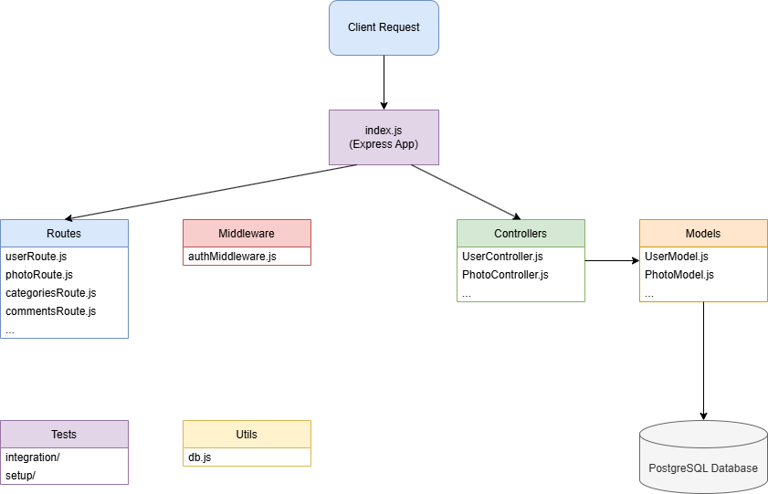

The entry point of the backend is the index file. It is written using the express framework, leveraging an MVC (without the view part as the frontend is separate) structure model. Upon a frontend request, the backend through index is making a call to the appropriate route which in turn is going to call a specific function of the controller that will finally call the appropriate model in order to retrieve or send data to the database. The operations that send data to the database are protected through a middleware that check if the user is authenticated and if necessary if the user is the admin for certain protected routes.

Frontend flow diagram:

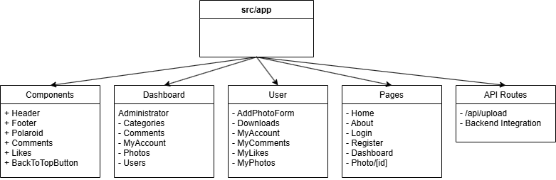

The frontend is separated in sections. The main pages of the frontend consist of the homepage, an about page, a login page for users that are not logged in, a register page, a dashboard page for logged in users and the individual photo pages. It includes the header and footer components that are present throughout the whole experience. The polaroid component which is a component I created to imitate the well-known polaroid style of photos with some extra features like enlargement when hovered or touched for mobile screens and interesting shadows to give a depth of field. There are also the comments and likes components as well as a basic back to the top component that appears on every page when the user scrolled past a certain point of the page. I split the dashboard into two parts, the administration part and the user part, with separate, distinct, responsibilities. The administrator has the ability to view all photos, users, comments and delete them if that is deemed necessary. The user on the other hand, has the ability to upload images, edit them, delete them, same with comments, view their likes and downloads and of course manage their account. Every action that requires a database function involves an API call to the backend.

# Code implementation

## Backend

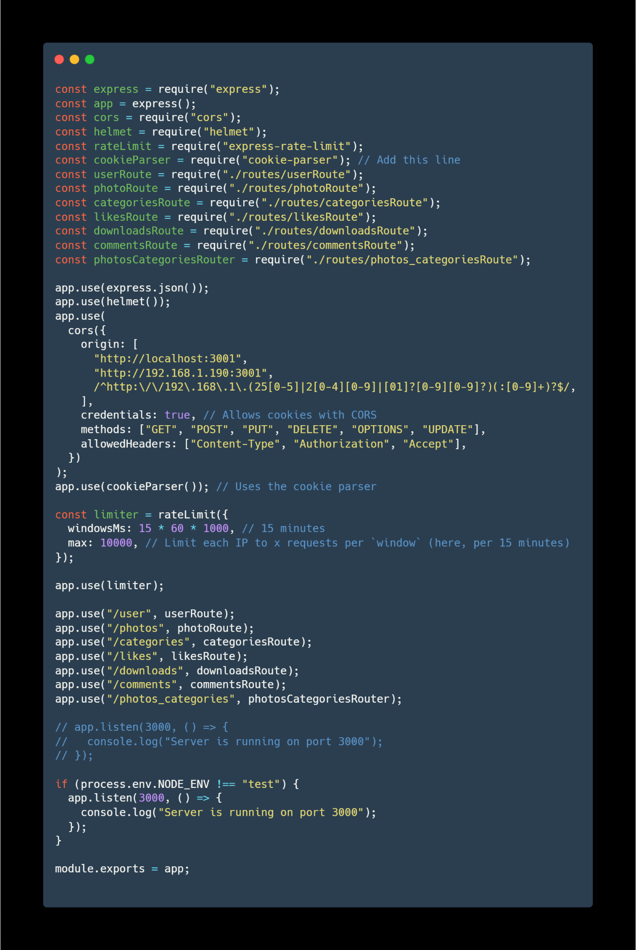

As mentioned earlier, the entry point for the backend is the index file. At the top of the file all the required libraries are called. The app is using express, helmet for security, cors also to restricted access from unknown sources, a cookie parser for the decoding of the jwt that is stored in an https only cookie, a limiter for limiting requests in order to avoid DOS attacks, followed by the routes and finally the definition of the port that the backend is listening to for active connections.

The cors section accepts localhost connections that are only coming from the port 3001 which is used by the frontend, the local address 192.168.1.190 which at the time of coding was the address assigned to my mobile phone for testing purposes as well as any local address in the range of 192.168.1.x/16 (0-255) which are local addresses for further testing. Credentials are required, meaning for certain routes a jwt is required. The methods that are allowed are GET methods in order to fetch data from the database and the rest of them that are in order to make a manipulation to the database which are all protected with the use of the middleware.

The app limiter restricts to 10.000 requests every 15 minutes in order to protect from malicious usage of the platform.

The app router calls all the required routes in order for the platform to function.

Finally we listen to a specified port for connections as long as the environment is set to be anything else except for test.

I chose the MVC structure as it helps me keep my files and folders more organized in a cleaner way and more important, it separates concerns of files which is a practice that keeps everything neat.

Database connection:

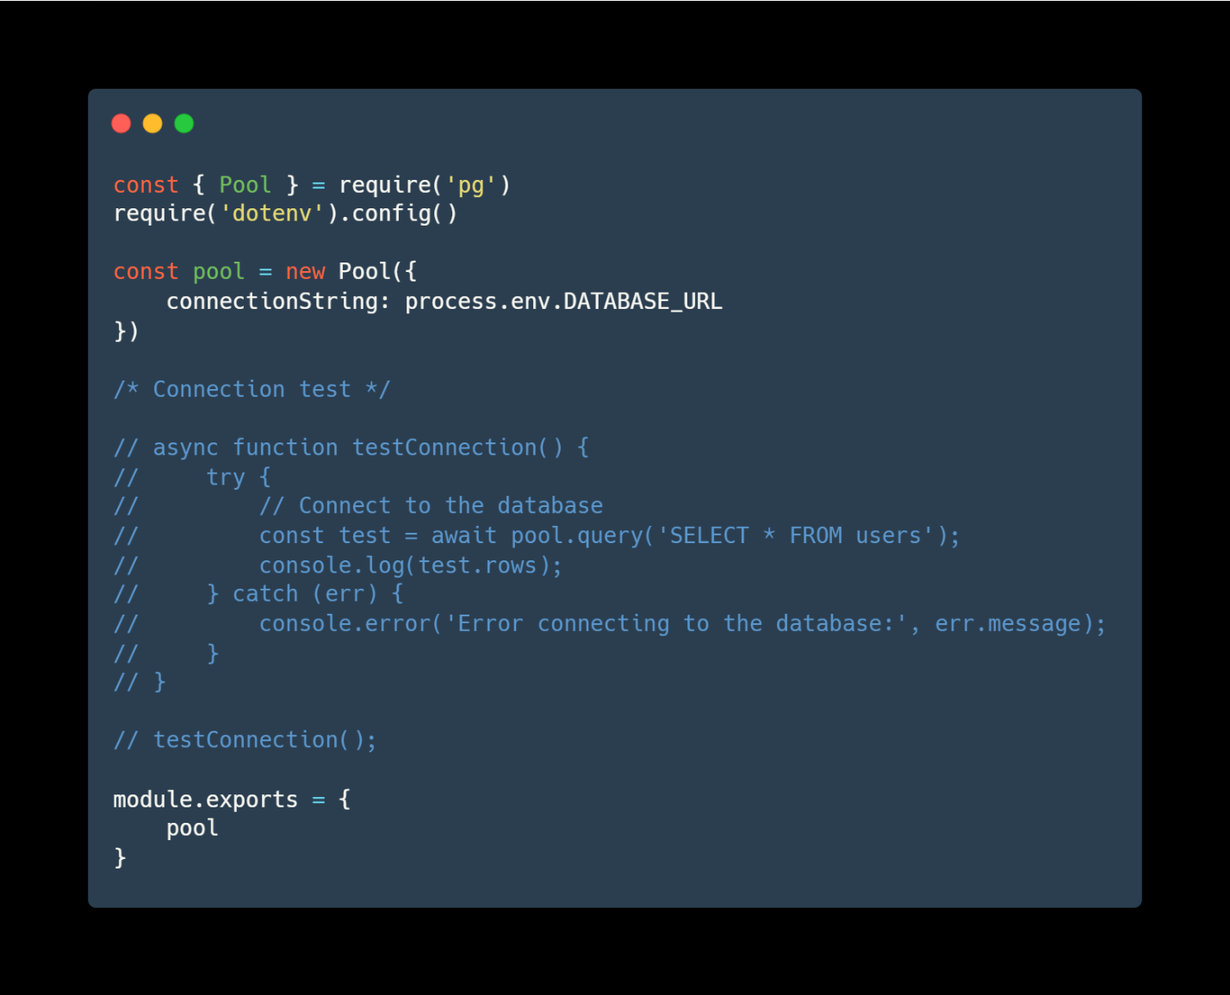

For the database connection I am using the “pg” library which is a library used to make connections to a PostgreSQL database. From it I call an object called Pool in order to handle, open and close, the connections to the database using the URL coming from the .env file (for security reasons it will not be shared here). The file also includes a connection test function that is used to determine whether the interaction with the database is successful or not. Finally, pool is exported in order to be used by other files.

Models:

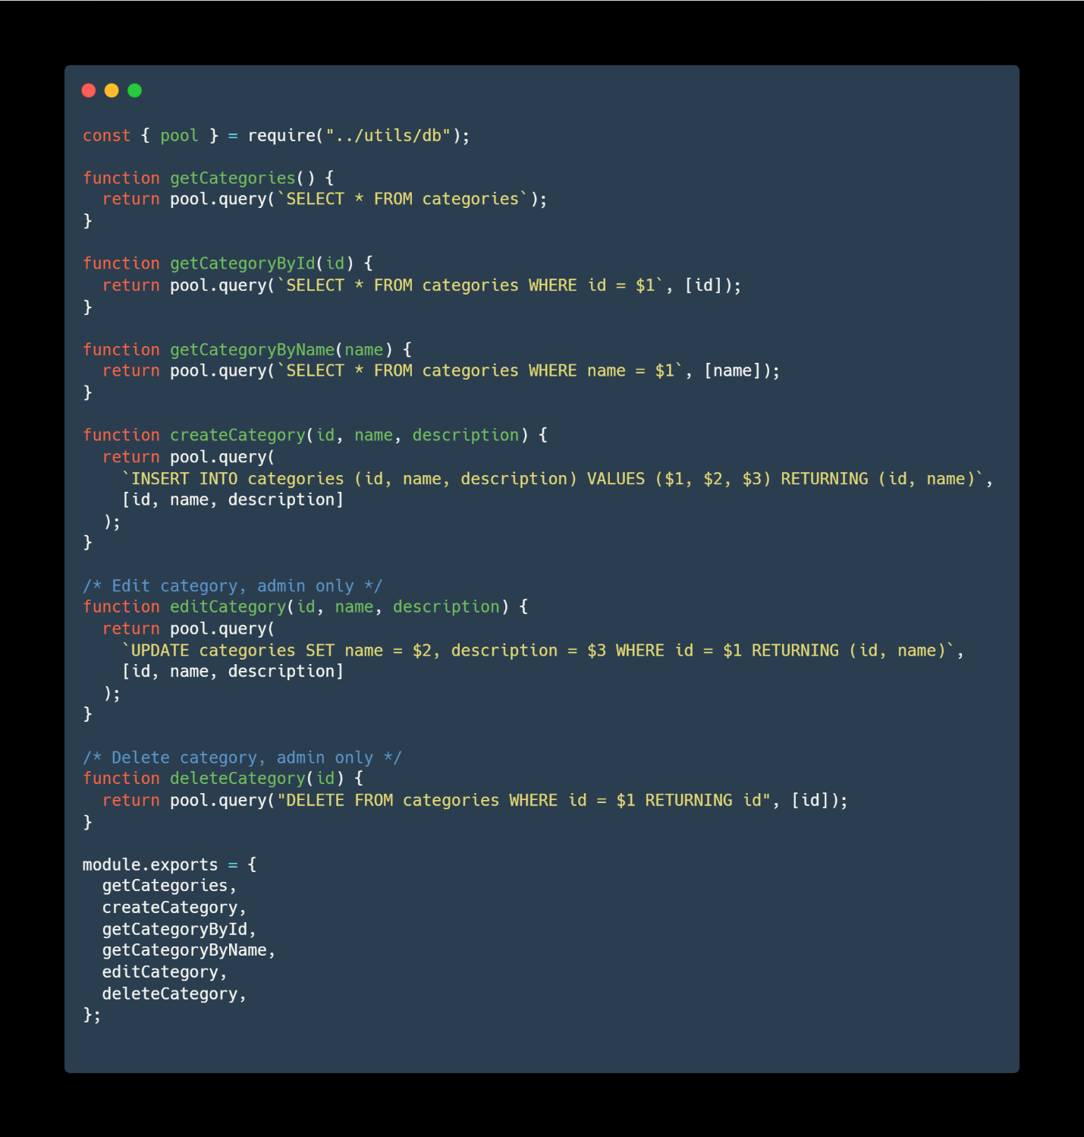

This is a model example from the categories model. At the very top of the file we call pool which is coming from the database file as described above in order to establish connections to the database. As an example, the first function is a performing a SELECT statement to the database in order to retrieve all the fields and the values from the table “categories” of the database by performing the query `SELECT * FROM categories`. After all the desired functions are defined, they are exported in order to be imported and used by the controller.

Controller:

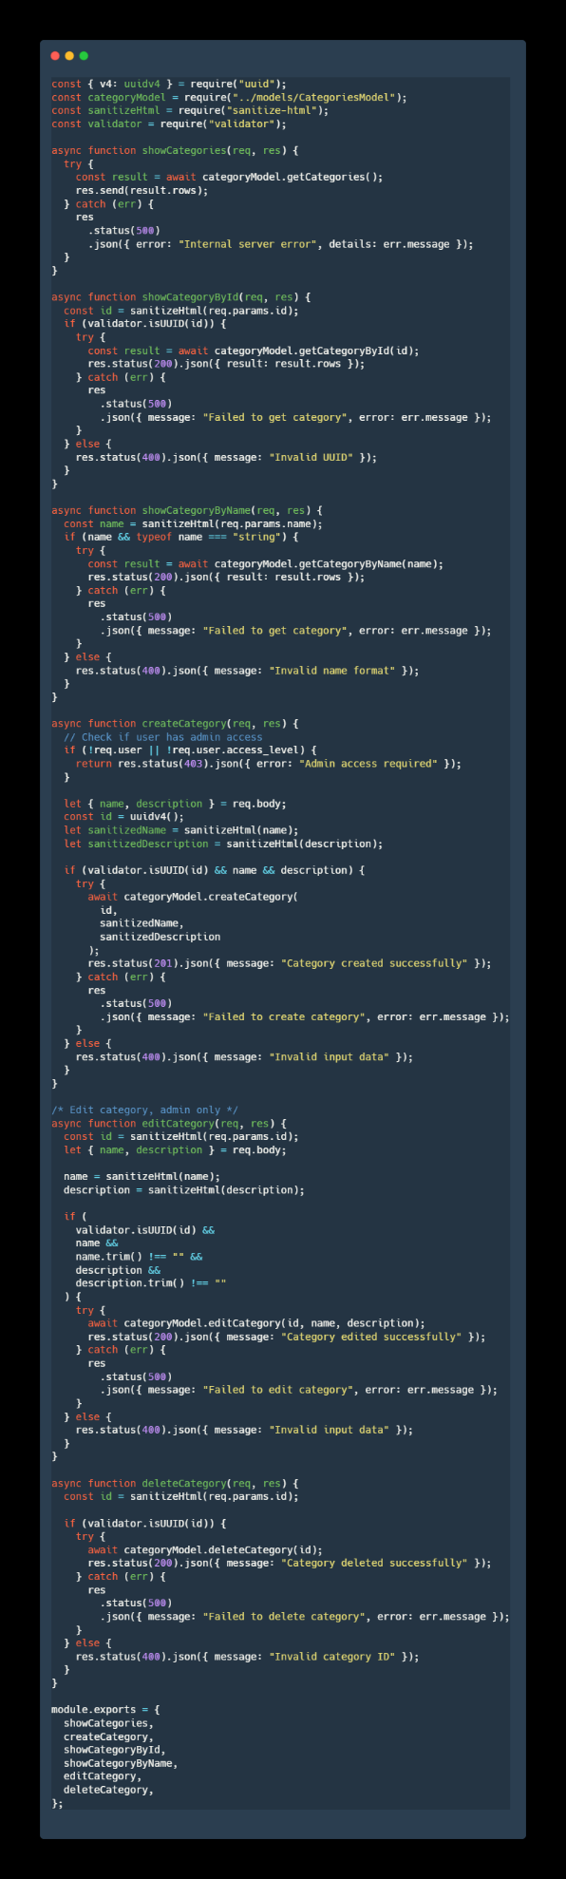Following the categories model, we have the categories controller. At the top of the file I perform the necessary imports, uuid for generating ids for the categories, the model itself so I can use its functions, sanitize-html and validator for security purposes. Taking as an example the creation of a category: first we check if the user performing the request is an administrator or not, if not, a status error 403 is returned meaning an unauthorized attempt of a request. Following we have the definition of variables. The reason it comes after the validation of the user is to avoid assigning addresses in memory when the request is unauthorized. I define the name of the category and the description of it, coming from the body of the request. Then I define an id using the “uuid” library that randomizes a text to assign and use an id. Then I sanitize my name and description variables and check if they are of the correct types using validator, if not I get an error 400, meaning there was a problem with the data that were sent. After, I try to send the request using the model’s “createCategory” function, passing the data required. If everything succeeds, I get a status code 201 with the message "Category created successfully" which means that everything went well. If there is a problem an error 500 is returned meaning there was an internal server error. Finally export my functions in order to be used by the routes.

Routes:

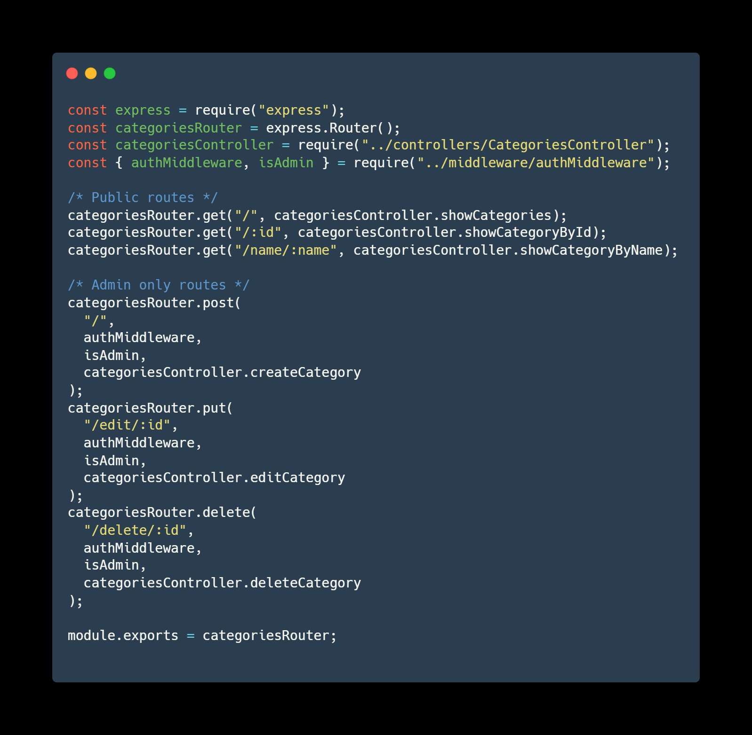

Using the categories route as an example, I import express and from express I use its Router method. I import the controller and the middleware’s function that authenticate the user and check if the user is an administrator. A typical route will use a method followed by the URL (eg. “/”) followed by the middleware functions if the route is protected or directly the controller function that needs to be executed. Finally the router is exported to be used from the index file as mentioned in the beginning of the chapter.

Middleware:

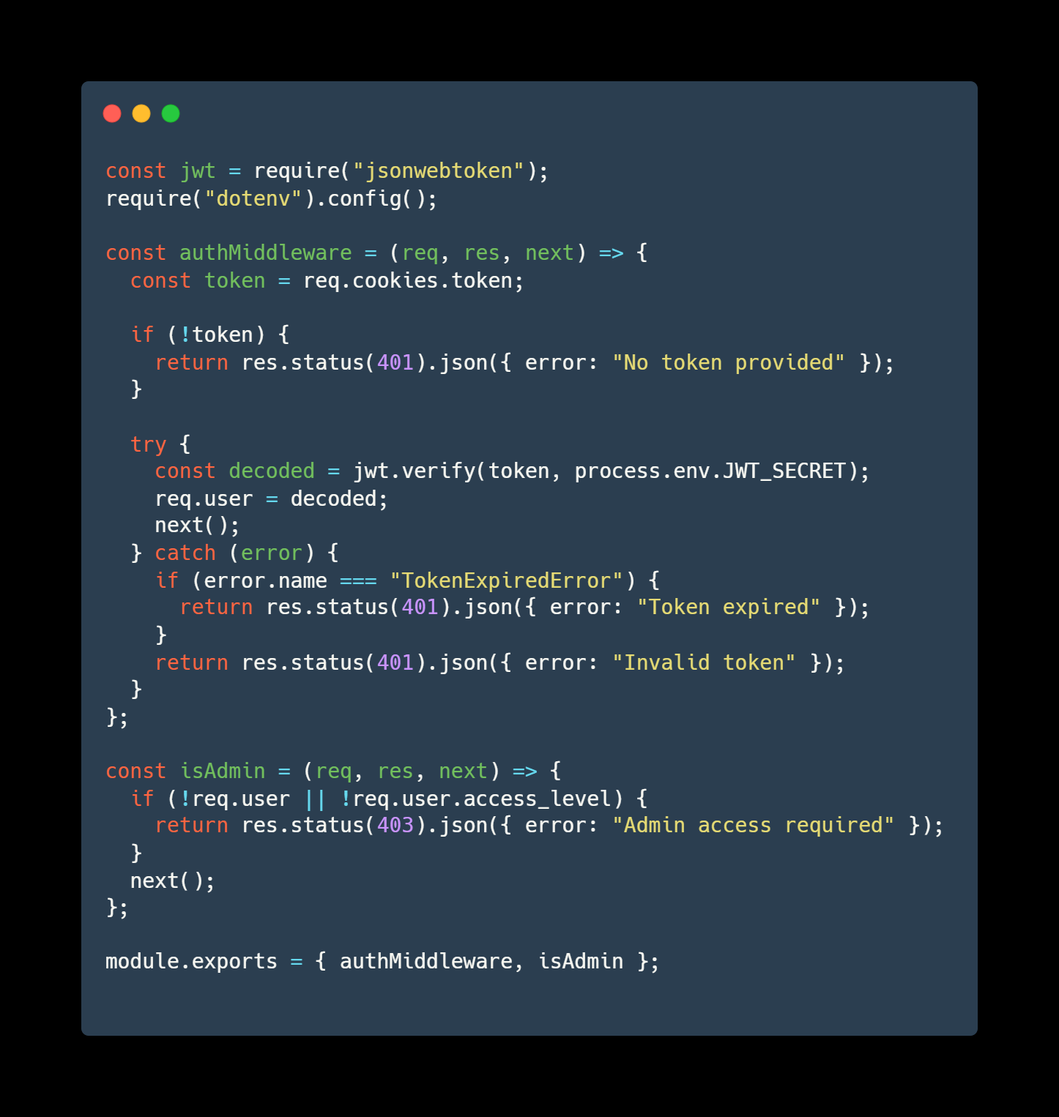

The middleware requires the use of jwt and the .env file variables. For the “authMiddleware” function I define the token coming from the requests cookies. If it does not exist, an error message is returned notifying the user that they did not provide a token. If the token exists, the function then tries to decode the token using the secret I defined in the .env file. The use of next(); is important, if it is not present the application will finish the action here, not moving to the next function. If there is an error, we get an appropriate message (eg: Token expired, or the token is invalid). The isAdmin function checks the if the user coming for the request has an access level of administrator and moves to the next function. The functions are also exported so they can be used by other files.

## Frontend

## Database

# Design and User Experience

## Wireframes

## User Flow

## Visual Design

# Data Management

## Database Schema

## Data Security

# Testing

## Testing Strategy

## Bug / Error Management

# Deployment and Maintenance

## Deployment Process

## Maintenance

# Challenges and Solutions

# Documentation and Conclusion

## Documentation

## Conclusion

# Annexes