### CUSTOMER CHURN PREDICTION USING MACHINE LEARNING

**TEAM MEMBER**

**412621243017:ESAKKIAPPAN.M**



# Phase-4 Dashboard using ibm cognos analytics

**Project:** *Customer Churn Prediction*

* machine learning algorithms to build a predictive model that identifies potential churners based on historical data and relevant features.

**Program and output**

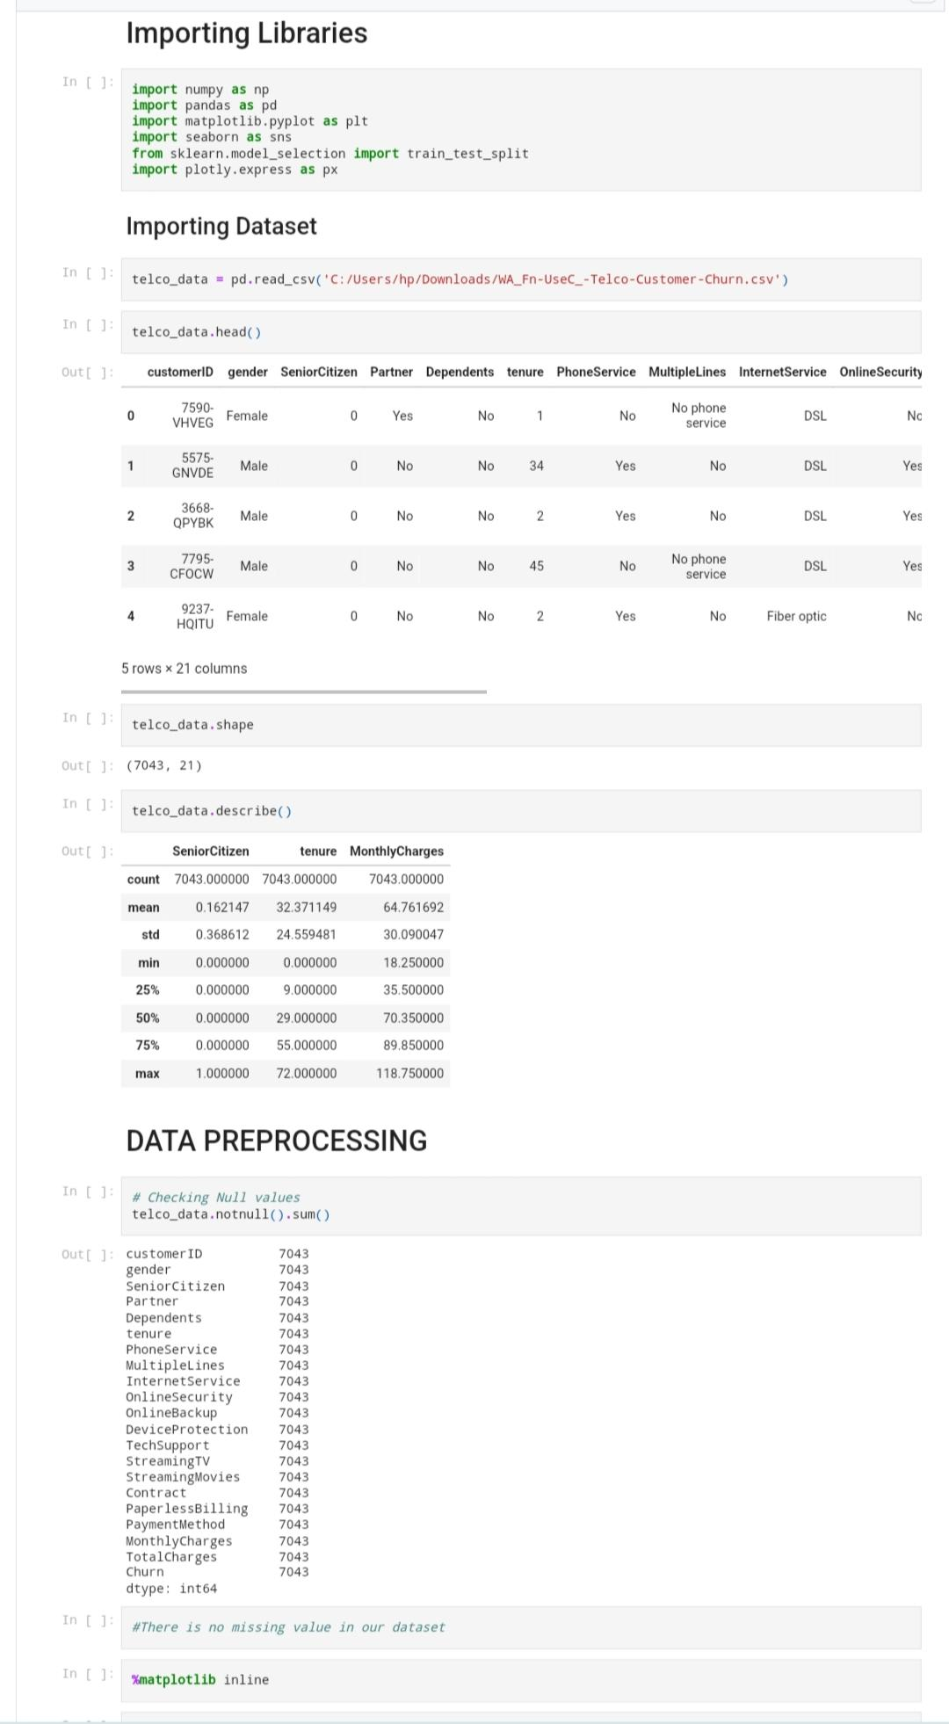

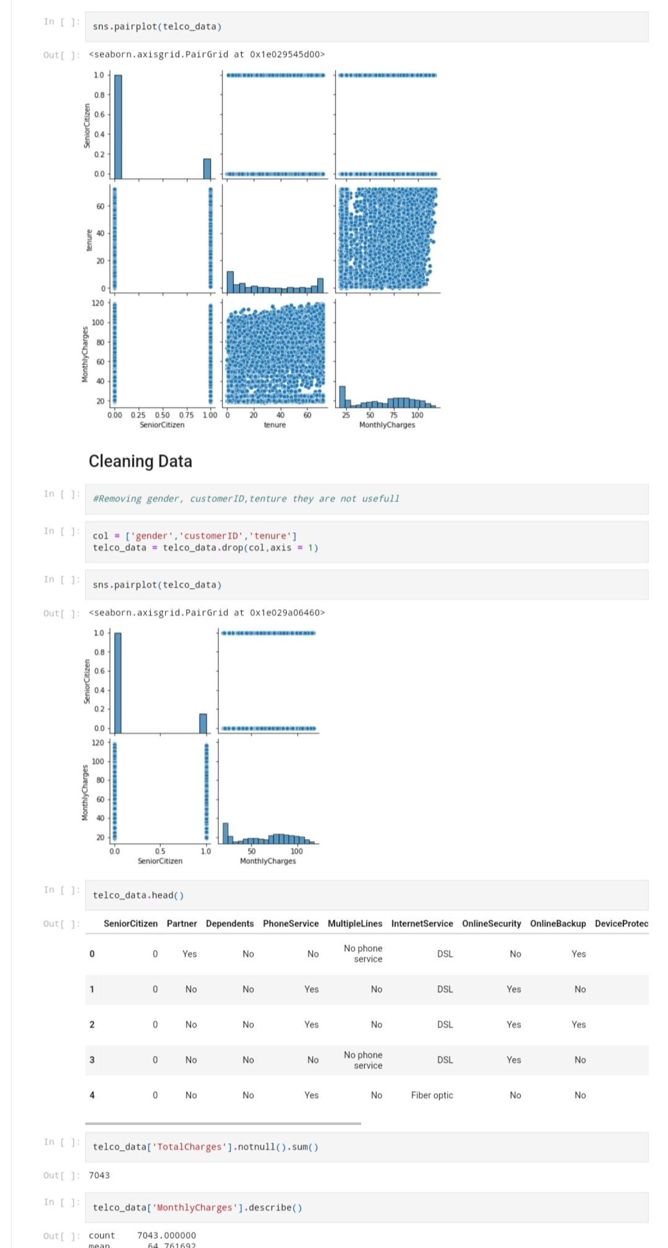

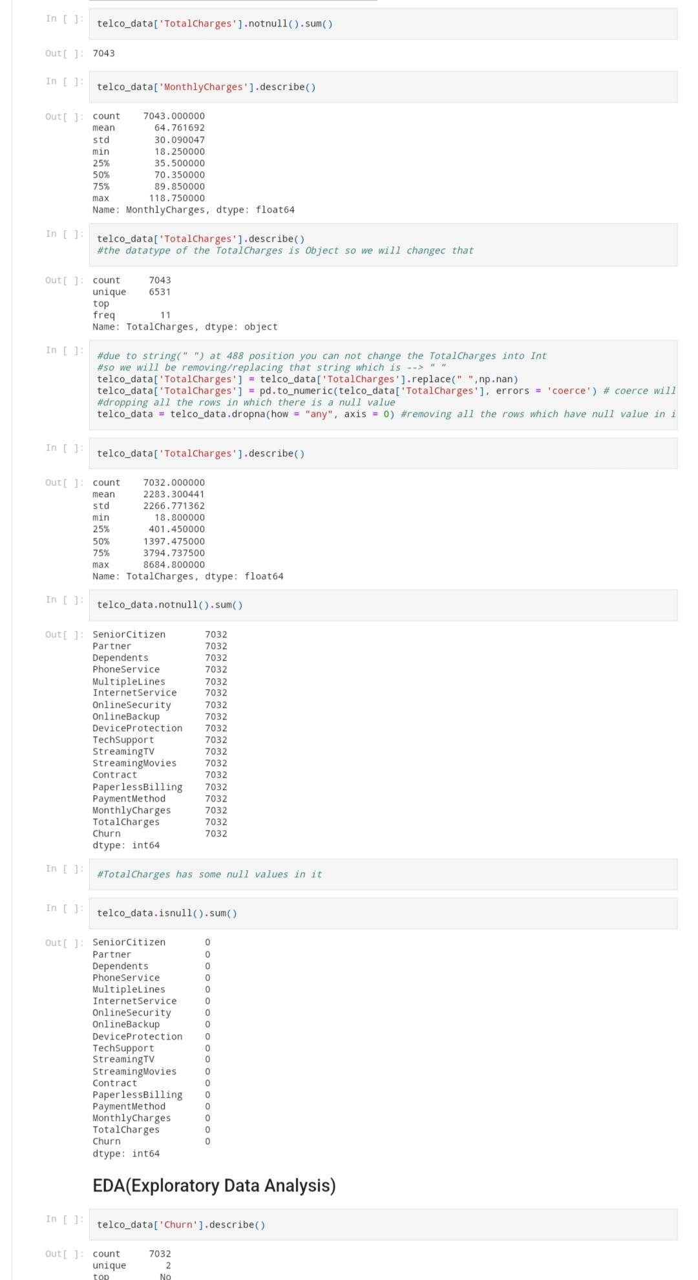

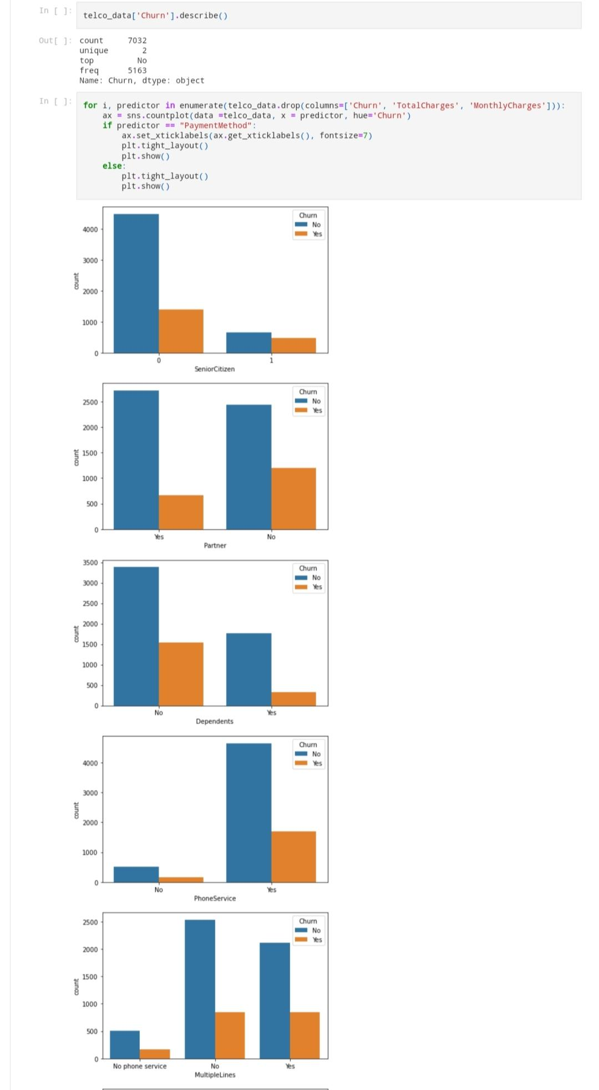

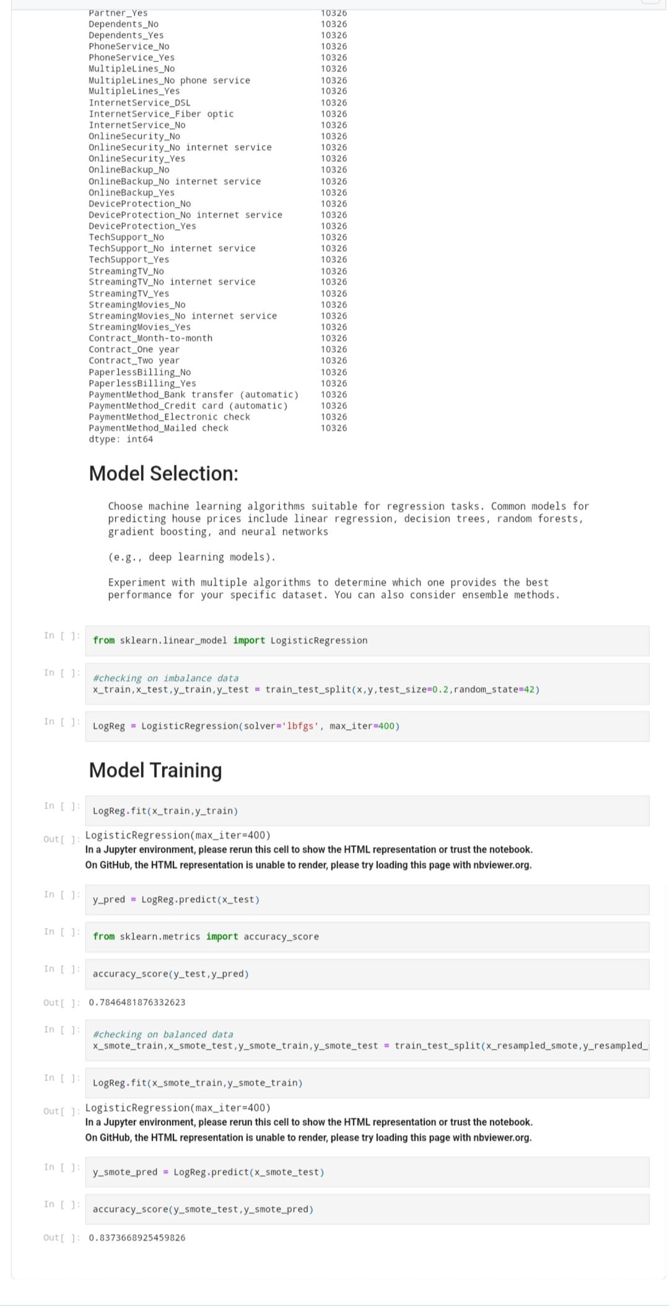

dashboard using ibm cognos analytics

