Scala

Functional and Object Oriented Programming Language

1. No Semi Colon Needed to end a Statement
2. // single /\* \*/ multi line Comments

Two Types of Variables are Avaialble

* 1. Val -> Immutable
  2. Var -> mutable

Converting String to Int

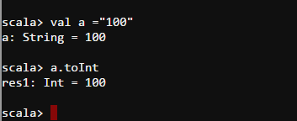

Declaring the variables

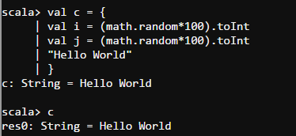

It will return Unit when we don’t have anything specified

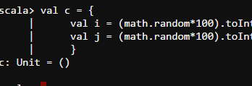

If Else Block

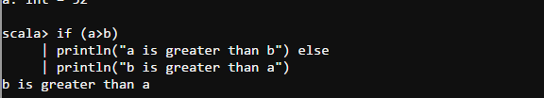

Run a Simple Program As script

If you want to run a Scala script as a Unix or Linux shell script -- such as hello.sh

#!/bin/sh

Exec scala “$0” “$@”

!#

Object Helloworld {

Def main(args:Array[String]){

Println(“Hello World” + args.toList)

}

}

Helloworld.main(args)

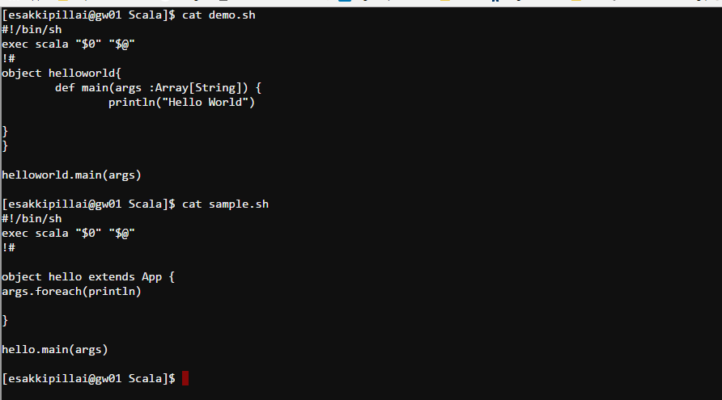

For Loop

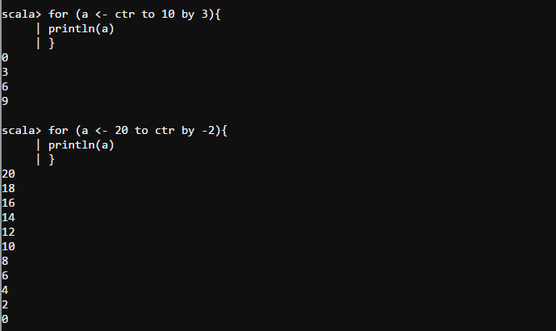

Functions In Scala