1. Do the below programs in anonymous function & IIFE
   1. Print odd numbers in an array

Outputs: anonymous function

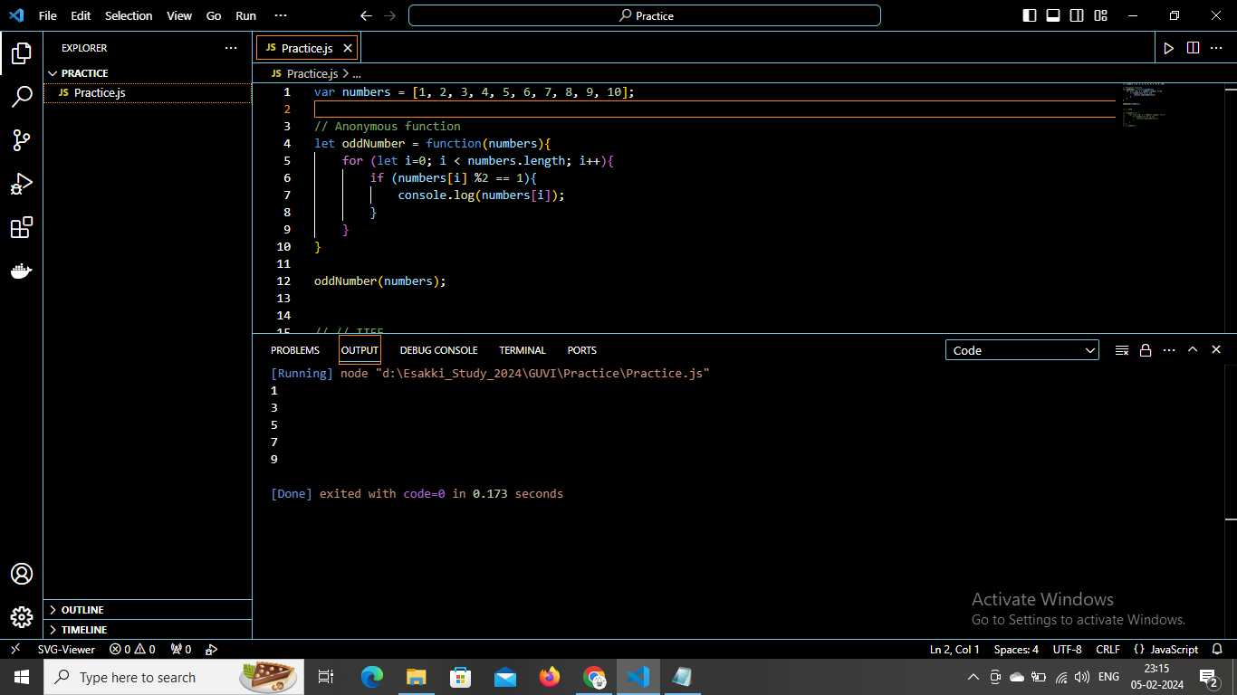

IIFE:

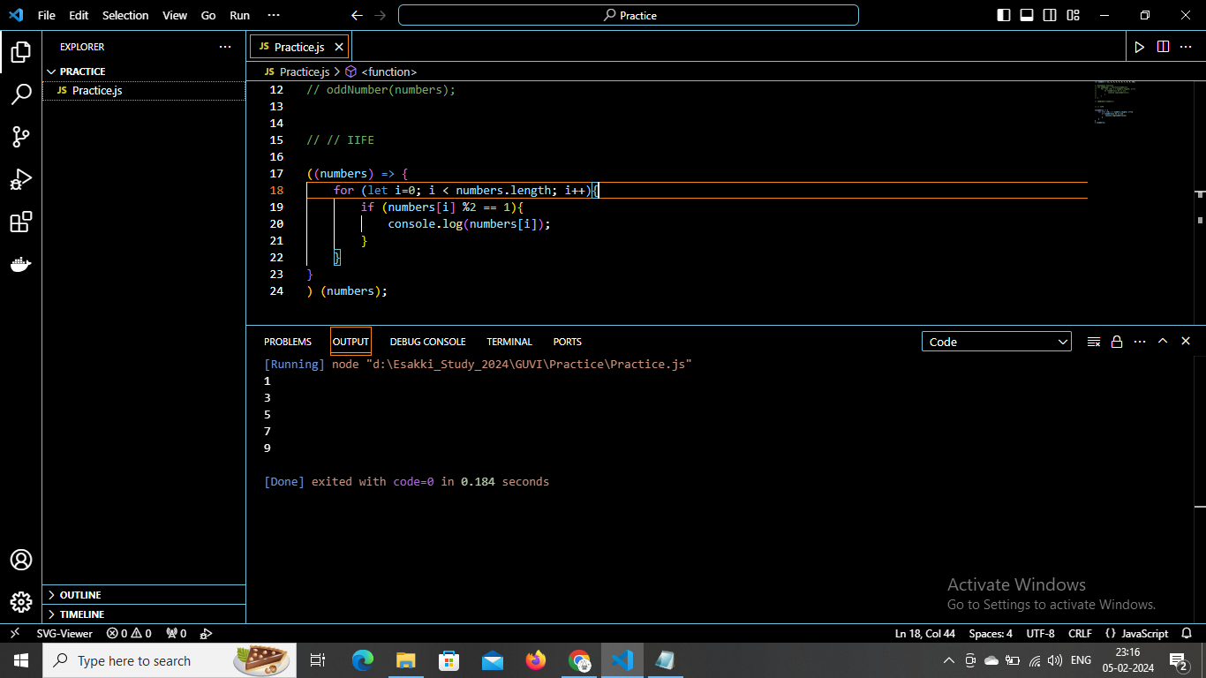

b. Convert all the strings to title caps in a string array\

anonymous function:

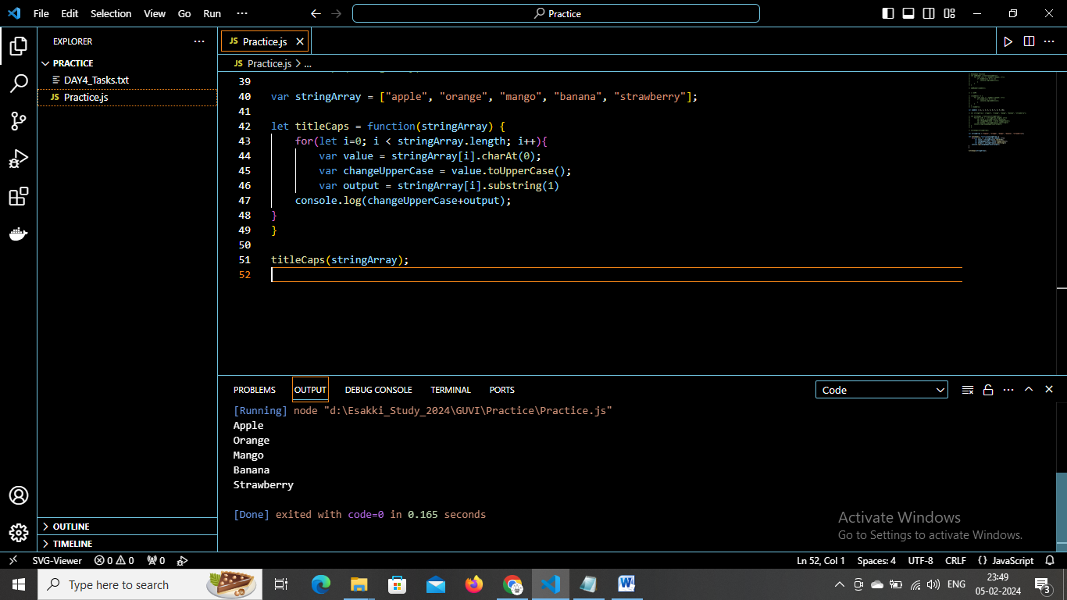

IIFE:

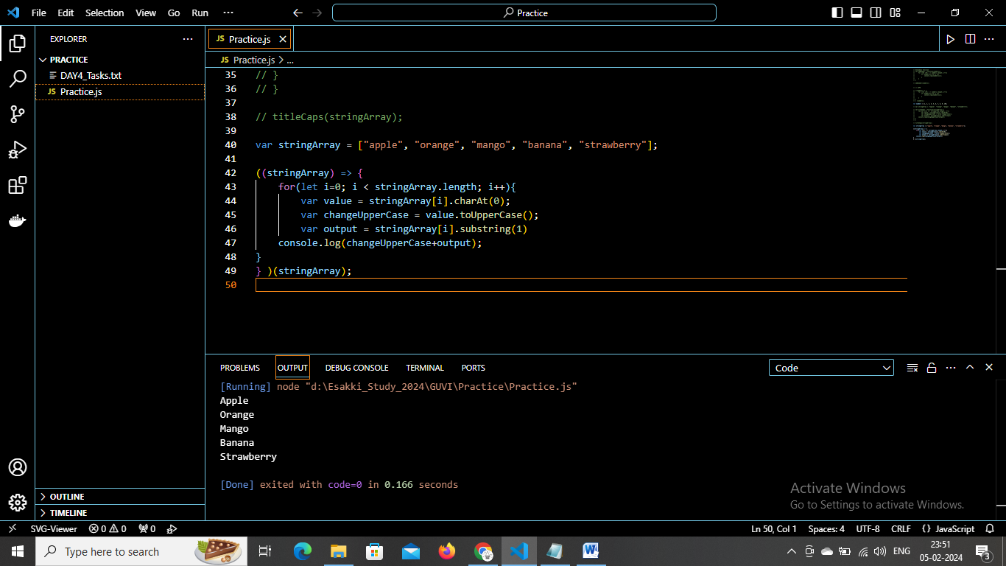

c. Sum of all numbers in an array

anonymous function:

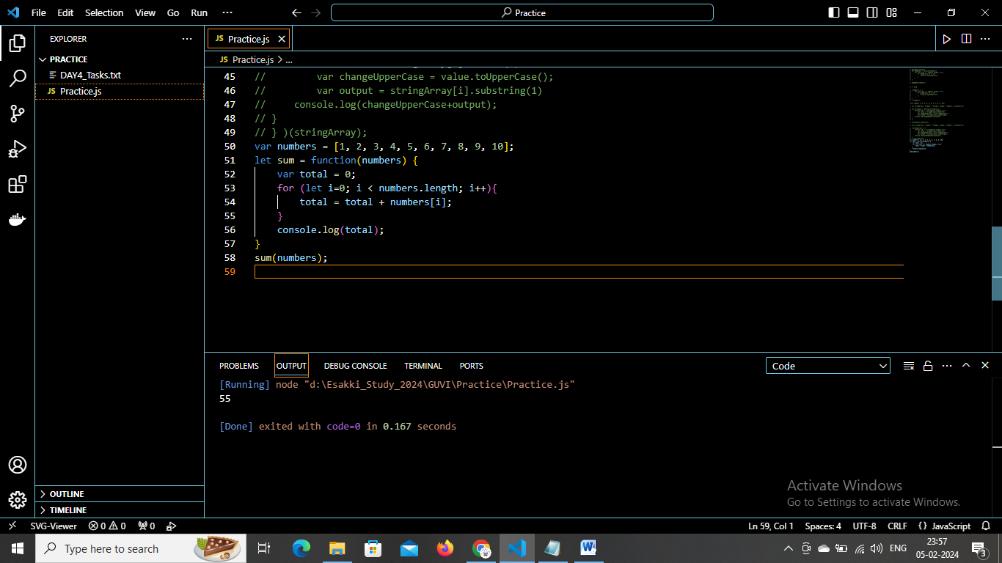

IIFE:

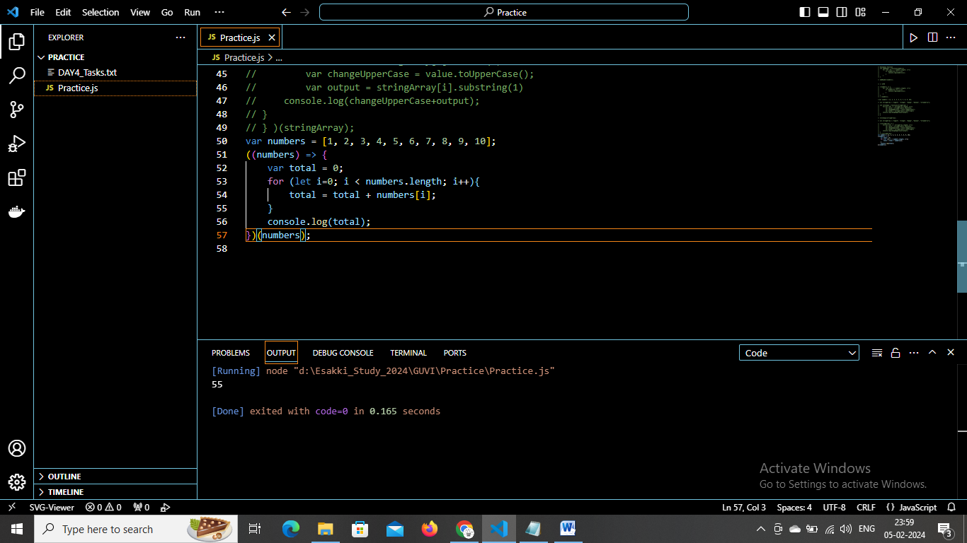

d. Return all the prime numbers in an array

anonymous function:

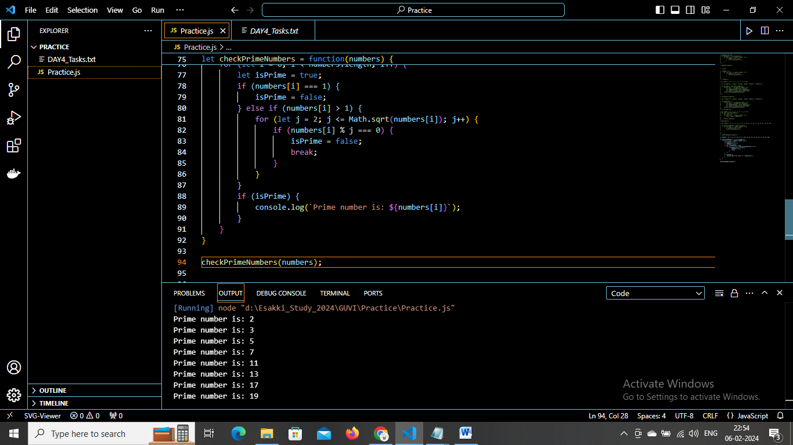

IIFE:

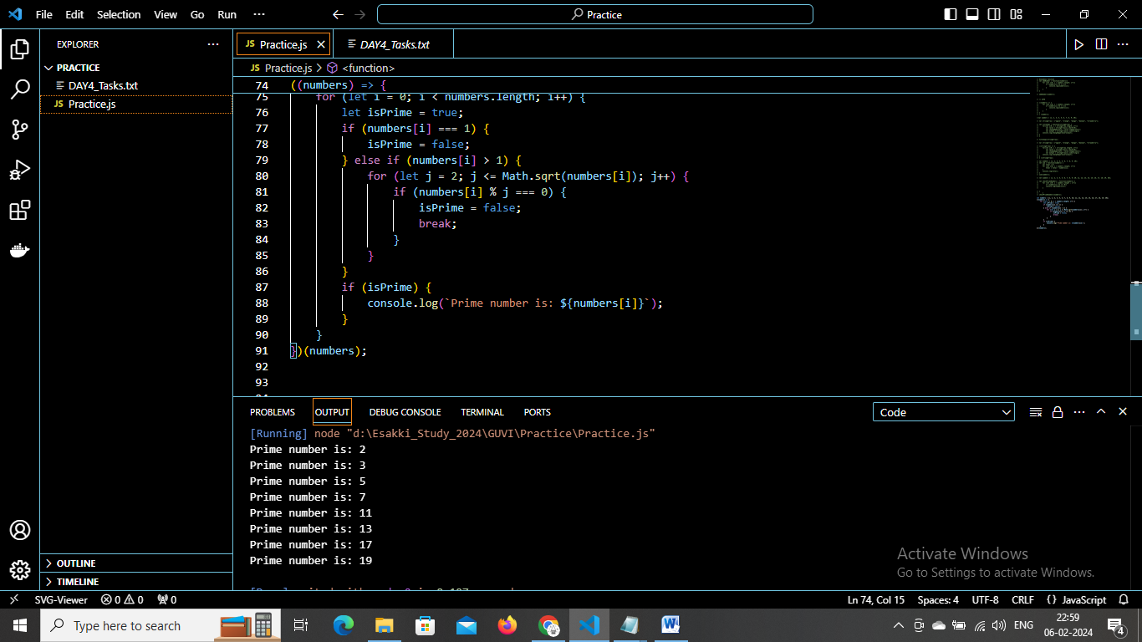

e. Return all the palindromes in an array

anonymous function:

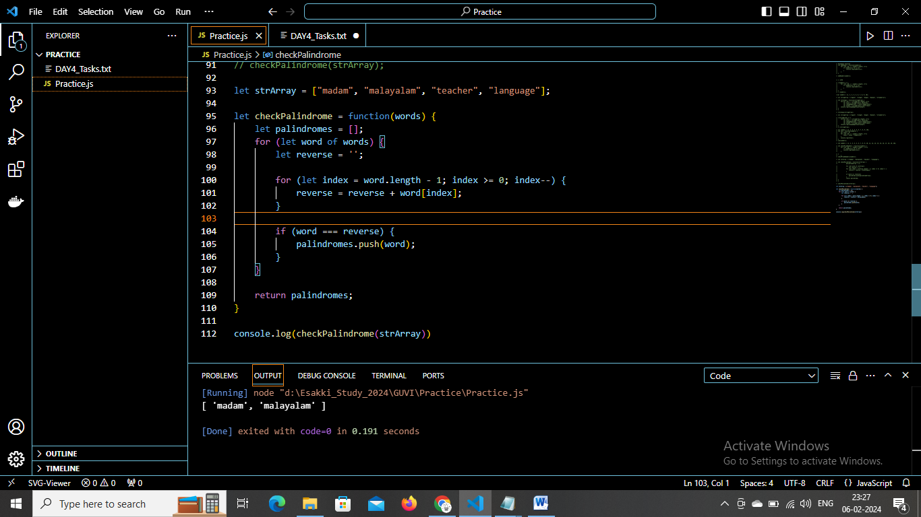

IIFE:

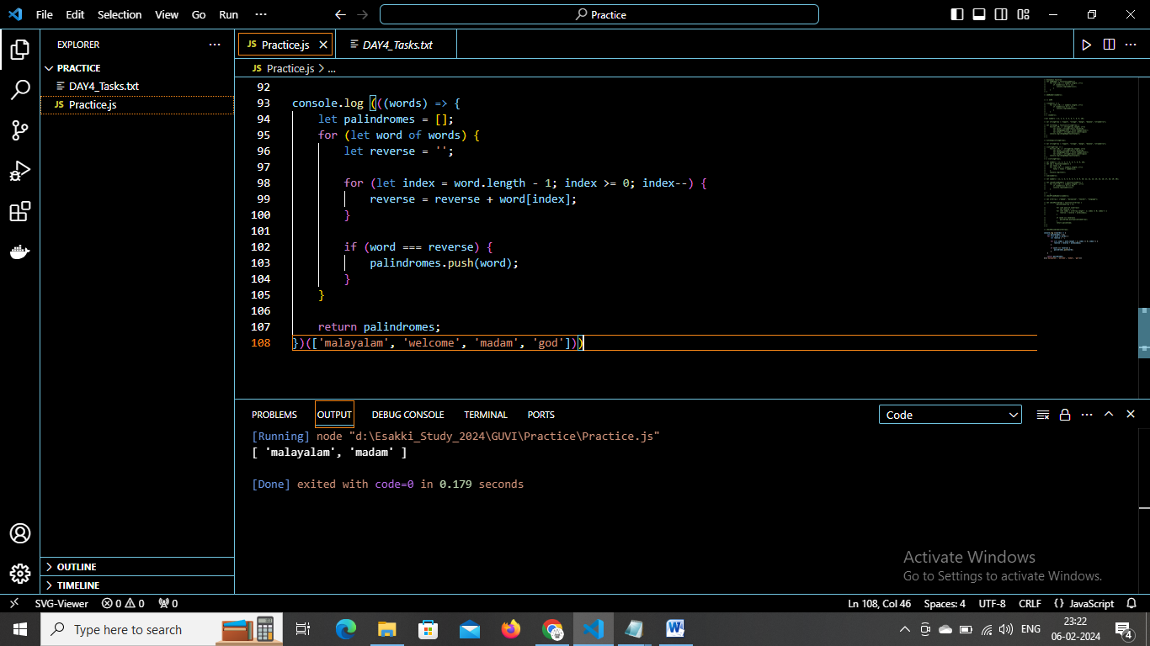

f. Return median of two sorted arrays of the same size.

Anonymous function:

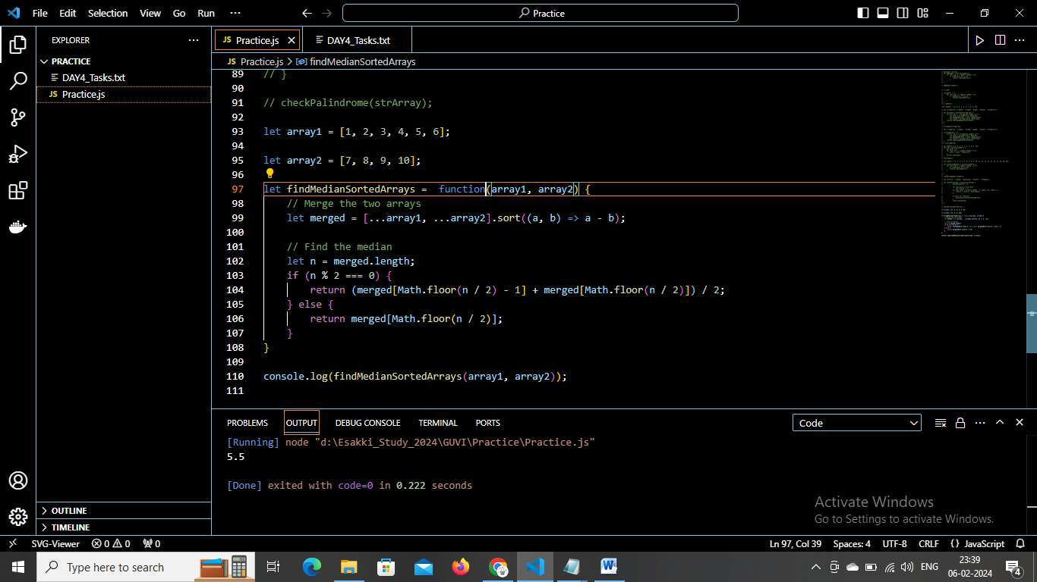

IIFE:

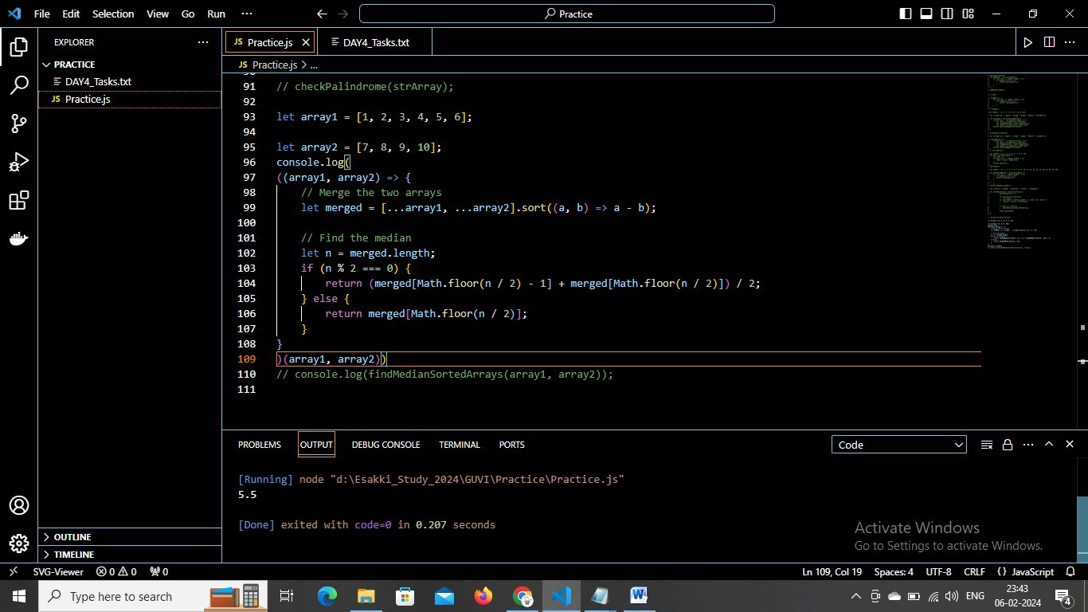

g. Remove duplicates from an array

anonymous function:

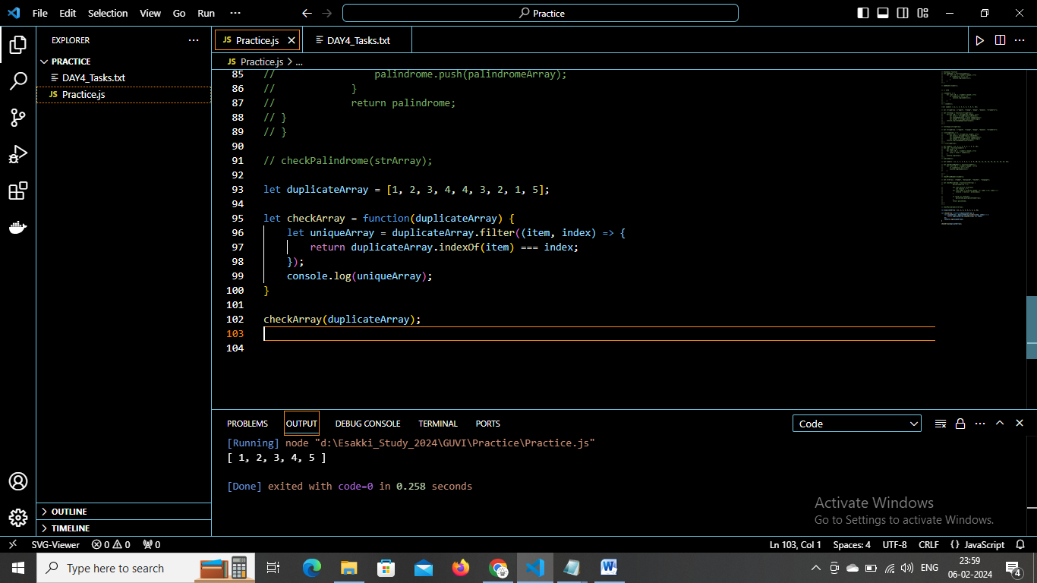

IIFE:

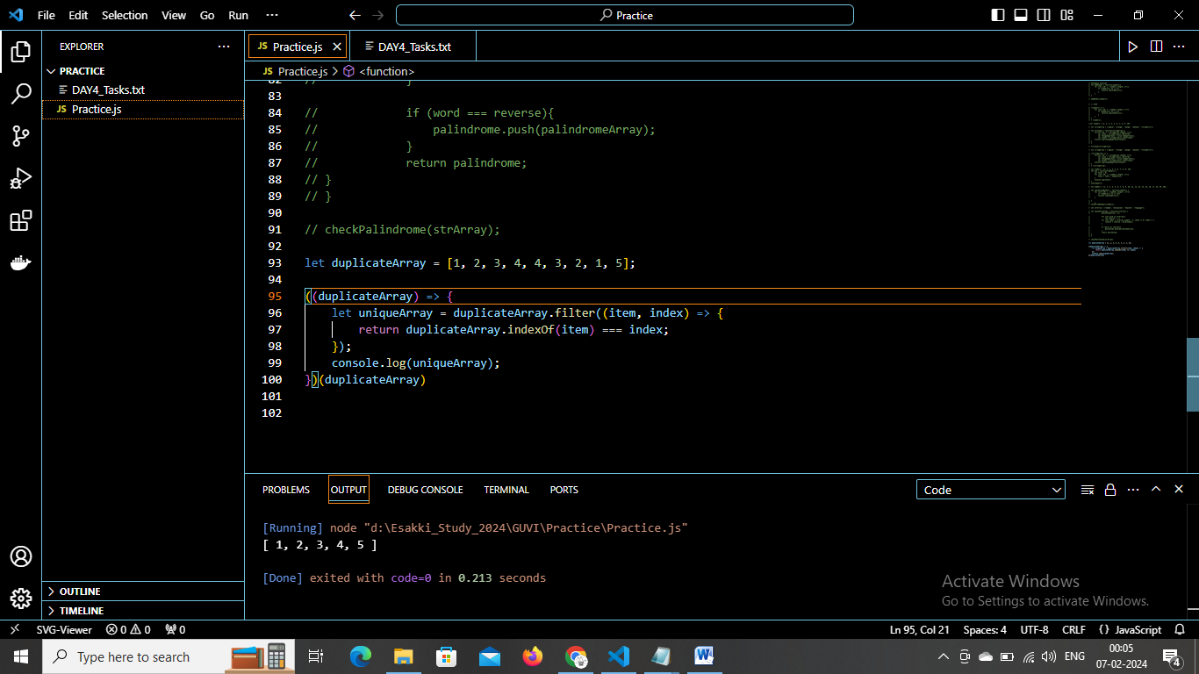

h. Rotate an array by k times

anonymous function:

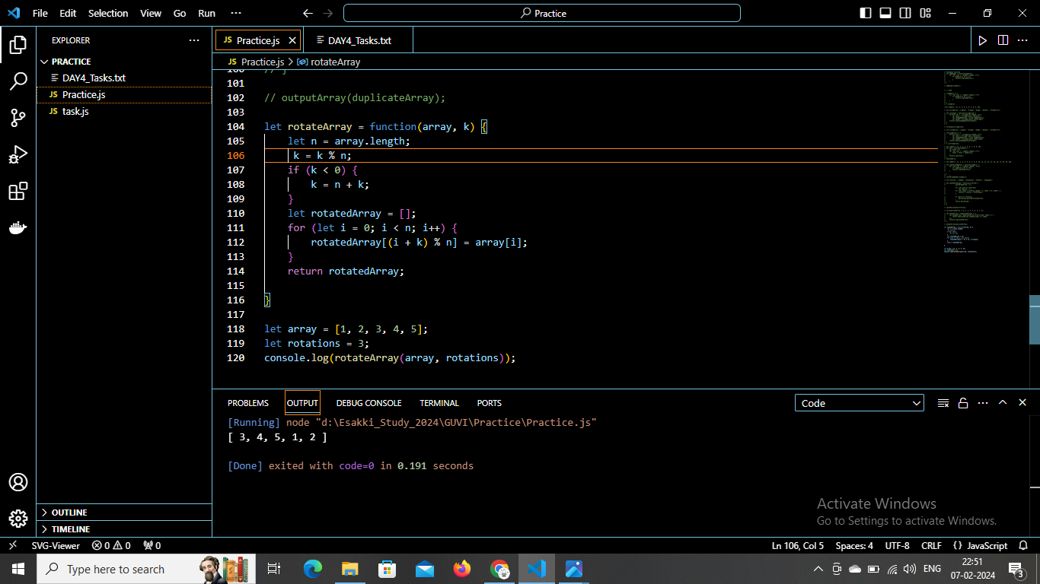

IIFE:

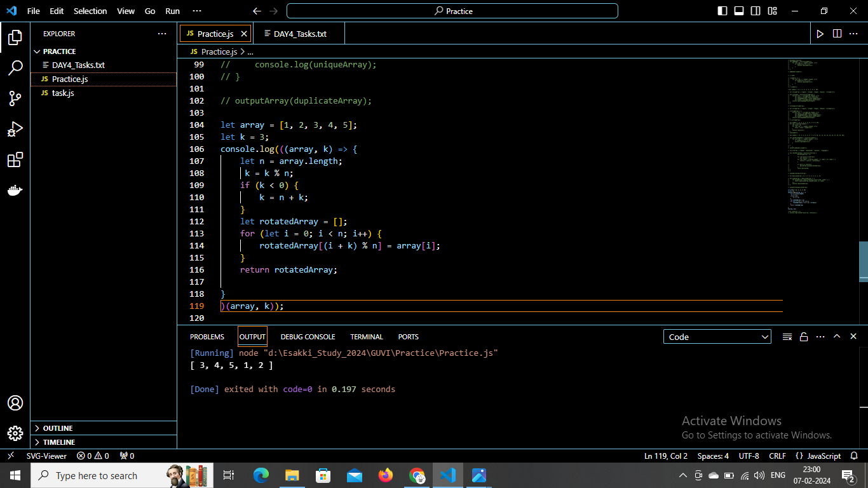

1. Do the below programs in arrow functions.

a.Print odd numbers in an array

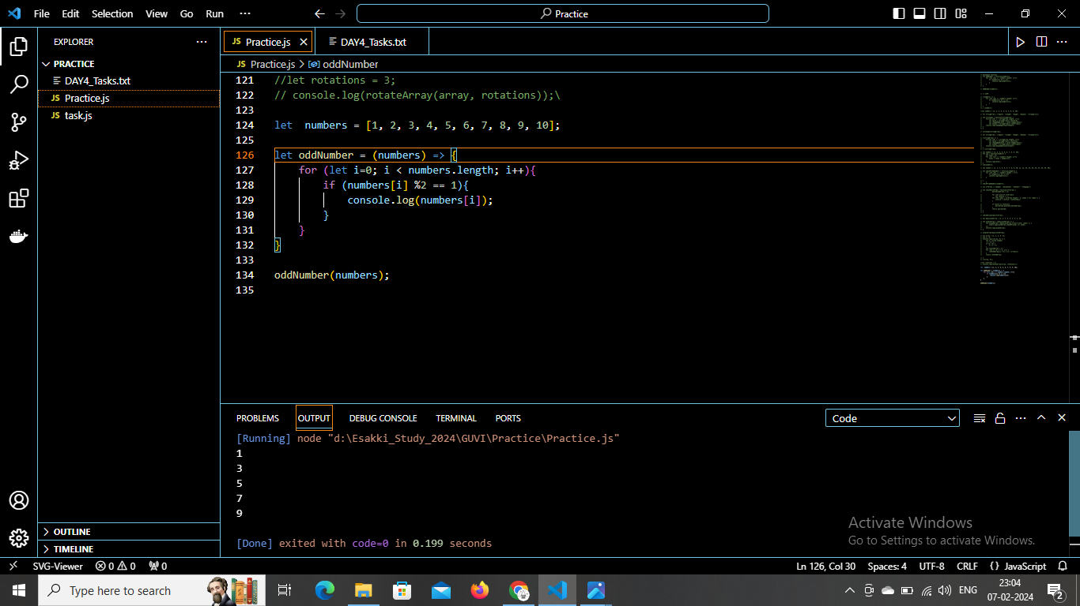

1. Convert all the strings to title caps in a string array

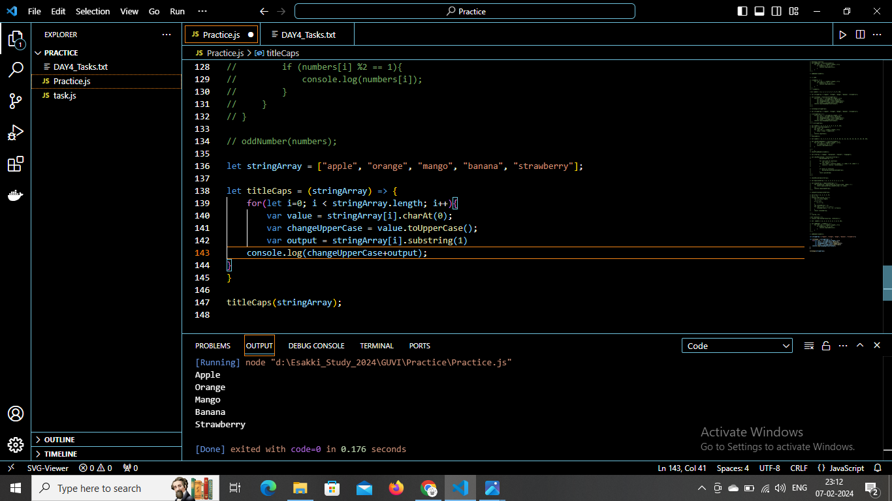

c. Sum of all numbers in an array

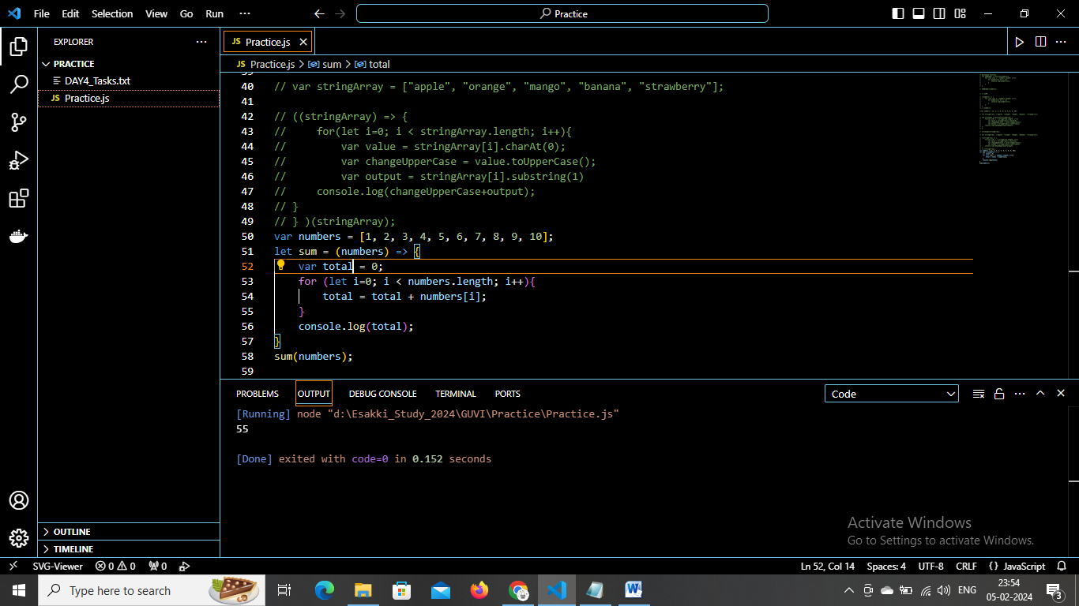

d.Return all the prime numbers in an array

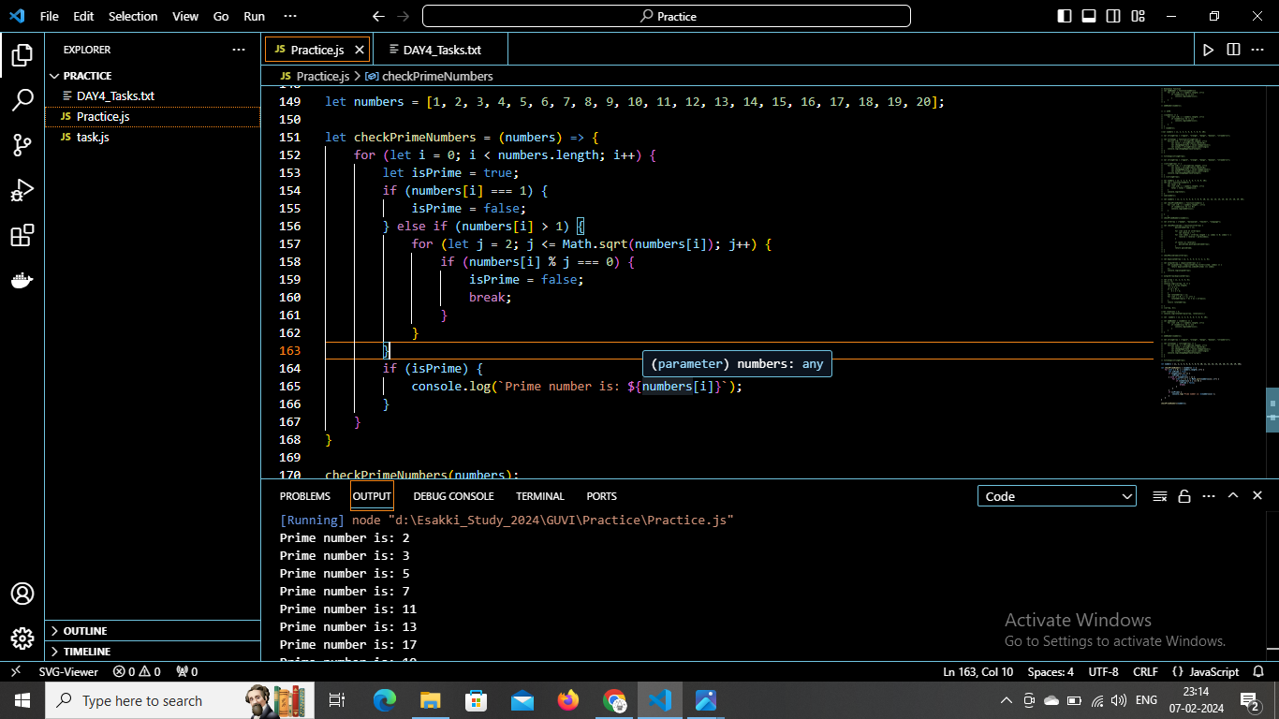

e. Return all the palindromes in an array

