Outputs:

**ARRAY METHODS**

1. Solving problems using array functions on rest countries data (<https://restcountries.com/v3.1/all>).
2. Get all the countries from Asia continent /region using Filter function

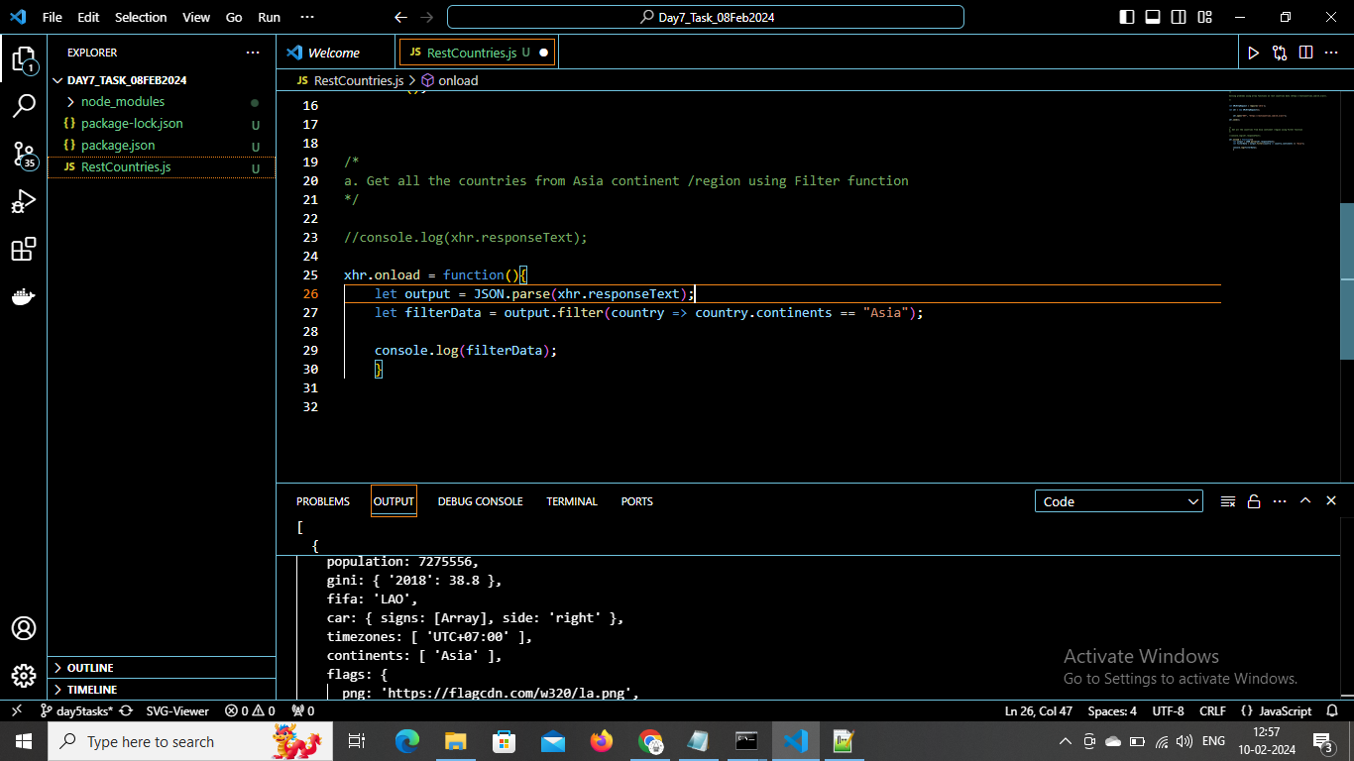

1. Get all the countries with a population of less than 2 lakhs using Filter function

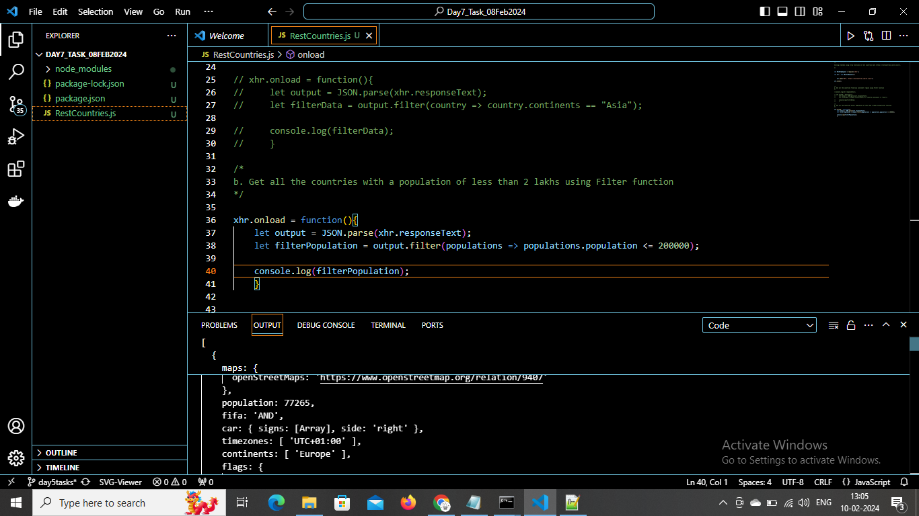

1. Print the following details name, capital, flag, using forEach function

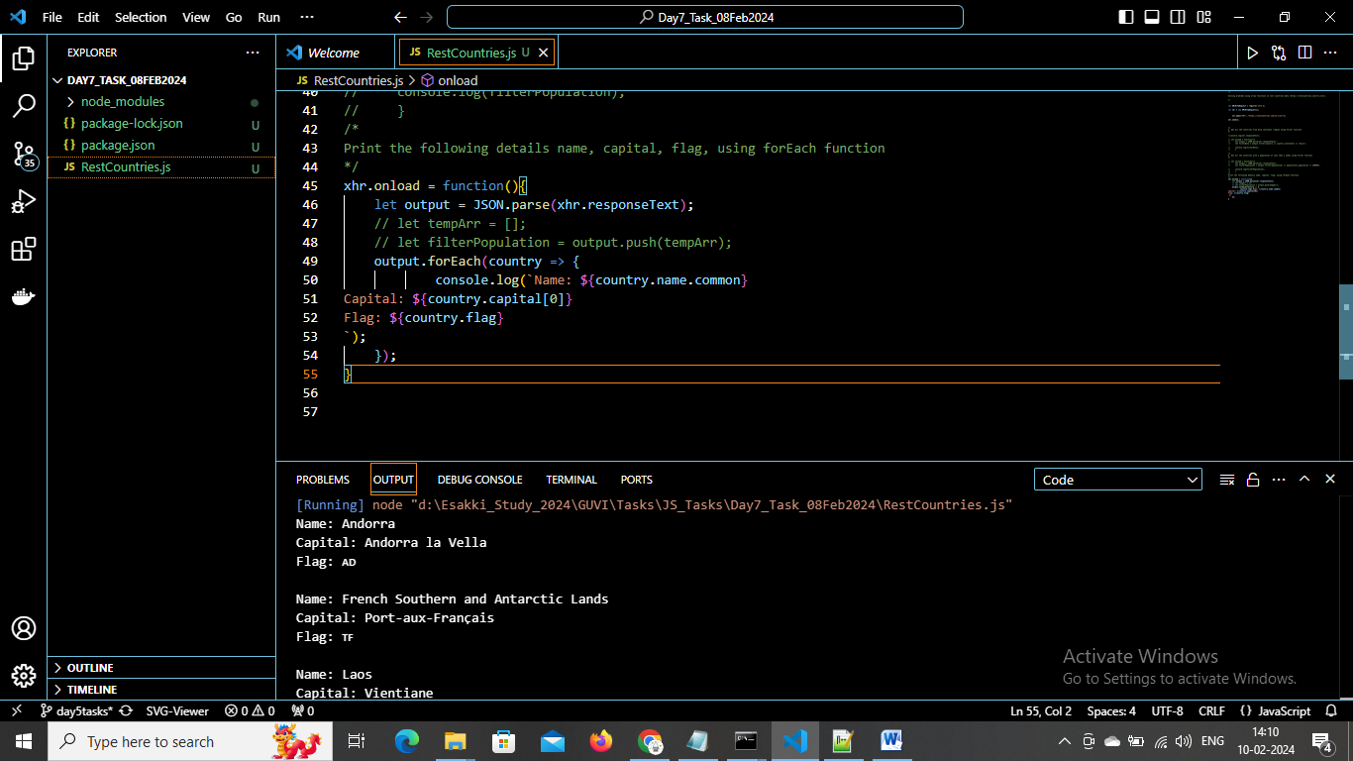

1. Print the total population of countries using reduce function

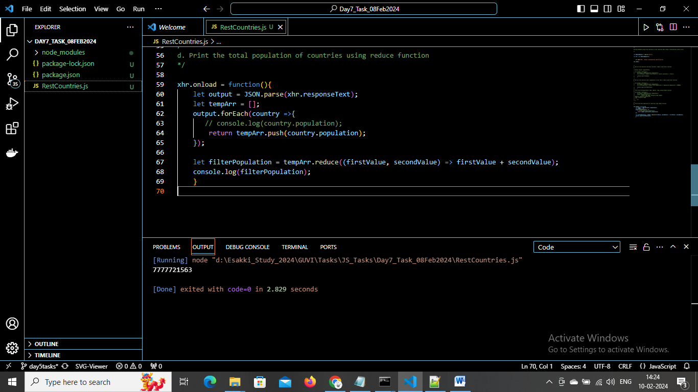

1. Print the country that uses US dollars as currency.

