QUERY and OUTPUTS:

1.SELECT author as AUTHOR FROM books where author like '%er';

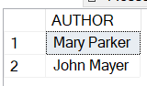

2. SELECT b.title, b.author , r.reviewer_name FROM books b, reviews r where b.id = r.book_id;

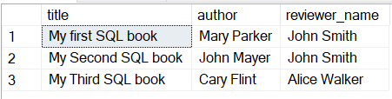

3. SELECT reviewer_name FROM reviews group by reviewer_name having count(book_id) > 1;

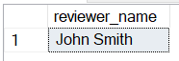

4. select name from customers where address like '%o%';

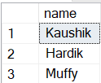

5. SELECT o.Date, count(c.id) AS NumofOrders FROM orders o, customers c where o.cust_id = c.id GROUP BY o.Date HAVING count(c.id)>1;

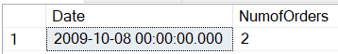

6.SELECT Lower(name) as LowerCaseName from Employee where salary IS NULL;

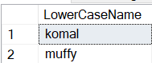

7. SELECT ISNULL(Gender,'Not Assigned') AS Gender, COUNT(RegisterNo) AS 'Total Employee' FROM students GROUP BY Gender;

