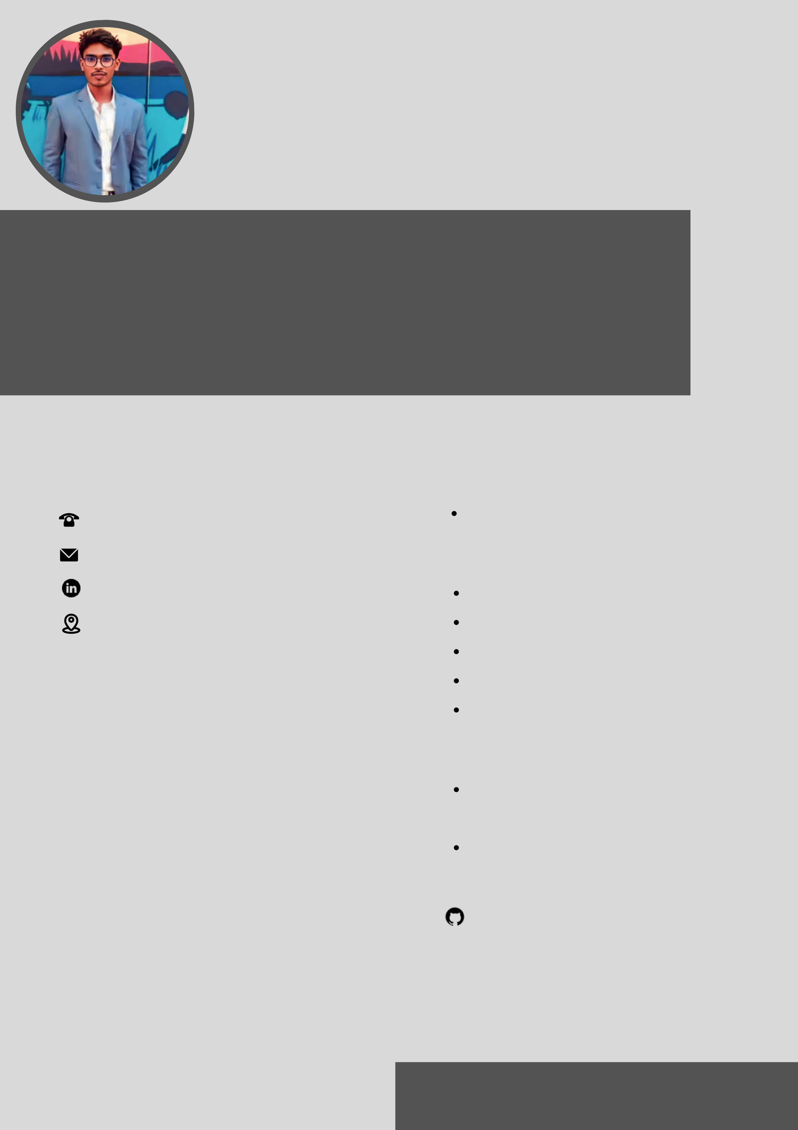

**ESAKKIPANDI R**

**P R O F I L E**

I am a Dedicated, Organized and Methodical Individual. I have good

InterPersonal Skills, also an Excellent Team worker and am Keen

and very willing to learn and develop new skills.

**C O N T A C T**  **C E R T I F I C A T E S**

8925722979 Microsoft Learn AI Skills Challenge

praveenpandian01@gmail.com

**T E C H N I C A L S K I L L S**

|  |  |  |  |
| --- | --- | --- | --- |
| www.linkedin.com/in/esakkipandi | Java | | using |
| 60, Kottai Pillaiyar Kovil Street | HTML/CSS | |
| Kayathar - 628 952 |
| JavaScript | |
| **E D U C A T I O N** | MongoDB | |
| **BACHELOR OF COMPUTER APPLICATION** | React JS | |
| St.Xaviers College , PalayamKottai, | **P R O J E C T S** | |
| Tirunelveli |
| Tic-Tc-Toe | Game |
| Percentage: 74% |
| 2019 - 2022 | React JS , HTML & css | |

**MASTER OF COMPUTER APPLICATION**

StopWatch using React JS ,

|  |  |
| --- | --- |
| Hindusthan Collage of Arts & Science, | HTML & css |

Coimbatore   
Percentage: 83%

2022 - Present

https://github.com/HBlackAngel01? tab=repositories



**W O R K S H O P**

Attended an workshop on "Data Analysis using Knime tool" Organised by Hindustan college of arts & science   
International Workshop on cyperSecurity

**S E M I N O R S**

Python With Data Science

(07/09/2022 - Present)

AI Implemented Cloud Application

(07/09/2022 - Present)

**S O F T S K I L L S**

Active Listening   
Problem Solving   
Teamwork and   
Collaboration