Source ID | Source Title | URL
950988106 | Numeracy | https://digitalcommons.usf.edu/numeracy/all_issues.html

1.Go to the URL and select the latest issue.
Source Title
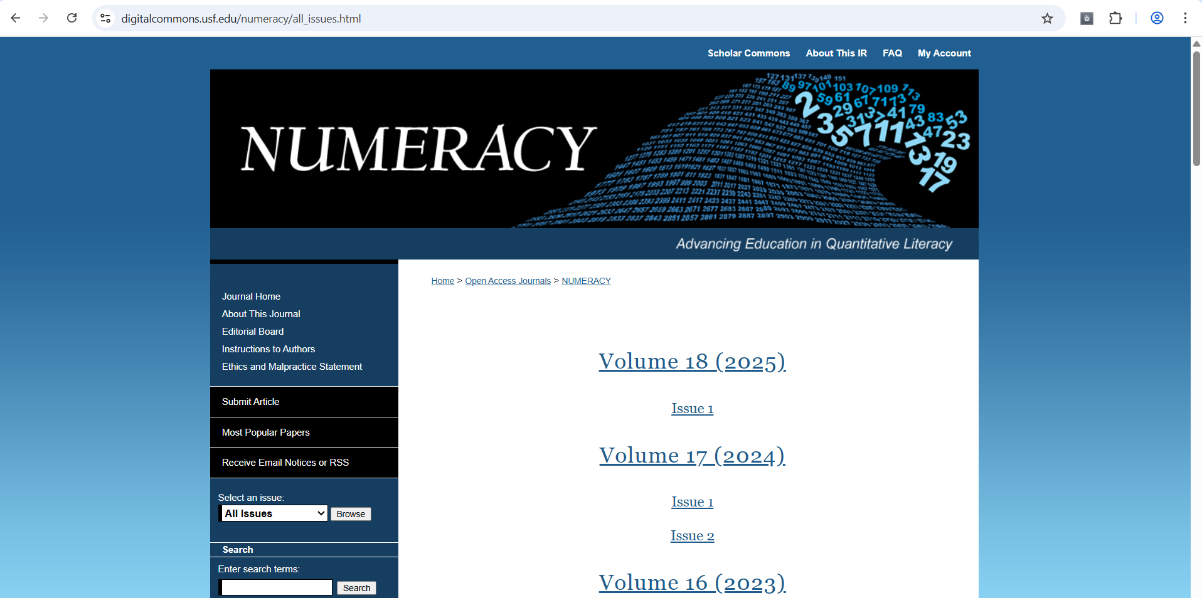
Year
Issue
Volume
Latest issue

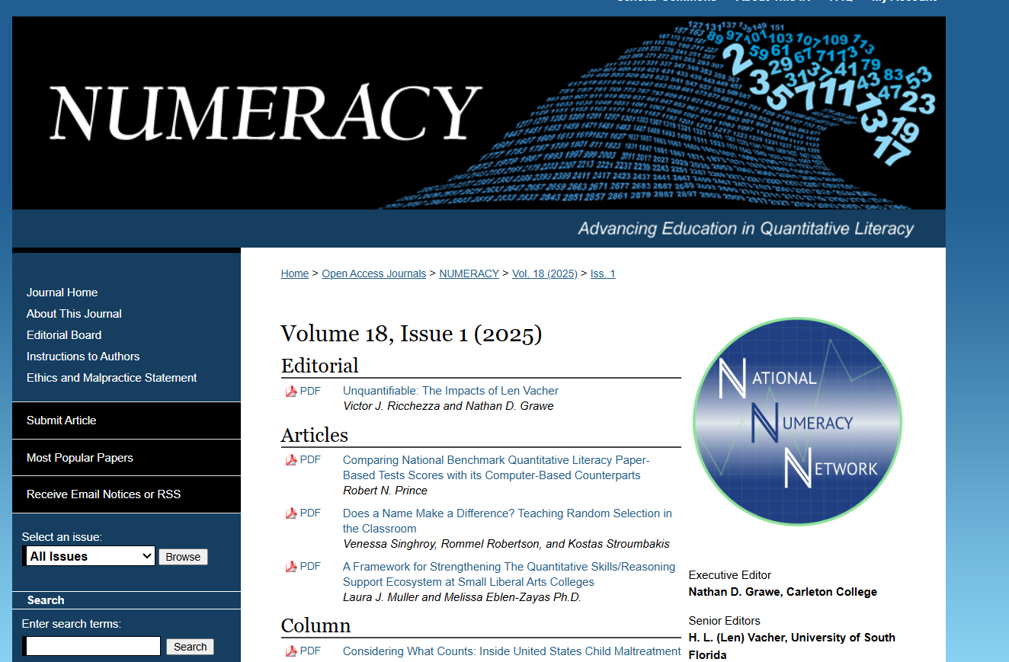
Click here

Title

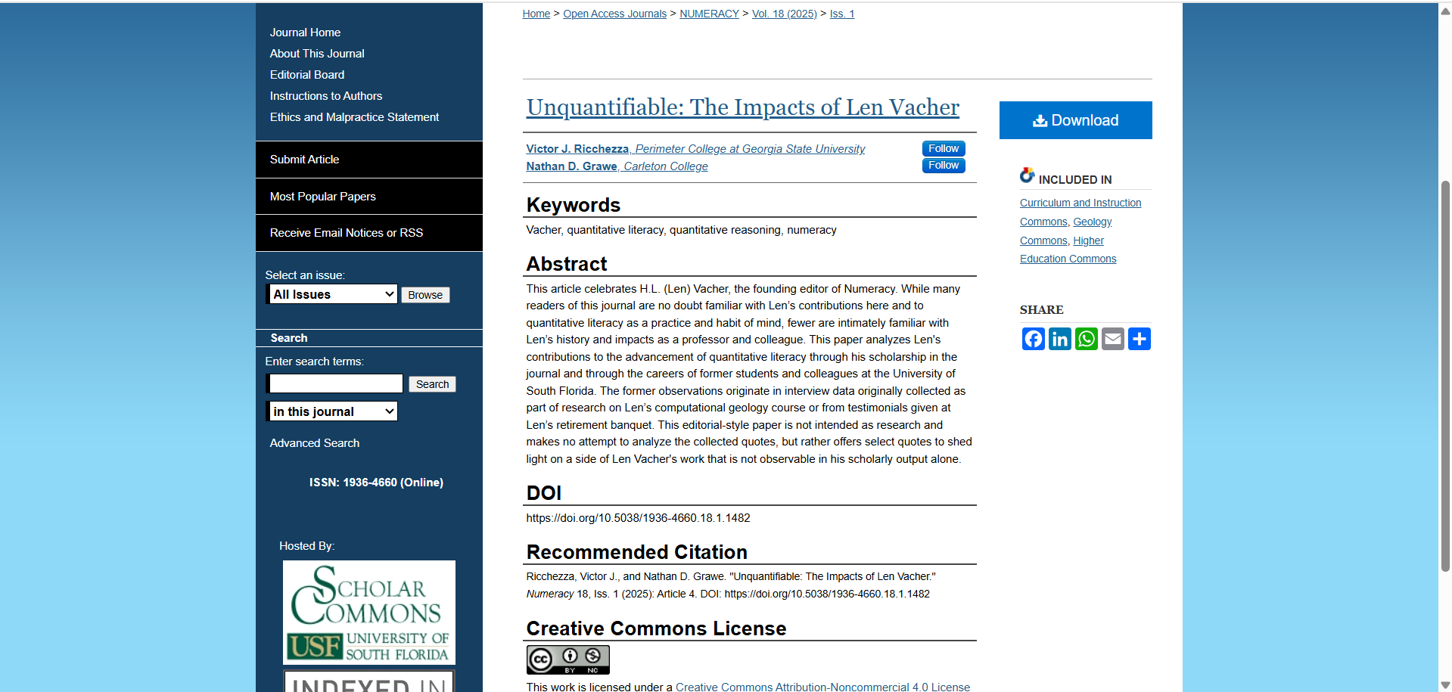
ISSN number
Article number
DOI
Click to download the PDF
Abstract
“D” should be added to the page range.

