Source ID | Source Title | URL
939594930 | Journal of Payavard Salamat | https://payavard.tums.ac.ir/page/12/About-the-Journal
* Go to the URL and capture the metadata as shown below.

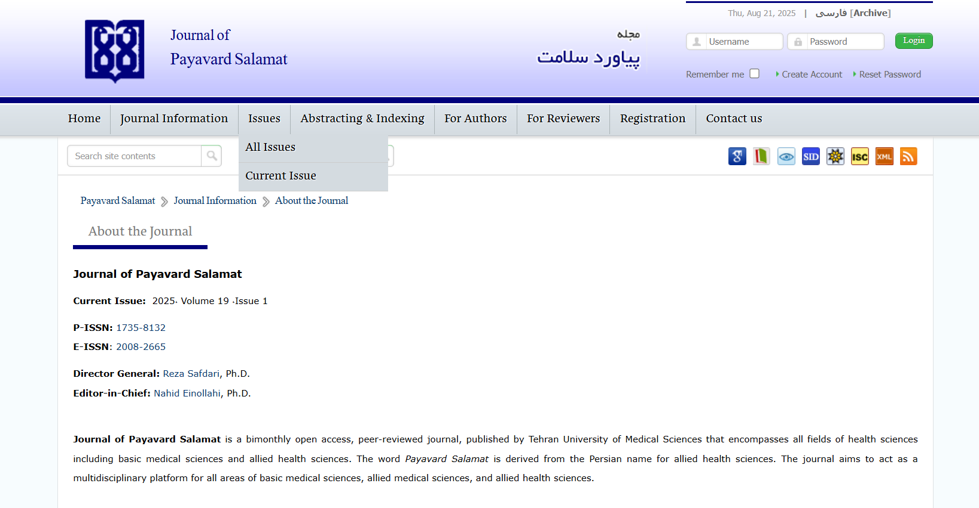
ISSN

Current Issue

*Click Issue and go to the current issue
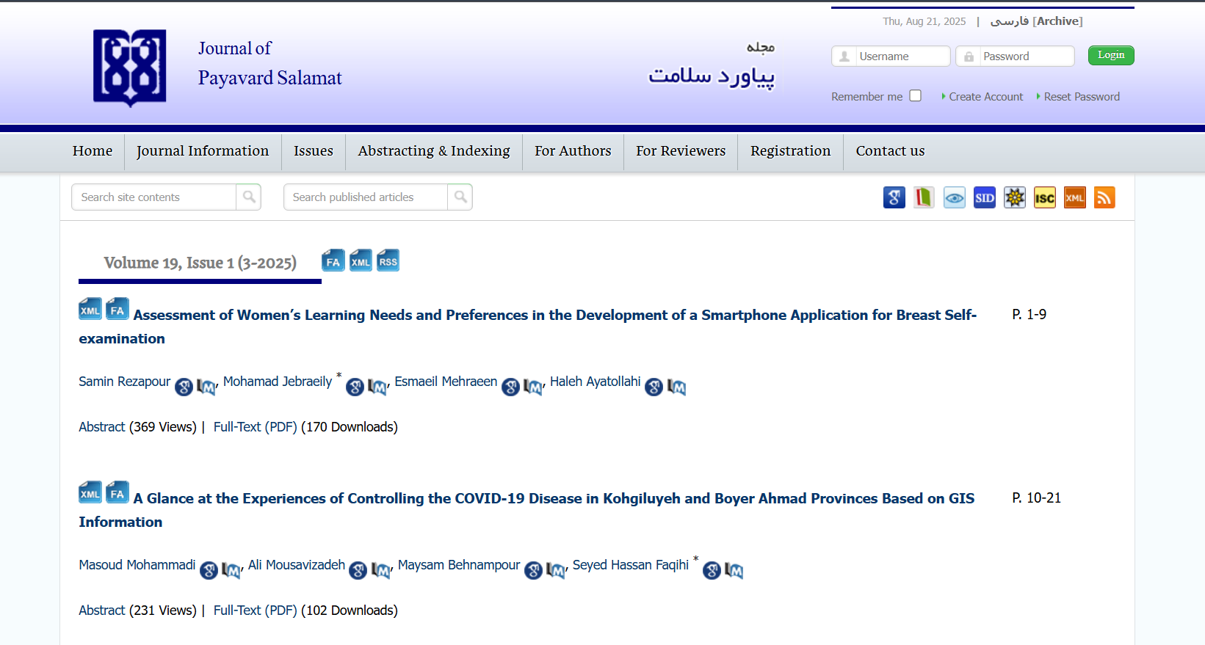
Article Title
Month/Year (Capture separately)

Click here to download the PDF
Page Range
Issue

Volume

Click here to Download PDF

Month is available as a number it should be captured in text (3 – March)
Both English and Persian TOC should be added
*Click the article title
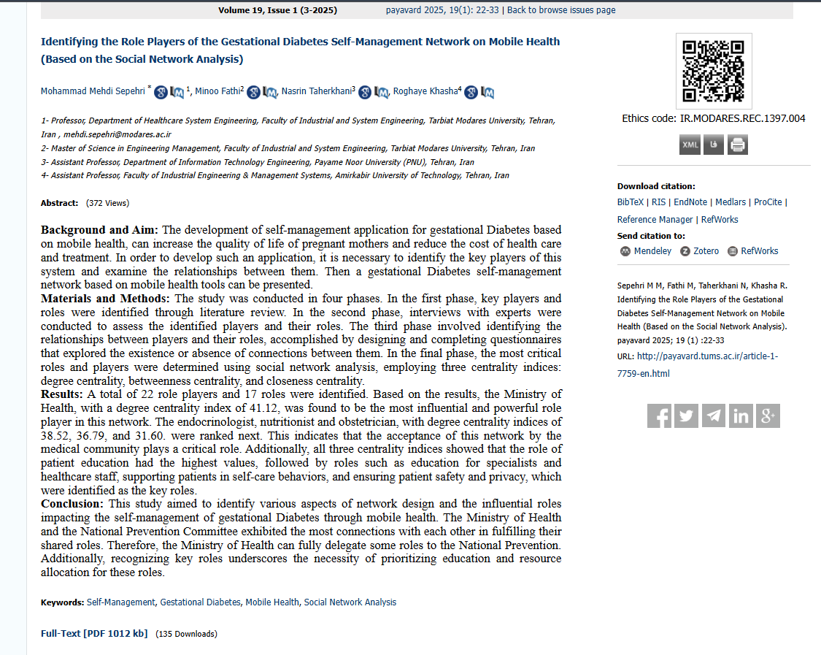
Abstract

Click here to download the PDF

