Source ID | Source Title | URL
665913536 | Reports of Biochemistry and Molecular Biology | https://rbmb.net/

- Go to the URL, capture the data below and select the current issue.

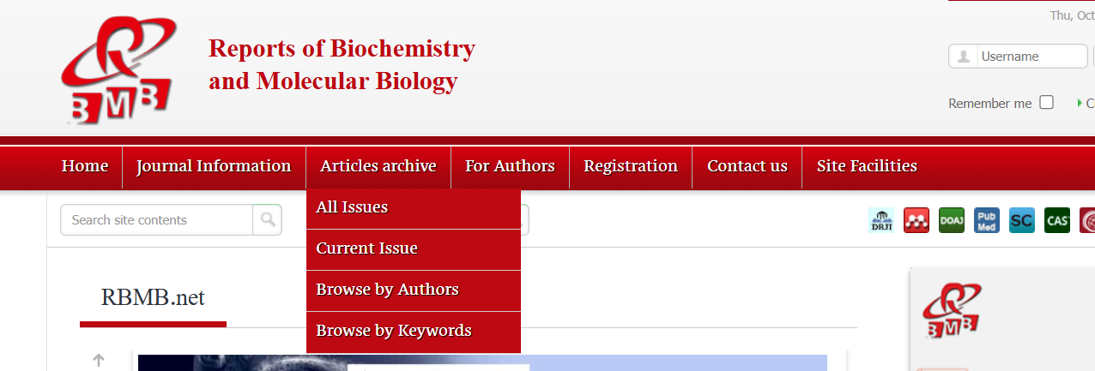
Current issue
Source title

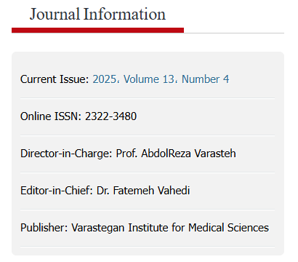

ISSN

- Capture metadata as below,
Volume
Issue
Month
Year
Article title
Page range
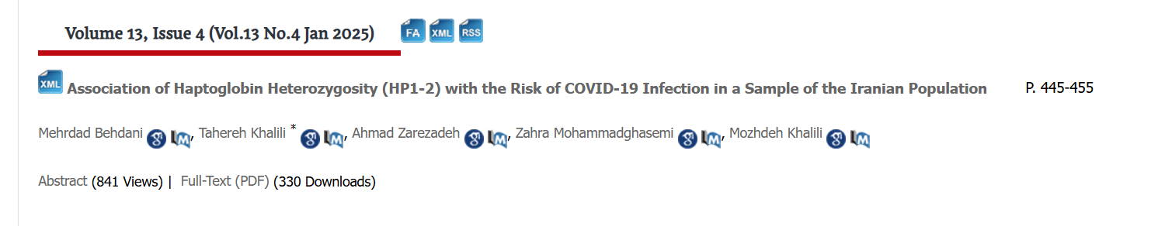
PDF

Month should be captured in full (Jan - January). This applies to all months.

- Click the article title to capture abstract and article type.
Abstract
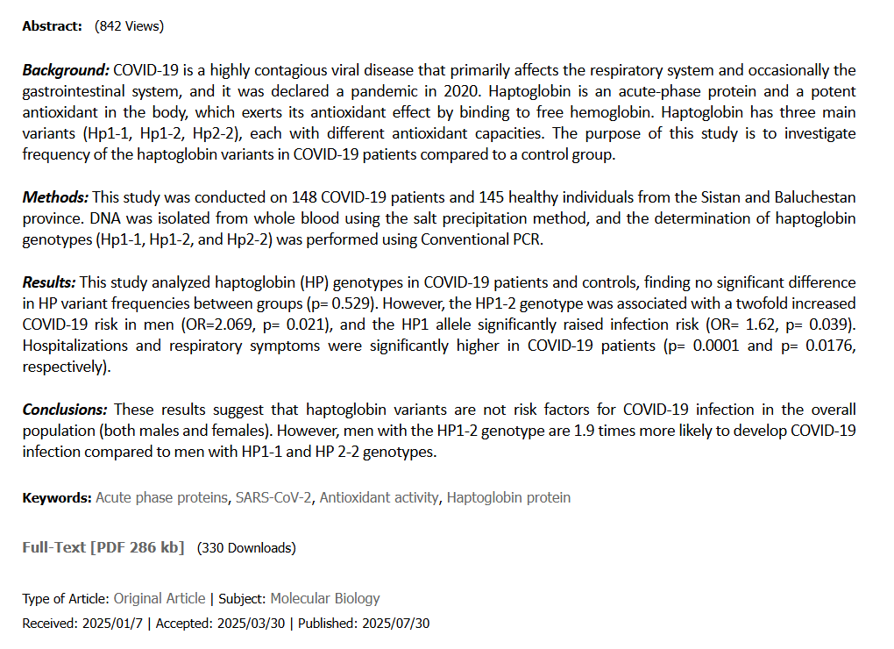
Article type

