Source ID | Source Title | URL
910210039 | Intersections (Australia) | http://intersections.anu.edu.au/back_issues.html

1.Go to the URL and select the latest issue.
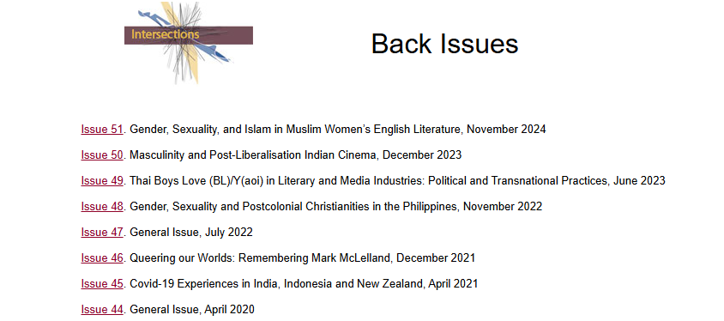
Month
Latest Issue
2.Capture metadata as below.
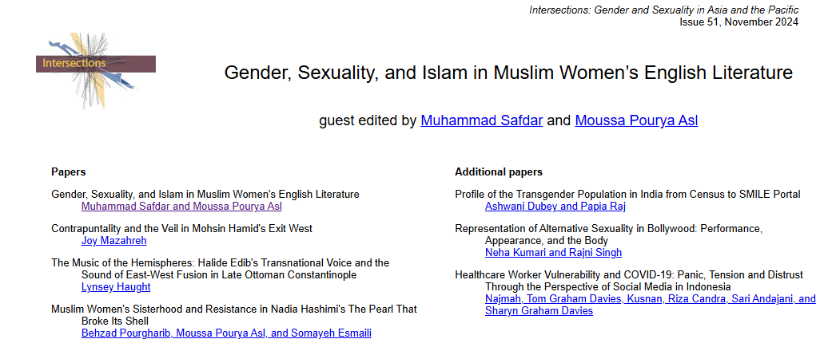
PDF
Article title
Year
Issue

2. After extracting all the metadata blue part below the article title to go to the pdf.

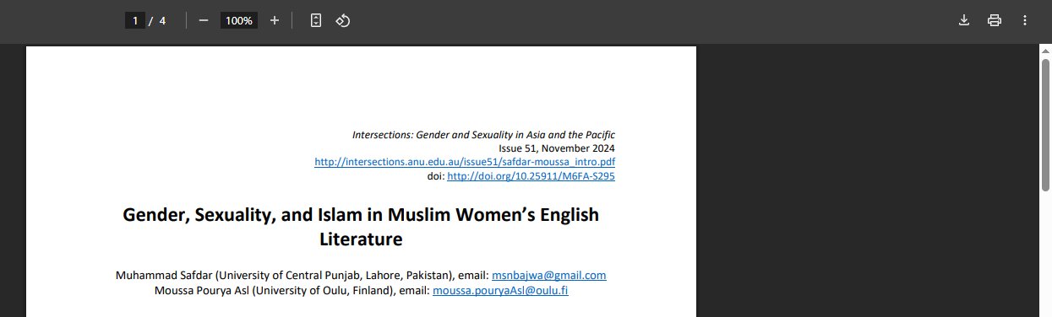
Click to download the PDF
DOI

