Source ID | Source Title | URL
950612509 | Computational Psychiatry | https://cpsyjournal.org/issue/archive

* Go to the URL and select the current issue

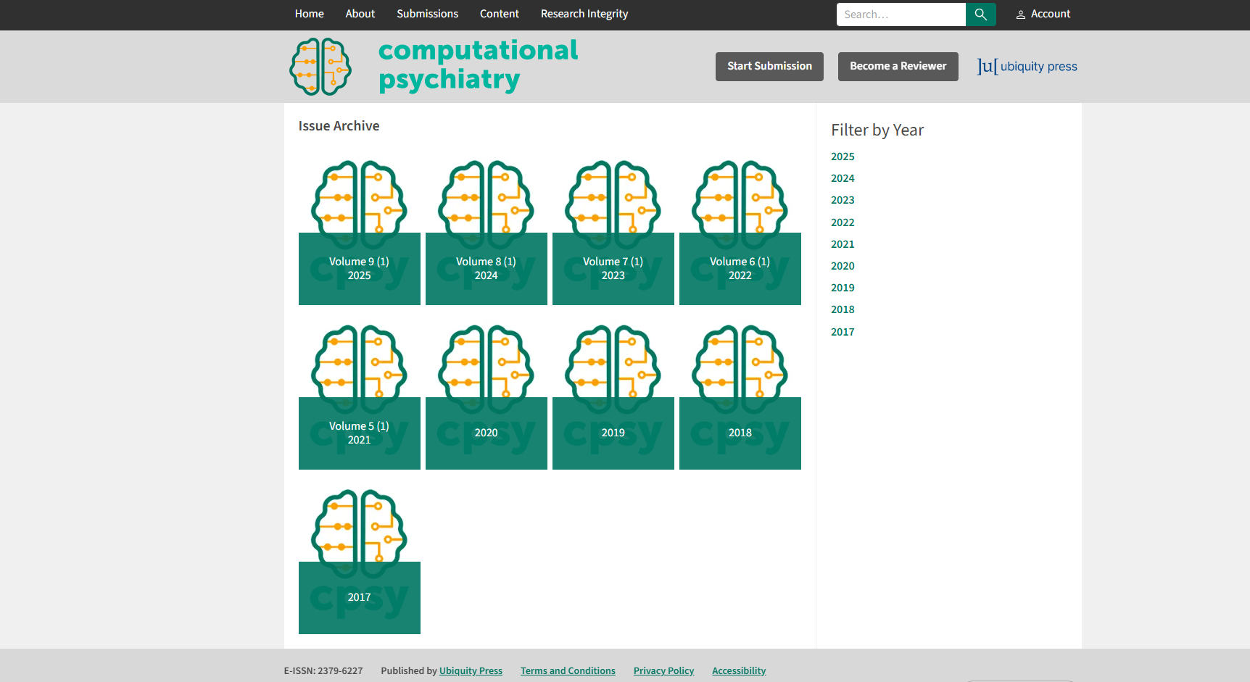
Current Issue
ISSN
Source Title

* Click the Current Issue see the Volume, Issue, Year, Month

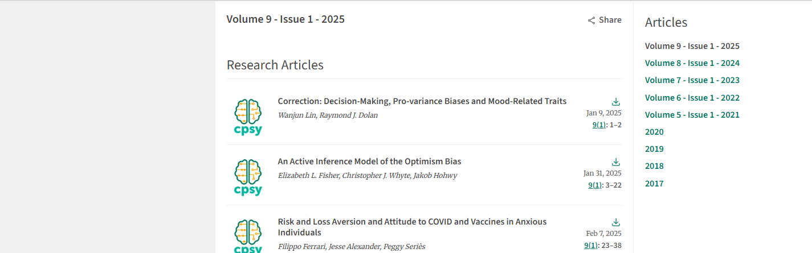
Click the Article
Volume
Issuee
Year

*Click the article title see the Abstract, DOI, PDF

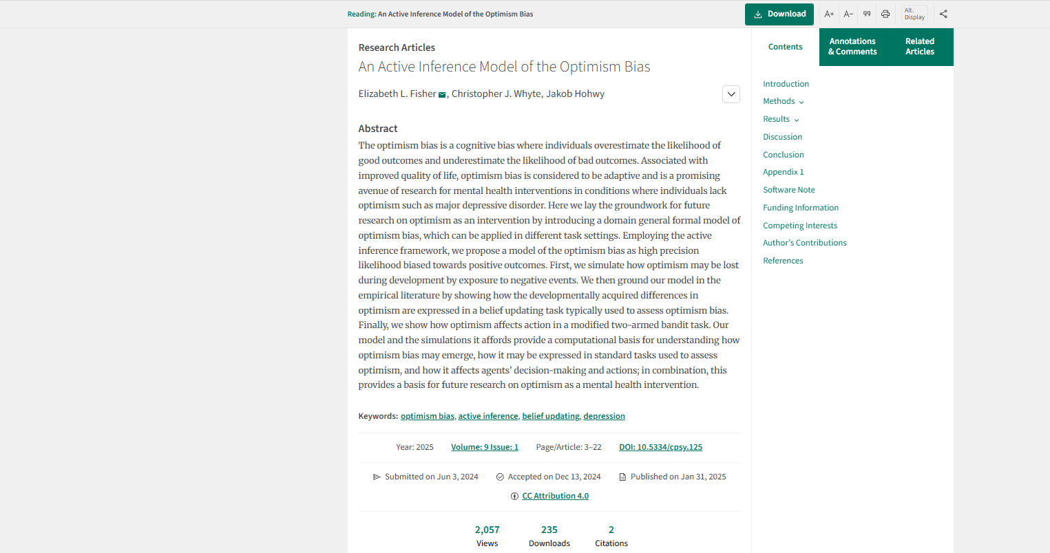
Article Type
Click to download PDF

DOI
Page Range
Abstract
Article Title

