Source ID | Source Title | URL
950988106 | Journal of Catholic Education | https://digitalcommons.lmu.edu/ce/

1.Go to the URL and select the latest issue.
Source Title
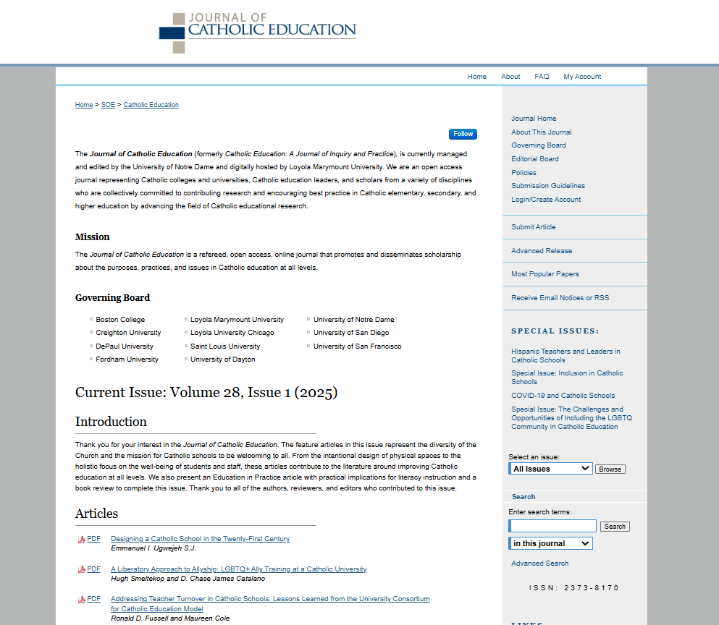
ISSN number
Article Title
Year
Issue
Volume
Latest issue

Article Title

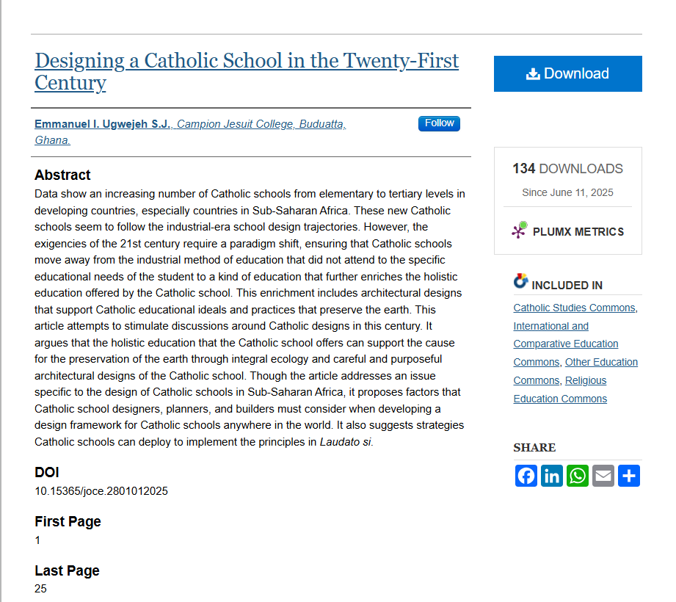
DOI
Abstract

Page Range

Page range should be captured as 1-25

